

Project Report

on

Bus Management System

*Submitted by*

Nishant

Enrollment No.: 176011833

BCA

*Under guidance of*

Mrs. Shuruti Singhal (MCA)

GitHub.com/NishantTheProgrammer/BusManagementSystem

INDIRA GANDHI NATIONAL OPEN UNIVERSITY

(2019-2020)

Index

Introduction 1

Objective 2

Tools / Environment Used 4

Hardware Requirements 4

Software Requirements 4

Analysis Documents 5

Data Flow Diagram 5

Entity Relationship Diagram 12

Process Logic 13

Class Diagram 14

Design Document 17

Database Model 17

Database Design 18

Module Description Error! Bookmark not defined.

Directory Hierarchy 27

Timeline 31

Source Code and Screenshots 34

Source Code Without Output 167

Testing 220

Testing Process 220

Test Cases 222

Security Implementation 226

Limitations of the Project 229

Is this project for Client/Industry? 231

No 231

Future Applications of the Project 232

Bibliography 233

# Introduction

Busses are the most frequently available and most used vehicle for going from small distance trip to very long trip. There’re a no. of types of buses available in the market according to the private or public.

In our case we’re about to start a new bus company (Shivaji Roadways) this company don’t want to go traditionally for management of the system manually.

So that we’re here to make a project which will be manage all the works related to database management and other operation such as E-ticket booking, Fair checking, estimated time for reaching location, Selecting best route etc.

Bus Management System is a web based management system. This system will ensure that the management process of this company are smoothly done. This system will also help in decreasing error mostly cause by human mistake. This system will develop as one the solution to transfer from current manual practices to a more systematic computerization system. This system will be developed by using HTML, CSS, JSP, JavaScript, and MySQL and will about to be run on Apache Tomcat 9.0 server on Windows 10.

Briefly there are three main modules for this system. The first module will be The Passenger Management System, the second module will be The Staff Management System and last one is for Company.

# Objective

The main objective of the Bus Management System is to manage the details of the following:

1. **Details for Passengers**

* **Distance** to inform Passengers how far are they for their destination (Distance between current location to destination).
* **Fair** to inform them about cost for ticket for both non A/C busses **(₹5/ ₹10/ ₹15)** and A/C busses **(₹10/ ₹15/ ₹20/ ₹25).**
* **Time** to inform them about estimated time for reaching destination from where he/she is.
* **Route** to suggest passengers best route for reaching a particular location with having less traffic jam and less taken time to complete out the journey.
* **E-Ticket** to provide facility for buy a ticket online.

1. **Details for Staff**

* **Salary** information regarding the salary of the employee such as salary package amount, and whole table about previews received salary.
* **Leave** Staff such as Driver, Conductor, Ticket checker and other peoples can online apply for a leave.
* **E-Report** they can report online if bus is being faulty.
* **Request for Transfer / Promotion** they can request for a transfer if their family is shifting somewhere else and also they can request for promotion if they think the sum of salary given by company is not negligible in respect of workload.
* **Fair** they can too know fairs (In such cases in arguing with passengers).

1. **Details for Company(Admin)**

* **Updating Fairs** bus company have right to increase or decrees fairs so that we’ll prove facility for do that.
* **Updating Routes** company will be able to maintain flow of busses to maximize profit by avoiding broken roads and heavy traffic jams and other issues.
* **Issuing more busses** if company purchases some new buses or get them on rent for temporary or permanent bases, we’ll provide a portal for updating information regarding new buses for maintain manageability.
* **Introducing New Route** company can introduce new routes, let’s take a real world scenario to know the importance of this. When the Signature bridge was under construction and the alter one (bridge of Wazirabad) was also under maintenance so that was the point when Dehli Transport Corporation (DTC) was introduce new route for 971 via Kashmiri gate. To implement it efficiently we’ll provide this module.
* **Staff Payment** this will store all the details of payments for staff this will also visible in for staff.
* **Policies of Company** This section will provide all the details about company policies to avoid misconception of staff duty and liabilities and other things.

# Tools / Environment Used

## Hardware Requirements

* **Operating System:** Windows 7/8/8.1/10
* **Hard Disks:** 40GB
* **RAM:** 256MB
* **GPS:** Needed
* **Graphic Card:** Decent
* **NIC:** Needed

## Software Requirements

* **Java 1.8** (JDK+JRE)
* **HTML, CSS and JavaScript**
* **MySQL 8.0**
* **Apache Tomcat 9.0**
* **GitBash 2.24**
* **JDBC Connectors**
* **Google Chrome (Browser)**
* **Visual Studios Code (IDE)**

# Analysis Documents

## Data Flow Diagram

### Level 0 DFD



### Level 1 DFD



### Level 2 DFD

#### 2.1 Authentication



#### 2.2 Fair



#### 2.3 Salary



#### 2.4 Report



#### 2.5 Leave

#### 

#### 2.6 Policies



#### 2.7 Route



#### 2.8 Bus Details



#### 2.9 Estimated Time Calculation



## Entity Relationship Diagram



## Process Logic



## Class Diagram

|  |
| --- |
| **Admin** |
| -id: int |
| -password: String |
| -name: String |
| -phone: int[1..3] |
| -email: String[1..3] |
| +setId(int): void |
| +getId(): int |
| +setPassword(String): void |
| +getPassword(): String |
| +setName(String): void |
| +getName(): String |
| +addPhone(int): void |
| +removePhone(int): void |
| +getPhoneNumbers(): int[] |
| +addEmail(String): void |
| +removeEmail(String): void |
| +getEmails(): String[] |

|  |
| --- |
| **BusStand** |
| -standNo: int |
| -name: String |
| -busNo: String [1..*] |
| +setStandNo(int): void |
| +getStandNo(): int |
| +setName(String): void |
| +getName(): String |
| +addBus(String): void |
| +removeBus(String): void |
| +getBusNumbers(): String[] |

|  |
| --- |
| **Ticket** |
| -serialNo: int |
| -routeNo: String |
| -amount: int |
| -dateTime: String |
| -origin: String |
| -destination: String |
| +setSerialNo(int): void |
| +getSerialNo(): int |
| +setRouteNo(String): void |
| +getRouteNo(): String |
| +setDate(): void |
| +getDate(): String |
| +setTime(): void |
| +getTime: void |
| +setOrigin(String): void |
| +getOrigin(): String |
| +setDestination(String): void |
| +getDestination(): String |

|  |
| --- |
| **Bus** |
| -busNo: String |
| -routeNo: String |
| -type: Boolean |
| +setBusNo(String): void |
| +getBusNo(): String |
| +setRouteNo(String): void |
| +getRouteNo(): String |
| +setType(Boolean): void |
| +getType(): Boolean |

|  |
| --- |
| **Driver** |
| -id: int |
| -password: String |
| -name: String  -joiningDate: String  -experience: int |
| -phone: int[1..3] |
| -email: String[1..3] |
| -licenceNo: String |
| +setId(int): void |
| +getId(): int |
| +setPassword(String): void |
| +getPassword(): String |
| +setName(String): void |
| +setJoiningDate(String): void |
| +getJoiningDate(): String |
| +setExperience(int): void |
| +getExperience(): int |
| +getName(): String |
| +addPhone(int): void |
| +removePhone(int): void |
| +getPhoneNumbers(): int[] |
| +addEmail(String): void |
| +removeEmail(String): void |
| +getEmails(): String[] |
| +setLicenceNo(String):void |
| +getLicenceNo():String |

|  |
| --- |
| **Conductor** |
| -id: int |
| -password: String |
| -name: String |
| -joiningDate: String |
| -phone: int[1..3] |
| -email: String[1..3] |
| +setId(int): void |
| +getId(): int |
| +setPassword(String): void |
| +getPassword(): String |
| +setName(String): void |
| +setJoiningDate(String): void |
| +getJoiningDate(): String |
| +getName(): String |
| +addPhone(int): void |
| +removePhone(int): void |
| +getPhoneNumbers(): int[] |
| +addEmail(String): void |
| +removeEmail(String): void |
| +getEmails(): String[] |

|  |
| --- |
| **TicketChecker** |
| -id: int |
| -password: String |
| -name: String  -joiningDate: String |
| -phone: int[1..3] |
| -email: String[1..3] |
| +setId(int): void |
| +getId(): int |
| +setPassword(String): void |
| +getPassword(): String |
| +setName(String): void |
| +getName(): String |
| +setJoiningDate(String): void |
| +getJoiningDate(): String |
| +addPhone(int): void |
| +removePhone(int): void |
| +getPhoneNumbers(): int[] |
| +addEmail(String): void |
| +removeEmail(String): void |
| +getEmails(): String[] |

|  |
| --- |
| **Passenger** |
| -id: int |
| -password: String |
| -name: String |
| -walletBalance: float |
| -phone: int[1..3] |
| -email: String[1..3] |
| +setId(int): void |
| +getId(): int |
| +setPassword(String): void |
| +getPassword(): String |
| +setName(String): void |
| +getName(): String |
| +updateBal(float): void |
| +getBal(): float |
| +addPhone(int): void |
| +removePhone(int): void |
| +getPhoneNumbers(): int[] |
| +addEmail(String): void |
| +removeEmail(String): void |
| +getEmails(): String[] |

# Design Document

## Database Model

**RDBMS** stands for “Relational Database Management System.” An RDBMS is a DBMS designed specifically for relational databases. Therefore, RDBMSes are subset of DBMSes.

A relational database refers to a database that stores data in a structured format, using rows and columns. This makes it easy to locate and access specific values within the database. It is “relational” because the values within each table are related to each other. Tables may also be related to other tables. The relational structure makes it possible to run queries across multiple tables at once.

While a relational database describes the type of database a RDBMS manages, the RDBMS refers to the database program itself. It is the software that executes queries on the data,

including adding, updating, and searching for values. A RDBMS may also provide a visual representation of the data. For example, it may display data in a tables like a spreadsheet, allowing you to view and even edit individual values in the table. Some RDBMS programs allow you to create forms that can streamline entering, editing and deleting data.

Most well-known DBMS applications fall into the RDBMS category. Examples include Oracle Database, MySQL, Microsoft SQL Server, and IBM DB2. Some of these programs are primarily used for relational database management.

Example of non-relational databases include Apache Hbase, IBM Domino, and Oracle NoSQL Database.

These type of database are managed by other DBMS programs that support NoSQL, which do not fall into the RDMBS category.

**In our case we’re about to use MySQL for RDBMS.**

## Database Design

### Admin

|  |  |  |  |  |  |
| --- | --- | --- | --- | --- | --- |
| Field | Type | Null | Key | Default | Extra |
| id | int(4) | NO | PRI | NULL | auto_incriment |
| password | varchar(20) | NO |  | NULL |  |
| name | varchar(20) | NO |  | NULL |  |
| email | varchar(30) | NO | UNI | NULL |  |
| phone | varchar(10) | YES |  | NULL |  |

### Conductor

|  |  |  |  |  |  |
| --- | --- | --- | --- | --- | --- |
| Field | Type | Null | Key | Default | Extra |
| id | int(4) | NO | PRI | NULL | auto_incriment |
| password | varchar(20) | NO |  | NULL |  |
| name | varchar(20) | NO |  | NULL |  |
| email | varchar(30) | NO | UNI | NULL |  |
| phone | varchar(10) | YES |  | NULL |  |
| joiningDate | date | NO |  | NULL |  |

### Passenger

|  |  |  |  |  |  |
| --- | --- | --- | --- | --- | --- |
| Field | Type | Null | Key | Default | Extra |
| id | int(4) | NO | PRI | NULL | auto_incriment |
| password | varchar(20) | NO |  | NULL |  |
| name | varchar(20) | NO |  | NULL |  |
| email | varchar(30) | NO | UNI | NULL |  |
| phone | varchar(10) | YES |  | NULL |  |
| walletBalance | float(7,2) | NO |  | 0.00 |  |

### Driver

|  |  |  |  |  |  |
| --- | --- | --- | --- | --- | --- |
| Field | Type | Null | Key | Default | Extra |
| id | int(4) | NO | PRI | NULL | auto_incriment |
| password | varchar(20) | NO |  | NULL |  |
| name | varchar(20) | NO |  | NULL |  |
| email | varchar(30) | NO | UNI | NULL |  |
| phone | varchar(10) | YES |  | NULL |  |
| joiningDate | date | NO |  | NULL |  |
| experience | int(2) | YES |  | NULL |  |
| licenceNo | varchar(10) | NO | UNI | NULL |  |

### Bus

|  |  |  |  |  |  |
| --- | --- | --- | --- | --- | --- |
| Field | Type | Null | Key | Default | Extra |
| busNo | varchar(6) | NO | PRI | NULL |  |
| routeNo | int(5) | NO | MUL | NULL |  |
| type | varchar(6) | NO |  | NULL |  |

### Ticket

|  |  |  |  |  |  |
| --- | --- | --- | --- | --- | --- |
| Field | Type | Null | Key | Default | Extra |
| serialNo | int(7) | NO | PRI | NULL | auto_incriment |
| routeNo | int(5) | NO | MUL | NULL |  |
| amount | int(2) | NO | MUL | NULL |  |
| dateTime | datetime | NO |  | CURRENT_  TIMESTAMP | DEFAULT_  GENERATED |
| destination | varchar(20) | NO |  | NULL |  |
| origin | varchar(20) | NO |  | NULL |  |

### BusStand

|  |  |  |  |  |  |
| --- | --- | --- | --- | --- | --- |
| Field | Type | Null | Key | Default | Extra |
| standNo | int(4) | NO | PRI | NULL | auto_increment |
| name | varchar(20) | NO |  | NULL |  |
| busNo | varchar(6) | NO |  | NULL |  |

### TicketChecker

|  |  |  |  |  |  |
| --- | --- | --- | --- | --- | --- |
| Field | Type | Null | Key | Default | Extra |
| id | int(4) | NO | PRI | NULL | auto_incriment |
| password | varchar(20) | NO |  | NULL |  |
| name | varchar(20) | NO |  | NULL |  |
| email | varchar(30) | NO | UNI | NULL |  |
| phone | varchar(10) | YES |  | NULL |  |
| joiningDate | date | NO |  | NULL |  |

### 

### Route

|  |  |  |  |  |  |
| --- | --- | --- | --- | --- | --- |
| Field | Type | Null | Key | Default | Extra |
| routeNo | varchar(6) | NO | PRI | NULL | auto_incriment |
| source | int(5) | NO | MUL | NULL |  |
| destination | int(5) | NO |  | NULL |  |

### Fair

|  |  |  |  |  |  |
| --- | --- | --- | --- | --- | --- |
| Field | Type | Null | Key | Default | Extra |
| amount | int(2) | NO | PRI | NULL |  |
| distance | int(2) | NO |  | NULL |  |

### Salary

|  |  |  |  |  |  |
| --- | --- | --- | --- | --- | --- |
| Field | Type | Null | Key | Default | Extra |
| tranId | int(4) | NO | PRI | NULL | auto_incriment |
| userId | int(4) | NO | MUL | NULL |  |
| date | date | NO |  | NULL |  |

### Policy

|  |  |  |  |  |  |
| --- | --- | --- | --- | --- | --- |
| Field | Type | Null | Key | Default | Extra |
| pNo | int(4) | NO | PRI | NULL | auto_incriment |
| type | varchar(10) | NO |  | NULL |  |
| discription | varchar(999) | NO |  | NULL |  |

**Modularization details**

### Authentication

#### Registration:

User information have to be compelled to be registered within the system thus on establish every of them unambiguously and do the required group acts as the real potential.

On the far side, this plenty of things require measure there wherever we will reference him. Without registration, there are few options and pages one user can see which are landing on the home page and taking the features read but he won’t be allowed to use those.

For use, he will have to register. One person needs to put his all the details correctly and precisely as it will be helpful in identifying them and believing that he is the real person who has booked for the same.

It also includes driver license for them who is driving and parameter too.

#### Log in:

After registration one will register within the system because of the operator of the system either on behalf of the user. When this he has the different helpful interfaces accessible for any action.

Here either bride or groom both have to log in with their unique identity and passwords. After this, they will be directed to the primary user interface from where they have further options.

#### Forgot password:

This is quite often that people tend to forget the password they keep for login. So this could be very tedious and hectic to recover the password manually in case if one needs to log in in the emergency.

So to overcome this problem we have this module named as forgot password and using this module user can recover their password in seconds. So here we need only to put our registered email Id and hit the enter.

Then one confirmation email will go to the email where he may reset the password. In seconds one can use this module and get rid of forgetting password problem.

### Fair

This module is for mange all the functions related to fair such as Update and view.

#### Update Fair:

As all of us knows increasing in public spending, hoarding, tax reductions, price rise in international markets are the **cause of inflation.** These factors leads to rising prices. Also, increase demands cause higher prices which leads to inflation. So may be in future we have to increase the Fairs of busses or may be reduce for implanting this functionality we have fair update module.

#### View Fair:

This sub-module is for showing the information related to Fairs for passengers and sometimes this is for Staff to in condition of arguing with the passengers.

### Salary

A **Salary** is a form of payment from an employer to an employee, which may be specified in an employment contract. It is contracted with piece wages, where each job, hour or other unit is paid separately, rather than on a periodic basis. From the point of view of running a business, salary can also be viewed as the cost of acquiring and retaining human resources for running operations, and is then termed personnel expense or salary expense. In our module staff can see the info regarding salary and salary can be updated through Admin.

### Report

A report is a document that presents information in an organized format a specific audience and purpose. Although summaries of reports may be delivered orally, complete reports are almost always in the form of written documents.

Staff can report in case of **bus is being faulty** and can get report no. which is generated through Admin

### Leave

A leave of absence in an extended period of time off from your job. Depending on the organization, you may simply be able to ask for time off from work. Or, there may be a formal process you need to follow approved for a leave of absence. In our Bus Management System Staff can request for a leave online and can get approval.

### Policies

Policies are needed because they set a general plan of action used to guide desired outcomes and is a fundamental guideline to help make decisions. The purpose of healthcare procedures it to communicate to employees the desired outcomes of the organization. We implement both sub modules for update and view policy.

### Route

A route is a way for travel or movement, the path from source location to the Destination location. The route module will give all the information to the passengers and routes can be modified through admin.

### Bus Details

This Module is to provide users information about bus from where this information maintained by the admin of the System

### Estimated Time Calculation

This module as per name suggests is for calculation the time for being journey complete which internally works on distance between locations and the flow of traffic

**User Interface Design**

User Interface (UI) design is the process of making interfaces in software or computerized devices with a focus on loos or style.

Designer aim to create design users will find easy to use and pleasurable. UI design typically refers to graphical user intgerface but also includes others, such as voice controlled ones.

**We use a symmetric design gain user’s attaintion on website**

Slogan

Navigation Bar

Title of page

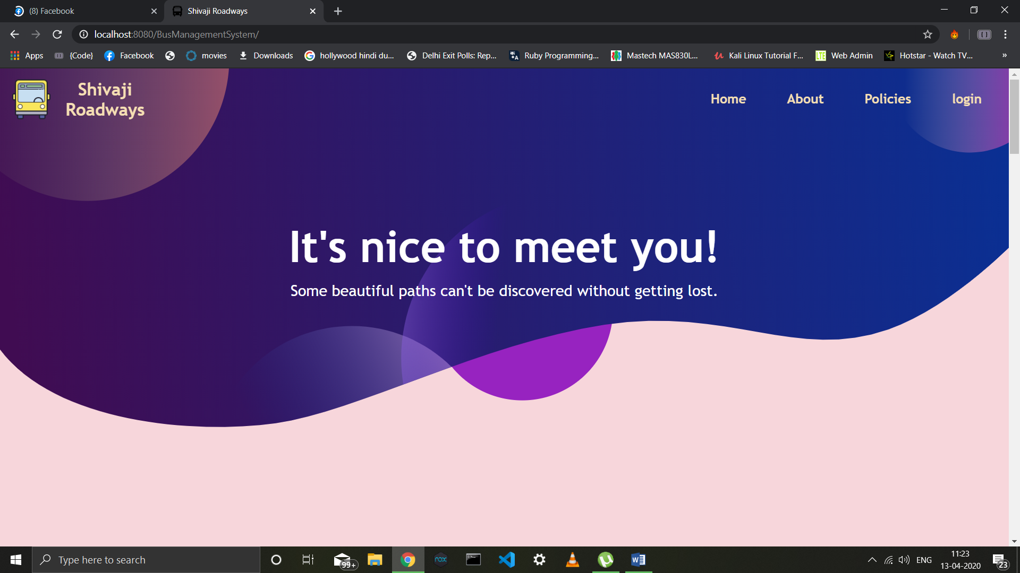

# Directory Hierarchy

BusManagementSystem

Databases

shivajiroadways.sql

images

… (Unnecessary to write names)

script

authentication.js

disabled.js

leave.js

navPannel.js

scrapRoute.py

scrapRouteStand.py

validate.js

sql

admin.sql

conductor.sql

createdb.sql

describer.sql

driver.sql

email.sql

leave.sql

passanger.sql

policy.sql

report.sql

route.sql

routeStands.sql

salary.sql

ticket.sql

ticketChecker.sql

ticketOutput.sql

style

about.css

authentication.css

calFare.css

common.css

confirmEmail.css

home.css

leave.css

Pacifio.ttf

policies.css

style.css

ticket.css

webfont.tff

WEB-INF

classes

CompareOTP.java

GenerateOTP.java

logout.java

SendMail.java

SendOTP.java

signIn.java

signUp.java

lib

activation.jar

common-fileupload-1.4.jar

common-io-2.6.jar

mysql-connector-java-8.0.18.jar

web.xml

about.jsp

addFeedback.jsp

authentication.jsp

authenticationAJAX.jsp

availableBuses.jsp

availableBusesAJAX.jsp

availableBusesAJAX.2jsp

busesResult.jsp

changeLeaveStatus.jsp

checkTicket.jsp

checkTicketAJAX.jsp

confirmEmail.jsp

createNewPassword.jsp

EnterOTP.jsp

estimatedTime.jsp

estimatedTimeAJAX.jsp

fare.jsp

fareAJAX.jsp

footer.jsp

home.jsp

leave.jsp

leaveRequestAJAX.jsp

leaveRequests.jsp

leaveStatusAJAX.jsp

navigationPannel.jsp

OTPnotMatched.jsp

output.txt

paySalary.jsp

paySalaryAJAX.jsp

paySalaryAJAX2.jsp

policies.jsp

printTicket.jsp

README.md

registeredSuccessfully.jsp

report.jsp

reports.jsp

route.jsp

routeAJAX.jsp

routeAJAX2.jsp

salary.jsp

sales.jsp

settings.jsp

signUpProcess.jsp

submitReport.jsp

svg.jsp

ticket.jsp

ticketAJAX.jsp

updateBuses.jsp

updatePassword.jsp

updateRoute.jsp

updateSalary.jsp

# Timeline

#### 09/02/2020

First commit

#### 11/02/2020

Forget password functionality added … change SendOTP.java configuration in order of code working put there

user=”Your Google email address” and pass=”Your Google password”

#### 12/02/2020

Improved sent mail and some background images

#### 16/02/2020

Home page, nav Panel and some login utilities added

#### 18/02/2020

About and policies page added

#### 20/02/2020

Added logout button and user setting button

#### 24/02/2020

Leave and report page and fix some structure bugs

#### 26/02/2020

Added pages for passenger and staff and some recognized some code, separating navigationPannel.jsp is big update

#### 03/03/2020

Added ticket printing page and some structure optimization

#### 04/03/2020

Added Email verification and profile picture section

#### 05/03/2020

Created python script for extracting route data from a website and store into database local

#### 08/03/2020

Database connectivity on route module and ticket module ticket fare calculation logic also build

#### 09/03/2020

Inserting booked ticket information into database, AJAX connection to know fare live with some page

#### 10/03/2020

Preventing users to put wrong data, added estimated time functionality

#### 10/03/2020

Added search bar for check bus availability

#### 14/03/2020

Login and registration through database, busResult page added

#### 15/03/2020

Image preview while logging in and email availability while registering through AJAX

#### 16/03/2020

Added database connection for requesting staff for leave and admin to approve/decline

#### 18/03/2020

Report, Salary module implemented for both side staff and admin and ticket checking module only for TC.

#### 19/03/2020

Profile editing module and sales summary for admin

#### 21/03/2020

Added feedback module… The last commit project done!

# Source Code and Screenshots

#### svg.jsp

This file I made for giving a modern look to my website I made this vector art using Figma.

#### Output

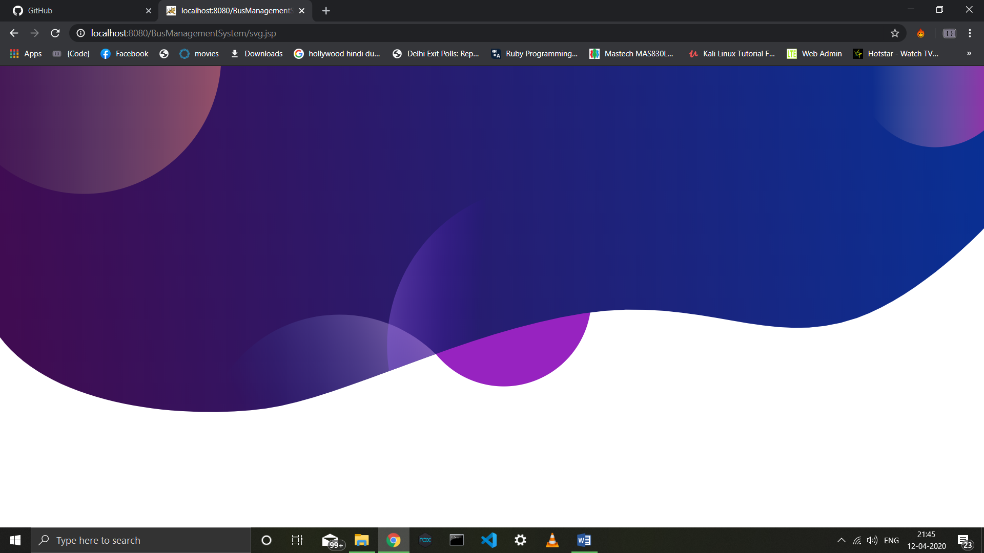

#### Source Code

<**svg** class**=**"svgGredient" width**=**"1536" height**=**"541" viewBox**=**"0 0 1536 541" fill**=**"none" xmlns**=**"http://www.w3.org/2000/svg">

    <**ellipse** cx**=**"786.381" cy**=**"363.536" rx**=**"136.658" ry**=**"137.145" fill**=**"#9723C0"/>

    <**path** d**=**"M415.124 535.125C293.029 552.177 83.6654 535.125 0 423.937V0H1536V56.2712V253.781C1536 253.781 1437.62 358.6 1337.81 393.735C1199.55 442.402 1097.2 358.212 910.651 386.631C724.106 415.049 537.22 518.074 415.124 535.125Z" fill**=**"url(#paint0_linear)"/>

    <**path** fill-rule**=**"evenodd" clip-rule**=**"evenodd" d**=**"M324.911 540.792C357.664 540.944 388.473 538.847 415.124 535.125C470.582 527.38 539.407 501.898 615.496 473.726C636.473 465.959 658.002 457.988 679.956 450.128C641.308 412.017 588.314 388.508 529.848 388.508C433.276 388.508 351.632 452.648 324.911 540.792Z" fill**=**"url(#paint1_linear)"/>

    <**path** fill-rule**=**"evenodd" clip-rule**=**"evenodd" d**=**"M344.717 0C336.972 111.633 244.276 199.781 131.064 199.781C81.6928 199.781 36.2237 183.017 0 154.853V0H344.717Z" fill**=**"url(#paint2_linear)"/>

    <**path** fill-rule**=**"evenodd" clip-rule**=**"evenodd" d**=**"M1102.59 391.002C1047.02 381.979 985.635 375.208 910.651 386.631C808.838 402.141 706.923 439.875 615.496 473.726C612.746 474.744 610.005 475.759 607.273 476.77C605.231 463.888 604.171 450.68 604.171 437.225C604.171 298.627 716.699 186.271 855.509 186.271C978.504 186.271 1080.86 274.484 1102.59 391.002Z" fill**=**"url(#paint3_linear)"/>

    <**path** fill-rule**=**"evenodd" clip-rule**=**"evenodd" d**=**"M1337.01 0L1536 0V56.2712V100.495C1515.12 117.055 1488.92 126.91 1460.48 126.91C1392.29 126.91 1337.01 70.2737 1337.01 0.409416C1337.01 0.272894 1337.01 0.136421 1337.01 0Z" fill**=**"url(#paint4_linear)"/>

    <**defs**>

    <**linearGradient** id**=**"paint0_linear" x1**=**"-2.92808e-05" y1**=**"243.829" x2**=**"1529.61" y2**=**"26.2909" gradientUnits**=**"userSpaceOnUse">

    <**stop** stop-color**=**"#400C52"/>

    <**stop** offset**=**"1" stop-color**=**"#093094"/>

    </linearGradient>

    <**linearGradient** id**=**"paint1_linear" x1**=**"442.739" y1**=**"675.898" x2**=**"746.756" y2**=**"532.252" gradientUnits**=**"userSpaceOnUse">

    <**stop** stop-color**=**"#0D3D52" stop-opacity**=**"0"/>

    <**stop** stop-color**=**"#192580" stop-opacity**=**"0"/>

    <**stop** offset**=**"1" stop-color**=**"#9271B5"/>

    </linearGradient>

    <**linearGradient** id**=**"paint2_linear" x1**=**"-83.1134" y1**=**"-15.5567" x2**=**"345.24" y2**=**"-15.5567" gradientUnits**=**"userSpaceOnUse">

    <**stop** stop-color**=**"#0D3D52" stop-opacity**=**"0"/>

    <**stop** stop-color**=**"#5C5C67" stop-opacity**=**"0"/>

    <**stop** offset**=**"0.558916" stop-color**=**"#906F74" stop-opacity**=**"0.39683"/>

    <**stop** offset**=**"1" stop-color**=**"#C66D6D" stop-opacity**=**"0.67"/>

    </linearGradient>

    <**linearGradient** id**=**"paint3_linear" x1**=**"413.322" y1**=**"437.225" x2**=**"745.132" y2**=**"461.673" gradientUnits**=**"userSpaceOnUse">

    <**stop** stop-color**=**"#E7DAFF"/>

    <**stop** offset**=**"1" stop-color**=**"#4700D0" stop-opacity**=**"0"/>

    </linearGradient>

    <**linearGradient** id**=**"paint4_linear" x1**=**"1337.01" y1**=**"-34.7979" x2**=**"1599.93" y2**=**"-33.5616" gradientUnits**=**"userSpaceOnUse">

    <**stop** offset**=**"0.0989583" stop-color**=**"#C4C4C4" stop-opacity**=**"0"/>

    <**stop** offset**=**"1" stop-color**=**"#BA05A8"/>

    </linearGradient>

    </**defs**>

</**svg**>

#### navigationPannel.jsp

Navigation panel is for navigate users to relevant pages as per their role for example if the logged in user is a ticket checker then ticket checking link will be available for that user in navigation panel.

#### Output



#### Source Code

<**div** class**=**"navPannel">

    <**div** class**=**"logo">

        <**div** class**=**"logoImage"></**div**>

        <**div** class**=**"logoHeading">Shivaji Roadways</**div**>

    </**div**>

    <**div** class**=**"navLinks">

        <%

        response.setHeader("Cache-Control", "no-cache, no-store, must-revalidate");

        response.setHeader("Pragma", "no-cache");

        response.setHeader("Expires", "0");

        if(session.getAttribute("email") == null)

        {%>

            <**a** class**=**"link" href**=**"authentication.jsp" onfocus**=**"elemFocused(this)" onblur**=**"elemBlurred(this)">login</**a**>

        <%}

        else if(session.getAttribute("role").equals("admin"))

        {%>

        <**div** class**=**"userProfile">

            <**p** class**=**"userName"><%=session.getAttribute("name").toString().split(" ")[0]%></**p**>

            <**div** class**=**"userImg" style**=**"background-image: url('images/userProfile/${profilePic}');"></**div**>

            <**div** class**=**"iconContainer">

                <**div** class**=**"setting" onclick**=**"window.location**=**'setting.jsp';"></**div**>

                <**div** class**=**"logout" onclick**=**"window.location**=**'logout';"></**div**>

            </**div**>

        </**div**>

        <**a** class**=**"link" href**=**"paySalary.jsp" onfocus**=**"elemFocused(this)" onblur**=**"elemBlurred(this)">Pay</**a**>

        <**a** class**=**"link" href**=**"leaveRequests.jsp" onfocus**=**"elemFocused(this)" onblur**=**"elemBlurred(this)">Leave</**a**>

        <**a** class**=**"link" href**=**"reports.jsp" onfocus**=**"elemFocused(this)" onblur**=**"elemBlurred(this)">Reports</**a**>

        <**a** class**=**"link" href**=**"sales.jsp" onfocus**=**"elemFocused(this)" onblur**=**"elemBlurred(this)">Sales</**a**>

        <%}

        else if(session.getAttribute("role").equals("driver") ||

                session.getAttribute("role").equals("conductor") ||

                session.getAttribute("role").equals("ticketchecker")

                )

        {

        %>

        <**div** class**=**"userProfile">

            <**p** class**=**"userName"><%=session.getAttribute("name").toString().split(" ")[0]%></**p**>

            <**div** class**=**"userImg" style**=**"background-image: url('images/userProfile/${profilePic}');"></**div**>

            <**div** class**=**"iconContainer">

                <**div** class**=**"setting" onclick**=**"window.location**=**'setting.jsp';"></**div**>

                <**div** class**=**"logout" onclick**=**"window.location**=**'logout';"></**div**>

            </**div**>

        </**div**>

        <**a** class**=**"link" href**=**"report.jsp" onfocus**=**"elemFocused(this)" onblur**=**"elemBlurred(this)">Report</**a**>

        <**a** class**=**"link" href**=**"leave.jsp" onfocus**=**"elemFocused(this)" onblur**=**"elemBlurred(this)">Leave</**a**>

        <**a** class**=**"link" href**=**"salary.jsp" onfocus**=**"elemFocused(this)" onblur**=**"elemBlurred(this)">Salary</**a**>

        <**a** class**=**"link" href**=**"fare.jsp" onfocus**=**"elemFocused(this)" onblur**=**"elemBlurred(this)">Fare</**a**>

        <%

        if(session.getAttribute("role").equals("ticketchecker"))

        {%>

            <**a** class**=**"link" href**=**"checkTicket.jsp" onfocus**=**"elemFocused(this)" onblur**=**"elemBlurred(this)">Check Ticket</**a**>

        <%}

        %>

        <%}

        else if(session.getAttribute("role").equals("passanger"))

        {%>

        <**div** class**=**"userProfile">

            <**p** class**=**"userName"><%=session.getAttribute("name").toString().split(" ")[0]%></**p**>

            <**div** class**=**"userImg" style**=**"background-image: url('images/userProfile/${profilePic}');"></**div**>

            <**div** class**=**"iconContainer">

                <**div** class**=**"setting" onclick**=**"window.location**=**'setting.jsp';"></**div**>

                <**div** class**=**"logout" onclick**=**"window.location**=**'logout';"></**div**>

            </**div**>

        </**div**>

        <**a** class**=**"link" href**=**"route.jsp" onfocus**=**"elemFocused(this)" onblur**=**"elemBlurred(this)">Route</**a**>

        <**a** class**=**"link" href**=**"fare.jsp" onfocus**=**"elemFocused(this)" onblur**=**"elemBlurred(this)">Fare</**a**>

        <**a** class**=**"link" href**=**"availableBuses.jsp" onfocus**=**"elemFocused(this)" onblur**=**"elemBlurred(this)">Availability</**a**>

        <**a** class**=**"link" href**=**"estimatedTime.jsp" onfocus**=**"elemFocused(this)" onblur**=**"elemBlurred(this)">Time</**a**>

        <**a** class**=**"link" href**=**"ticket.jsp" onfocus**=**"elemFocused(this)" onblur**=**"elemBlurred(this)">Ticket</**a**>

        <%}%>

        <**a** class**=**"link" href**=**"policies.jsp" onfocus**=**"elemFocused(this)" onblur**=**"elemBlurred(this)">Policies</**a**>

        <**a** class**=**"link" href**=**"about.jsp" onfocus**=**"elemFocused(this)" onblur**=**"elemBlurred(this)">About</**a**>

        <**a** class**=**"link" href**=**"home.jsp" onfocus**=**"elemFocused(this)" onblur**=**"elemBlurred(this)">Home</**a**>

    </**div**>

</**div**>

#### footer.jsp

As usual footer in for providing company related information such as copyright, domain name or some social links like Facebook, Twitter, Instagram or GitHub profile link.

#### Output



#### Source Code

<**div** class**=**"footer">

    <**h1**>&copy;shivajiroadways.com</**h1**>

    <**a**  href**=**"https://twitter.com/nishant29769070" class**=**"social" style**=**"background-image: url('images/twitter.png');"></**a**>

    <**a** href**=**"https://www.facebook.com/profile.php?id=100006100632588" class**=**"social" style**=**"background-image: url('images/facebook.png');"></**a**>

    <**a** href**=**"https://www.instagram.com/experimentswithcode/" class**=**"social" style**=**"background-image: url('images/instagram.png');"></**a**>

</**div**>

#### home.jsp

A home page is a webpage that serves as the starting point of website. It is the default webpage that loads when you visit a web address that only contain a domain name. For example, <https://shivajiroadways.com> will display the **Shivaji Roadways** home page.

The home page is located in the root directory of a website. Most web server allow the home page to have one of several different file names. Example include index.html, index.htm, index.php, default.html and home.jsp .The default filename of a website’s home page can be customized on both Apache and IIS servers. Since the home page file is loaded automatically from the root directory, the home page URL does not need to include the filename.

#### Output

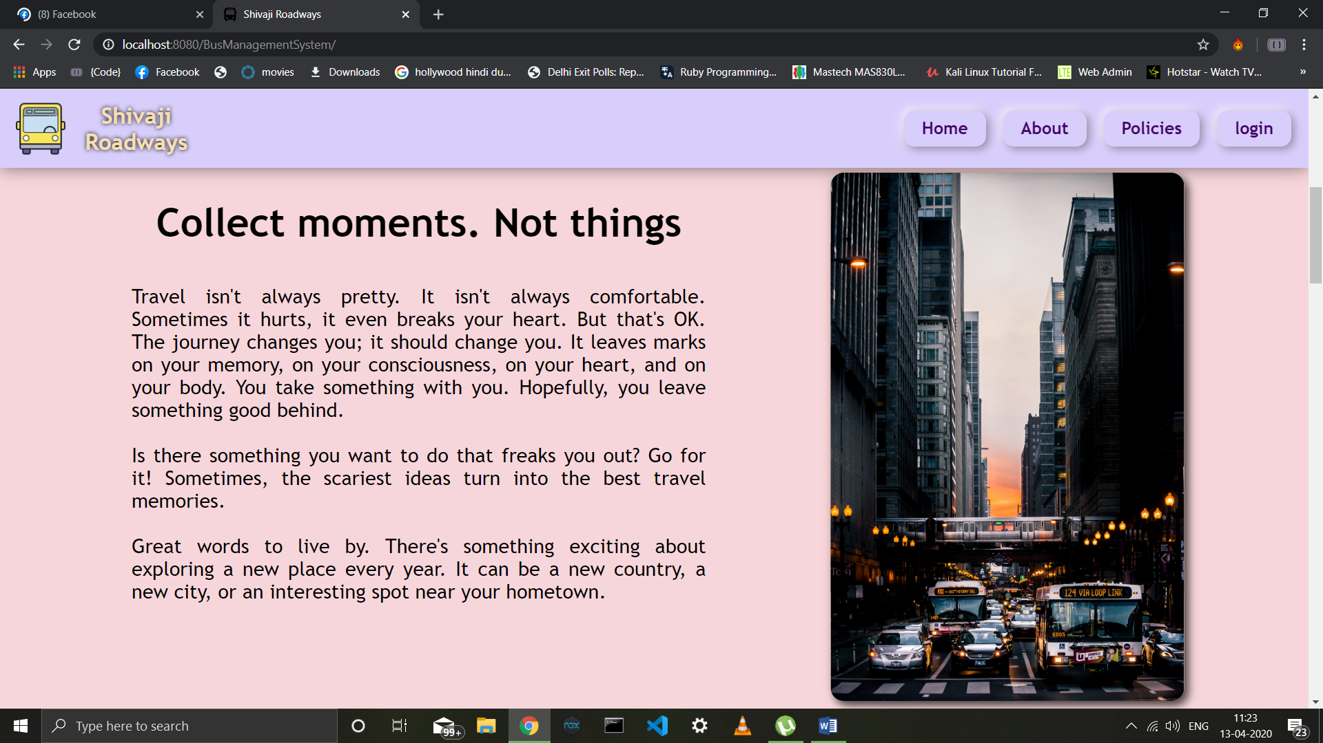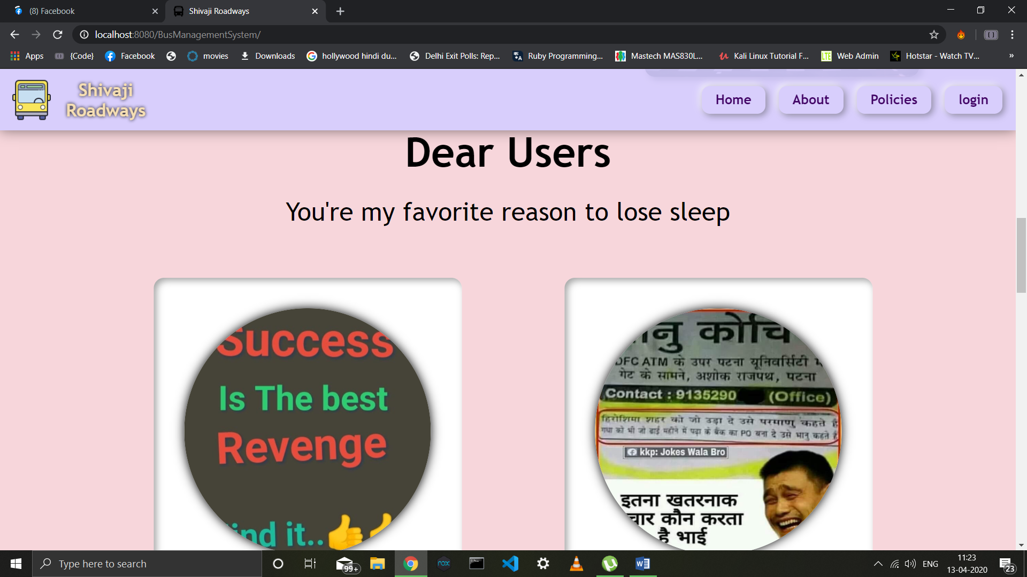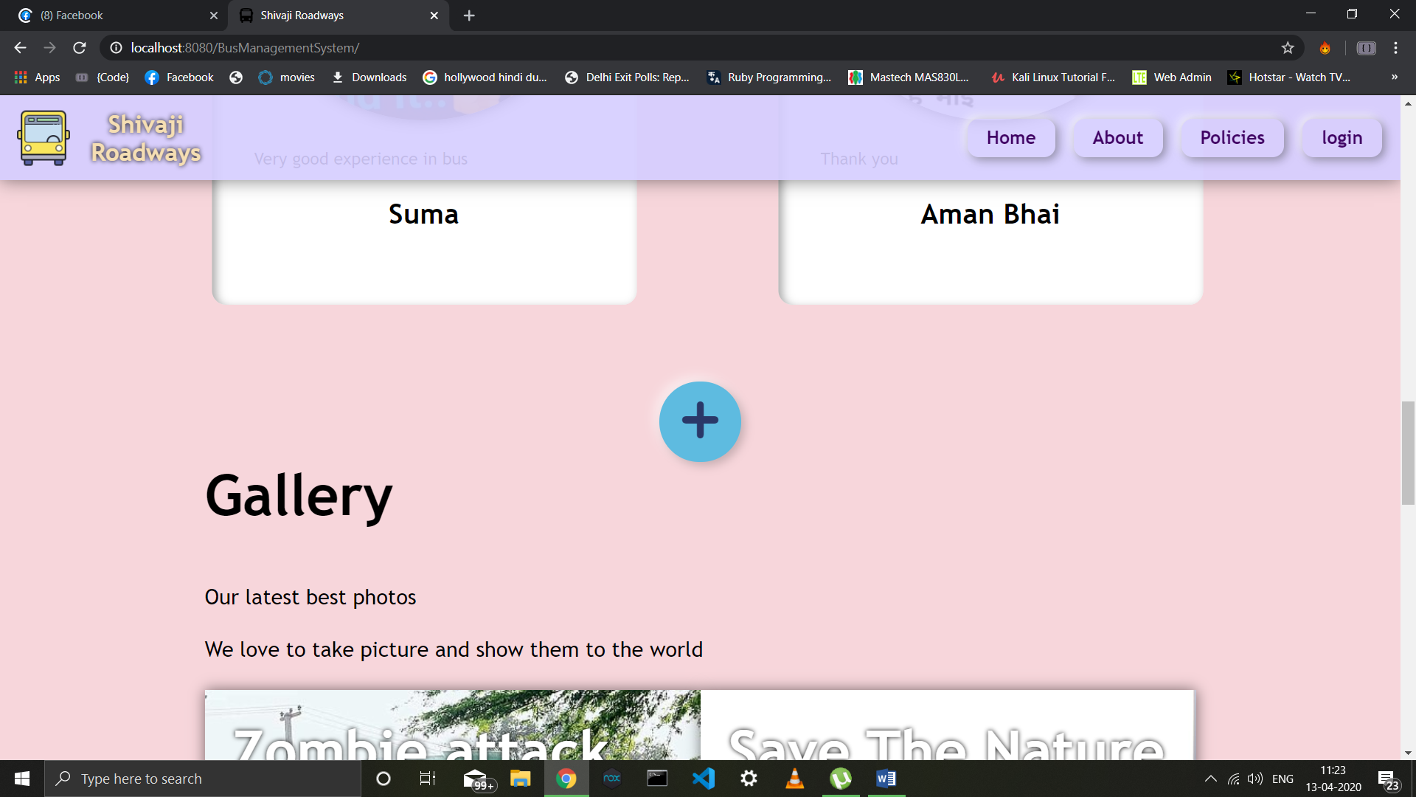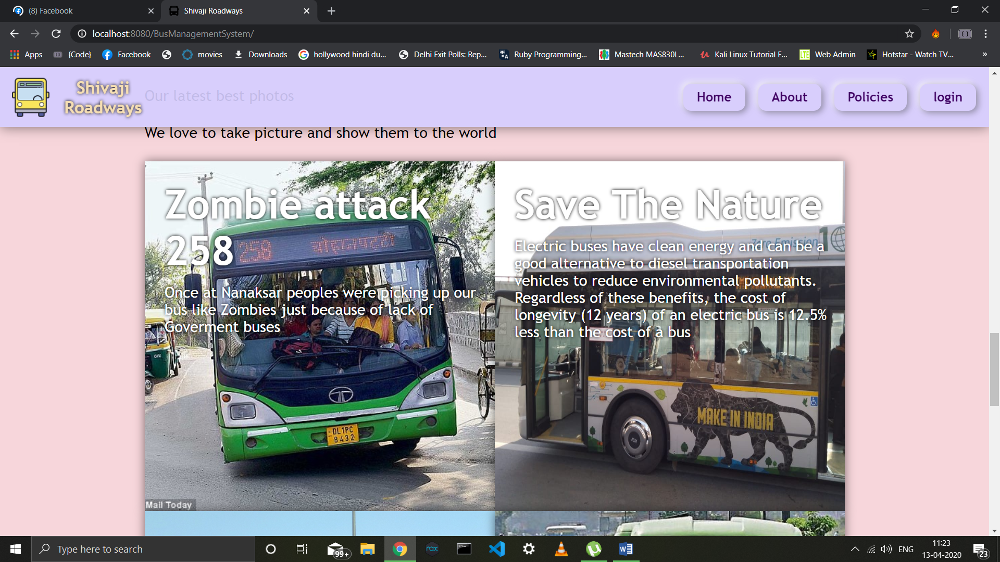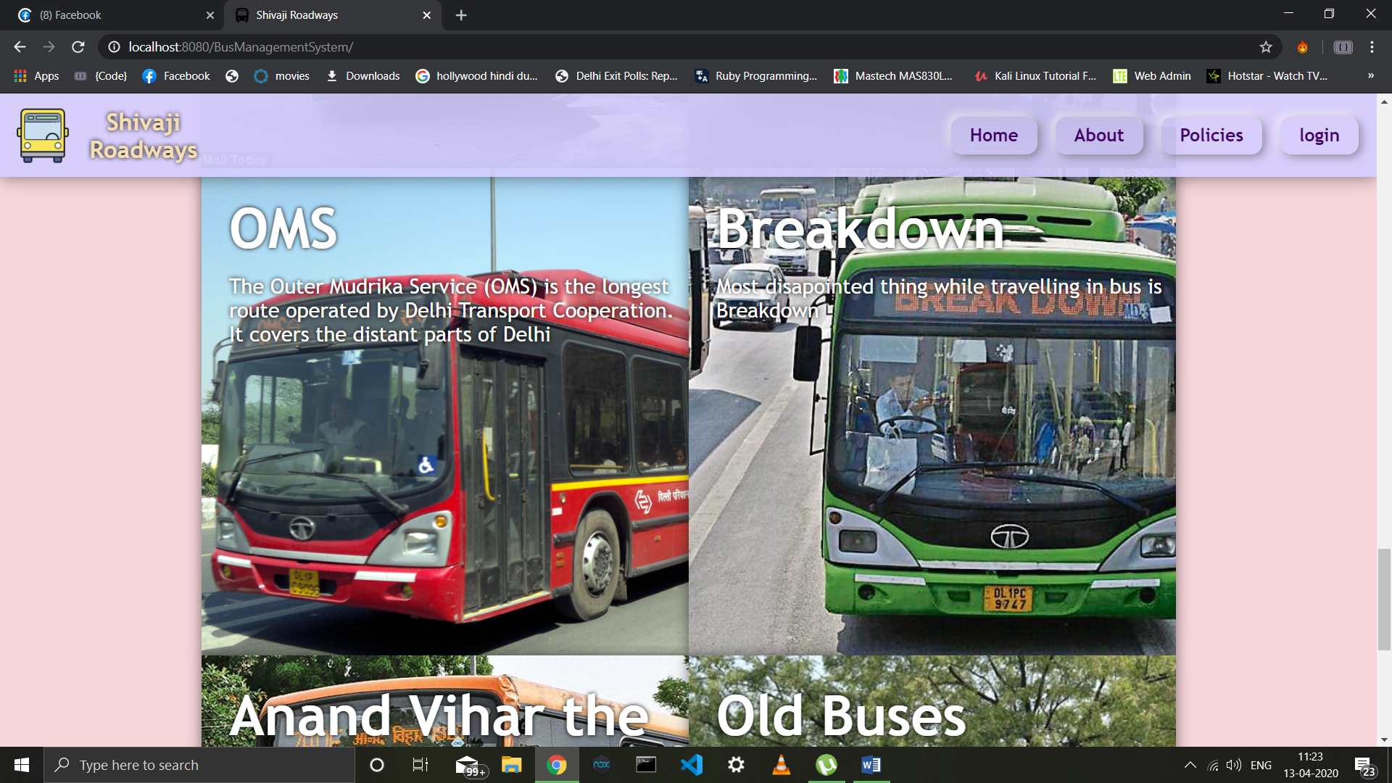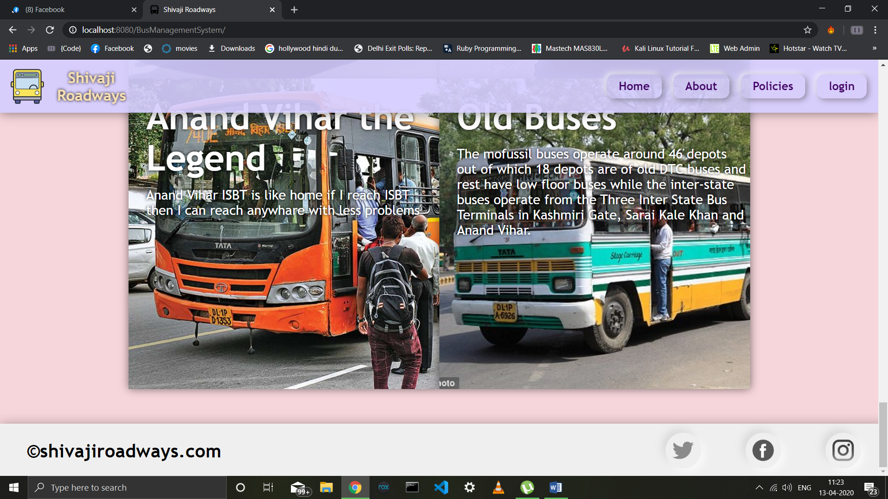

#### Source Code

<!**DOCTYPE** html>

<**html** lang**=**"en">

<head>

    <**meta** charset**=**"UTF-8">

    <**meta** name**=**"viewport" content**=**"width=device-width, initial-scale=1.0">

    <**meta** http-equiv**=**"X-UA-Compatible" content**=**"ie=edge">

    <**link** rel**=**"stylesheet" href**=**"styles/style.css">

    <**link** rel**=**"stylesheet" href**=**"styles/common.css">

    <**link** rel**=**"stylesheet" href**=**"styles/home.css">

    <**link** rel**=**"icon" href**=**"images/icon.png">

    <**title**>Shivaji Roadways</**title**>

</head>

<body>

    <**div** class**=**"updationWindow">

        <**div** id**=**"close" onclick**=**"closeWindow();">&#10006;</**div**>

        <**h1** id**=**"result"></**h1**>

        <**form** id**=**"nameForm" onsubmit**=**"**return** updateFeedback();">

            <**input** type**=**"text" name**=**"ticketNo" placeholder**=**"Ticket No">

            <**input** type**=**"text" name**=**"feedback" placeholder**=**"Feedback">

            <**input** type**=**"submit" value**=**"Submit Feeback">

        </**form**>

    </**div**>

    <**jsp:include** page**=**"navigationPannel.jsp"></**jsp:include**>

    <**div** class**=**"container">

        <**jsp:include** page**=**"svg.jsp"></**jsp:include**>

            <**div** class**=**"innerContainer">

                <**h1** class**=**"greeting">It's nice to meet you!</**h1**>

                <**p** class**=**"tagline">Some beautiful paths can't be discovered without getting lost.</**p**>

            </**div**>

            <**div** class**=**"imgWithArticle">

                <**div** class**=**"articleDiv">

                    <**h1**>Collect moments. Not things</**h1**>

                    <**p**>Travel isn't always pretty. It isn't always comfortable. Sometimes it hurts, it even breaks your heart. But that's OK. The journey changes you; it should change you. It leaves

                     marks on your memory, on your consciousness, on your heart, and on your body. You take something with you. Hopefully, you leave something good behind.<**br**><**br**>

                    Is there something you want to do that freaks you out? Go for it! Sometimes, the scariest ideas turn into the best travel memories.<**br**><**br**>

                        Great words to live by. There's something exciting about exploring a new place every year. It can be a new country, a new city, or an interesting spot near your hometown.

                    </**p**>

                </**div**>

                <**div** class**=**"articleImg">

                </**div**>

            </**div**>

            <**div** class**=**"userFeedbacks">

                <**h1**>Dear Users</**h1**>

                <**p**>You're my favorite reason to lose sleep</**p**>

                <%@page import="java.sql.*"%>

                <%

                    String ticketNo = request.getParameter("ticketNo");

                    String feedback = request.getParameter("feedback");

                    Connection con = null;

                    Statement st = null;

                    ResultSet rs = null;

                    try

                    {

                        Class.forName("com.mysql.jdbc.Driver");

                        con = DriverManager.getConnection("jdbc:mysql://localhost:3306/shivajiroadways", "root", "1234");

                        st = con.createStatement();

                        String query = "select profilePic, feedback, name, bookingDate from ticketOutput inner join passanger on ticketOutput.email = passanger.email where feedback is not null order by  bookingDate desc limit 2";

                        rs = st.executeQuery(query);

                        rs.next();

                    }

                    catch(Exception e){out.print(e.getMessage());}

                %>

                <**div** class**=**"user">

                    <**div** class**=**"userImg" style**=**"background-image: url('./images/userProfile/<%=rs.getString("profilePic")%>');"></**div**>

                    <**p**><%=rs.getString("feedback")%></**p**>

                    <**h2**><%=rs.getString("name")%></**h2**>

                </**div**>

                <%rs.next();%>

                <**div** class**=**"user">

                    <**div** class**=**"userImg" style**=**"background-image: url('./images/userProfile/<%=rs.getString("profilePic")%>');"></**div**>

                    <**p**><%=rs.getString("feedback")%></**p**>

                    <**h2**><%=rs.getString("name")%></**h2**>

                </**div**>

            </**div**>

            <**div** class**=**"plus" title**=**"Add your feedback" onclick**=**"change()">+</**div**>

            <**div** class**=**"photoGallery">

                <**h1**>Gallery</**h1**>

                <**p**>Our latest best photos</**p**>

                <**p**>We love to take picture and show them to the world</**p**>

                <**div** class**=**"photoRow">

                    <**div** class**=**"Img" style**=**"background-image: url('images/bus1.jpg');">

                        <**h1**>Zombie attack 258</**h1**>

                        <**p**>Once at Nanaksar peoples were picking up our bus like Zombies just because of lack of Goverment buses</**p**>

                    </**div**>

                </**div**>

                <**div** class**=**"photoRow">

                    <**div** class**=**"Img" style**=**"background-image: url('images/bus2.jpg');">

                        <**h1**>Save The Nature</**h1**>

                        <**p**>Electric buses have clean energy and can be a good alternative to diesel transportation vehicles to reduce

                            environmental pollutants. Regardless of these benefits, the cost of longevity (12 years) of an electric

                            bus is 12.5% less than the cost of a bus</**p**>

                    </**div**>

                </**div**>

                <**div** class**=**"photoRow">

                    <**div** class**=**"Img" style**=**"background-image: url('images/bus3.jpg');">

                        <**h1**>OMS</**h1**>

                        <**p**>The Outer Mudrika Service (OMS) is the longest route operated by Delhi Transport Cooperation. It covers the

                             distant parts of Delhi</**p**>

                    </**div**>

                </**div**>

                <**div** class**=**"photoRow">

                    <**div** class**=**"Img" style**=**"background-image: url('images/bus4.jpg');">

                        <**h1**>Breakdown</**h1**>

                        <**p**>Most disapointed thing while travelling in bus is Breakdown</**p**>

                    </**div**>

                </**div**>

                <**div** class**=**"photoRow">

                    <**div** class**=**"Img" style**=**"background-image: url('images/bus5.jpg');">

                        <**h1**>Anand Vihar the Legend</**h1**>

                        <**p**>Anand Vihar ISBT is like home if I reach ISBT then I can reach anywhare with less problems</**p**>

                    </**div**>

                </**div**>

                <**div** class**=**"photoRow">

                    <**div** class**=**"Img" style**=**"background-image: url('images/bus6.jpg');">

                        <**h1**>Old Buses</**h1**>

                        <**p**>The mofussil buses operate around 46 depots out of which 18 depots are of old DTC buses and rest

                             have low floor buses while the inter-state buses operate from the Three Inter State Bus Terminals

                              in Kashmiri Gate, Sarai Kale Khan and Anand Vihar.</**p**>

                    </**div**>

                </**div**>

            </**div**>

            <**jsp:include** page**=**"footer.jsp"></**jsp:include**>

    </**div**>

</body>

<**script** src**=**"scripts/navPannel.js">

</script>

<script>

**function** change()

    {

**var** updatingWindow **=** document.getElementsByClassName("updationWindow")[0];

        updatingWindow.style.height **=** "20vw";

        updatingWindow.style.width **=** "40vw";

        updatingWindow.style.opacity **=** "1";

    }

**function** closeWindow()

    {

**var** updatingWindow **=** document.getElementsByClassName("updationWindow")[0];

        updatingWindow.style.height **=** "0";

        updatingWindow.style.width **=** "0";

        updatingWindow.style.opacity **=** "0";

    }

**function** updateFeedback()

    {

**var** ticketNo **=** document.getElementsByName('ticketNo')[0].value;

        ticketNo **=** ticketNo.slice(7, ticketNo.lenght)

**var** feedback **=** document.getElementsByName('feedback')[0].value;

**var** xmlhttp **=** **new** XMLHttpRequest();

**var** param **=** "?ticketNo=" +  ticketNo + "&feedback=" + feedback;

        param **=** encodeURI(param);

        xmlhttp.open("POST", "addFeedback.jsp" + param, false);

        xmlhttp.onreadystatechange **=** **function**()

        {

**var** result **=** document.getElementById("result");

            document.getElementById("nameForm").style.display **=** "none";

            result.style.display **=** "block";

            result.innerText **=** xmlhttp.responseText.trim();

            setInterval(**function**(){

**var** updatingWindow **=** document.getElementsByClassName("updationWindow")[0];

                updatingWindow.style.height **=** "0";

                updatingWindow.style.width **=** "0";

                updatingWindow.style.opacity **=** "0";

            }, 1000);

            setInterval(**function**(){

                location.reload();

            }, 1500);

        }

        xmlhttp.send();

**return** false;

    }

</script>

</**html**>

#### about.jsp

When we have a great story about how our service was built to change lives, sharing it through about section of website is a good way. The “About Us” page is a great place for it to live, too. Good stories humanize your brand, providing context and meaning for your product.

What’s more, good stories are sticky –which means peoples are more likely to connect with them and pass them on.

In our about section we provide why we are here to help peoples through our transport services, objectives of our company and some other information like The **peoples who are leading shivaji roadways** and some statistics like staff members, sold Tickets in a year and the total revenue.

At the bottom of the about page we provide some contact information like location of headquarter, Official email address, mobile no and the website

#### Output

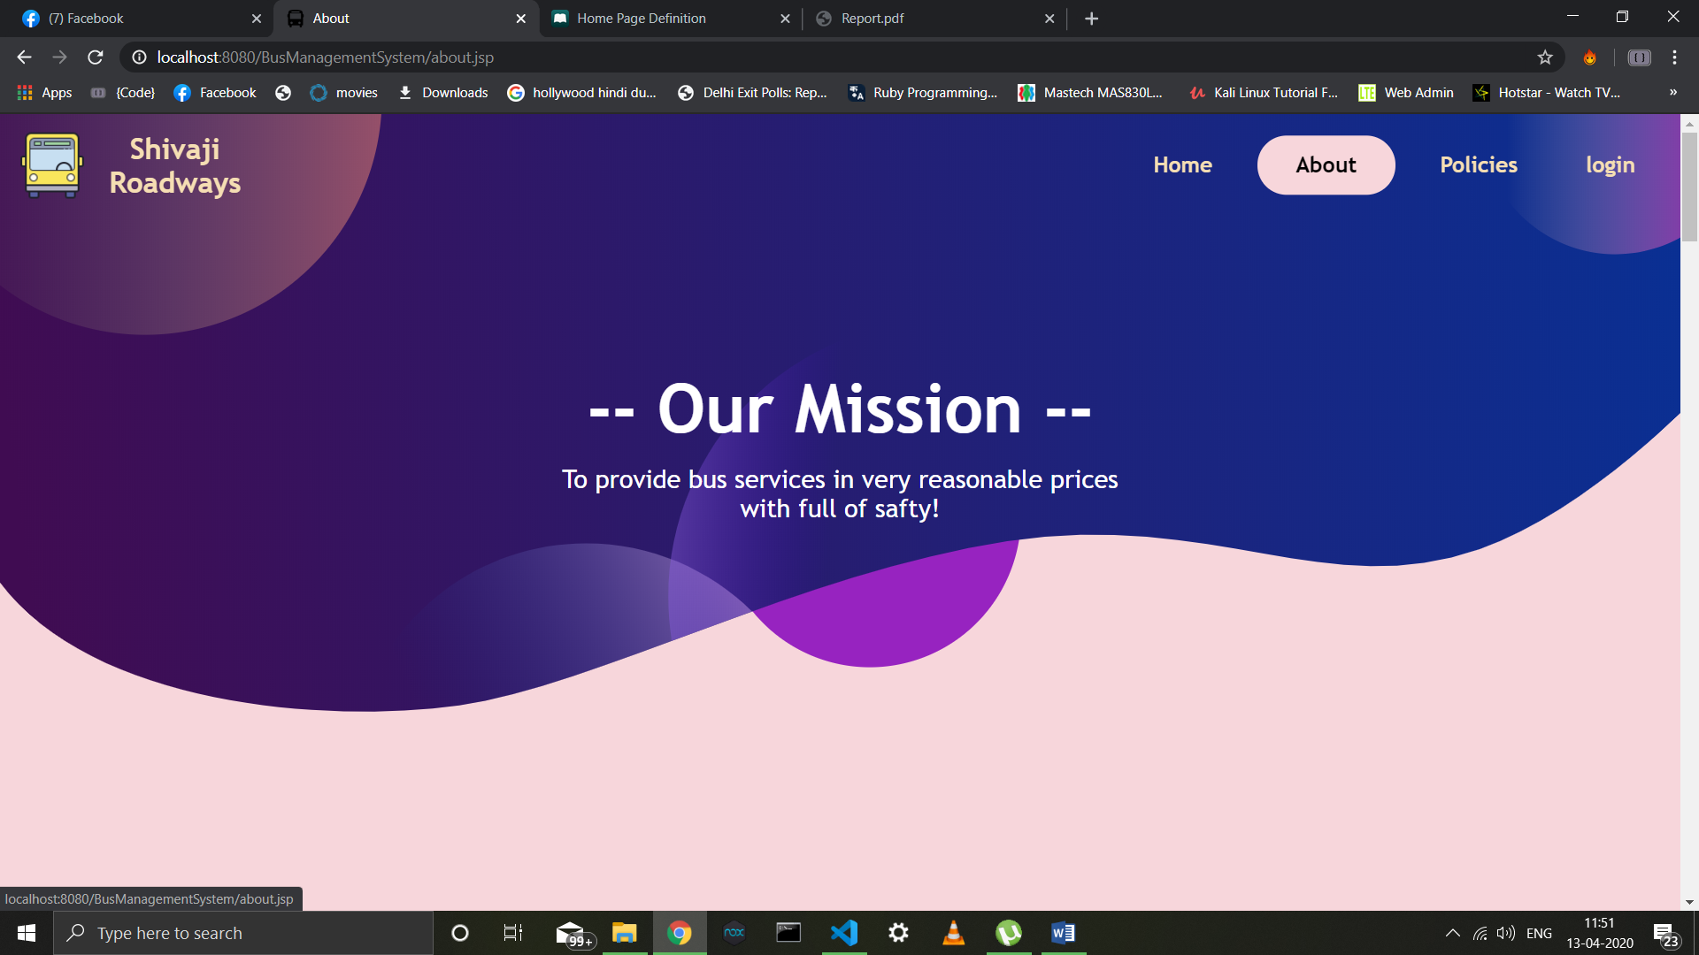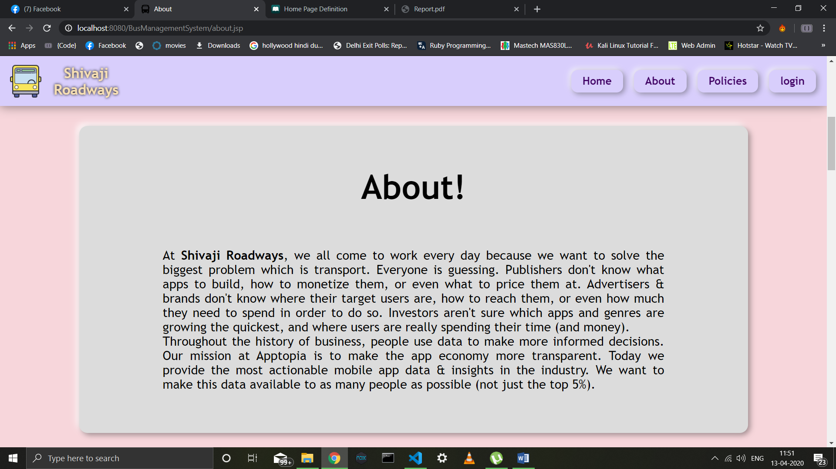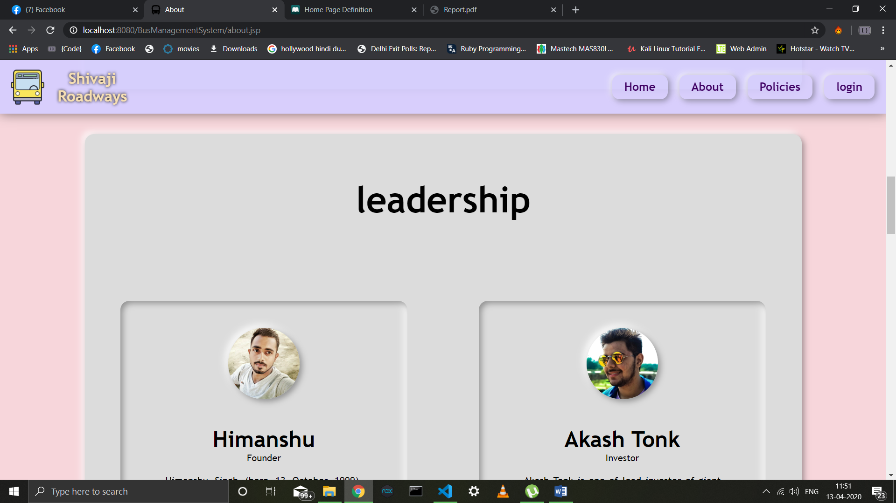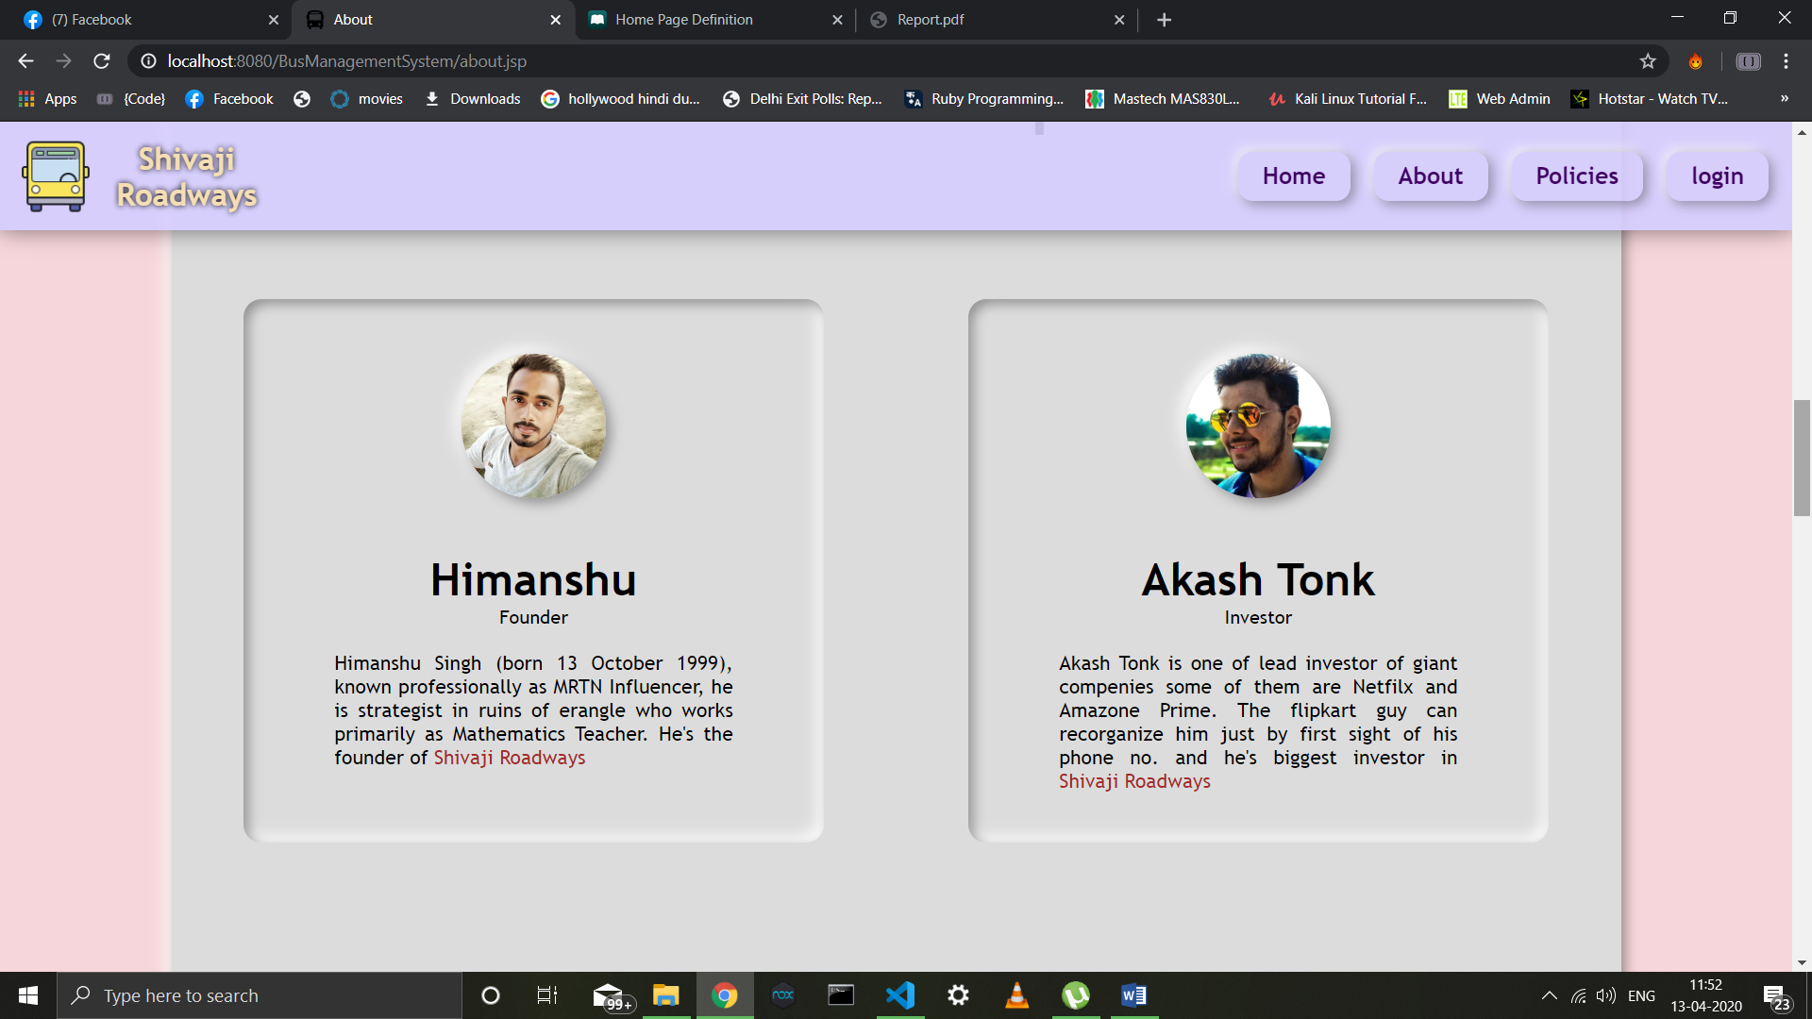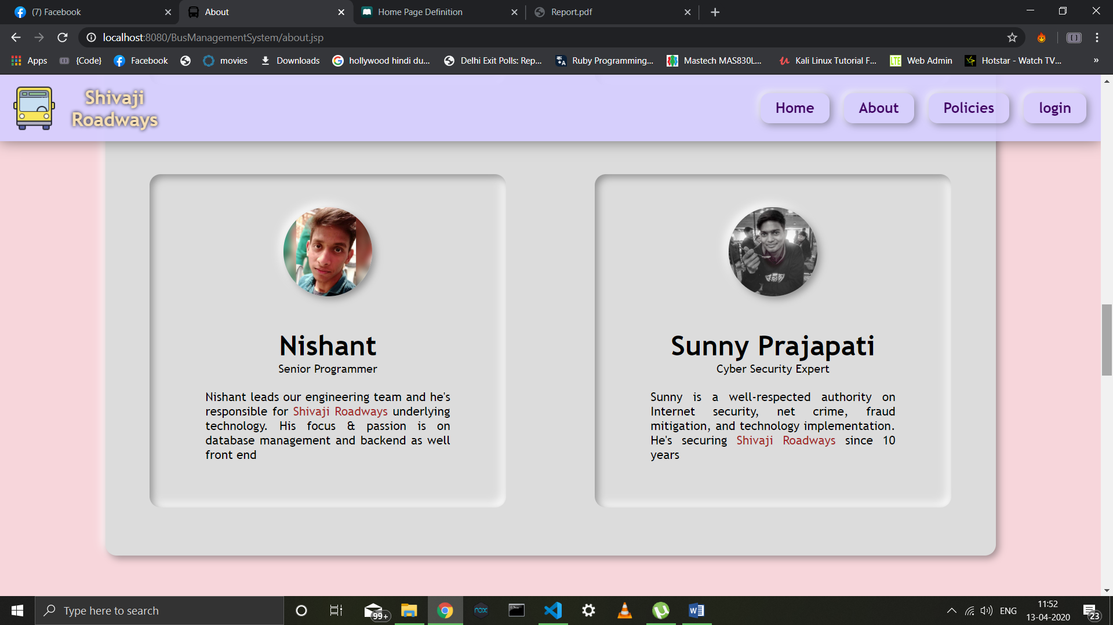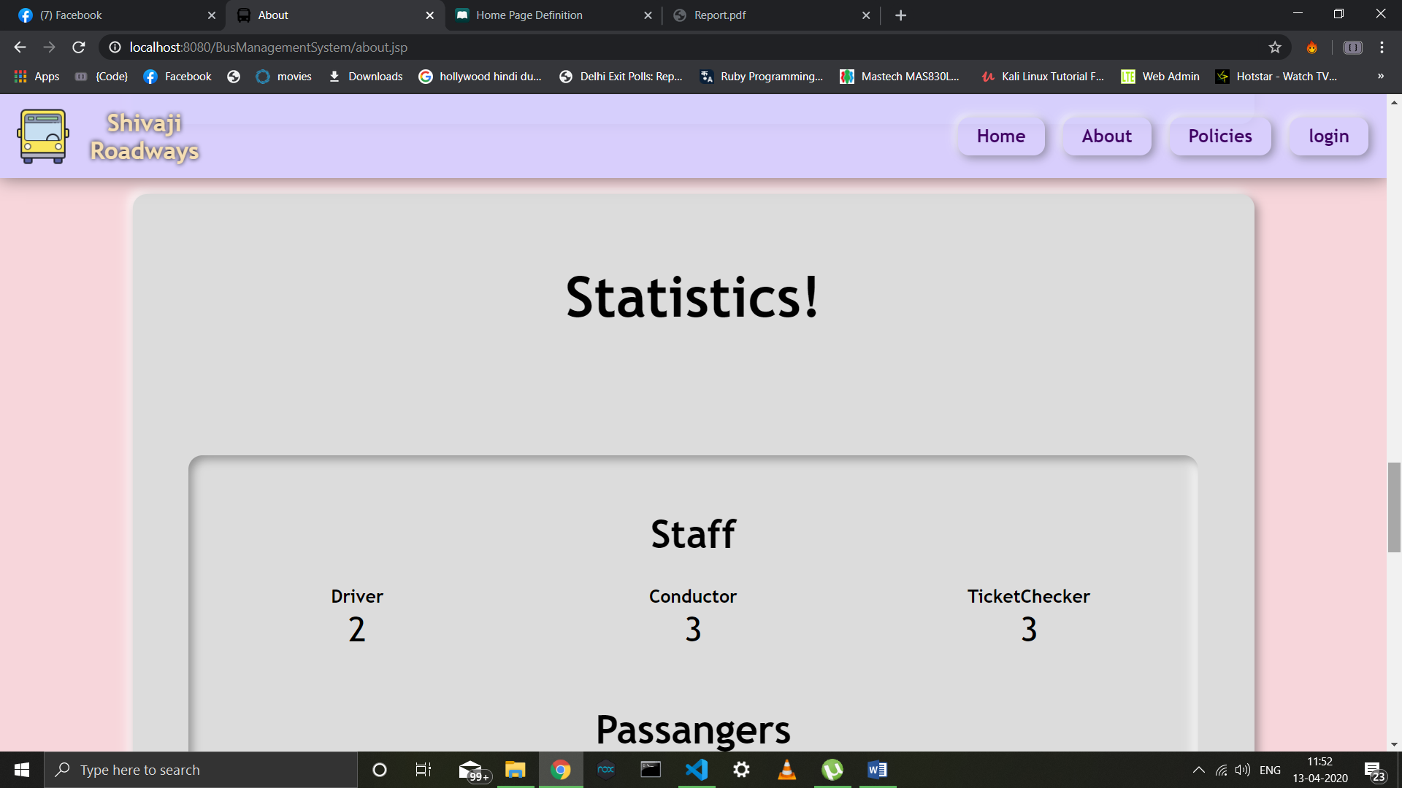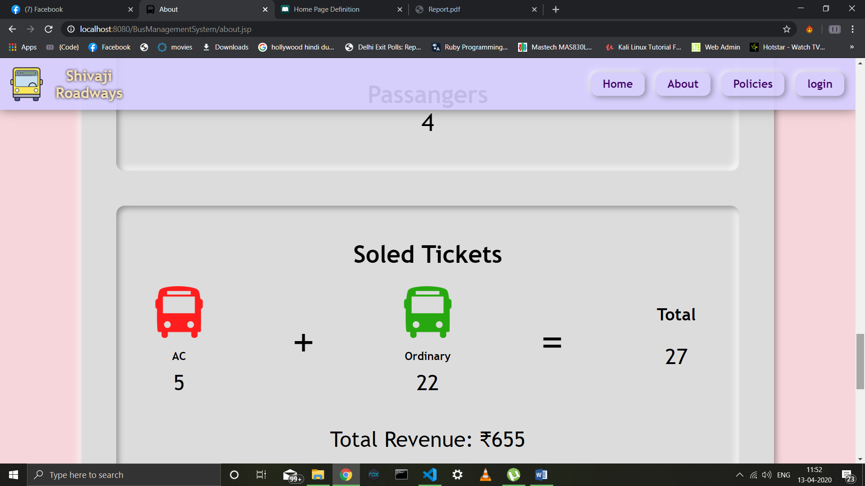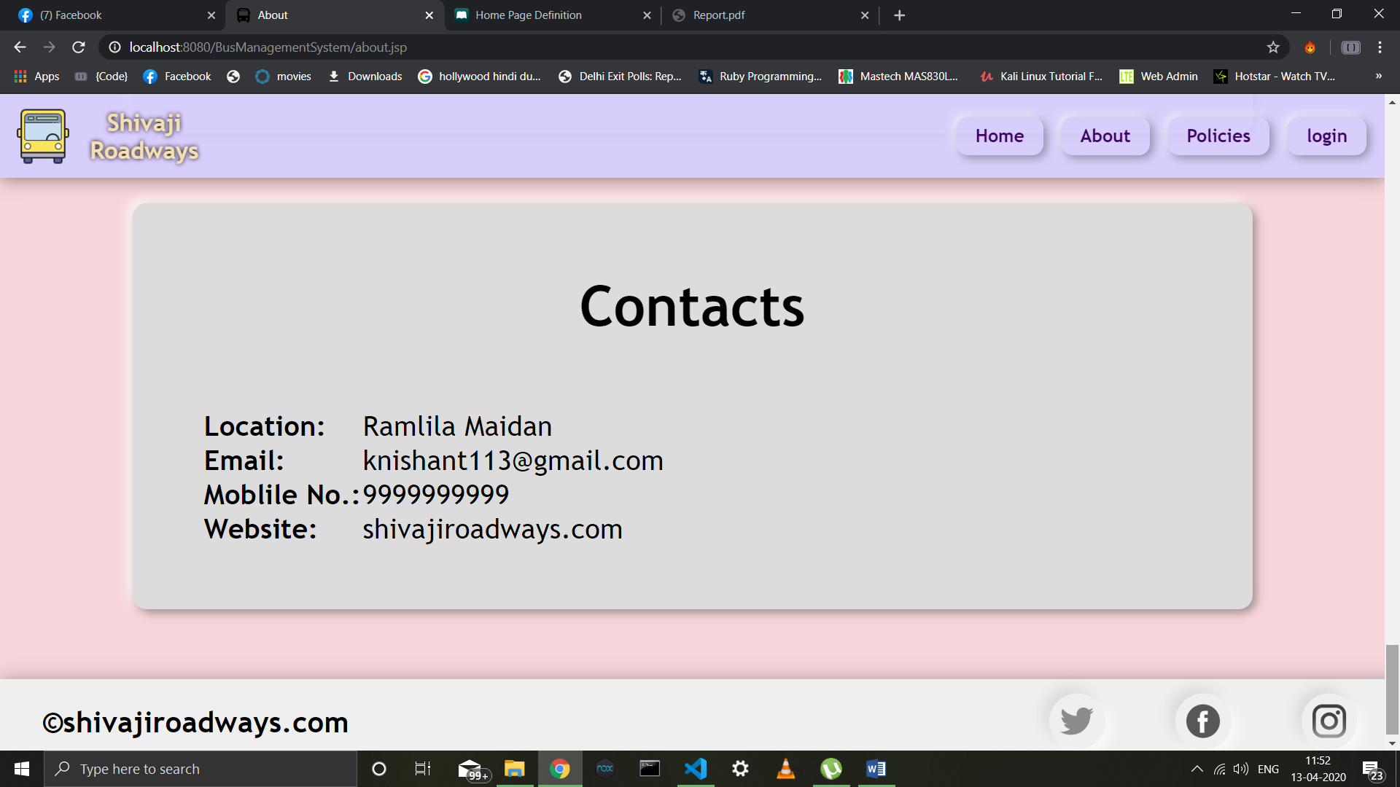

#### Source Code

<!**DOCTYPE** html>

<**html** lang**=**"en">

<head>

    <**meta** charset**=**"UTF-8">

    <**meta** name**=**"viewport" content**=**"width=device-width, initial-scale=1.0">

    <**meta** http-equiv**=**"X-UA-Compatible" content**=**"ie=edge">

    <**link** rel**=**"stylesheet" href**=**"styles/style.css">

    <**link** rel**=**"stylesheet" href**=**"styles/common.css">

    <**link** rel**=**"stylesheet" href**=**"styles/about.css">

    <**link** rel**=**"icon" href**=**"images/icon.png">

    <**title**>About</**title**>

    <**style**>

**.staff**

        {

            box-shadow**:** inset 4px 4px 10px rgba(0, 0, 0, 0.356), inset -5px -5px 12px 0 rgb(255, 255, 255);

            border-radius**:** 1vw;

            width**:** 90%;

            padding-top**:** 4vw;

            padding-bottom**:** 4vw;

            margin**:** 4vw auto;

        }

**.staff** **h2**

        {

            font-size**:** 2.8vw;

        }

        .about table

        {

            margin-top**:** 2vw;

            width**:** 100%;

            table-layout**:** fixed;

        }

        .about table tr th

        {

            font-size**:** 1.3vw;

        }

        .about table tr td

        {

            font-size**:** 2.5vw;

        }

**td** **img**

        {

            height**:** 6vw;

            width**:** 6vw;

        }

    </**style**>

</head>

<body>

    <**jsp:include** page**=**"navigationPannel.jsp"></**jsp:include**>

    <**div** class**=**"container">

        <**jsp:include** page**=**"svg.jsp"></**jsp:include**>

        <**div** class**=**"innerContainer">

            <**h1**>-- Our Mission --</**h1**>

            <**p**>To provide bus services in very reasonable prices<**br**>

                with full of safty!</**p**>

        </**div**>

        <**div** class**=**"about">

            <**h1**>About!</**h1**>

            <**p**>At <**b**>Shivaji Roadways</**b**>, we all come to work every day because we

                want to solve the biggest problem which is transport. Everyone

                is guessing. Publishers don't know what apps to build,

                how to monetize them, or even what to price them at.

                Advertisers & brands don't know where their target

                users are, how to reach them, or even how much they

                need to spend in order to do so. Investors aren't sure

                which apps and genres are growing the quickest, and where

                users are really spending their time (and money).<**br**>

                Throughout the history of business, people use data to make

                more informed decisions. Our mission at Apptopia is to make

                the app economy more transparent. Today we provide the most

                actionable mobile app data & insights in the industry. We

                want to make this data available to as many people as

                possible (not just the top 5%).</**p**>

        </**div**>

        <**div** class**=**"leadership">

            <**h1**>leadership</**h1**>

            <**div** class**=**"leaderRow">

                <**div** class**=**"leader">

                    <**div** class**=**"leaderImg" style**=**"background-image: url('images/himanshu.jpg');"></**div**>

                    <**h1**>Himanshu</**h1**>

                    <**p**>Founder</**p**>

                    <**div** class**=**"aboutLeader">Himanshu Singh (born 13 October 1999), known professionally

                        as MRTN Influencer, he is strategist in ruins of erangle who works primarily as Mathematics Teacher.

                        He's the founder of <**span** style**=**"color:brown;">Shivaji Roadways</**span**>

                    </**div**>

                </**div**>

                <**div** class**=**"leader">

                    <**div** class**=**"leaderImg" style**=**"background-image: url('images/akashtonk.jpg');"></**div**>

                    <**h1**>Akash Tonk</**h1**>

                    <**p**>Investor</**p**>

                    <**div** class**=**"aboutLeader">Akash Tonk is one of lead investor of giant compenies some of them are Netfilx

                        and Amazone Prime.

                        The flipkart guy can recorganize him just by first sight of his phone no. and he's biggest investor in

                        <**span** style**=**"color:brown;">Shivaji Roadways</**span**>

                    </**div**>

                </**div**>

            </**div**>

            <**div** class**=**"leaderRow">

                <**div** class**=**"leader">

                    <**div** class**=**"leaderImg" style**=**"background-image: url('images/nishant.jpg');"></**div**>

                    <**h1**>Nishant</**h1**>

                    <**p**>Senior Programmer</**p**>

                    <**div** class**=**"aboutLeader">Nishant leads our engineering team and he's responsible for

                        <**span** style**=**"color:brown;">Shivaji Roadways</**span**> underlying technology. His

                        focus & passion is on database management and backend as well front end</**div**>

                </**div**>

                <**div** class**=**"leader">

                    <**div** class**=**"leaderImg" style**=**"background-image: url('images/sunny.jpeg');"></**div**>

                    <**h1**>Sunny Prajapati</**h1**>

                    <**p**>Cyber Security Expert</**p**>

                    <**div** class**=**"aboutLeader">Sunny is a well-respected authority on Internet security,

                        net crime, fraud mitigation, and technology implementation. He's securing

                        <**span** style**=**"color:brown;">Shivaji Roadways</**span**> since 10 years

                    </**div**>

                </**div**>

            </**div**>

        </**div**>

        <**div** class**=**"about" style**=**"margin-top: 5vw; padding-bottom: 0.1vw;">

            <**h1**>Statistics!</**h1**>

            <**div** class**=**"staff">

                <**h2**>Staff</**h2**>

                <**table**>

                    <**tr**>

                        <**th**>Driver</**th**>

                        <**th**>Conductor</**th**>

                        <**th**>TicketChecker</**th**>

                    </**tr**>

                    <**tr**>

                        <%@page import="java.sql.*"%>

                        <%

                            String applicationNo = request.getParameter("applicationNO");

                            String email = (String)session.getAttribute("email");

                            Connection con = null;

                            Statement st = null;

                            ResultSet rs = null;

                            try

                            {

                                Class.forName("com.mysql.jdbc.Driver");

                                con = DriverManager.getConnection("jdbc:mysql://localhost:3306/shivajiroadways", "root", "1234");

                                st = con.createStatement();

                                rs = st.executeQuery("select count(*) as count from Driver");

                                if(rs.next())

                                {%>

                                    <**td**><%=rs.getString("count")%></**td**>

                                <%}

                                rs = st.executeQuery("select count(*) as count from Conductor");

                                if(rs.next())

                                {%>

                                    <**td**><%=rs.getString("count")%></**td**>

                                <%}

                                rs = st.executeQuery("select count(*) as count from TicketChecker");

                                if(rs.next())

                                {%>

                                    <**td**><%=rs.getString("count")%></**td**>

                                <%}

                            }

                            catch(Exception e){out.print(e.getMessage());}

                            %>

                            </**tr**>

                        </**table**>

                        <**h2** style**=**"margin-top: 4vw;">Passangers</**h2**>

                        <%

                            rs = st.executeQuery("select count(*) as count from Passanger");

                            if(rs.next())

                            {%>

                                <**p** style**=**"font-size: 2.8vw;  padding-bottom: 0; text-align: center;"><%=rs.getString("count")%></**p**>

                            <%}

                        %>

                    </**div**>

            <**div** class**=**"staff">

                <**h2**>Soled Tickets</**h2**>

                <**table**>

                    <**tr**>

                        <**td**><**img** src**=**"images/ac.png"></**td**>

                        <**td** rowspan**=**"3" style**=**"font-size: 5vw;">+</**td**>

                        <**td**><**img** src**=**"images/ord.png"></**td**>

                        <**td** rowspan**=**"3" style**=**"font-size: 5vw;">=</**td**>

                        <**th** style**=**"font-size: 2vw;">Total</**th**>

                    </**tr**>

                    <**tr**>

                        <**th**>AC</**th**>

                        <**th**>Ordinary</**th**>

                        <%

                            rs = st.executeQuery("select count(*) as count from ticketOutput");

                            if(rs.next())

                            {%>

                                <**td**><%=rs.getString("count")%></**td**>

                            <%}

                        %>

                    </**tr**>

                    <**tr**>

                        <%

                            rs = st.executeQuery("select count(*) as count from ticketOutput where type='AC'");

                            if(rs.next())

                            {%>

                                <**td**><%=rs.getString("count")%></**td**>

                            <%}

                            rs = st.executeQuery("select count(*) as count from ticketOutput where type='ORD'");

                            if(rs.next())

                            {%>

                                <**td**><%=rs.getString("count")%></**td**>

                            <%}

                        %>

                    </**tr**>

                    <**tr** style**=**"height: 10vw;">

                        <%

                            rs = st.executeQuery("select sum(fare) as sum from ticketOutput");

                            if(rs.next())

                            {%>

                                <**td** colspan**=**"5">Total Revenue: &#8377;<%=rs.getString("sum")%></**td**>

                            <%}

                        %>

                    </**tr**>

                </**table**>

            </**div**>

        </**div**>

        <**div** class**=**"contacts">

            <**h1**>Contacts</**h1**>

            <**p**>

                <**table**>

                    <**tr**>

                        <**td**><**b**>Location:</**b**></**td**>

                        <**td**>Ramlila Maidan</**td**>

                    </**tr**>

                    <**tr**>

                        <**td**><**b**>Email:</**b**></**td**>

                        <**td**>knishant113@gmail.com</**td**>

                    </**tr**>

                    <**tr**>

                        <**td**><**b**>Moblile No.: </**b**></**td**>

                        <**td**>9999999999</**td**>

                    </**tr**>

                    <**tr**>

                        <**td**><**b**>Website:</**b**></**td**>

                        <**td**>shivajiroadways.com</**td**>

                    </**tr**>

                </**table**>

            </**p**>

        </**div**>

    </**div**>

    <**jsp:include** page**=**"footer.jsp"></**jsp:include**>

</body>

<**script** src**=**"scripts/navPannel.js">

</script>

</html>

#### polices.jsp

Policies are general statements that guides in decision-making. A policy refers to a continuing decision which applies to repetitive situations. It is standing answer to a recurring question. Policy decisions are taken by the Chief Executive and Board. Manager should get the participation of all his subordinates in policy making.

As per our policies slogan says:

**Specifying policies is best way to avoid misunderstandings!**

#### Output

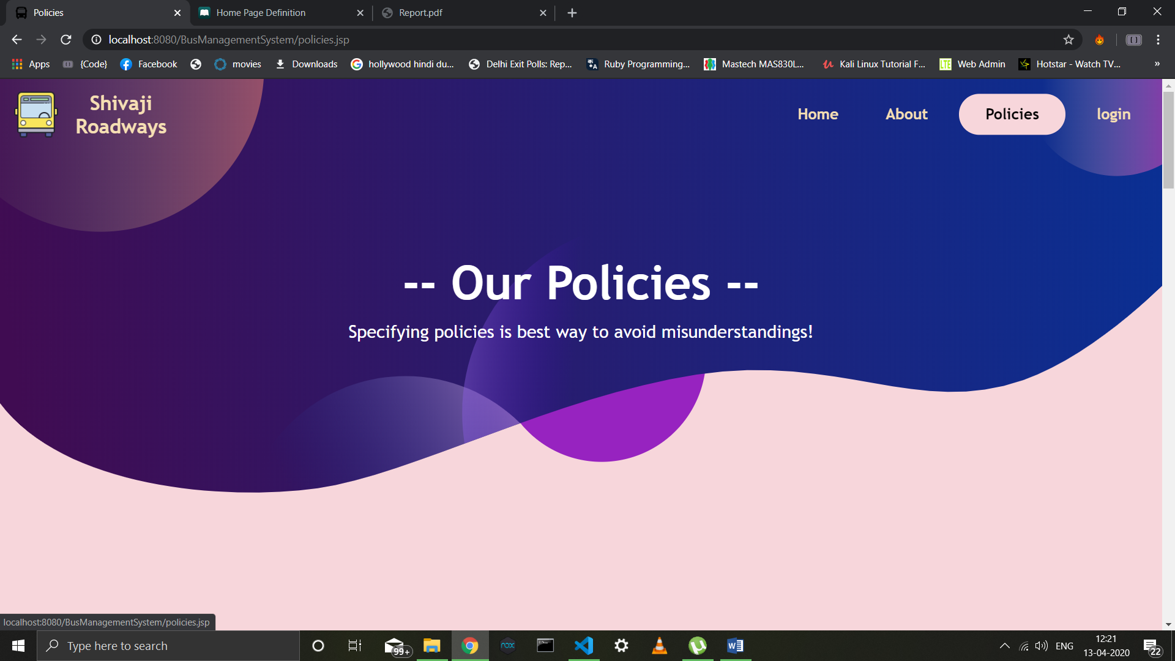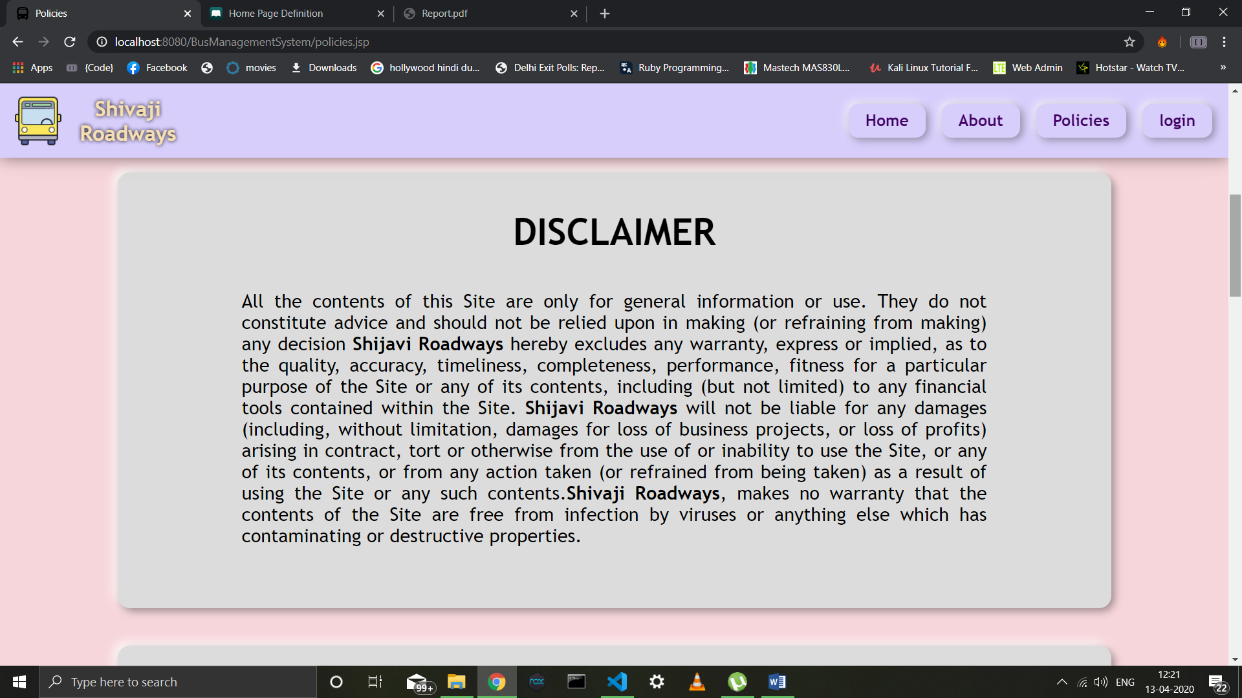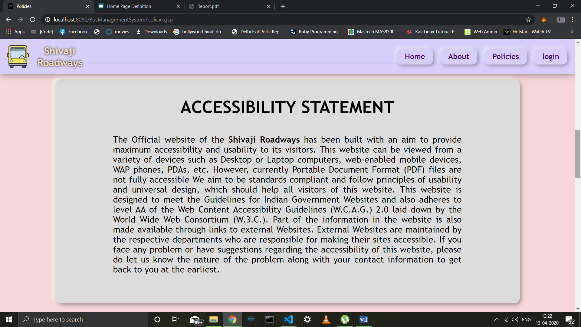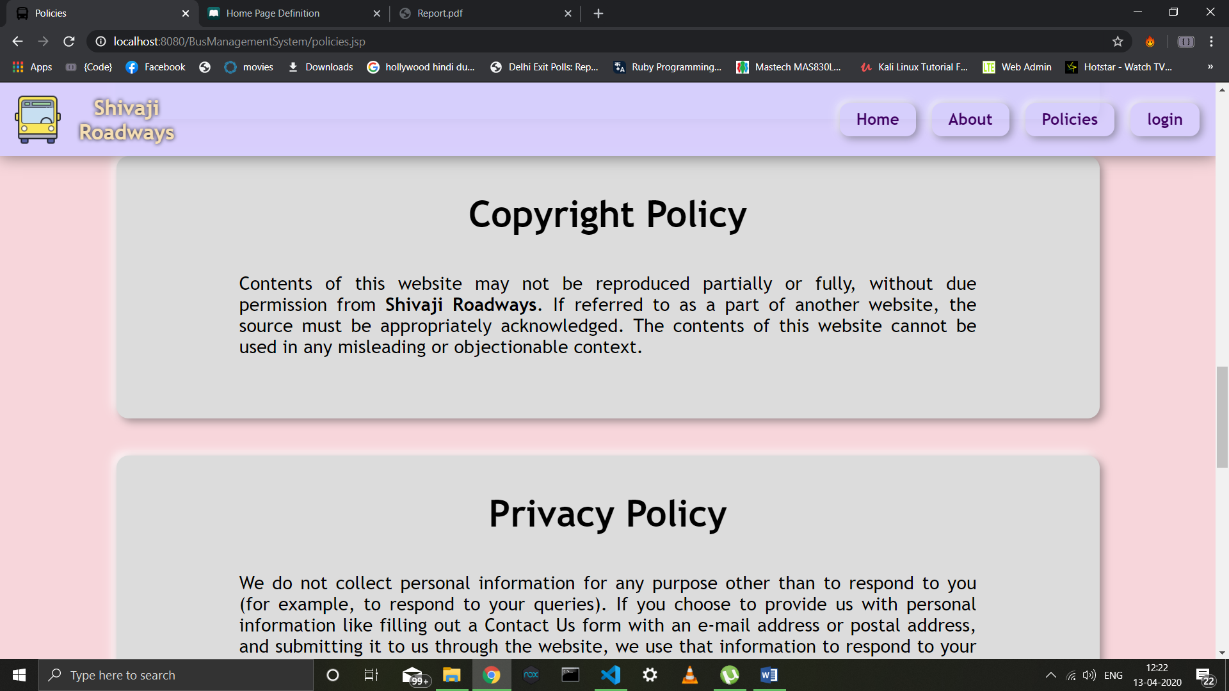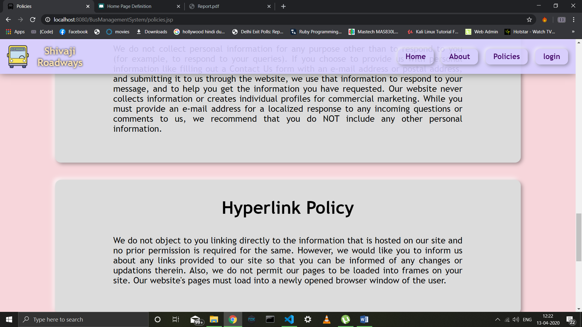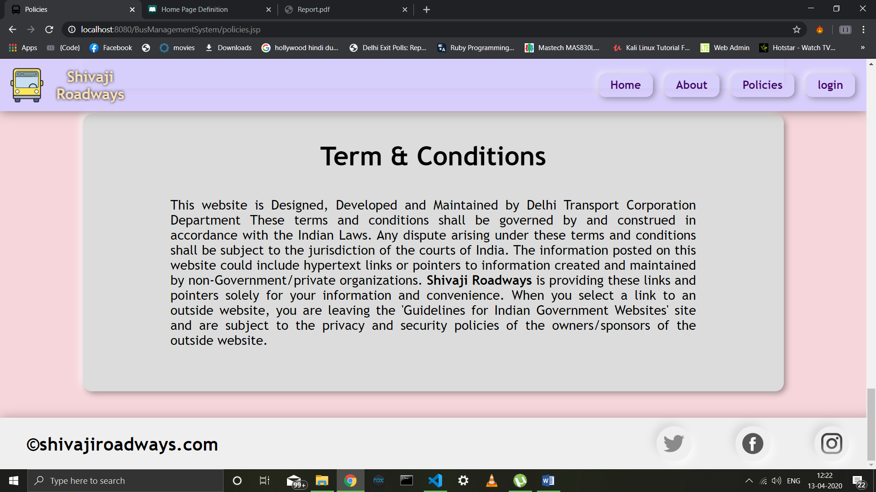

#### Source Code

<!**DOCTYPE** html>

<**html** lang**=**"en">

<head>

    <**meta** charset**=**"UTF-8">

    <**meta** name**=**"viewport" content**=**"width=device-width, initial-scale=1.0">

    <**meta** http-equiv**=**"X-UA-Compatible" content**=**"ie=edge">

    <**link** rel**=**"stylesheet" href**=**"styles/style.css">

    <**link** rel**=**"stylesheet" href**=**"styles/common.css">

    <**link** rel**=**"stylesheet" href**=**"styles/policies.css">

    <**link** rel**=**"icon" href**=**"images/icon.png">

    <**title**>Policies</**title**>

</head>

<body>

<%@page import="java.sql.*"%>

<%

    Connection con = null;

    Statement st = null;

    ResultSet rs = null;

    try

    {

        Class.forName("com.mysql.jdbc.Driver");

        con = DriverManager.getConnection("jdbc:mysql://localhost:3306/shivajiroadways", "root", "1234");

        st = con.createStatement();

        String query = "select pName, pDescription from Policy";

        rs = st.executeQuery(query);

    }

    catch(Exception e)

    {

        out.print(e.getMessage());

    }

%>

    <**jsp:include** page**=**"navigationPannel.jsp"></**jsp:include**>

    <**div** class**=**"container">

        <**jsp:include** page**=**"svg.jsp"></**jsp:include**>

        <**div** class**=**"innerContainer">

            <**h1**>-- Our Policies --</**h1**>

            <**p**>Specifying policies is best way to avoid misunderstandings!</**p**>

        </**div**>

        <%

            while(rs.next())

            {%>

                <**div** class**=**"policy">

                    <**h1**><%=rs.getString("pName")%></**h1**>

                    <**p**><%=rs.getString("pDescription")%></**p**>

                </**div**>

            <%}

        %>

    </**div**>

    <**jsp:include** page**=**"footer.jsp"></**jsp:include**>

</body>

<**script** src**=**"scripts/navPannel.js">

</script>

</html>

#### authentication.jsp

Authentication is the act of providing an assertion, such as the identity of a computer system user. In contrast with Identification, the act of indicating a person of thing’s identify, authentication is the process of verifying that identity. It might involve validating personal identity documents, verifying the authenticity of a website with a digital certificate, determining the age of an artefact by carbon dating, or ensuring that a product or document in not counterfeit.

We have three sub modules under this authentication module:

#### Sign In

In computer security, Sign In is the process by which an individual gains access to a computer system by identifying and authenticating themselves. The user credentials are typically some form **“Email”** and a matching **“password”** and these credentials themselves are sometimes referred to as a login. In practice, modern secure systems often require a second factor such as email confirmation for extra security.

#### Sign Up

Sign up is a phrase referring to the creating of an online account using an e-mail address or username and password. The online account is usually for a website or web-based service. Once someone has signed up for a service, they can access their account by Sign In

It can also be used to refer to subscribing to a free or paid service, like a video or audio streaming service.

#### Forget Password

Forget password is the action of invalidating the current password for an account on a website, service or device, and then creating new one.

#### Output

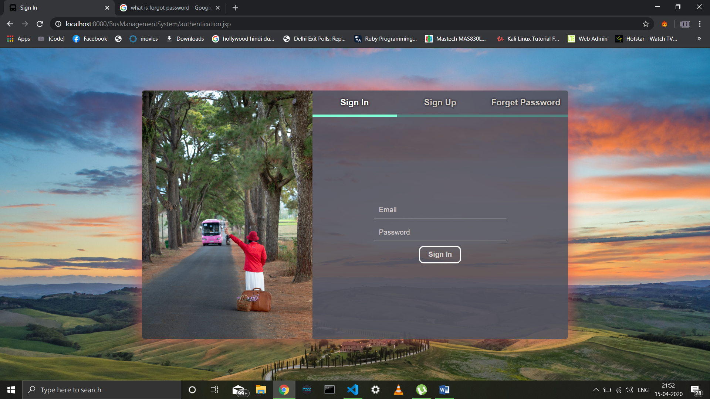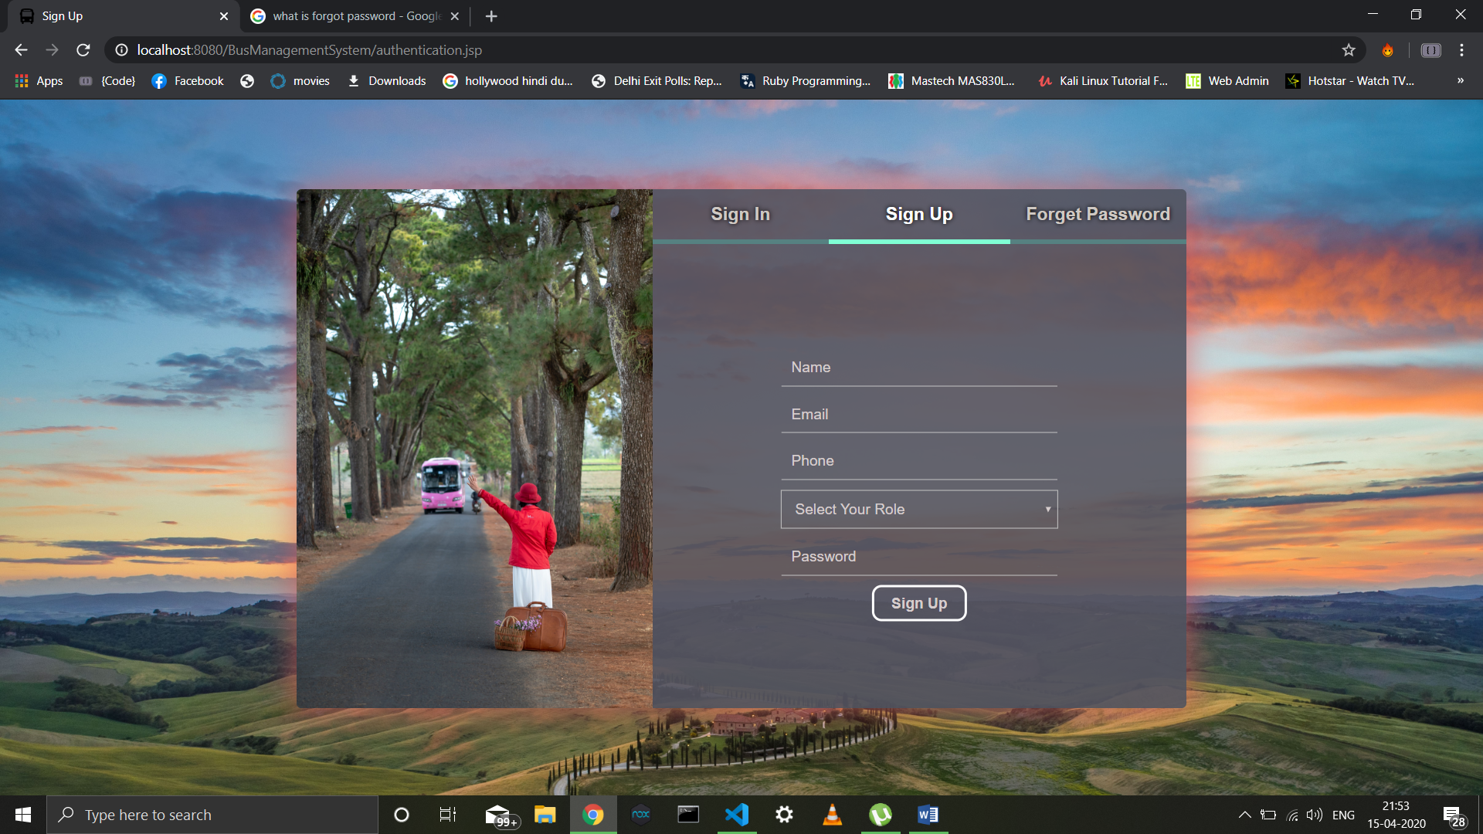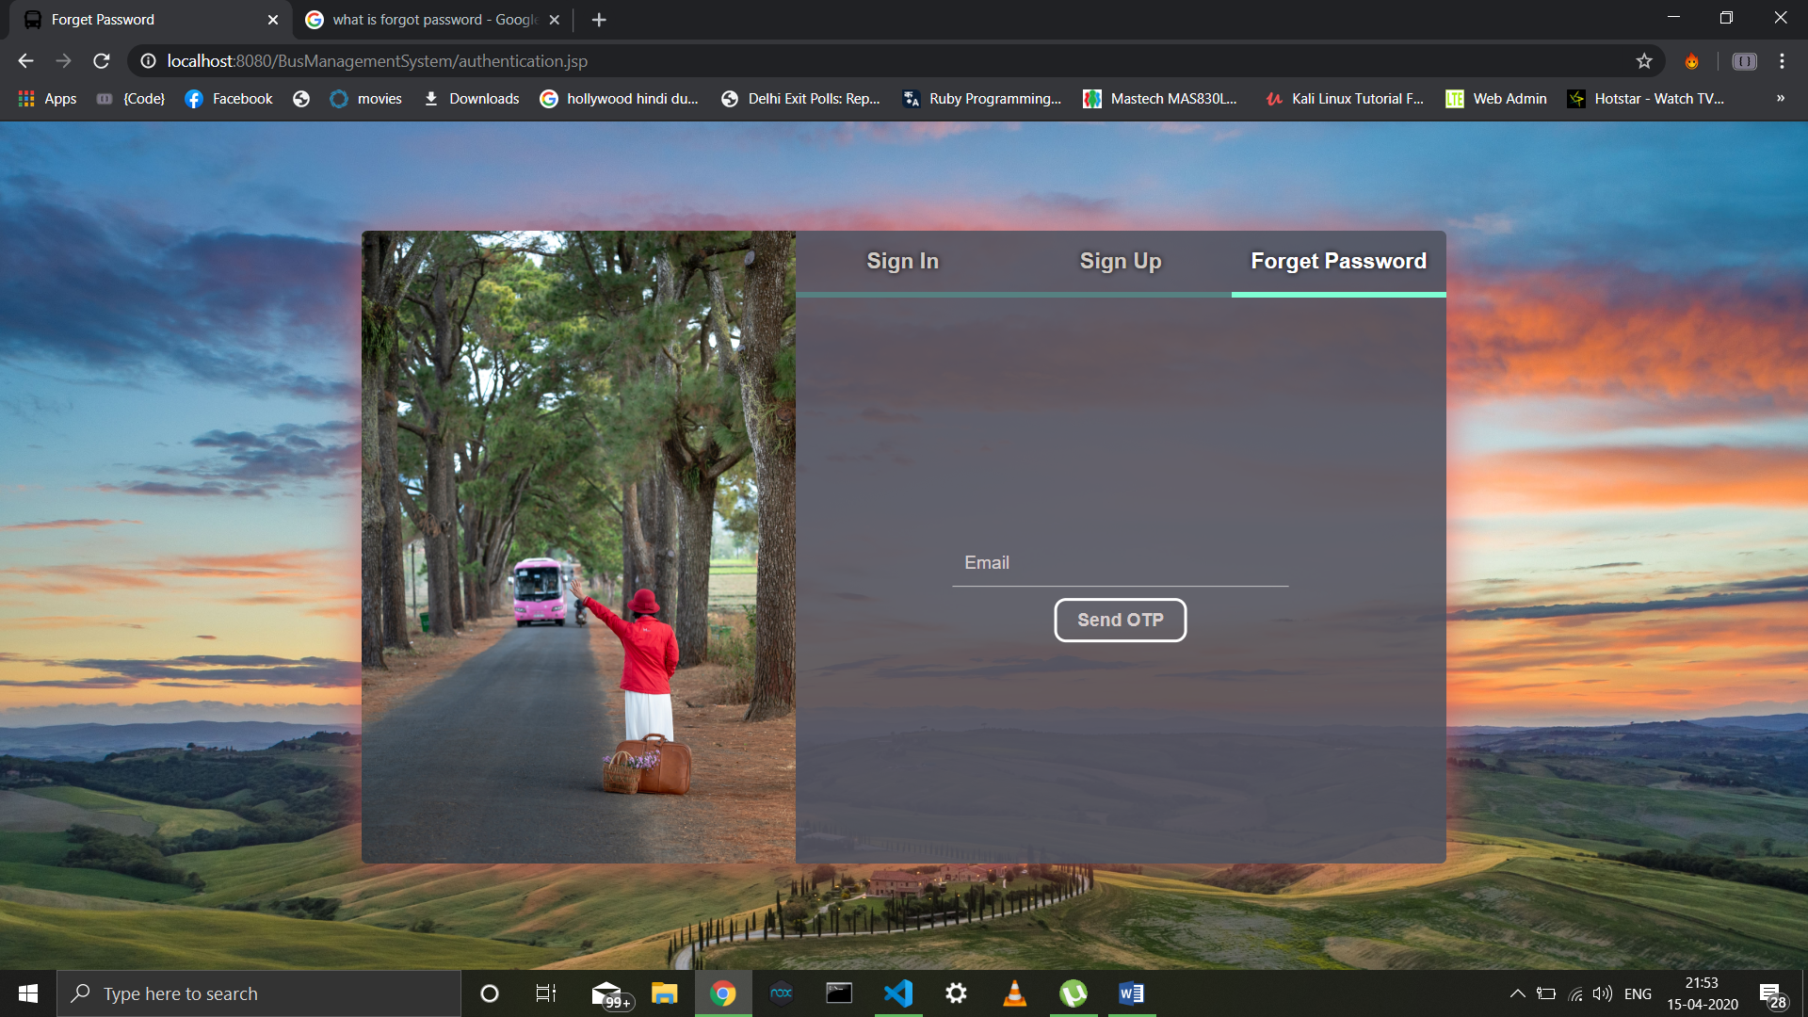

#### Source Code

<!**DOCTYPE** html>

<**html** lang**=**"en">

<head>

    <**meta** charset**=**"UTF-8">

    <**meta** name**=**"viewport" content**=**"width=device-width, initial-scale=1.0">

    <**meta** http-equiv**=**"X-UA-Compatible" content**=**"ie=edge">

    <**link** rel**=**"stylesheet" href**=**"styles/style.css">

    <**link** rel**=**"stylesheet" href**=**"styles/authentication.css">

    <**link** rel**=**"icon" href**=**"images/icon.png">

    <**title**>Authentication</**title**>

</head>

<body>

    <**div** class**=**"container">

        <**div** class**=**"imageDiv">

        </**div**>

        <**div** class**=**"workspace">

            <**div** class**=**"actionSelector">

                <**div** class**=**"signInMenu" id**=**"sin" onclick**=**"toggleFun(this.id)">Sign In</**div**>

                <**div** class**=**"signUpMenu" id**=**"sup" onclick**=**"toggleFun(this.id)">Sign Up</**div**>

                <**div** class**=**"forgetPasswordMenu" id**=**"fp" onclick**=**"toggleFun(this.id)">Forget Password</**div**>

            </**div**>

            <**div** id**=**"formContainer" >

                <**div** class**=**"signIn" >

                    <**form** action**=**"signIn" method**=**"post" onsubmit**=**"**return** validatePassword(0)">

                        <**div** class**=**"ImgResult">

                        </**div**>

                        <**input** type**=**"text" name**=**"id" placeholder**=**"Email" autocomplete**=**"off" onkeyup**=**"checkAccount(this.value);">

                        <**input** type**=**"password" name**=**"password" placeholder**=**"Password">

                        <**input** type**=**"submit" value**=**"Sign In">

                    </**form**>

                </**div**>

                <**div** class**=**"signUp">

                    <**form** action**=**"SignUp" method**=**"POST" onsubmit**=**"**return** validateForm();">

                    <!-- <form action="test.jsp" method="POST"> -->

                        <**input** type**=**"text" name**=**"name" placeholder**=**"Name" onblur**=**"validateName();" autocomplete**=**"off">

                        <**input** type**=**"text" name**=**"email" placeholder**=**"Email" onblur**=**"validateEmail(0);" autocomplete**=**"off">

                        <**input** type**=**"text" name**=**"phone" placeholder**=**"Phone" onblur**=**"validatePhone();" autocomplete**=**"off">

                        <**select** id**=**"role" onchange**=**"toggleFields(this.value)" name**=**"role"  onblur**=**"validateRole();">

                            <**option** value**=**"" disabled selected >Select Your Role</**option**>

                            <**option**>Admin</**option**>

                            <**option**>Passanger</**option**>

                            <**optgroup** label**=**"Staff">

                                <**option**  >Driver</**option**>

                                <**option**>Conductor</**option**>

                                <**option**>Ticket Checker</**option**>

                            </**optgroup**>

                            <**input** type**=**"text" name**=**"walletBalance" placeholder**=**"Wallet Balance" id**=**"walletBalance" autocomplete**=**"off" style**=**"display: none;" onblur**=**"validateWalletBal();">

                            <**input** type**=**"text" name**=**"licenceNo" placeholder**=**"Licence No" id**=**"licenceNo" autocomplete**=**"off" style**=**"display: none;" onblur**=**"validateLicence();">

                            <**input** type**=**"text" name**=**"experience" placeholder**=**"Experience" id**=**"experience" autocomplete**=**"off" style**=**"display: none;" onblur**=**"validateExperience();">

                            <**input** type**=**"date" name**=**"joiningDate" id**=**"joiningDate" onblur**=**"validateJoiningDate();">

                        </**select**>

                        <**input** type**=**"password" name**=**"password" onblur**=**"validatePassword(1);" placeholder**=**"Password">

                        <**input** type**=**"submit" value**=**"Sign Up">

                    </**form**>

                </**div**>

                <**div** class**=**"forgetPassword">

                    <**form** action**=**"SendOTP" method**=**"post" onsubmit**=**"**return** validateEmail(1);">

                        <**input** type**=**"text" name**=**"email" placeholder**=**"Email" autocomplete**=**"off" onblur**=**"validateEmail(1);">

                        <**input** type**=**"submit" value**=**"Send OTP">

                    </**form** >

                </**div**>

            </**div**>

        </**div**>

    </**div**>

</body>

<**script** src**=**"scripts/authentication.js"></**script**>

<**script** src**=**"scripts/validate.js"></**script**>

<script>

**function** checkAccount(email)

    {

**var** param **=** "?email=" +  email;

        param **=** param.replace("+", "%2b")

**var** xmlhttp **=** **new** XMLHttpRequest();

        xmlhttp.open("POST", "authenticationAJAX.jsp" + param, true);

        xmlhttp.onreadystatechange **=** **function**(){

            document.getElementsByClassName("ImgResult")[0].innerHTML **=** xmlhttp.responseText;

        }

        xmlhttp.send();

    }

</script>

</html>

#### Signing In with Passenger’s account

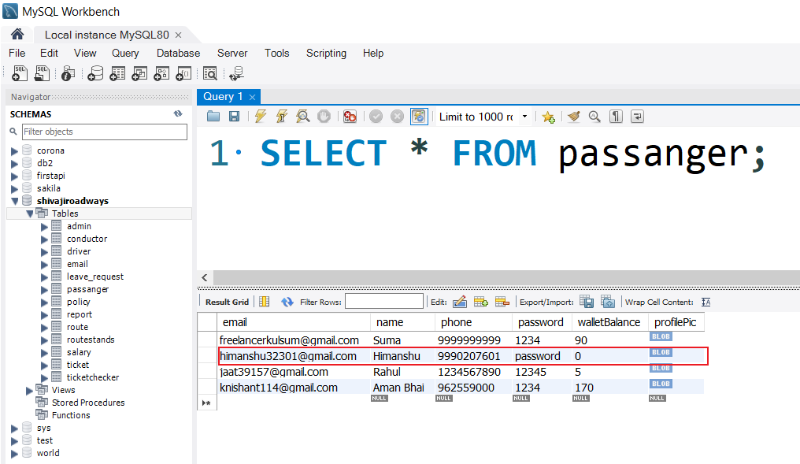

**Role**: Passenger

Credentials:

* **Email**: [himanshu32301@gmail.com](mailto:himanshu32301@gmail.com)
* **Password**: password

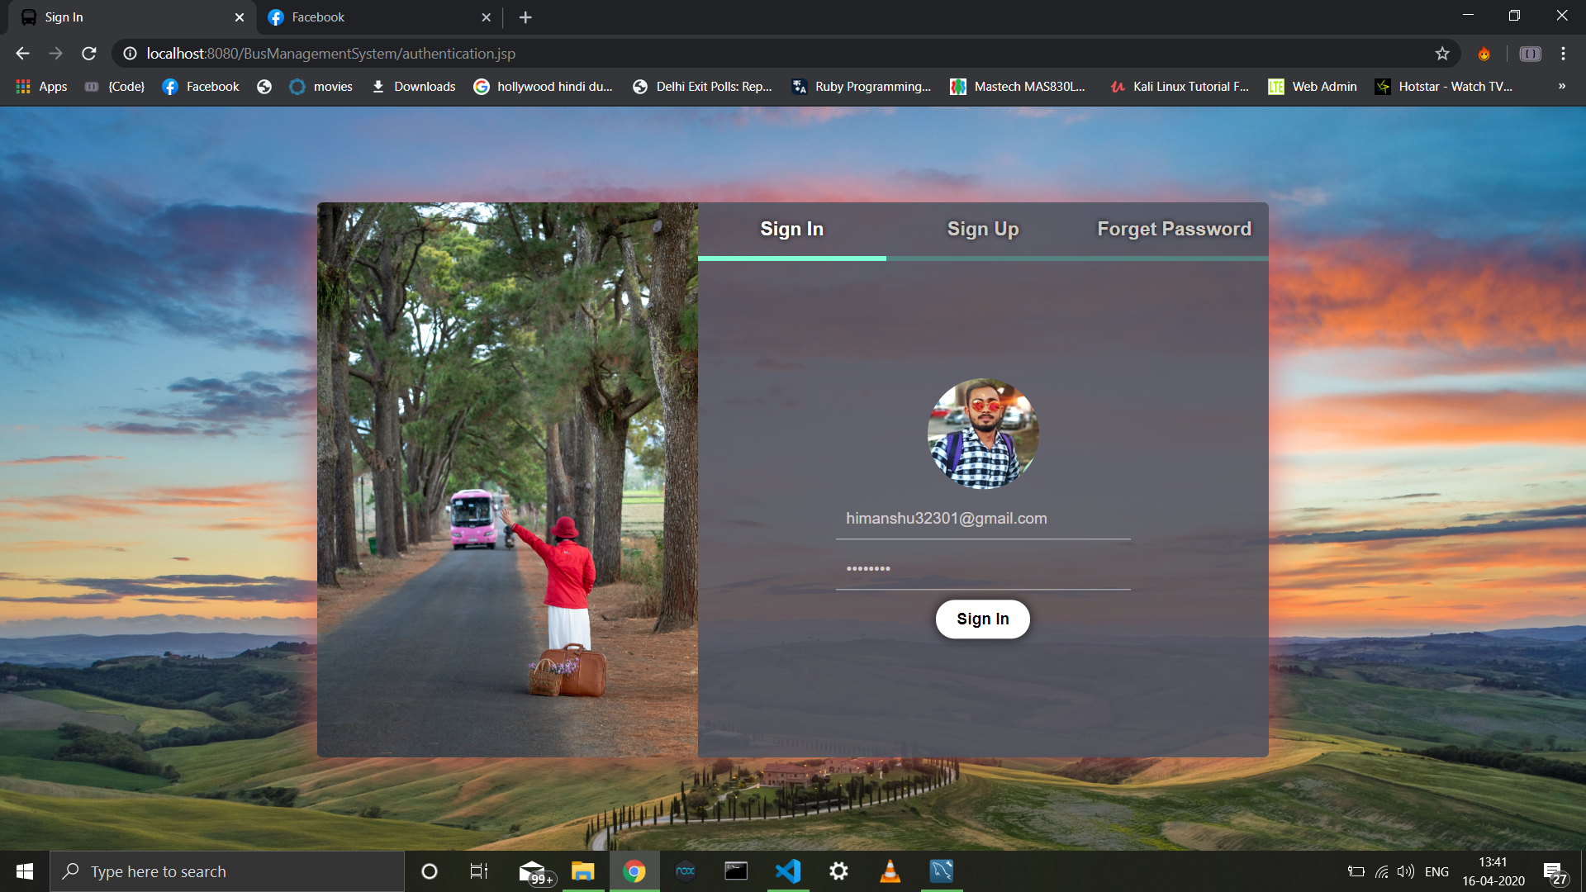

#### Signed In

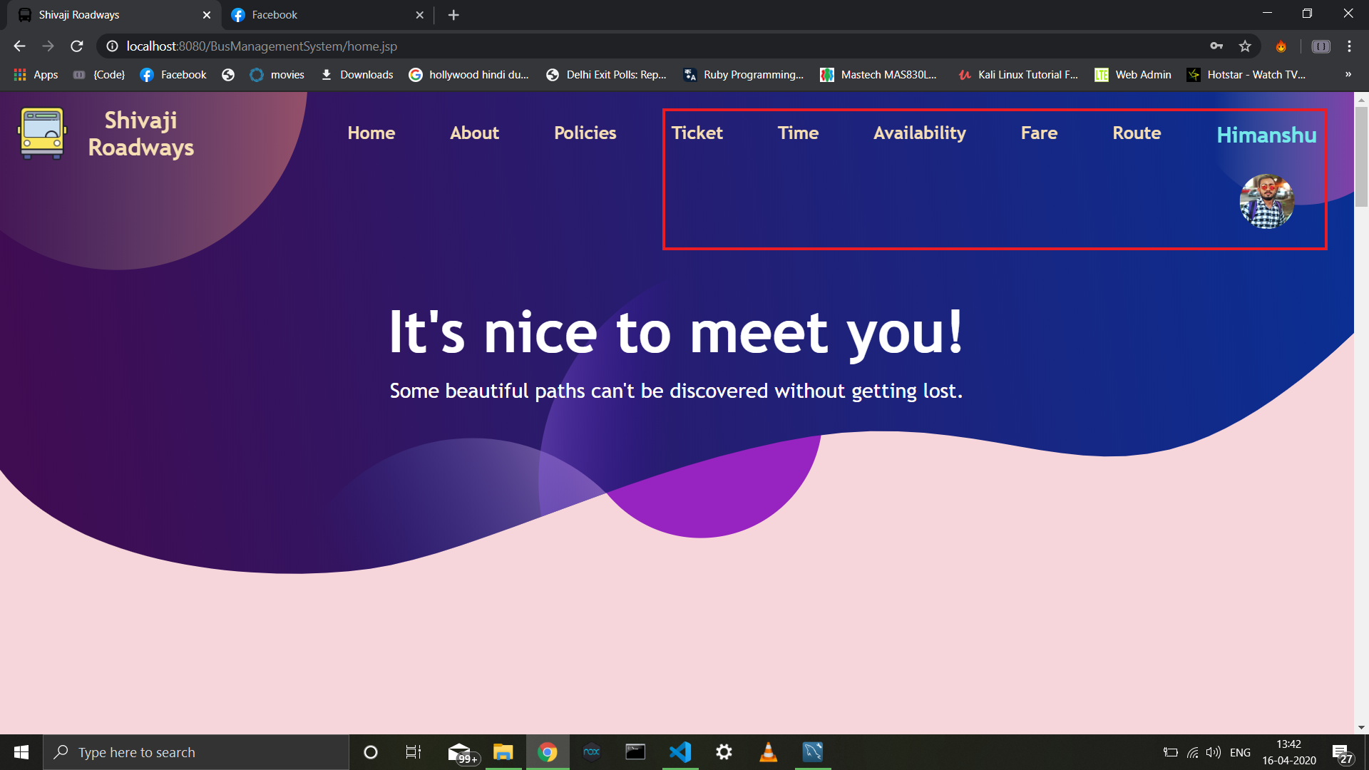

We have some new links in our navigation panel

* Ticket
* Time
* Availability
* Fare
* Route

Let’s explore them one by one

#### ticket.jsp

This module is for booking tickets in **Shivajiroadways** it takes all the routes from database and each stage in respect of selected route also we have radio buttons to select type of bus (AC or Ordinary) and a slider for selecting no of passengers in range of 1 to 20.

#### Output

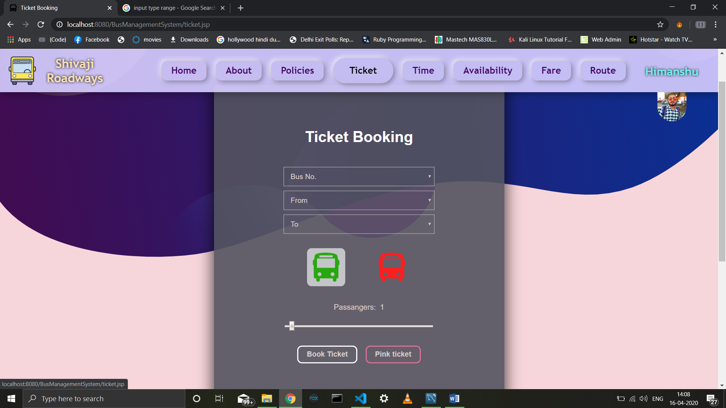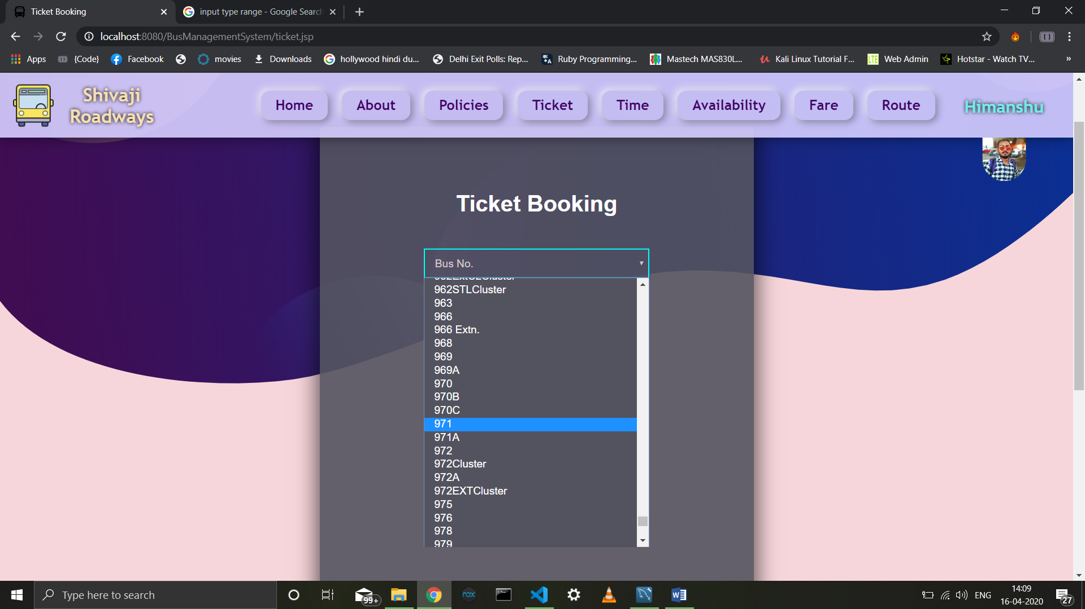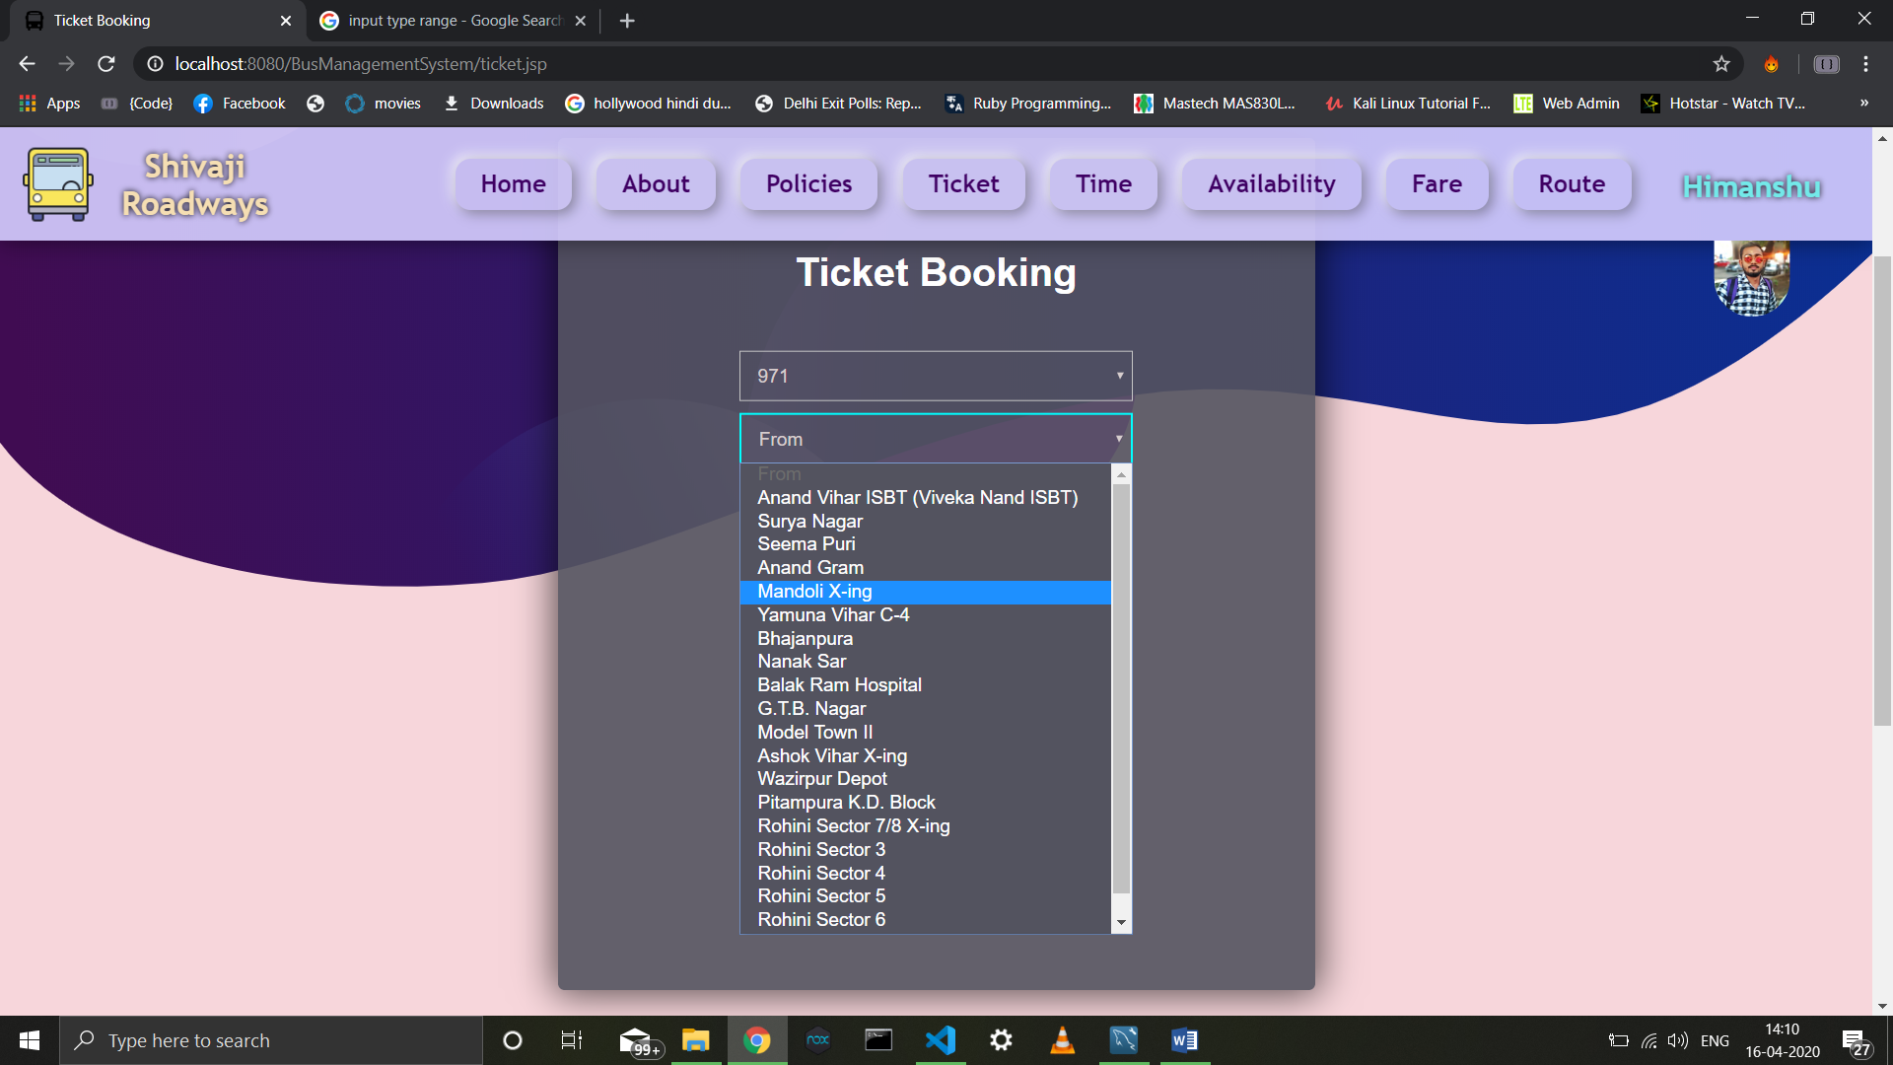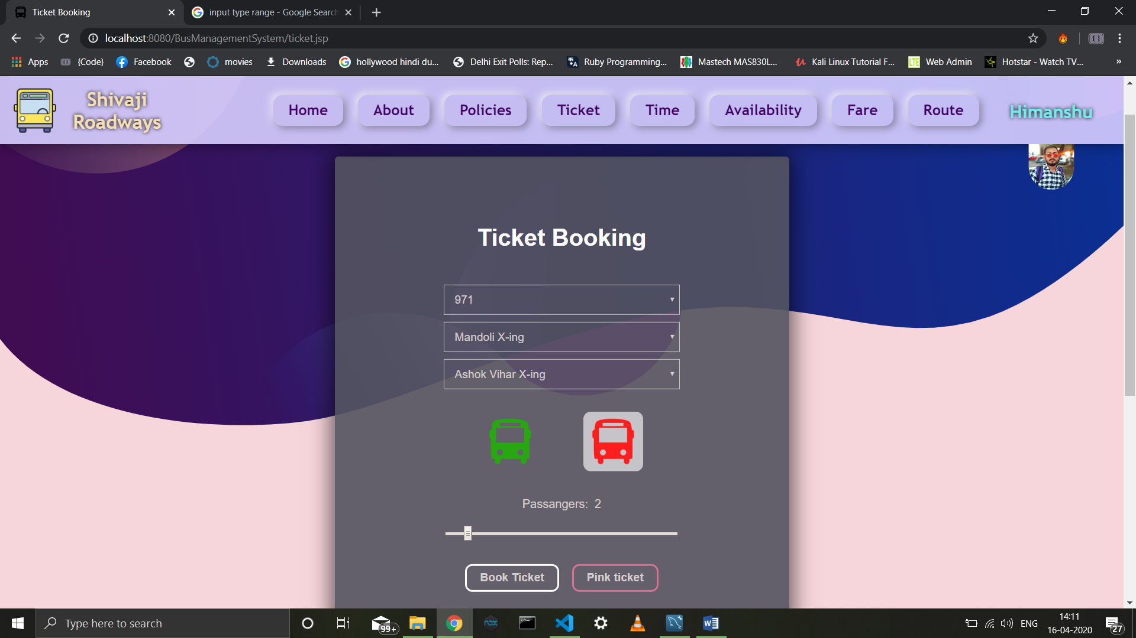

**Selection**: action → printTicket.jsp

|  |  |
| --- | --- |
| Route | 971 |
| Source | Mandoli X-ing |
| Destination | Ashok Vihar X-ing |
| Type | AC |
| No of Passengers | 2 |

**Source Code**

<!**DOCTYPE** html>

<**html** lang**=**"en">

<head>

    <**meta** charset**=**"UTF-8">

    <**meta** name**=**"viewport" content**=**"width=device-width, initial-scale=1.0">

    <**meta** http-equiv**=**"X-UA-Compatible" content**=**"ie=edge">

    <**link** rel**=**"stylesheet" href**=**"styles/style.css">

    <**link** rel**=**"stylesheet" href**=**"styles/authentication.css">

    <**link** rel**=**"stylesheet" href**=**"styles/common.css">

    <**link** rel**=**"stylesheet" href**=**"styles/leave.css">

    <**link** rel**=**"icon" href**=**"images/icon.png">

    <**title**>Ticket Booking</**title**>

    <**style**>

        .busTypeContainer

        {

            width**:** 220px;

            margin**:** 2vw auto;

        }

        .busTypeContainer label

        {

            background-size**:** 80% 80%;

            background-repeat**:** no-repeat;

            background-position**:** center;

            border-radius**:** 10px;

            transition**:** ease-in-out .7s;

        }

**input**[type="radio"]{

            display**:**none;

        }

**label**:last-child {

            float**:** right !important;

        }

**input**[type="radio"] + **label**

        {

            border**:** 2px solid transparent;

            height**:** 5vw;

            width**:** 5vw;

            display**:**inline-block;

            padding**:** 0 0 0 0px;

            cursor**:** pointer;

        }

**input**[type="radio"]:checked + **label**

        {

            background-color**:** rgba(255, 255, 255, 0.63);

            height**:** 5vw;

            width**:** 5vw;

            display**:**inline-block;

            padding**:** 0 0 0 0px;

            cursor**:** default;

        }

**form** **input**[type="submit"]

        {

            display**:** inline;

        }

        .submitContainer

        {

            margin**:** 0 auto;

            width**:** 17vw;

        }

        .submitContainer

        {

            position**:** relative;

            transform**:** translateY("20px");

        }

**.submitContainer** :first-child

        {

            float**:** right;

            border-color**:** palevioletred;

        }

**.submitContainer** :first-child:hover

        {

            position**:** relative;

            cursor**:** pointer;

            animation-name**:** pink;

            animation-duration**:** 1s;

            animation-fill-mode**:** forwards;

        }

**@keyframes** pink

        {

            100%

            {

                color**:** black;

                background-color**:** palevioletred;

                box-shadow**:** 0 0 10px 1px rgba(0, 0, 0, 0.63);

                border-radius**:** 50px;

            }

        }

        .pinkSubmit

        {

            border-color**:** pink;

        }

    </**style**>

</head>

<**body** onload**=**"changeRange();">

<%

if(session.getAttribute("email") == null || !session.getAttribute("role").equals("passanger"))

{

    response.sendRedirect("authentication.jsp");

}

%>

<%@page import="java.sql.*"%>

<%

    Connection con = null;

    Statement st = null;

    ResultSet rs = null;

    try

    {

        Class.forName("com.mysql.jdbc.Driver");

        con = DriverManager.getConnection("jdbc:mysql://localhost:3306/shivajiroadways", "root", "1234");

        st = con.createStatement();

        String query = "select routeNo from route order by serialNo";

        rs = st.executeQuery(query);

    }

    catch(Exception e)

    {

        out.print(e.getMessage());

    }

%>

    <**jsp:include** page**=**"navigationPannel.jsp"></**jsp:include**>

    <**jsp:include** page**=**"svg.jsp"></**jsp:include**>

    <**div** class**=**"container" style**=**"height: 45vw; margin-top: 34vw;">

        <**div** class**=**"workspace">

            <**form** action**=**"printTicket.jsp">

                <**h1**>Ticket Booking</**h1**>

            <**select** name**=**"routeNo" onchange**=**"updateStands(this.value);" required>

                    <**option** value**=**"" disabled selected >Bus No.</**option**>

                    <%

                        while(rs.next())

                        {%>

                            <**option**><%=rs.getString("routeNo")%></**option**>

                        <%}

                    %>

                </**select**>

                <**select** name**=**"source" required  onchange**=**"disableTo(this.value, this.length)">

                    <**option** value**=**"" disabled selected >From</**option**>

                </**select**>

                <**select** name**=**"destination" required  onchange**=**"disableFrom(this.value, this.length)">

                    <**option** value**=**"" disabled selected >To</**option**>

                </**select**>

                <**div** class**=**"busTypeContainer">

                    <**input** type**=**"radio" id**=**"ORD" value**=**"ORD" name**=**"type" checked>

                    <**label** for**=**"ORD" style**=**"background-image: url('images/ord.png');"></**label**>

                    <**input** type**=**"radio" id**=**"AC" value**=**"AC" name**=**"type">

                    <**label** for**=**"AC" style**=**"background-image: url('images/ac.png');"></**label**>

                </**div**>

                <**p** id**=**'rangeOutput'></**p**>

                <**input** type**=**"range" value**=**"1" min**=**"1" max**=**"20" onchange**=**"changeRange();" class**=**"noOfPassangers" name**=**"noOfPassangers">

                <**div** class**=**"submitContainer">

                    <**input** type**=**"submit" value**=**"Pink ticket">

                    <**input** type**=**"submit" value**=**"Book Ticket">

                </**div**>

            </**form**>

        </**div**>

    </**div**>

    <**jsp:include** page**=**"footer.jsp"></**jsp:include**>

</body>

<**script** src**=**"scripts/navPannel.js"></**script**>

<**script** src**=**"scripts/disable.js"></**script**>

<script>

**function** changeRange()

    {

**var** range **=** document.getElementsByClassName('noOfPassangers')[0].value;

        document.getElementById('rangeOutput').innerHTML **=** range;

    }

**function** updateStands(routeNo)

    {

**var** source **=** document.getElementsByName('source')[0];

**var** destination **=** document.getElementsByName('destination')[0];

**var** param **=** "?routeNo=" +  routeNo;

        param **=** param.replace("+", "%2b")

**var** xmlhttp **=** **new** XMLHttpRequest();

        xmlhttp.open("POST", "ticketAJAX.jsp" + param, false);

        xmlhttp.onreadystatechange **=** **function**(){

            source.innerHTML **=**

            destination.innerHTML **=** xmlhttp.responseText;

        }

        xmlhttp.send();

**var** placeholder **=** document.getElementsByClassName('placeholder');

        placeholder[0].text **=** "From";

        placeholder[1].innerHTML **=** "To";

    }

    window.addEventListener('load', **function** () {

**var** routeNo **=** document.getElementsByName('routeNo')[0].value;

**if**(routeNo)

        {

            setTimeout(**function**(){

                updateStands(routeNo);

            }, 200);

        }

    })

</script>

</html>

#### printTicket.jsp

#### Output

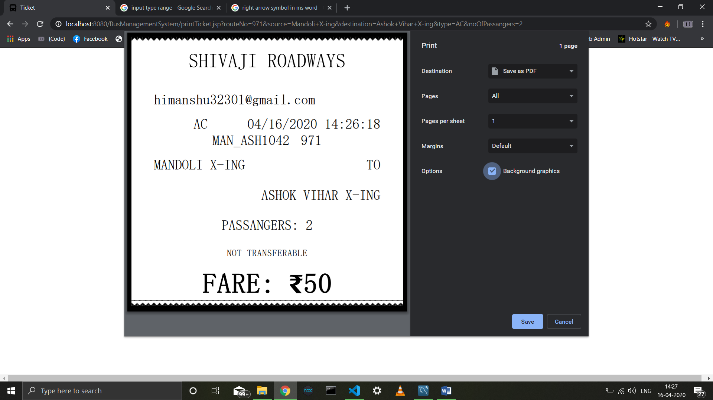

#### Entry into database

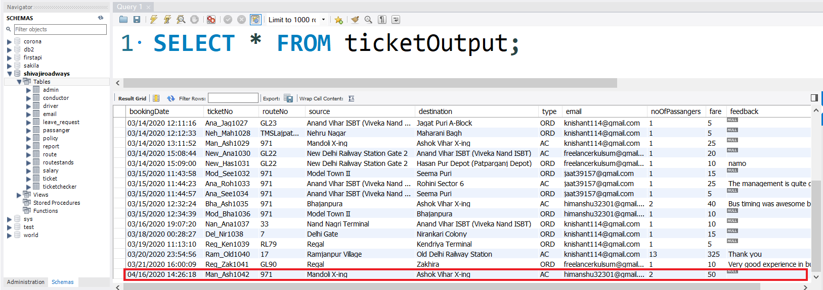

In case we have not enough balance to buy ticket

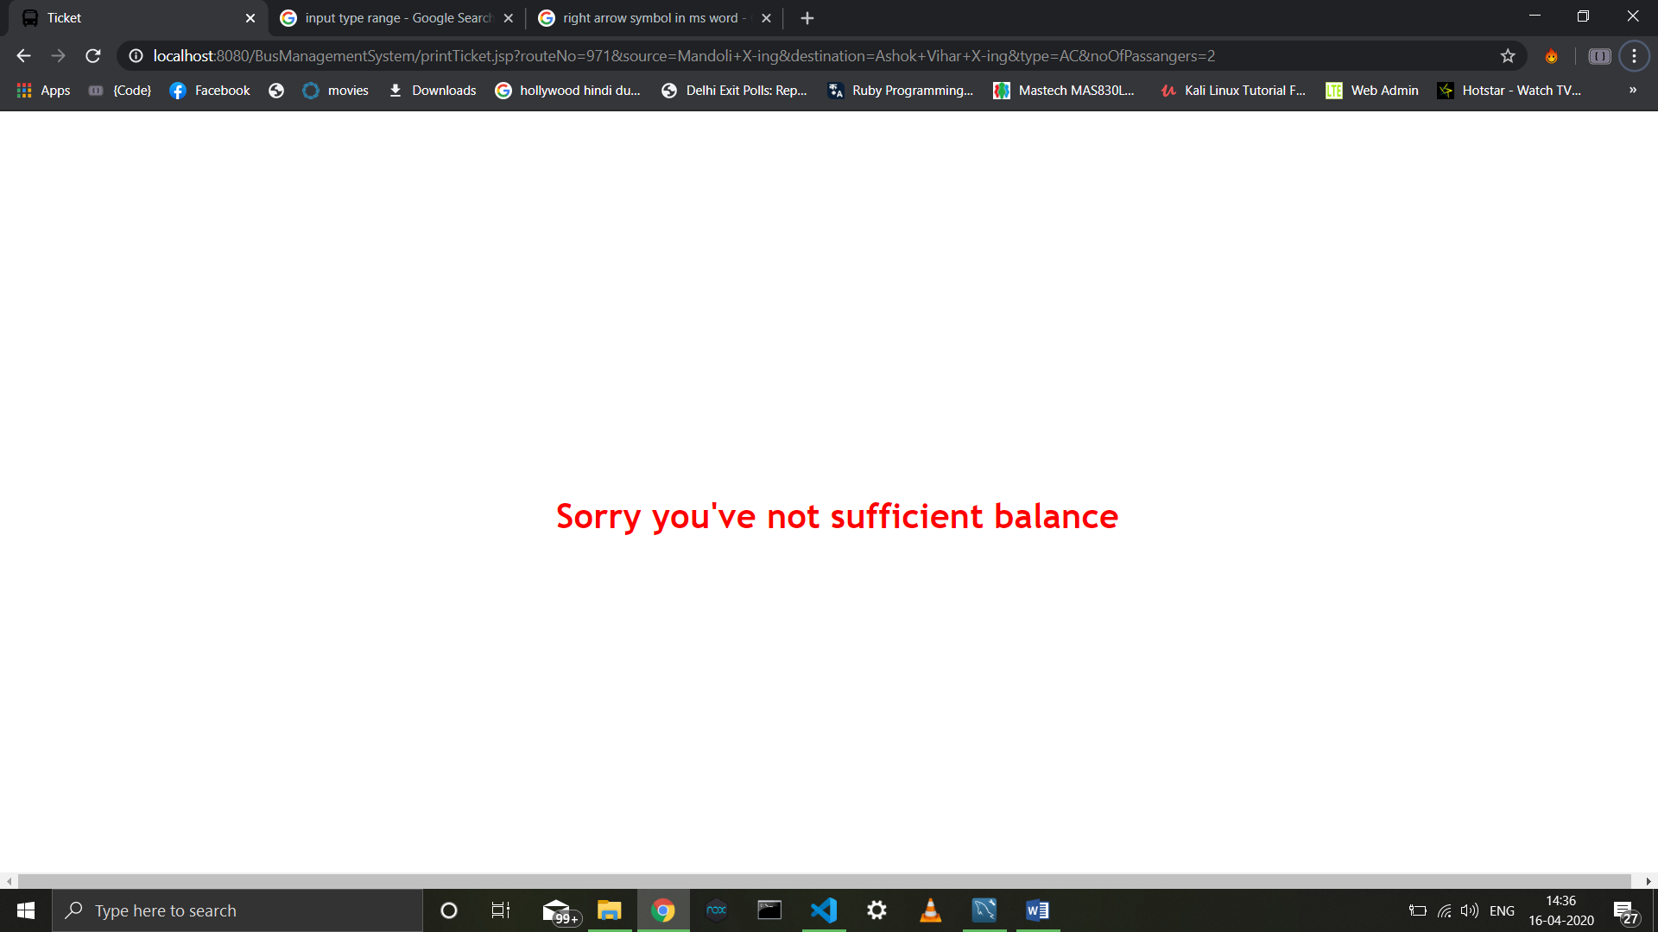

#### Source Code

<!**DOCTYPE** html>

<**html** lang**=**"en">

<head>

    <**meta** charset**=**"UTF-8">

    <**meta** name**=**"viewport" content**=**"width=device-width, initial-scale=1.0">

    <**link** rel**=**"stylesheet" href**=**"styles/ticket.css">

    <**link** rel**=**"icon" href**=**"images/icon.png">

    <**title**>Ticket</**title**>

</head>

<body>

<%@page import="java.sql.*"%>

<%

    int fare = 0;

    String routeNo = request.getParameter("routeNo");

    String sourceName = request.getParameter("source");

    String destinationName = request.getParameter("destination");

    String busType = request.getParameter("type");

    int no = Integer.parseInt(request.getParameter("noOfPassangers"));

    Boolean isSufficientBalance = false;

    Connection con = null;

    Statement st = null;

    ResultSet rs = null;

    try

    {

        Class.forName("com.mysql.jdbc.Driver");

        con = DriverManager.getConnection("jdbc:mysql://localhost:3306/shivajiroadways", "root", "1234");

        st = con.createStatement();

        String query = "select standNo from routestands where routeNo='" + routeNo + "' and standName='" + sourceName + "' union select standNo from routestands where routeNo='" + routeNo + "' and standName='" + destinationName + "';";

        rs = st.executeQuery(query);

        rs.next();

        int sourceNo = rs.getInt("standNo");

        rs.next();

        int destinationNo = rs.getInt("standNo");

        int destance = Math.abs(sourceNo - destinationNo);

        if(busType.equals("ORD"))

        {

            if(destance <= 2)

                fare = 5 * no;

            else if(destance <= 5)

                fare = 10 * no;

            else

                fare = 15 * no;

        }

        else if(busType.equals("AC"))

        {

            if(destance <= 2)

                fare = 10 * no;

            else if(destance <= 4)

                fare = 15 * no;

            else if(destance <= 6)

                fare = 20 * no;

            else

                fare = 25 * no;

        }

        query = "select walletBalance from passanger where email = '"+session.getAttribute("email")+"' and walletBalance >=" + fare;

        rs = st.executeQuery(query);

        if(rs.next())

        {

            isSufficientBalance = true;

            query = "update passanger set walletBalance = walletBalance - "+fare+" where email = '"+session.getAttribute("email")+"'";

            st.executeUpdate(query);

            query = "insert into ticket(routeNo, source, destination, email, type, noOfpassangers, fare) values('" +routeNo+ "', '" +sourceName+ "', '" +destinationName+ "', '"+session.getAttribute("email")+"', '" +busType+ "', " +no+ ", " +fare+ ");";

            st.executeUpdate(query);

            rs = st.executeQuery("select * from ticketoutput where email = '"+session.getAttribute("email")+"' order by bookingDate desc limit 1;");

            rs.next();

        }

    }

    catch(Exception e){out.print(e.getMessage());}

%>

    <%

    if(isSufficientBalance)

    {%>

    <**script**>

        print();

    </**script**>

    <**h1** id**=**"msg">CTRL + P for Print Ticket (<**span** style**=**"color: red">balance have already deducted</**span**>)</**h1**>

    <**div** class**=**"container"">

        <**p** style**=**"font-size: 35px; text-align: center; ">Shivaji Roadways</**p**>

        <**div** style**=**"text-transform: lowercase;" id**=**"busNo"><%=rs.getString("email")%></**div**>

        <**div** style**=**"width: 100%;">

            <**span** class**=**"dateTime" style**=**"float: right;"><%=rs.getString("bookingDate")%></**span**>

        </**div**>

        <**div** style**=**"text-align: center;">

            <**span** id**=**"ticketNo"><%=busType%> <%=rs.getString("ticketNo")%></**span**><**span** style**=**"margin-left: 20px;"><%=rs.getString("routeNo")%></**span**>

        </**div**>

        <**p** style**=**"width: 100%;"><%=rs.getString("source").length() < 25? rs.getString("source"): rs.getString("source").substring(0, 25)%><**span** style**=**"float: right; ;">To</**span**></**span**></**p**>

        <**p** style**=**"text-align: right;"><%=rs.getString("destination").length() < 25? rs.getString("destination"): rs.getString("destination").substring(0, 25)%></**p**>

        <**p** style**=**"text-align: center;">Passangers: <%=rs.getInt("noOfPassangers")%></**p**>

        <**p** style**=**"text-align: center; font-size: 17px;">Not transferable</**p**>

        <**p** style**=**"text-align: center; font-size: 50px; font-weight: bold;">FARE: <**span**>&#x20B9;<%=rs.getInt("fare")%></**span**></**p**>

    </**div**>

    <%}

    else

    {%>

        <**h1** id**=**"msg"><**span** style**=**"color: red">Sorry you've not sufficient balance</**span**></**h1**>

    <%}

    %>

</body>

</html>

#### estimatedTime.jsp

This module is provide information about the time is to be taken by the bus in completion of journey.

#### Output

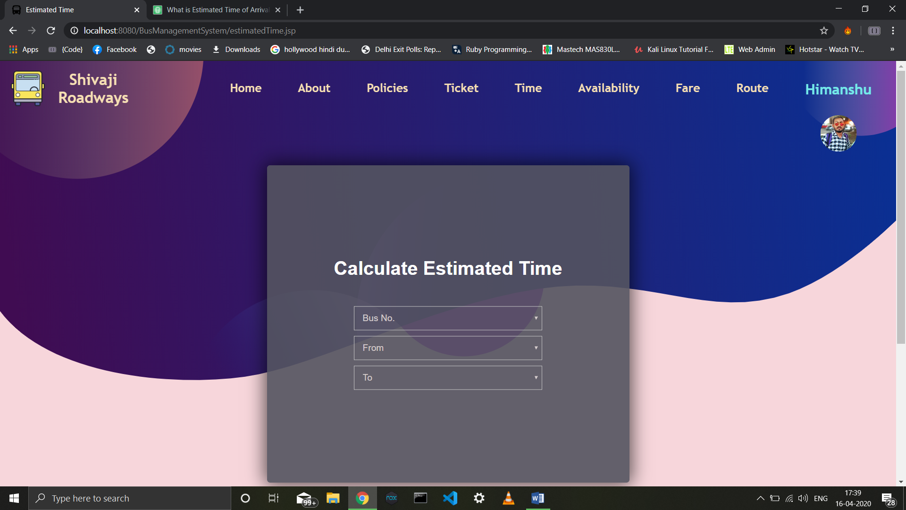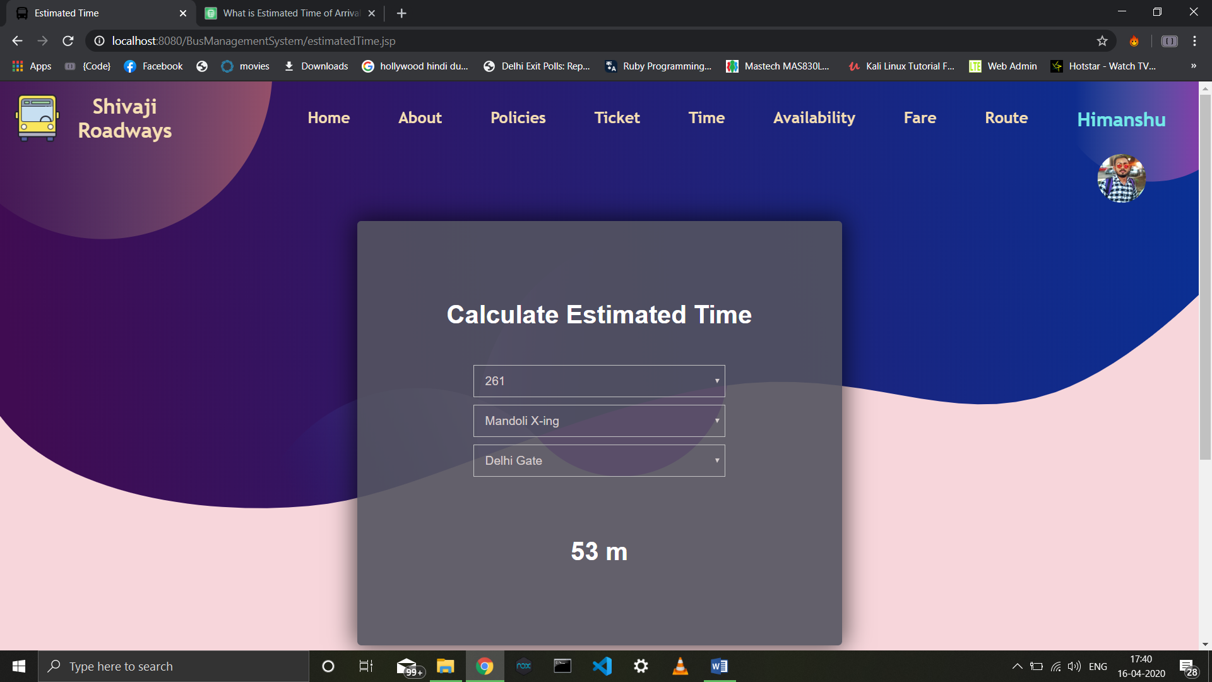

#### Source Code

<!**DOCTYPE** html>

<**html** lang**=**"en">

<head>

    <**meta** charset**=**"UTF-8">

    <**meta** name**=**"viewport" content**=**"width=device-width, initial-scale=1.0">

    <**meta** http-equiv**=**"X-UA-Compatible" content**=**"ie=edge">

    <**link** rel**=**"stylesheet" href**=**"styles/style.css">

    <**link** rel**=**"stylesheet" href**=**"styles/authentication.css">

    <**link** rel**=**"stylesheet" href**=**"styles/common.css">

    <**link** rel**=**"stylesheet" href**=**"styles/leave.css">

    <**link** rel**=**"icon" href**=**"images/icon.png">

    <**title**>Estimated Time</**title**>

</head>

<**body** onchange**=**"calculateEsTime();">

<%

if(session.getAttribute("email") == null || !session.getAttribute("role").equals("passanger"))

{

    response.sendRedirect("authentication.jsp");

}

%>

<%@page import="java.sql.*"%>

<%

    Connection con = null;

    Statement st = null;

    ResultSet rs = null;

    try

    {

        Class.forName("com.mysql.jdbc.Driver");

        con = DriverManager.getConnection("jdbc:mysql://localhost:3306/shivajiroadways", "root", "1234");

        st = con.createStatement();

        String query = "select routeNo from route order by serialNo";

        rs = st.executeQuery(query);

    }

    catch(Exception e)

    {

        out.print(e.getMessage());

    }

%>

    <**jsp:include** page**=**"navigationPannel.jsp"></**jsp:include**>

    <**jsp:include** page**=**"svg.jsp"></**jsp:include**>

    <**div** class**=**"container">

        <**div** class**=**"workspace">

            <**form**>

                <**h1**>Calculate Estimated Time</**h1**>

                <**select** name**=**"routeNo" onchange**=**"updateStands(this.value);">

                    <**option** value**=**"" disabled selected >Bus No.</**option**>

                    <%

                        while(rs.next())

                        {%>

                            <**option**><%=rs.getString("routeNo")%></**option**>

                        <%}

                    %>

                </**select**>

                <**select** name**=**"source" onchange**=**"disableTo(this.value, this.length)">

                    <**option** value**=**"" disabled selected >From</**option**>

                </**select**>

                <**select** name**=**"destination" onchange**=**"disableFrom(this.value, this.length)">

                    <**option** value**=**"" disabled selected >To</**option**>

                </**select**>

                <**h1** style**=**"margin-top: 5vw;" id**=**"est"></**h1**>

            </**form**>

        </**div**>

    </**div**>

    <**jsp:include** page**=**"footer.jsp"></**jsp:include**>

</body>

<**script** src**=**"scripts/navPannel.js"></**script**>

<**script** src**=**"scripts/disable.js"></**script**>

<script>

**function** updateStands(routeNo)

    {

**var** source **=** document.getElementsByName('source')[0];

**var** destination **=** document.getElementsByName('destination')[0];

**var** param **=** "?routeNo=" +  routeNo;

        param **=** param.replace("+", "%2b")

**var** xmlhttp **=** **new** XMLHttpRequest();

        xmlhttp.open("POST", "estimatedTimeAJAX.jsp" + param, false);

        xmlhttp.onreadystatechange **=** **function**(){

            source.innerHTML **=**

            destination.innerHTML **=** xmlhttp.responseText;

        }

        xmlhttp.send();

**var** placeholder **=** document.getElementsByClassName('placeholder');

        placeholder[0].text **=** "From";

        placeholder[1].innerHTML **=** "To";

    }

    window.addEventListener('load', **function** () {

**var** routeNo **=** document.getElementsByName('routeNo')[0].value;

**if**(routeNo)

        {

            setTimeout(**function**(){

                updateStands(routeNo);

            }, 500);

        }

    })

**function** calculateEsTime()

    {

**var** source **=** document.getElementsByName('source')[0].value;

**var** destination **=** document.getElementsByName('destination')[0].value;

**if**(source **&&** destination)

        {

**var** time **=** "";

**var** MINUTES **=** Math.abs(source - destination) * 6;    // assumed 1 km cover 6 min;

**if**(MINUTES > 20)

                MINUTES **+=** Math.floor(Math.random() * (+6 - +0) + +0); //random trafic of 0 to 5 min

**var** m **=** MINUTES % 60;

**var** h **=** (MINUTES-m)/60;

**if**(h > 0)

            {

                time **=** h+" h " + m + " m";

            }

**else**

            {

                time **=** m +" m";

            }

            document.getElementById('est').innerHTML **=** time;

            console.log(time);

        }

**else**

        document.getElementById('est').innerHTML **=** "";

    }

</script>

</html>

#### availableBuses.jsp

This module provide information about all the available buses from a source to destination as per request of passanger.

#### Output

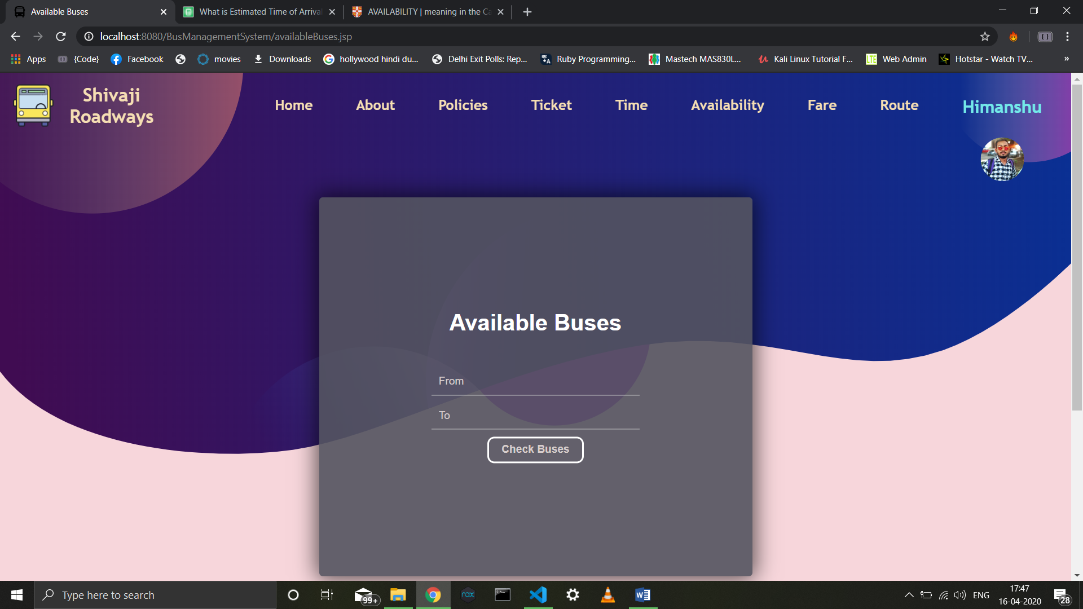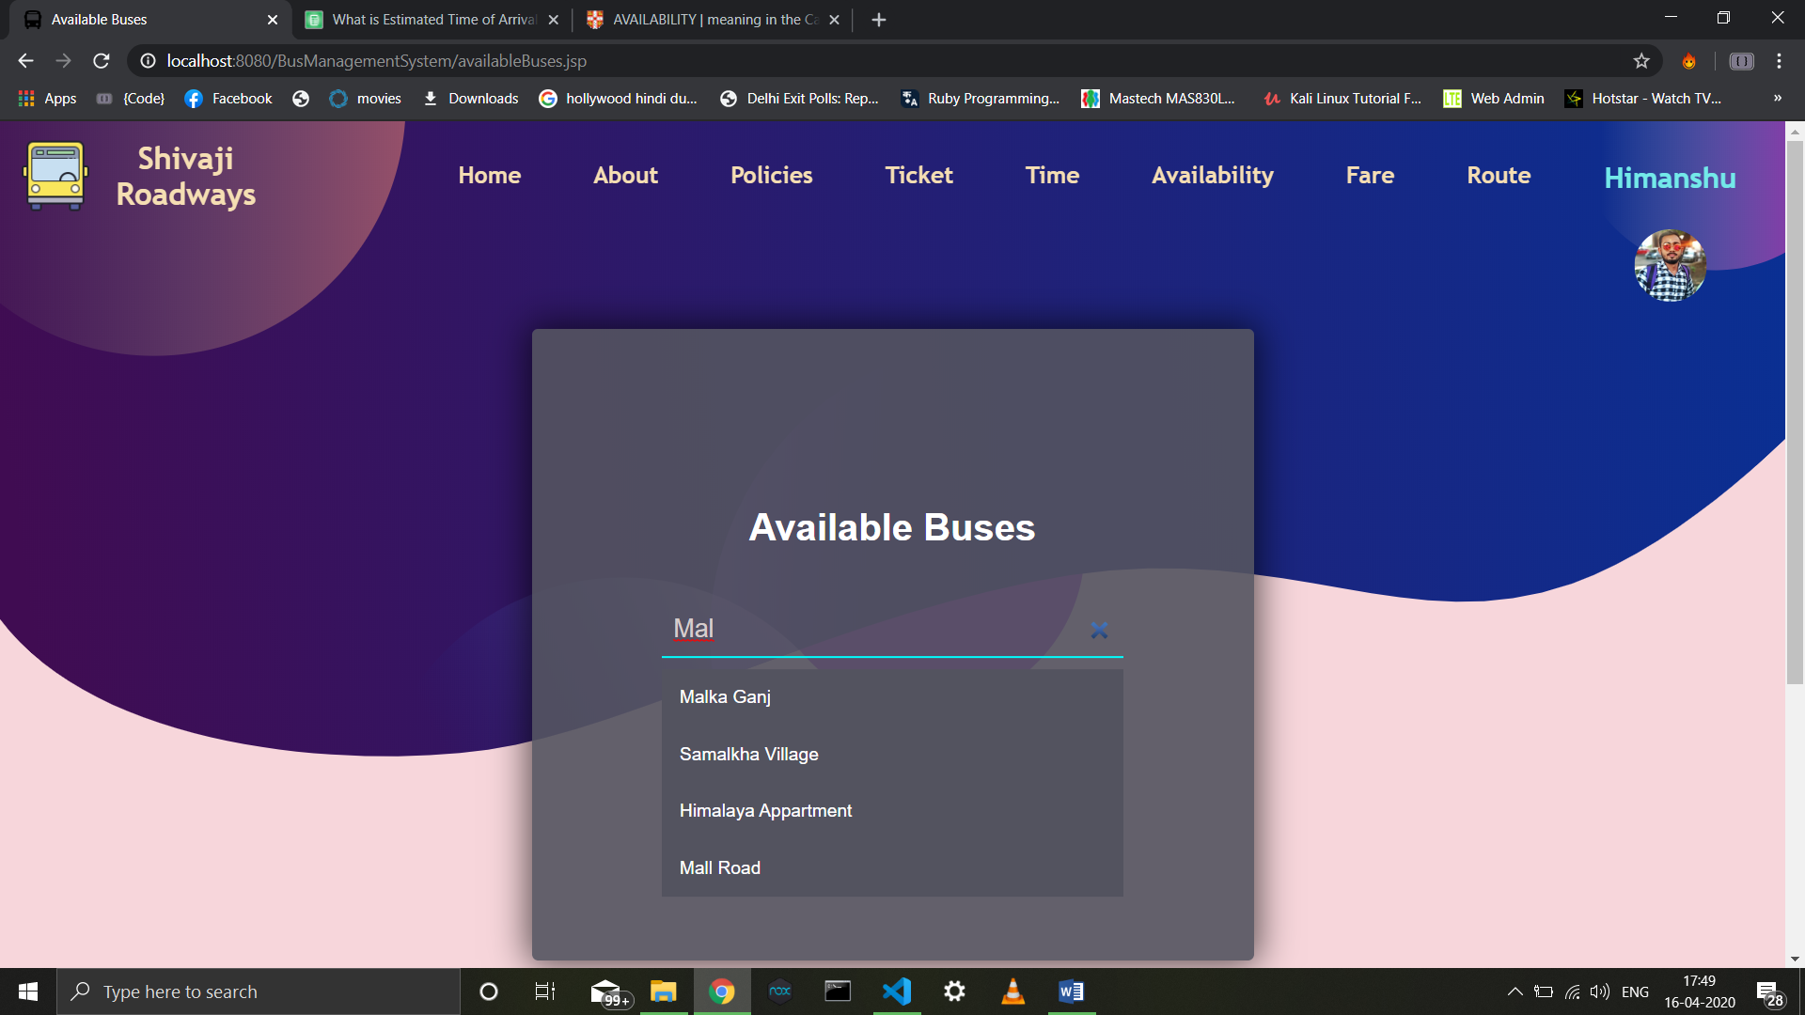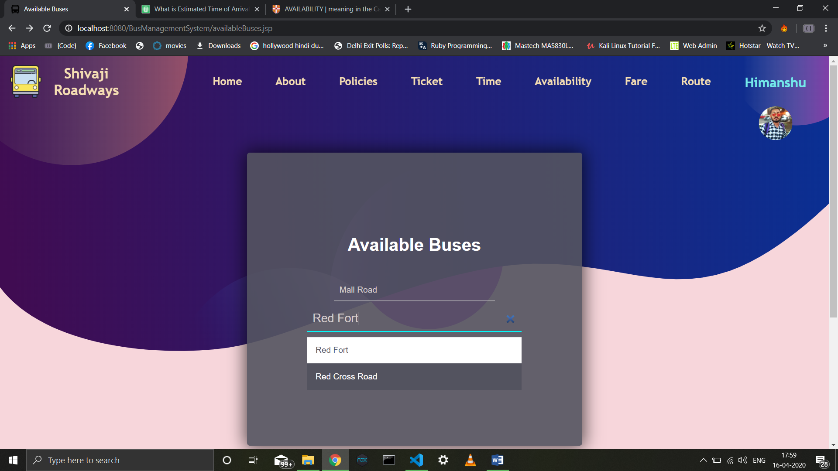

**Selection**: action → busesResult.jsp

|  |  |
| --- | --- |
| Source | Mall Road |
| Destination | Red Fort |

#### Source Code

<!**DOCTYPE** html>

<**html** lang**=**"en">

<head>

    <**meta** charset**=**"UTF-8">

    <**meta** name**=**"viewport" content**=**"width=device-width, initial-scale=1.0">

    <**meta** http-equiv**=**"X-UA-Compatible" content**=**"ie=edge">

    <**link** rel**=**"stylesheet" href**=**"styles/style.css">

    <**link** rel**=**"stylesheet" href**=**"styles/authentication.css">

    <**link** rel**=**"stylesheet" href**=**"styles/common.css">

    <**link** rel**=**"stylesheet" href**=**"styles/leave.css">

    <**link** rel**=**"icon" href**=**"images/icon.png">

    <**title**>Available Buses</**title**>

    <**style**>

    .searchOutput

    {

        background-color**:**green;

        height**:** 0;

        width**:** 80%;

        margin**:** 0 auto;

        display**:** none;

    }

    .searchOutput .list

    {

        background-color**:** rgb(83, 83, 95);

        width**:** 100%;

        max-height**:** 12.6vw;

        overflow-y**:** scroll;

        position**:** relative;

    }

**.searchOutput** **.list**::-webkit-scrollbar

    {

        display**:** none;

    }

    .searchOutput .list p

    {

        color**:** white;

        padding**:** 1vw;

        font-size**:** 1vw;

        margin**:** 0 auto;

        transition**:** ease all .7s;

    }

    .searchOutput .list p:hover

    {

        background-color**:** white;

        cursor**:** pointer;

        color**:** rgb(83, 83, 95);

    }

**input**[type="search"]:focus + **.searchOutput**

    {

        display**:** block;

    }

    </**style**>

</head>

<body>

<%

if(session.getAttribute("email") == null || !session.getAttribute("role").equals("passanger"))

{

    response.sendRedirect("authentication.jsp");

}

%>

    <**jsp:include** page**=**"navigationPannel.jsp"></**jsp:include**>

    <**jsp:include** page**=**"svg.jsp"></**jsp:include**>

    <**div** class**=**"container">

        <**div** class**=**"workspace">

            <**form** action**=**"busesResult.jsp">

                <**h1**>Available Buses</**h1**>

                <**input** type**=**"search" id**=**"from" placeholder**=**"From" onkeyup**=**"getFrom(this.value);" name**=**"source" autocomplete**=**"on">

                <**div** class**=**"searchOutput">

                    <**div** class**=**"list""></**div**>

                </**div**>

                <**input** type**=**"search" id**=**"to" placeholder**=**"To" onkeyup**=**"getTo(this.value);" name**=**"destination" autocomplete**=**"on">

                <**div** class**=**"searchOutput">

                    <**div** class**=**"list""></**div**>

                </**div**>

                <**input** type**=**"submit" value**=**"Check Buses">

            </**form**>

        </**div**>

    </**div**>

    <**jsp:include** page**=**"footer.jsp"></**jsp:include**>

</body>

<**script** src**=**"scripts/navPannel.js"></**script**>

<script>

**function** setFrom(value)

{

    console.log(value);

    document.getElementById('from').value **=** value;

}

**function** setTo(value)

{

    console.log(value);

    document.getElementById('to').value **=** value;

}

**function** getFrom(keyword)

{

**var** param **=** "?keyword=" +  keyword;

    param **=** param.replace("+", "%2b")

**var** xmlhttp **=** **new** XMLHttpRequest();

    xmlhttp.open("POST", "availableBusesAJAX.jsp" + param, false);

    xmlhttp.onreadystatechange **=** **function**(){

        document.getElementsByClassName('list')[0].innerHTML **=** xmlhttp.responseText;

    }

    xmlhttp.send();

}

**function** getTo(keyword)

{

**var** param **=** "?keyword=" +  keyword;

    param **=** param.replace("+", "%2b")

**var** xmlhttp **=** **new** XMLHttpRequest();

    xmlhttp.open("POST", "availableBusesAJAX2.jsp" + param, false);

    xmlhttp.onreadystatechange **=** **function**(){

        document.getElementsByClassName('list')[1].innerHTML **=** xmlhttp.responseText;

    }

    xmlhttp.send();

}

</script>

</html>

#### busesResult.jsp

#### Output

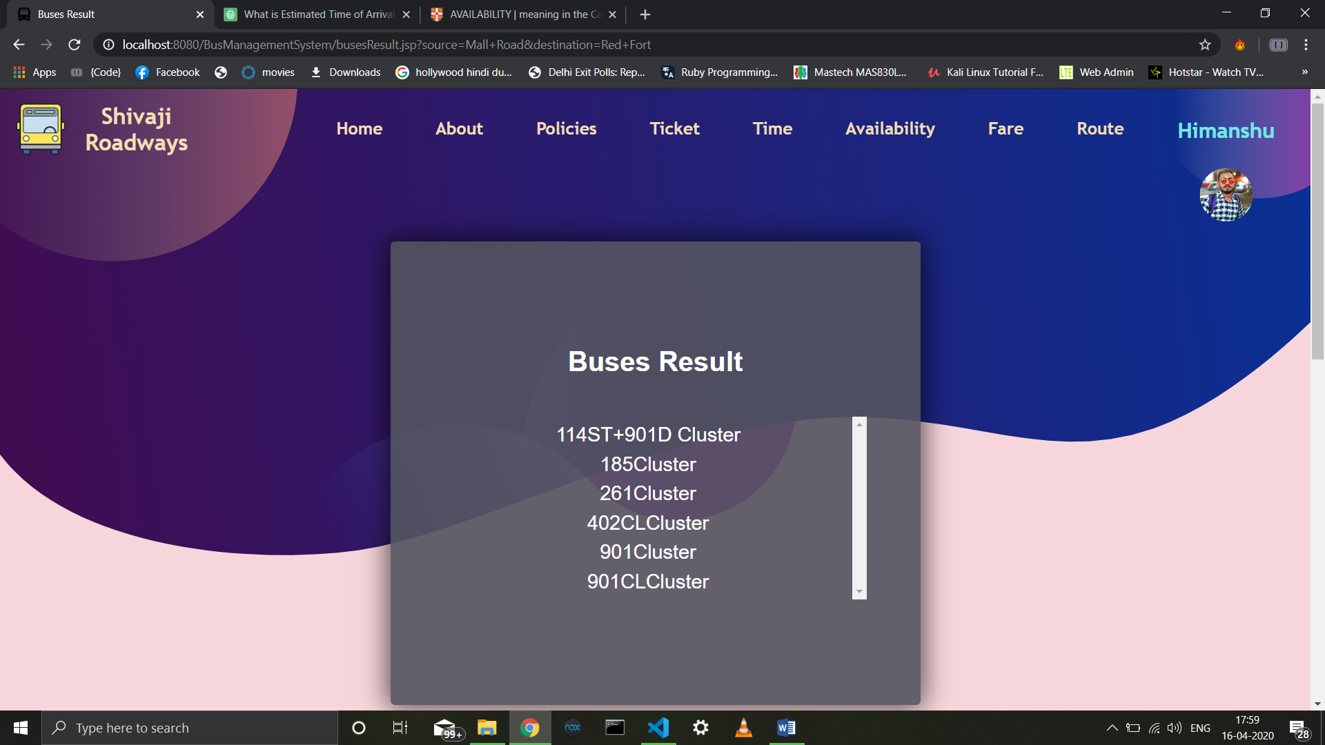

#### Source Code

<!**DOCTYPE** html>

<**html** lang**=**"en">

<head>

    <**meta** charset**=**"UTF-8">

    <**meta** name**=**"viewport" content**=**"width=device-width, initial-scale=1.0">

    <**meta** http-equiv**=**"X-UA-Compatible" content**=**"ie=edge">

    <**link** rel**=**"stylesheet" href**=**"styles/style.css">

    <**link** rel**=**"stylesheet" href**=**"styles/authentication.css">

    <**link** rel**=**"stylesheet" href**=**"styles/common.css">

    <**link** rel**=**"stylesheet" href**=**"styles/leave.css">

    <**link** rel**=**"icon" href**=**"images/icon.png">

    <**title**>Buses Result</**title**>

    <**style**>

    .workspace form p

    {

        color**:** white;

        margin**:** .5vw;

        text-align**:** center;

        font-size**:** 1.5vw;

    }

    </**style**>

</head>

<body>

<%@page import="java.sql.*"%>

<%

    String source = request.getParameter("source");

    String destination = request.getParameter("destination");

    Connection con = null;

    Statement st = null;

    ResultSet rs = null;

    try

    {

        Class.forName("com.mysql.jdbc.Driver");

        con = DriverManager.getConnection("jdbc:mysql://localhost:3306/shivajiroadways", "root", "1234");

        st = con.createStatement();

        String query = "select routeNo from routeStands where standName= '" + source + "' and routeNo in( select routeNo from routeStands where standName = '" + destination + "');";

        rs = st.executeQuery(query);

    }

    catch(Exception e)

    {}

%>

    <**jsp:include** page**=**"navigationPannel.jsp"></**jsp:include**>

    <**jsp:include** page**=**"svg.jsp"></**jsp:include**>

    <**div** class**=**"container">

        <**div** class**=**"workspace">

            <**form** action**=**"temp.jsp">

                <%

                if(rs.next())

                {

                    rs.previous();

                    %>

                    <**h1**>Buses Result</**h1**>

                <%}

                else

                {%>

                    <**h1**>No Bus Found</**h1**>

                <%}

                %>

                <**div** class**=**"result" style**=**"max-height: 20vw;; overflow-y: scroll;">

                    <%

                        while(rs.next())

                        {%>

                            <**p**><%=rs.getString("routeNo")%></**p**>

                        <%}

                    %>

                </**div**>

            </**form**>

        </**div**>

    </**div**>

    <**div** class**=**"container" style**=**"margin-top: 4vw;">

        <**div** class**=**"workspace" id**=**"standList" style**=**"height: auto; color: white;padding-top: 0.5vw; padding-bottom: 0.5vw; opacity: 0;">

        </**div**>

    </**div**>

    <**jsp:include** page**=**"footer.jsp"></**jsp:include**>

</body>

<**script** src**=**"scripts/navPannel.js"></**script**>

</html>

#### fare.jsp

This module is for calculating fare for a route from a source to destination with having type (AC or ORD) and no of passengers. This page make an AJAX request and display FARE.

#### Output

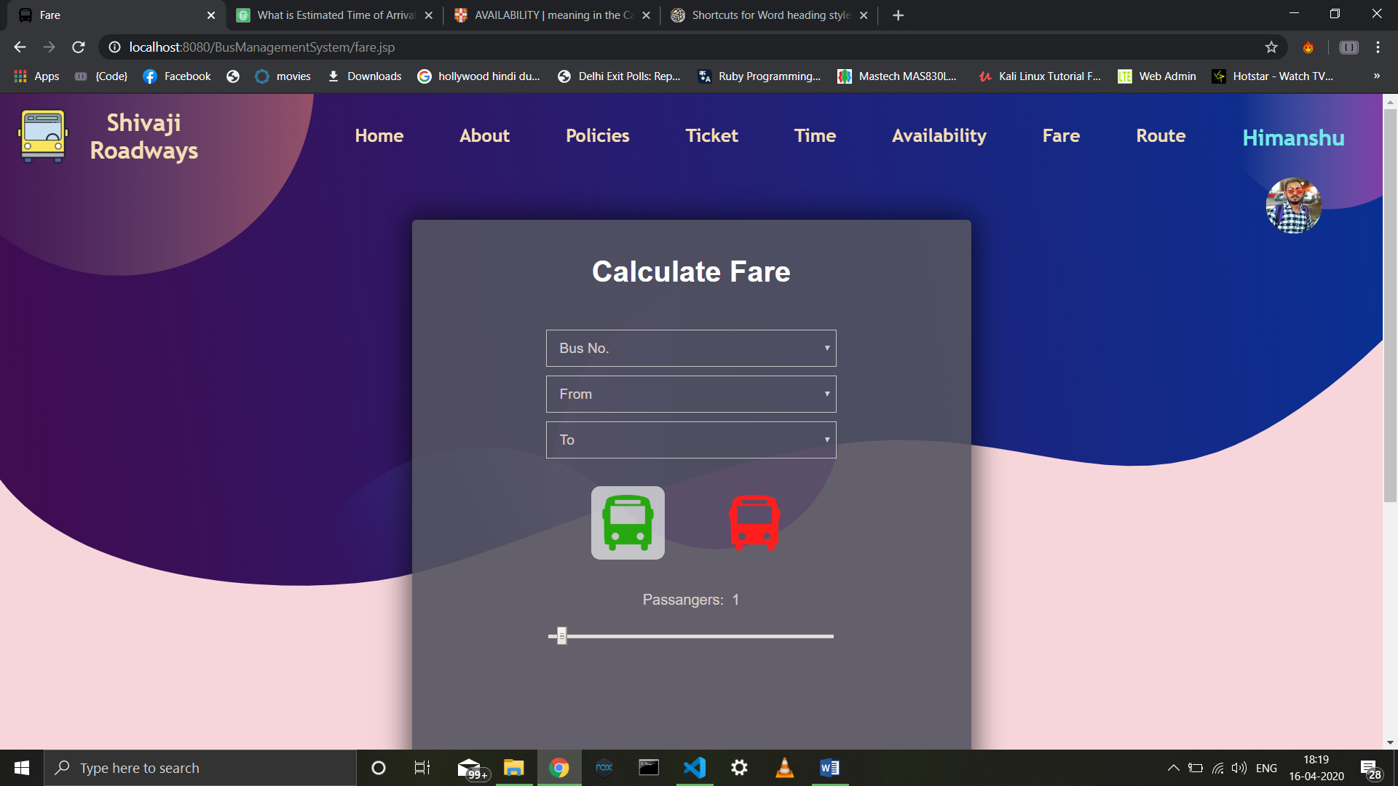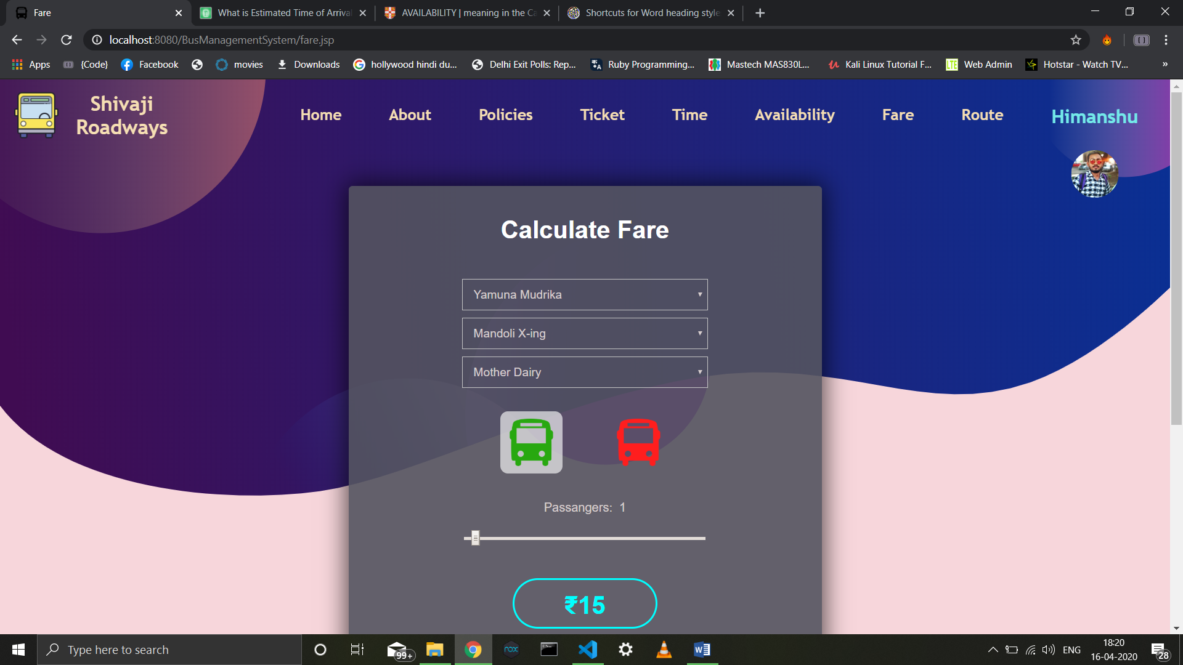

#### Source Code

<!**DOCTYPE** html>

<**html** lang**=**"en">

<head>

    <**meta** charset**=**"UTF-8">

    <**meta** name**=**"viewport" content**=**"width=device-width, initial-scale=1.0">

    <**meta** http-equiv**=**"X-UA-Compatible" content**=**"ie=edge">

    <**link** rel**=**"stylesheet" href**=**"styles/style.css">

    <**link** rel**=**"stylesheet" href**=**"styles/authentication.css">

    <**link** rel**=**"stylesheet" href**=**"styles/common.css">

    <**link** rel**=**"stylesheet" href**=**"styles/leave.css">

    <**link** rel**=**"icon" href**=**"images/icon.png">

    <**title**>Fare</**title**>

    <**style**>

        .busTypeContainer

        {

            width**:** 220px;

            margin**:** 2vw auto;

        }

        .busTypeContainer label

        {

            background-size**:** 80% 80%;

            background-repeat**:** no-repeat;

            background-position**:** center;

            border-radius**:** 10px;

            transition**:** ease-in-out .7s;

        }

**input**[type="radio"]{

            display**:**none;

        }

**label**:last-child {

            float**:** right !important;

        }

**input**[type="radio"] + **label**

        {

            border**:** 2px solid transparent;

            height**:** 5vw;

            width**:** 5vw;

            display**:**inline-block;

            padding**:** 0 0 0 0px;

            cursor**:** pointer;

        }

**input**[type="radio"]:checked + **label**

        {

            background-color**:** rgba(255, 255, 255, 0.63);

            height**:** 5vw;

            width**:** 5vw;

            display**:**inline-block;

            padding**:** 0 0 0 0px;

            cursor**:** default;

        }

**#fare**

        {

            margin**:** 2vw auto;

            border**:** 2px solid aqua;

            color**:** aqua;

            padding**:** 1vw;

            width**:** 10vw;

            border-radius**:** 2.5vw;

            transition**:** ease-in-out .7s;

            height**:** 2vw;

        }

**#fare**:empty

        {

            opacity**:** 0;

        }

    </**style**>

</head>

<**body** onload**=**"changeRange();" onchange**=**"checkValid('Dom changed');">

<%@page import="java.sql.*"%>

<%

    Connection con = null;

    Statement st = null;

    ResultSet rs = null;

    try

    {

        Class.forName("com.mysql.jdbc.Driver");

        con = DriverManager.getConnection("jdbc:mysql://localhost:3306/shivajiroadways", "root", "1234");

        st = con.createStatement();

        String query = "select routeNo from route order by serialNo";

        rs = st.executeQuery(query);

    }

    catch(Exception e)

    {

        out.print(e.getMessage());

    }

%>

    <**jsp:include** page**=**"navigationPannel.jsp"></**jsp:include**>

    <**jsp:include** page**=**"svg.jsp"></**jsp:include**>

    <**div** class**=**"container" style**=**"height: 40vw; margin-top: 29vw;">

        <**div** class**=**"workspace">

            <**form**>

                <**h1**>Calculate Fare</**h1**>

                <**select** name**=**"routeNo" onchange**=**"updateStands(this.value);">

                    <**option** value**=**"" disabled selected >Bus No.</**option**>

                    <%

                        while(rs.next())

                        {%>

                            <**option**><%=rs.getString("routeNo")%></**option**>

                        <%}

                    %>

                </**select**>

                <**select** name**=**"source" onchange**=**"disableTo(this.value, this.length)">

                    <**option** value**=**"" disabled selected >From</**option**>

                </**select**>

                <**select** name**=**"destination" onchange**=**"disableFrom(this.value, this.length)">

                    <**option** value**=**"" disabled selected >To</**option**>

                </**select**>

                <**div** class**=**"busTypeContainer">

                    <**input** type**=**"radio" id**=**"ORD" value**=**"ORD" name**=**"type" checked>

                    <**label** for**=**"ORD" style**=**"background-image: url('images/ord.png');"></**label**>

                    <**input** type**=**"radio" id**=**"AC" value**=**"AC" name**=**"type">

                    <**label** for**=**"AC" style**=**"background-image: url('images/ac.png');"></**label**>

                </**div**>

                <**p** id**=**'rangeOutput'></**p**>

                <**input** type**=**"range" value**=**"1" min**=**"1" max**=**"20" onchange**=**"changeRange();" class**=**"noOfPassangers" name**=**"noOfPassangers">

                <**h1** id**=**"fare"></**h1**>

            </**form**>

        </**div**>

    </**div**>

    <**jsp:include** page**=**"footer.jsp"></**jsp:include**>

</body>

<**script** src**=**"scripts/navPannel.js"></**script**>

<**script** src**=**"scripts/disable.js"></**script**>

<script>

**function** changeRange()

    {

**var** range **=** document.getElementsByClassName('noOfPassangers')[0].value;

        document.getElementById('rangeOutput').innerHTML **=** range;

    }

**function** updateStands(routeNo)

    {

**var** source **=** document.getElementsByName('source')[0];

**var** destination **=** document.getElementsByName('destination')[0];

**var** param **=** "?routeNo=" +  routeNo;

        param **=** param.replace("+", "%2b")

**var** xmlhttp **=** **new** XMLHttpRequest();

        xmlhttp.open("POST", "ticketAJAX.jsp" + param, false);

        xmlhttp.onreadystatechange **=** **function**(){

            source.innerHTML **=**

            destination.innerHTML **=** xmlhttp.responseText;

        }

        xmlhttp.send();

**var** placeholder **=** document.getElementsByClassName('placeholder');

        placeholder[0].text **=** "From";

        placeholder[1].innerHTML **=** "To";

    }

    window.addEventListener('load', **function** () {

**var** routeNo **=** document.getElementsByName('routeNo')[0].value;

**if**(routeNo)

        {

            setTimeout(**function**(){

                updateStands(routeNo);

            }, 200);

        }

    })

**function** checkValid()

    {

**var** routeNo **=** document.getElementsByName('routeNo')[0].value;

**var** source **=** document.getElementsByName('source')[0].value;

**var** destination **=** document.getElementsByName('destination')[0].value;

**var** nop **=** document.getElementsByClassName('noOfPassangers')[0].value;

**var** type **=** ""

**if** (document.getElementById('ORD').checked) {

            type **=** document.getElementById('ORD').value;

        }

**else** **if** (document.getElementById('AC').checked) {

            type **=** document.getElementById('AC').value;

        }

**if**(routeNo **&&** source **&&** destination)

        {

            getFare(routeNo, source, destination, nop, type)

        }

    }

**function** getFare(routeNo, source, destination, nop, type)

    {

**var** fareValue **=** document.getElementById('fare');

**if** (document.getElementById('ORD').checked) {

            type **=** document.getElementById('ORD').value;

        }

**else** **if** (document.getElementById('AC').checked) {

            type **=** document.getElementById('AC').value;

        }

**var** param **=** "?routeNo=" + routeNo + "&source=" + source + "&destination=" + destination + "&type=" + type + "&noOfPassangers=" + nop;

        param **=** param.replace("+", "%2b")

        param **=** param.replace("(", "%28")

        param **=** param.replace(")", "%29")

**var** xmlhttp **=** **new** XMLHttpRequest();

        xmlhttp.open("POST", "fareAJAX.jsp" + param, false);

        xmlhttp.onreadystatechange **=** **function**(){

            source.innerHTML **=**

            fareValue.innerHTML **=** xmlhttp.responseText;

        }

        xmlhttp.send();

    }

</script>

</html>

#### route.jsp

This module is to provide source and destination of a given route and also all the stages.

#### Output

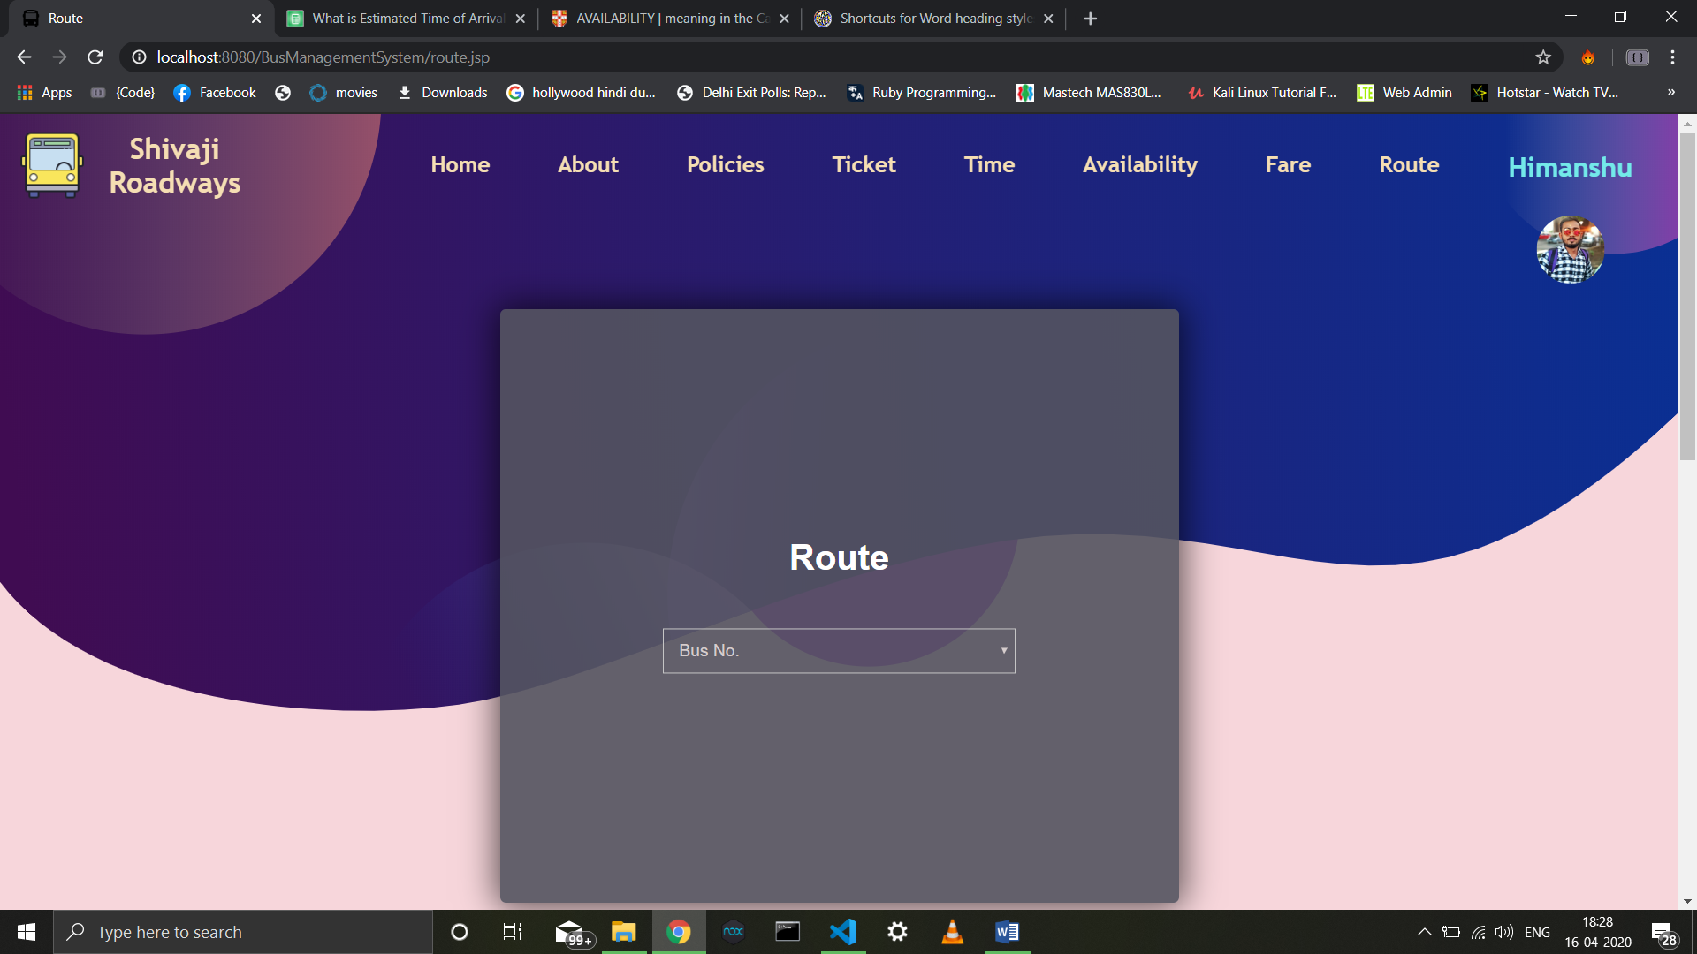

**Selecting route**: 33

**Getting** : Bhajanpura (Source) and Noida Sector 37 (Destination)

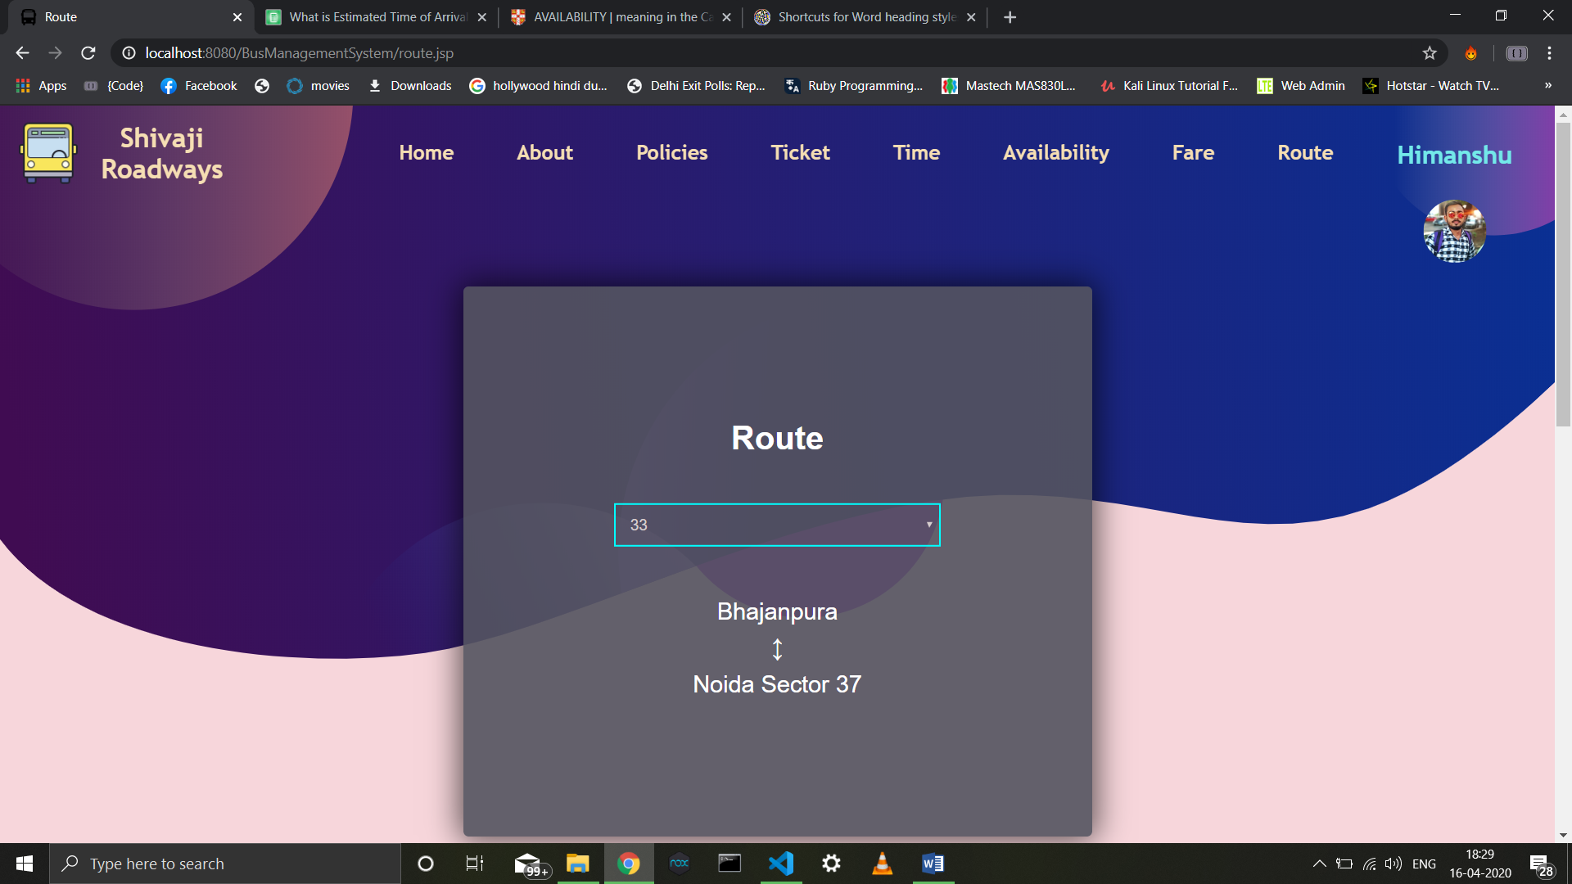

**Stages of selected route**: 33

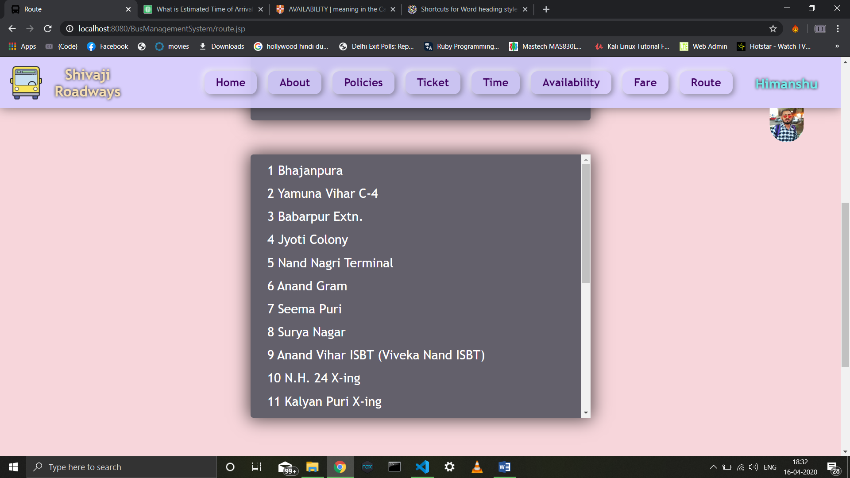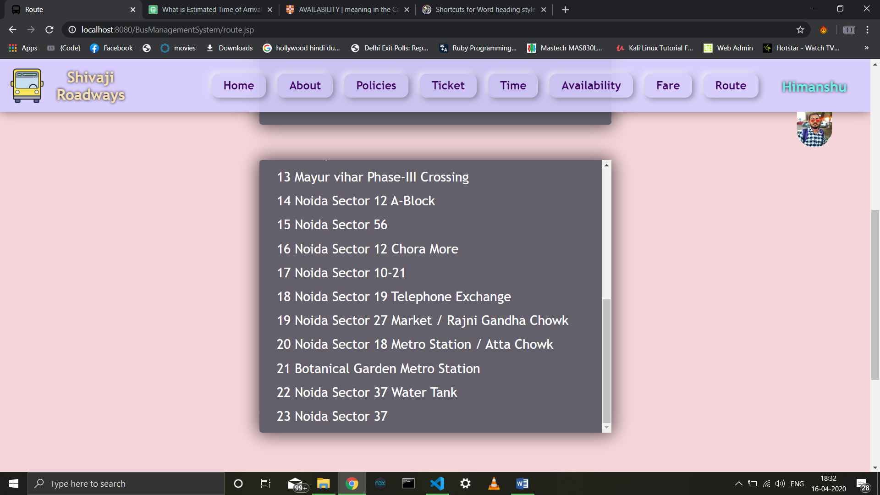

#### Source Code

<!**DOCTYPE** html>

<**html** lang**=**"en">

<head>

    <**meta** charset**=**"UTF-8">

    <**meta** name**=**"viewport" content**=**"width=device-width, initial-scale=1.0">

    <**meta** http-equiv**=**"X-UA-Compatible" content**=**"ie=edge">

    <**link** rel**=**"stylesheet" href**=**"styles/style.css">

    <**link** rel**=**"stylesheet" href**=**"styles/authentication.css">

    <**link** rel**=**"stylesheet" href**=**"styles/common.css">

    <**link** rel**=**"stylesheet" href**=**"styles/leave.css">

    <**link** rel**=**"icon" href**=**"images/icon.png">

    <**title**>Route</**title**>

    <**style**>

        #standList

        {

            max-height**:** 30vw;

            overflow-y**:** scroll;

        }

        .workspace p

        {

            font-size**:** 1.5vw;

            padding-top**:** 0.5vw;

            padding-bottom**:** 0.5vw;

            padding-left**:** 2vw;

        }

    </**style**>

</head>

<body>

    <%

    if(session.getAttribute("email") == null || !session.getAttribute("role").equals("passanger"))

    {

        response.sendRedirect("authentication.jsp");

    }

    %>

<%@page import="java.sql.*" %>

<%

    Connection con = null;

    Statement st = null;

    ResultSet rs = null;

    try

    {

        Class.forName("com.mysql.jdbc.Driver");

        con = DriverManager.getConnection("jdbc:mysql://localhost:3306/shivajiroadways", "root", "1234");

        st = con.createStatement();

        String query = "SELECT routeNo FROM route order by serialNo";

        rs = st.executeQuery(query);

    }

    catch(Exception e)

    {

        out.print(e.getMessage());

    }

%>

    <**jsp:include** page**=**"navigationPannel.jsp"></**jsp:include**>

    <**jsp:include** page**=**"svg.jsp"></**jsp:include**>

    <**div** class**=**"container">

        <**div** class**=**"workspace">

            <**form** action**=**"temp.jsp">

                <**h1**>Route</**h1**>

                <**select** name**=**"routeNo" onchange**=**"getResults(this.value); getStandList(this.value);">

                    <**option** value**=**"" disabled selected >Bus No.</**option**>

                    <%

                    while(rs.next())

                    {%>

                        <**option**><%=rs.getString("routeNo")%></**option**>

                    <%}

                    %>

                </**select**>

                <**div** id**=**"result"></**div**>

            </**form**>

        </**div**>

    </**div**>

    <**div** class**=**"container" style**=**"margin-top: 4vw;">

        <**div** class**=**"workspace" id**=**"standList" style**=**"height: auto; color: white;padding-top: 0.5vw; padding-bottom: 0.5vw; opacity: 0;">

        </**div**>

    </**div**>

    <**jsp:include** page**=**"footer.jsp"></**jsp:include**>

</body>

<**script** src**=**"scripts/navPannel.js"></**script**>

<script>

**function** getResults(route)

    {

**var** xmlhttp **=** **new** XMLHttpRequest();

**var** param **=** "?routeNo=" +  route;

        param **=** param.replace("+", "%2b")

        xmlhttp.open("POST", "routeAJAX.jsp" + param, true);

        xmlhttp.send();

        xmlhttp.onreadystatechange **=** **function**()

        {

            document.getElementById('result').innerHTML **=** xmlhttp.responseText;

        }

    }

**function** getStandList(route)

    {

        document.getElementById('standList').style.opacity **=** "1";

**var** xmlhttp **=** **new** XMLHttpRequest();

**var** param **=** "?routeNo=" +  route;

        param **=** param.replace("+", "%2b")

        xmlhttp.open("POST", "routeAJAX2.jsp" + param, true);

        xmlhttp.send();

        xmlhttp.onreadystatechange **=** **function**()

        {

            document.getElementById('standList').innerHTML **=** xmlhttp.responseText;

        }

    }

</script>

</html>

#### Signing In with Staff’s account

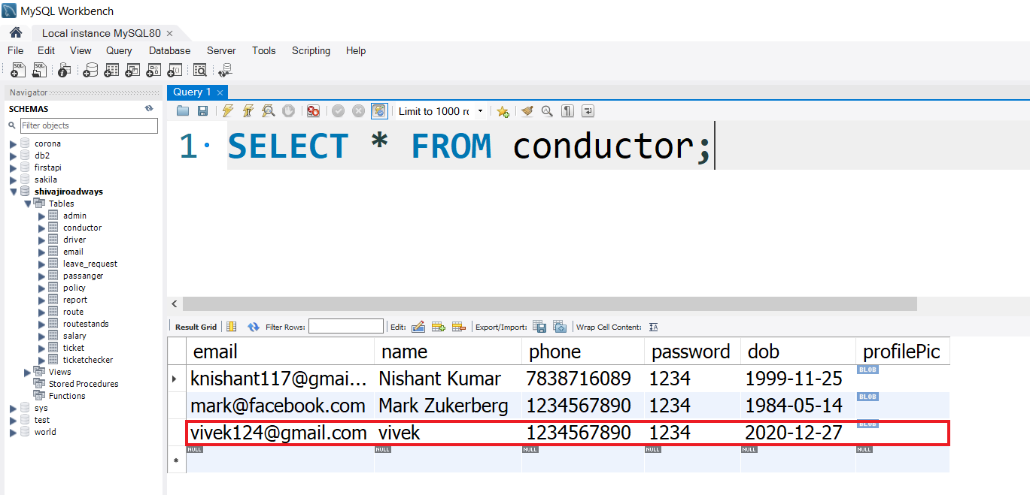

**Role**: Conductor

Credentials:

* **Email**: [vivek124@gmail.com](mailto:vivek124@gmail.com)
* **Password**: 1234

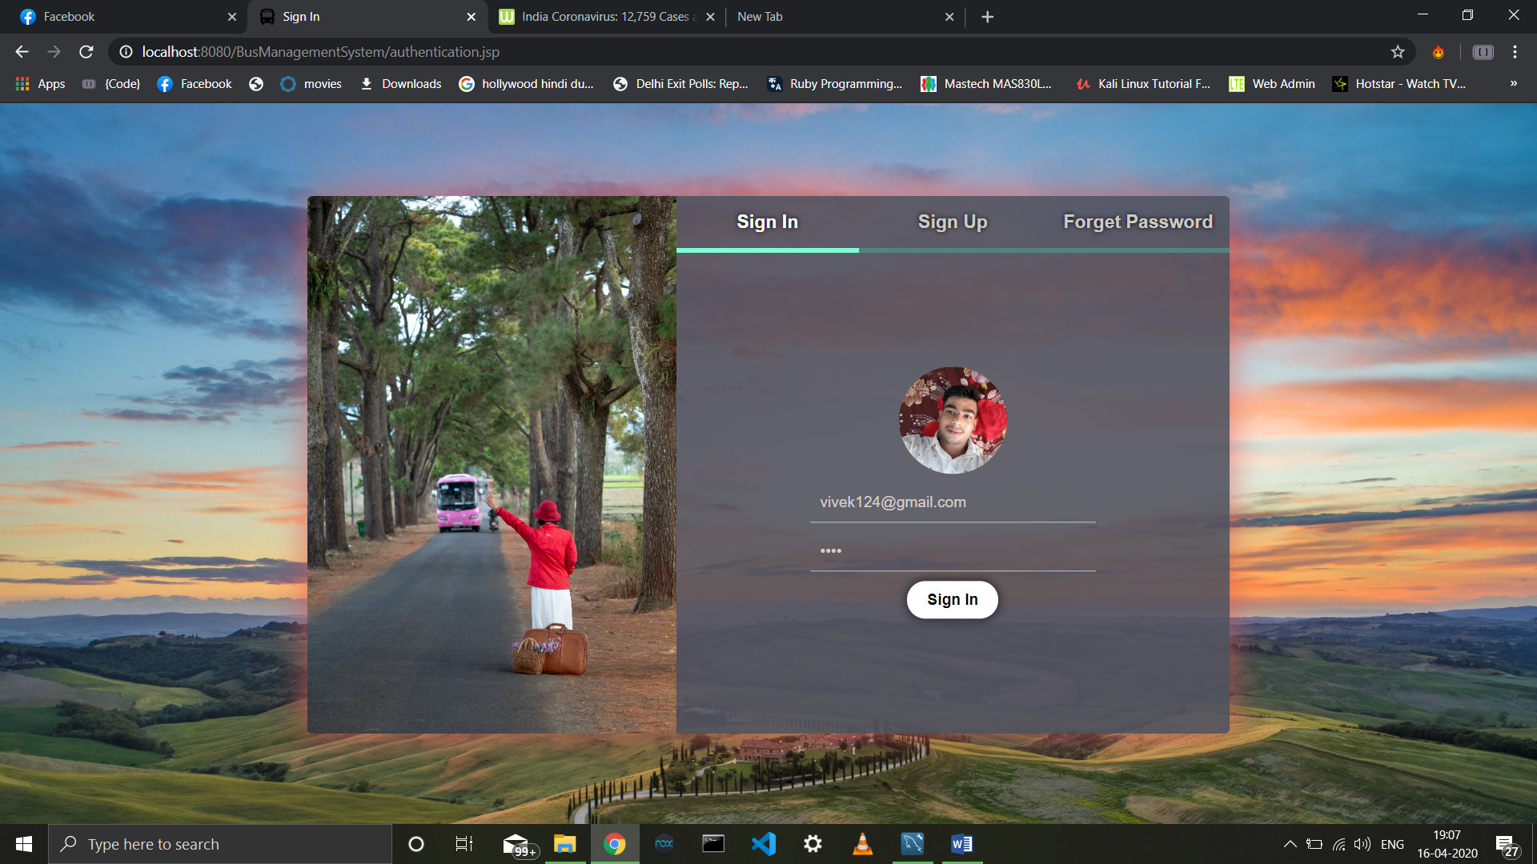

#### Signed In

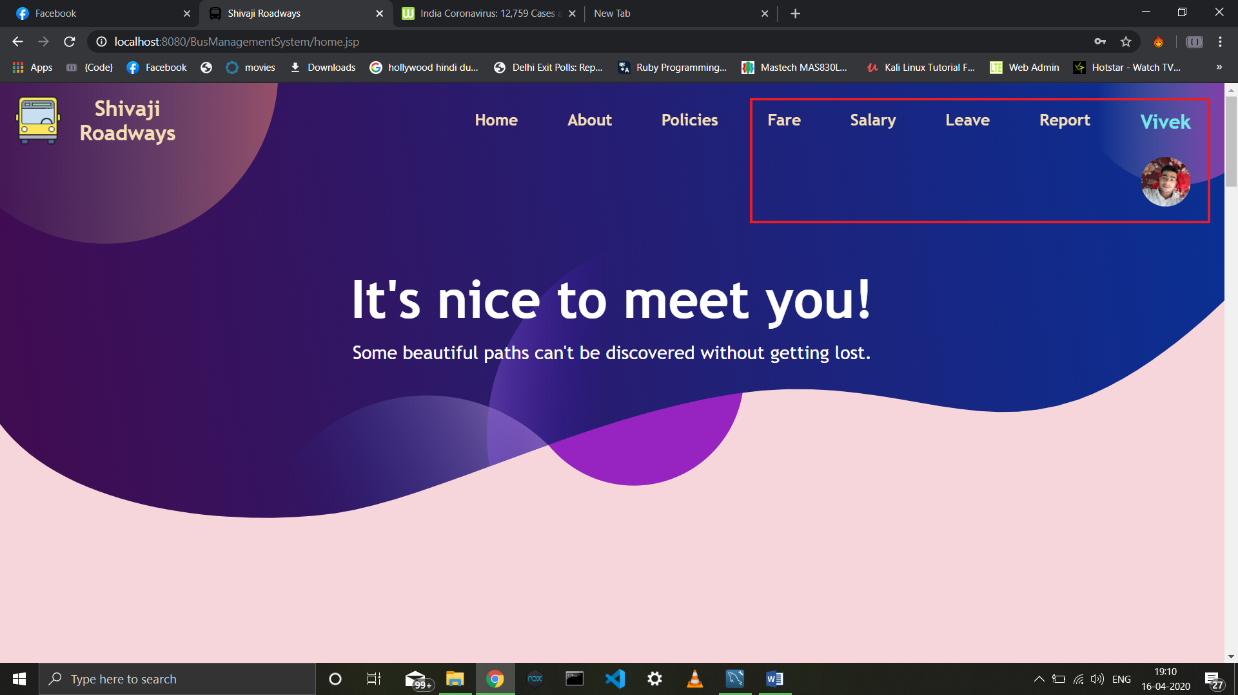

We have some new links in our navigation panel

* Fare
* Salary
* Leave
* Report

Let’s explore them one by one

#### fare.jsp

This module is already discussed above so don’t need to again rewrite those stuffs you can manually go into fare.jsp or can click fare.jsp

#### salary.jsp

Salary module is to provide information regarding salary on the particular logged in account.

#### Output

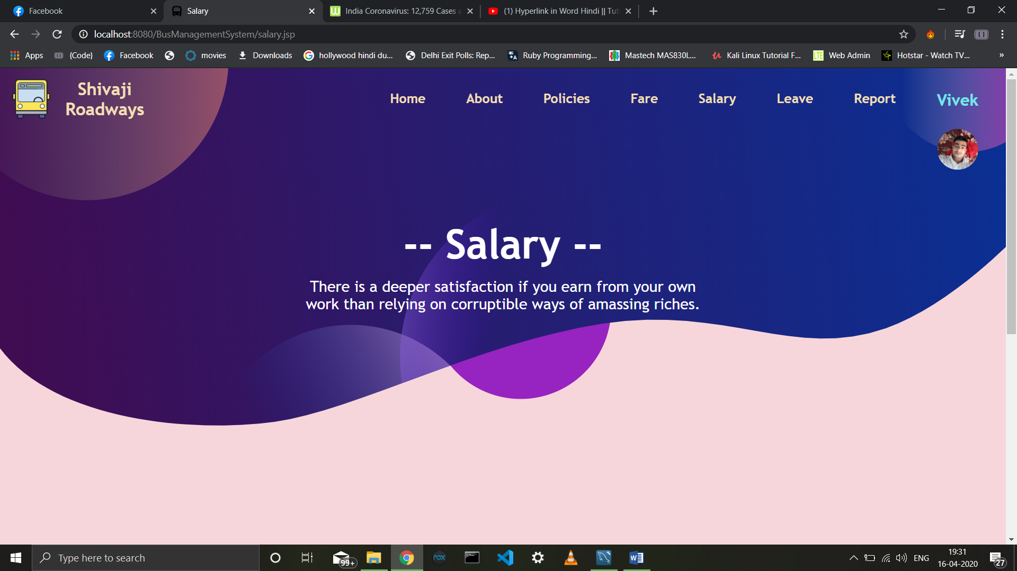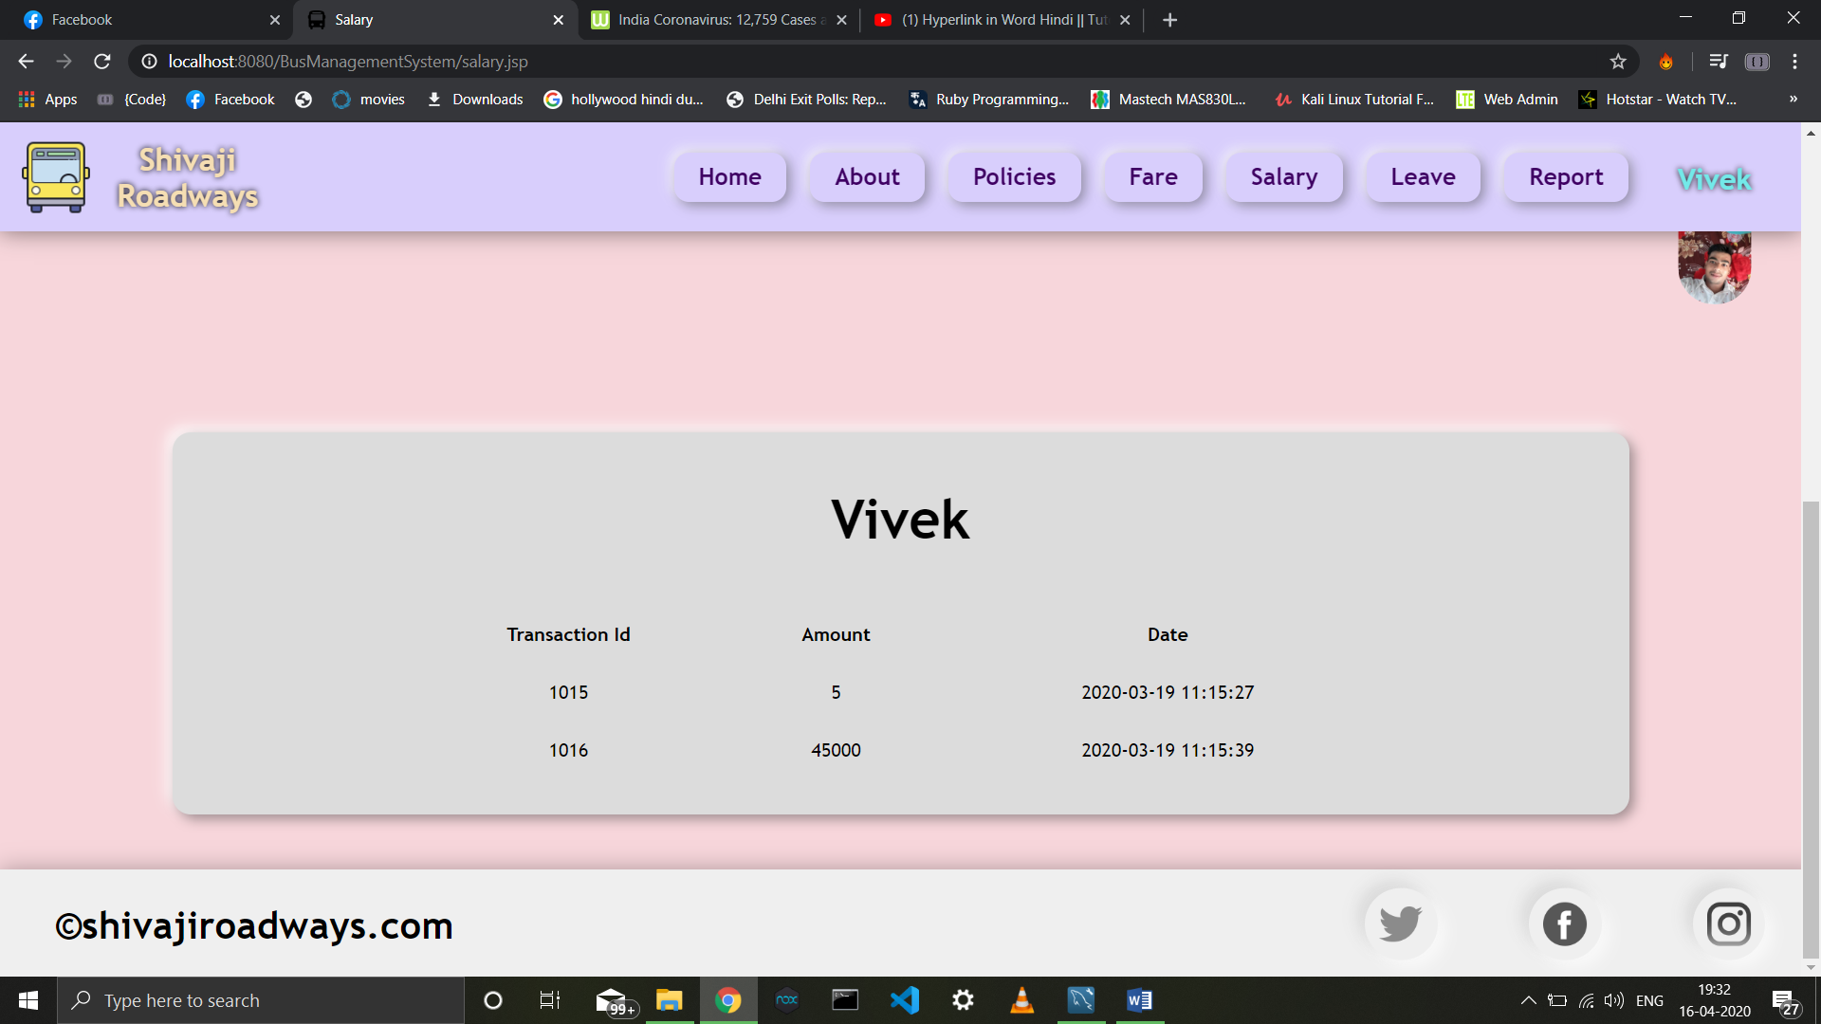

#### Database Output

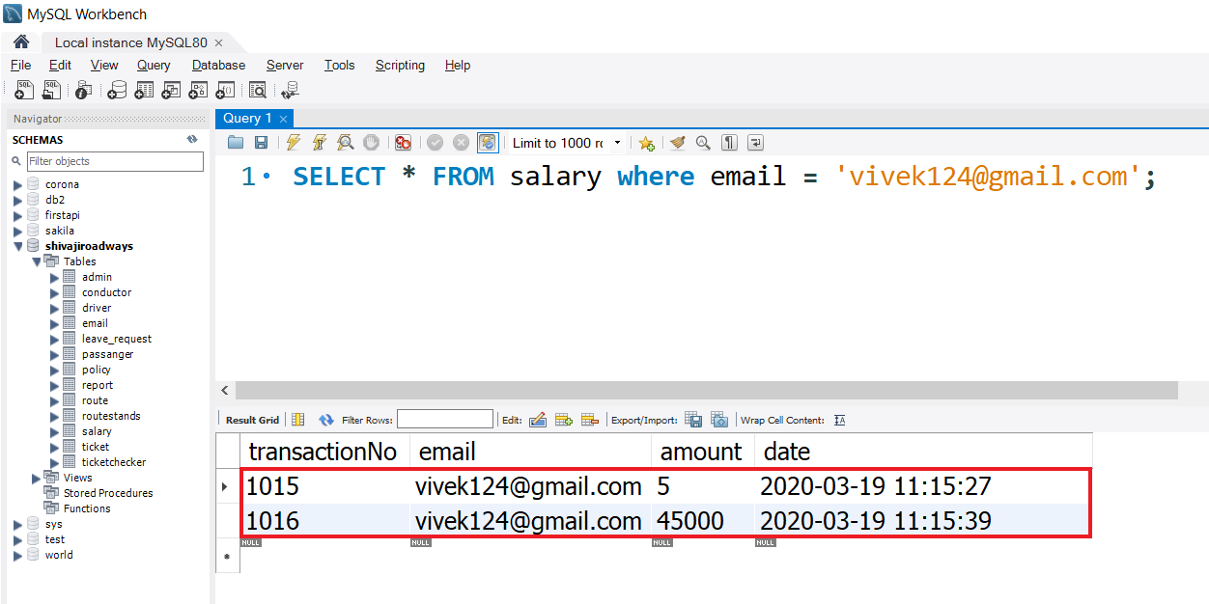

#### Source Code

<!**DOCTYPE** html>

<**html** lang**=**"en">

<head>

    <**meta** charset**=**"UTF-8">

    <**meta** name**=**"viewport" content**=**"width=device-width, initial-scale=1.0">

    <**meta** http-equiv**=**"X-UA-Compatible" content**=**"ie=edge">

    <**link** rel**=**"stylesheet" href**=**"styles/style.css">

    <**link** rel**=**"stylesheet" href**=**"styles/common.css">

    <**link** rel**=**"stylesheet" href**=**"styles/policies.css">

    <**link** rel**=**"icon" href**=**"images/icon.png">

    <**title**>Salary</**title**>

</head>

<body>

    <%

    if(session.getAttribute("email") == null)

    {

        response.sendRedirect("authentication.jsp");

    }

    else if(session.getAttribute("role").equals("admin"))

    {

        response.sendRedirect("authentication.jsp");

    }

    else if(session.getAttribute("role").equals("passanger"))

    {

        response.sendRedirect("authentication.jsp");

    }

    %>

<%@page import="java.sql.*"%>

    <**jsp:include** page**=**"navigationPannel.jsp"></**jsp:include**>

    <**div** class**=**"container">

        <**jsp:include** page**=**"svg.jsp"></**jsp:include**>

        <**div** class**=**"innerContainer">

            <**h1**>-- Salary --</**h1**>

            <**p**>There is a deeper satisfaction if you earn from your own<**br**> work than relying on corruptible ways of amassing riches.</**p**>

        </**div**>

        <**div** class**=**"policy">

            <**h1** style**=**"text-transform: capitalize;">${name}</**h1**>

            <**table**>

                <**tr**>

                    <**th**>Transaction Id</**th**>

                    <**th**>Amount</**th**>

                    <**th**>Date</**th**>

                </**tr**>

                <%

                Connection con = null;

                Statement st = null;

                ResultSet rs = null;

                try

                {

                    Class.forName("com.mysql.jdbc.Driver");

                    con = DriverManager.getConnection("jdbc:mysql://localhost:3306/shivajiroadways", "root", "1234");

                    st = con.createStatement();

                    String query = "select transactionNo, amount, date from salary where email='"+session.getAttribute("email")+"'";

                    rs = st.executeQuery(query);

                    while(rs.next())

                    {%>

                        <**tr**>

                            <**tr**>

                                <**td**><%=rs.getInt("transactionNo")%></**td**>

                                <**td**><%=rs.getInt("amount")%></**td**>

                                <**td**><%=rs.getString("date")%></**td**>

                            </**tr**>

                        </**tr**>

                    <%}

                }

                catch(Exception e){out.print(e.getMessage());}

            %>

            </**table**>

        </**div**>

    </**div**>

    <**jsp:include** page**=**"footer.jsp"></**jsp:include**>

</body>

<**script** src**=**"scripts/navPannel.js"></**script**>

</html>

#### leave.jsp

This module is to providing facility to staff for online apply for a leave

#### Output

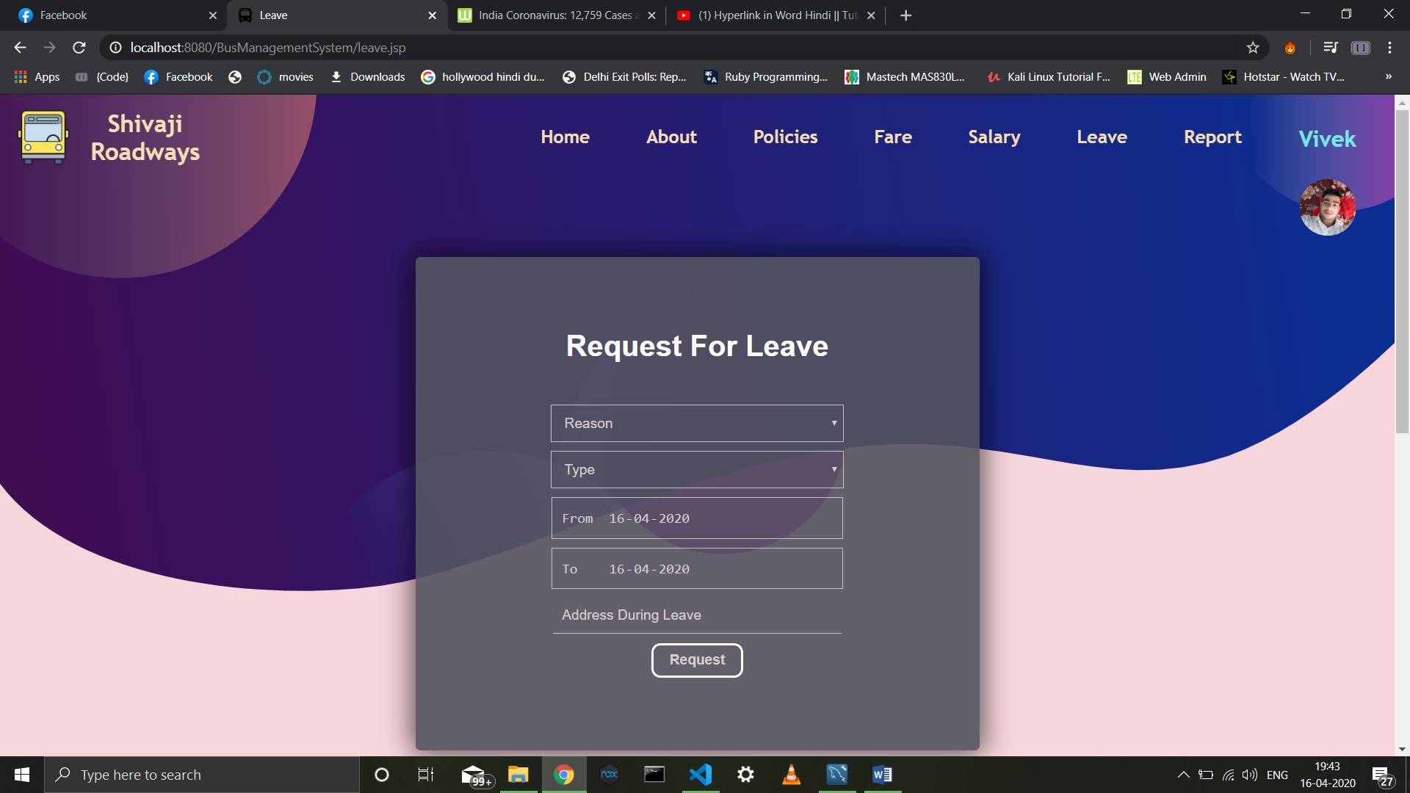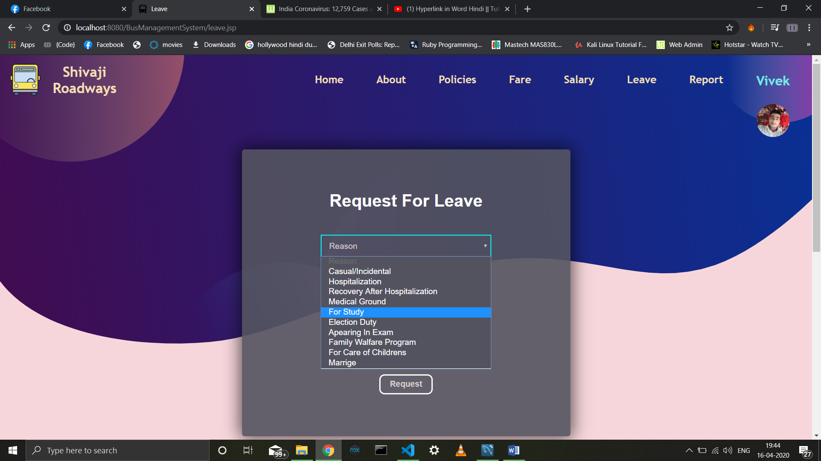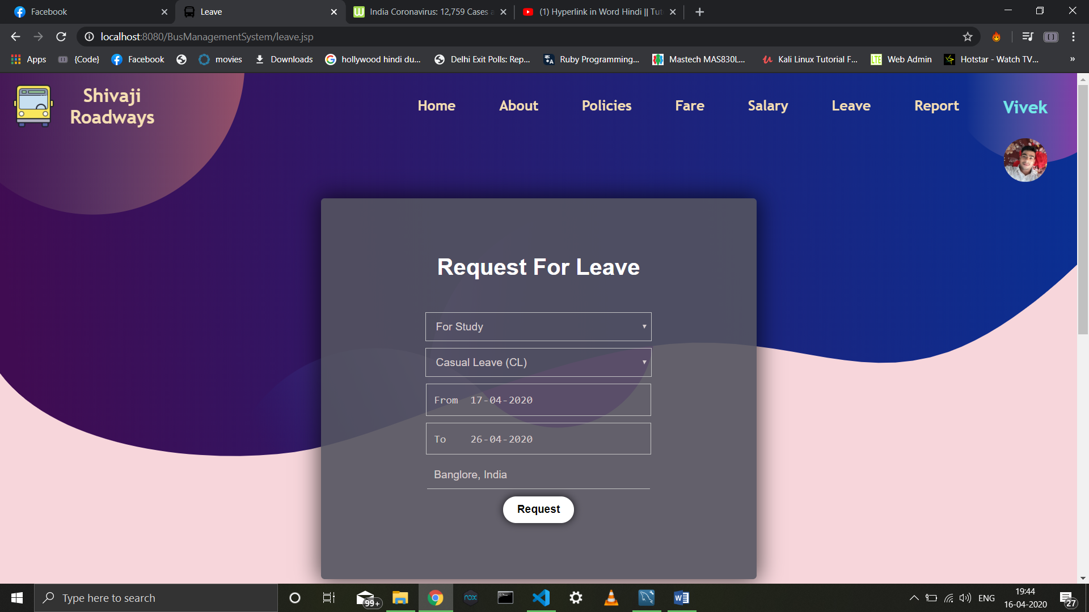

**Getting Application No:** 1019

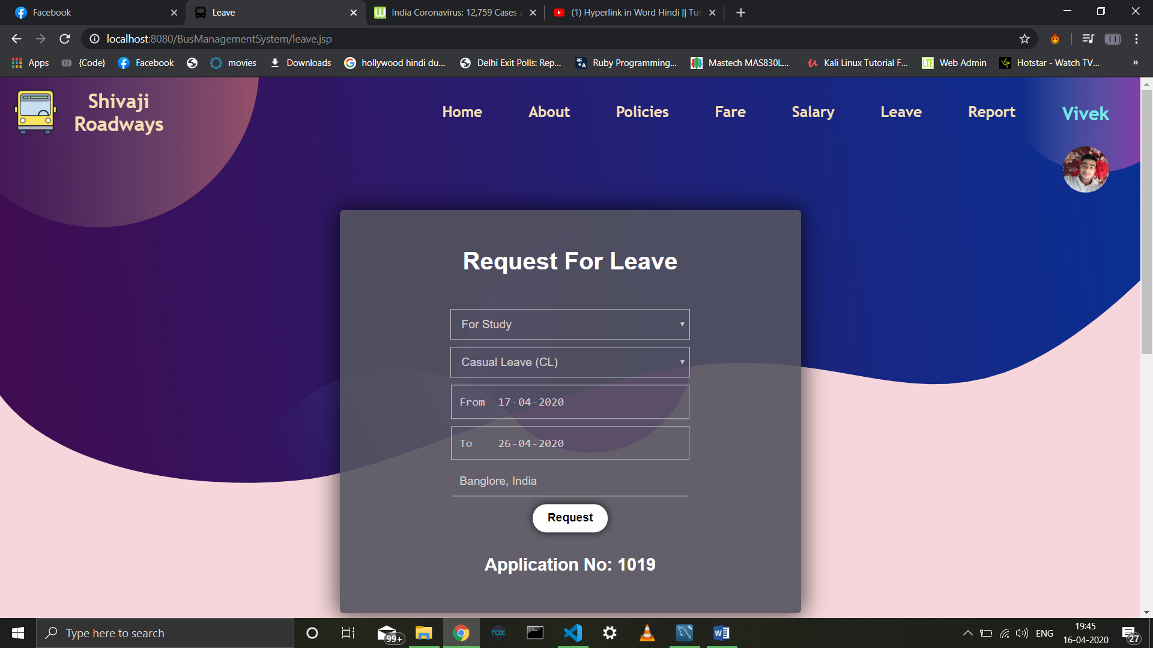

#### Entry into database

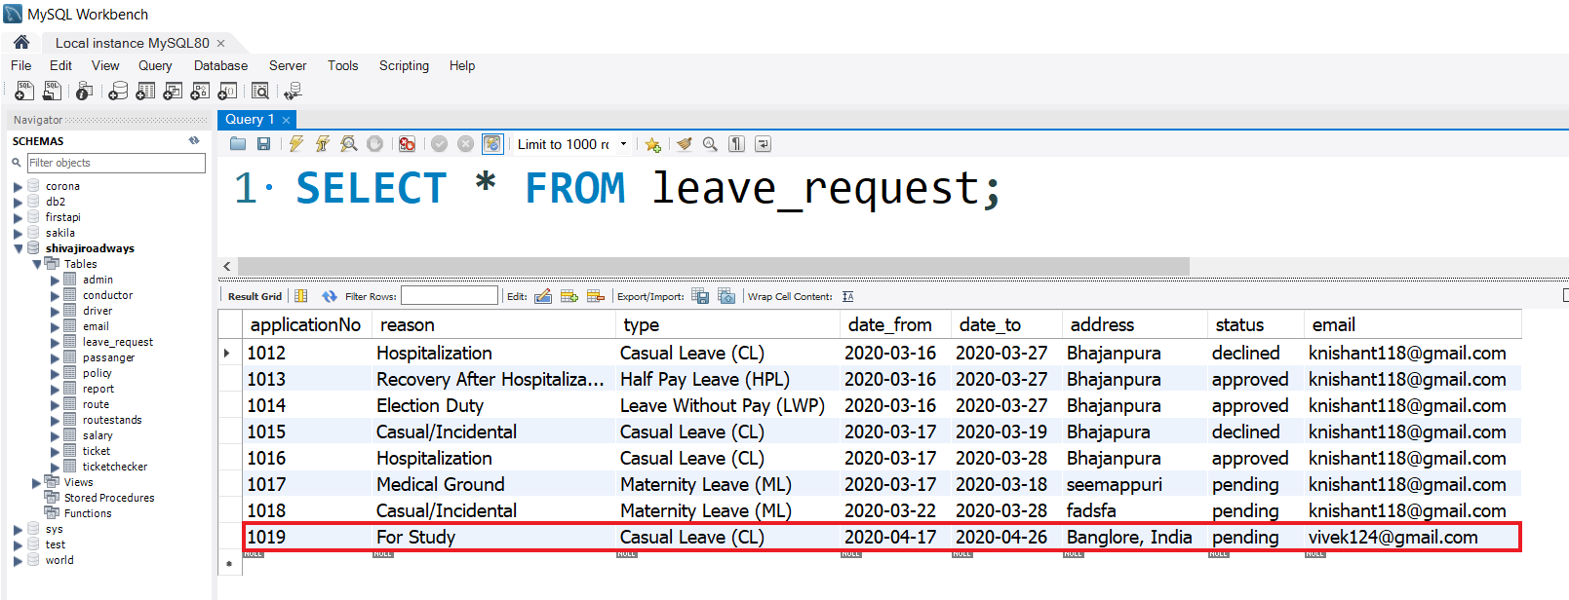

Let’s check status of our leave application with application no: **1019**

**Status**: Pending

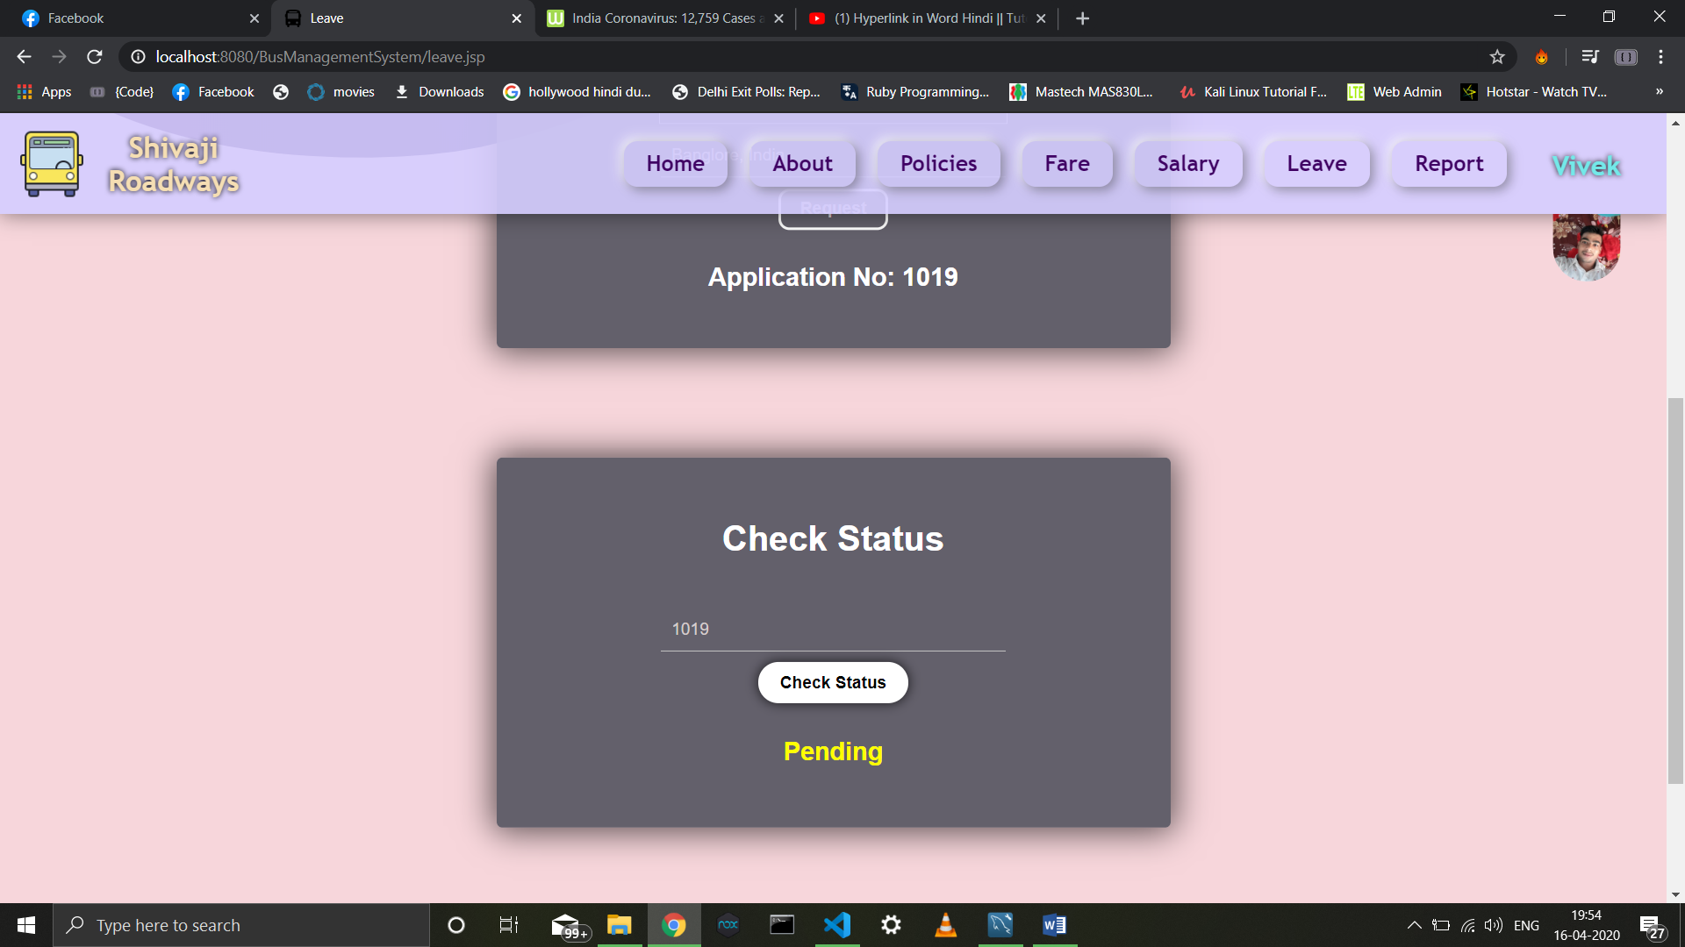

#### Source Code

<!**DOCTYPE** html>

<**html** lang**=**"en">

<head>

    <**meta** charset**=**"UTF-8">

    <**meta** name**=**"viewport" content**=**"width=device-width, initial-scale=1.0">

    <**meta** http-equiv**=**"X-UA-Compatible" content**=**"ie=edge">

    <**link** rel**=**"stylesheet" href**=**"styles/style.css">

    <**link** rel**=**"stylesheet" href**=**"styles/authentication.css">

    <**link** rel**=**"stylesheet" href**=**"styles/common.css">

    <**link** rel**=**"stylesheet" href**=**"styles/leave.css">

    <**link** rel**=**"icon" href**=**"images/icon.png">

    <**title**>Leave</**title**>

</head>

<**body** onload**=**"setDates();">

    <**style**>

        #appNoResult,  #applicationStatus

        {

            color**:** white;

            font-weight**:** bold;

            text-align**:** center;

            margin-top**:** 2vw;

            font-size**:** 1.5vw;

            text-transform**:** capitalize;

        }

    </**style**>

    <**jsp:include** page**=**"navigationPannel.jsp"></**jsp:include**>

    <**jsp:include** page**=**"svg.jsp"></**jsp:include**>

    <**div** class**=**"container">

        <**div** class**=**"workspace">

            <**form** onsubmit**=**"**return** getApplicationNo()">

                <**h1**>Request For Leave</**h1**>

                <**select** id**=**"reason" required>

                    <**option** value**=**"" disabled selected style**=**"color: rgb(214, 205, 205);">Reason</**option**>

                    <**option**>Casual/Incidental</**option**>

                    <**option**>Hospitalization</**option**>

                    <**option**>Recovery After Hospitalization</**option**>

                    <**option**>Medical Ground</**option**>

                    <**option**>For Study</**option**>

                    <**option**>Election Duty</**option**>

                    <**option**>Apearing In Exam</**option**>

                    <**option**>Family Walfare Program</**option**>

                    <**option**>For Care of Childrens</**option**>

                    <**option**>Marrige</**option**>

                </**select**>

                <**select** id**=**"type" required>

                    <**option** value**=**"" disabled selected style**=**"color: rgb(214, 205, 205);">Type</**option**>

                    <**option**>Casual Leave (CL)</**option**>

                    <**option**>Half Pay Leave (HPL)</**option**>

                    <**option**>Maternity Leave (ML)</**option**>

                    <**option**>Maternity Leave (ML)</**option**>

                    <**option**>Child Care Leave (CCL)</**option**>

                    <**option**>Leave Without Pay (LWP)</**option**>

                    <**option**>Compansative Casual Leave (CCL)</**option**>

                    <**option**>Priviledge Leave (PL)</**option**>

                </**select**>

                <**input** required type**=**"date" id**=**"from" onchange**=**"updateMin(this.value);" name**=**"from" style**=**"display: block;">

                <**input** required type**=**"date" id**=**"to" value**=**"2018-07-22" name**=**"to" style**=**"display: block;">

                <**input** required type**=**"text" name**=**"tempAddress" id**=**"tempAddress" placeholder**=**"Address During Leave">

                <**input** type**=**"submit" value**=**"Request">

                <**p** id**=**"appNoResult"></**p**>

            </**form**>

        </**div**>

    </**div**>

    <**div** class**=**"container" style**=**"margin: 0;

                            height: 22vw;">

        <**div** class**=**"workspace">

            <**form** onsubmit**=**"**return**  getStatus();">

                <**h1**>Check Status</**h1**>

                <**input** type**=**"text" name**=**"applicationNo" id**=**"applicationNo" placeholder**=**"Application No.">

                <**input** type**=**"submit" value**=**"Check Status">

                <**p** id**=**"applicationStatus"></**p**>

            </**form**>

        </**div**>

    </**div**>

    <**jsp:include** page**=**"footer.jsp"></**jsp:include**>

</body>

<%

    if(session.getAttribute("email") == null)

    {

        response.sendRedirect("authentication.jsp");

    }

    else if(session.getAttribute("role").equals("admin"))

    {

        response.sendRedirect("authentication.jsp");

    }

    else if(session.getAttribute("role").equals("passanger"))

    {

        response.sendRedirect("authentication.jsp");

    }

%>

<**script** src**=**"scripts/navPannel.js"></**script**>

<**script** src**=**"scripts/leave.js"></**script**>

<script>

**function** getApplicationNo()

    {

**var** reason **=** document.getElementById("reason").value;

**var** type **=** document.getElementById("type").value;

**var** from **=** document.getElementById("from").value;

**var** to **=** document.getElementById("to").value;

**var** tempAddress **=** document.getElementById("tempAddress").value;

**var** param **=** "?reason=" + reason + "&type=" + type + "&from=" + from + "&to=" + to + "&tempAddress=" + tempAddress;

        param **=** param.replace("+", "%2b")

        param **=** param.replace("(", "%28")

        param **=** param.replace(")", "%29")

**var** xmlhttp **=** **new** XMLHttpRequest();

        xmlhttp.open("POST", "leaveRequestAJAX.jsp" + param, false);

        xmlhttp.onreadystatechange **=** **function**(){

            document.getElementById("appNoResult").innerText **=** xmlhttp.responseText.trim();

        }

        xmlhttp.send();

**return** false;

    }

**function** getStatus()

    {

**var** applicationNO **=** document.getElementById("applicationNo").value;

**var** param **=** "?applicationNO=" + applicationNO;

        param **=** param.replace("+", "%2b")

        param **=** param.replace("(", "%28")

        param **=** param.replace(")", "%29")

**var** xmlhttp **=** **new** XMLHttpRequest();

        xmlhttp.open("POST", "leaveStatusAJAX.jsp" + param, false);

        xmlhttp.onreadystatechange **=** **function**(){

**var** result **=** document.getElementById("applicationStatus")

**var** status **=** xmlhttp.responseText.trim();

**if**(status **==** "pending")

                result.style.color **=** "yellow";

**else** **if**(status **==** "declined")

                result.style.color **=** "rgb(78, 12, 12)";

**else** **if**(status **==** "approved")

                result.style.color **=** "rgb(90, 218, 90)";

**else**

                result.style.color **=** "white";

            result.innerText **=** status;

        }

        xmlhttp.send();

**return** false;

    }

</script>

</html>

#### report.jsp

E-report module is for reporting online is the cases of bus needs to be repaired or and violence in the bus or something else.

#### Output

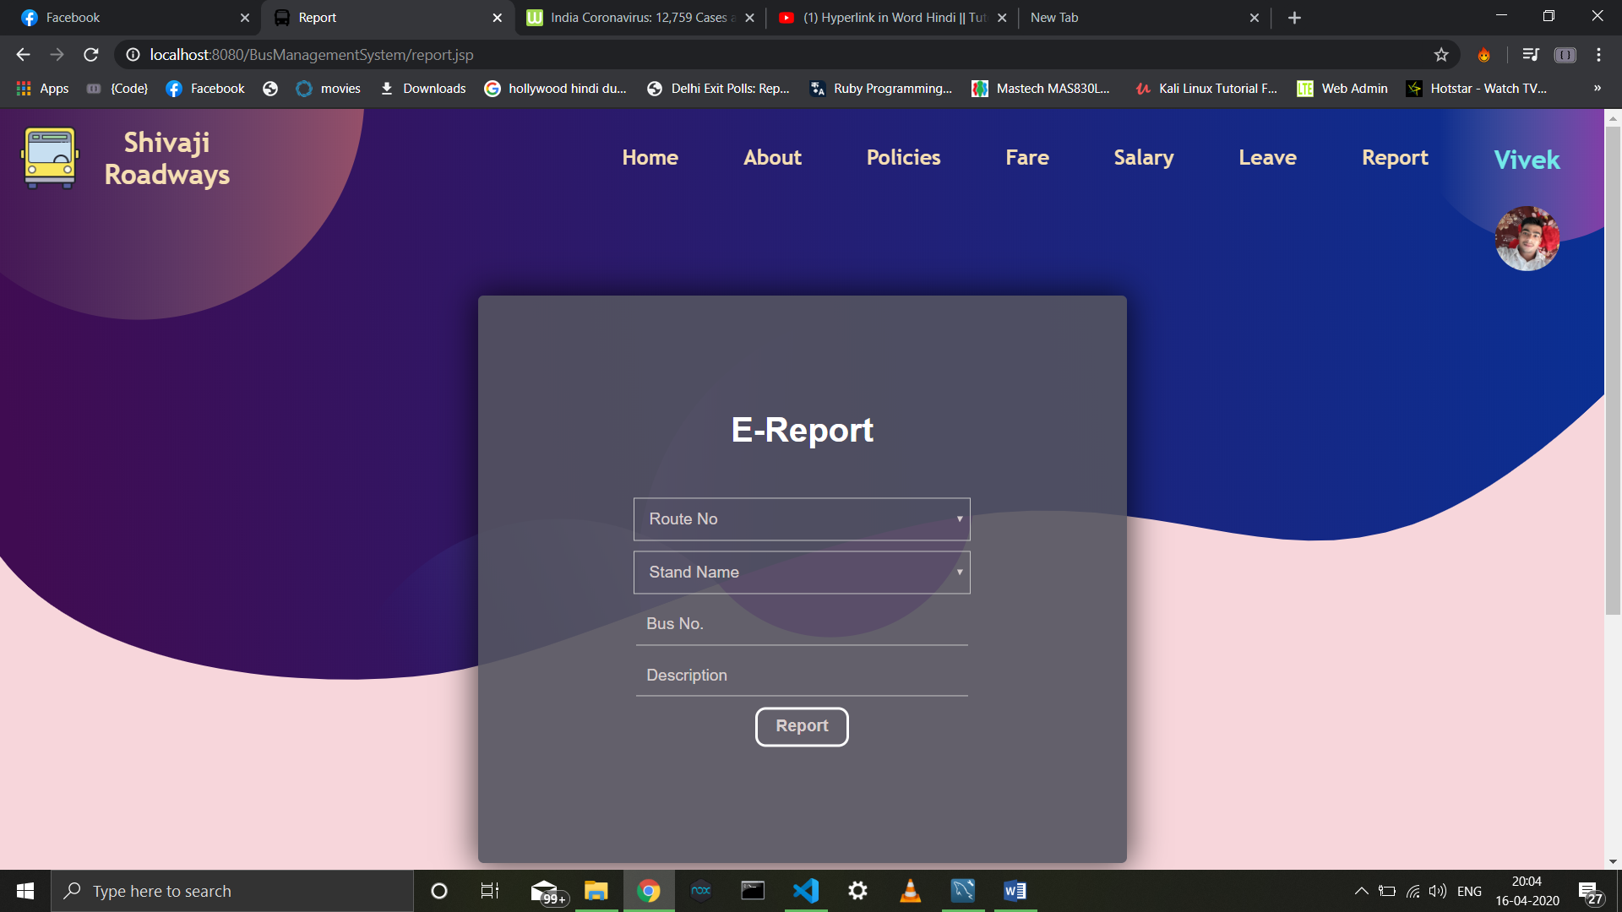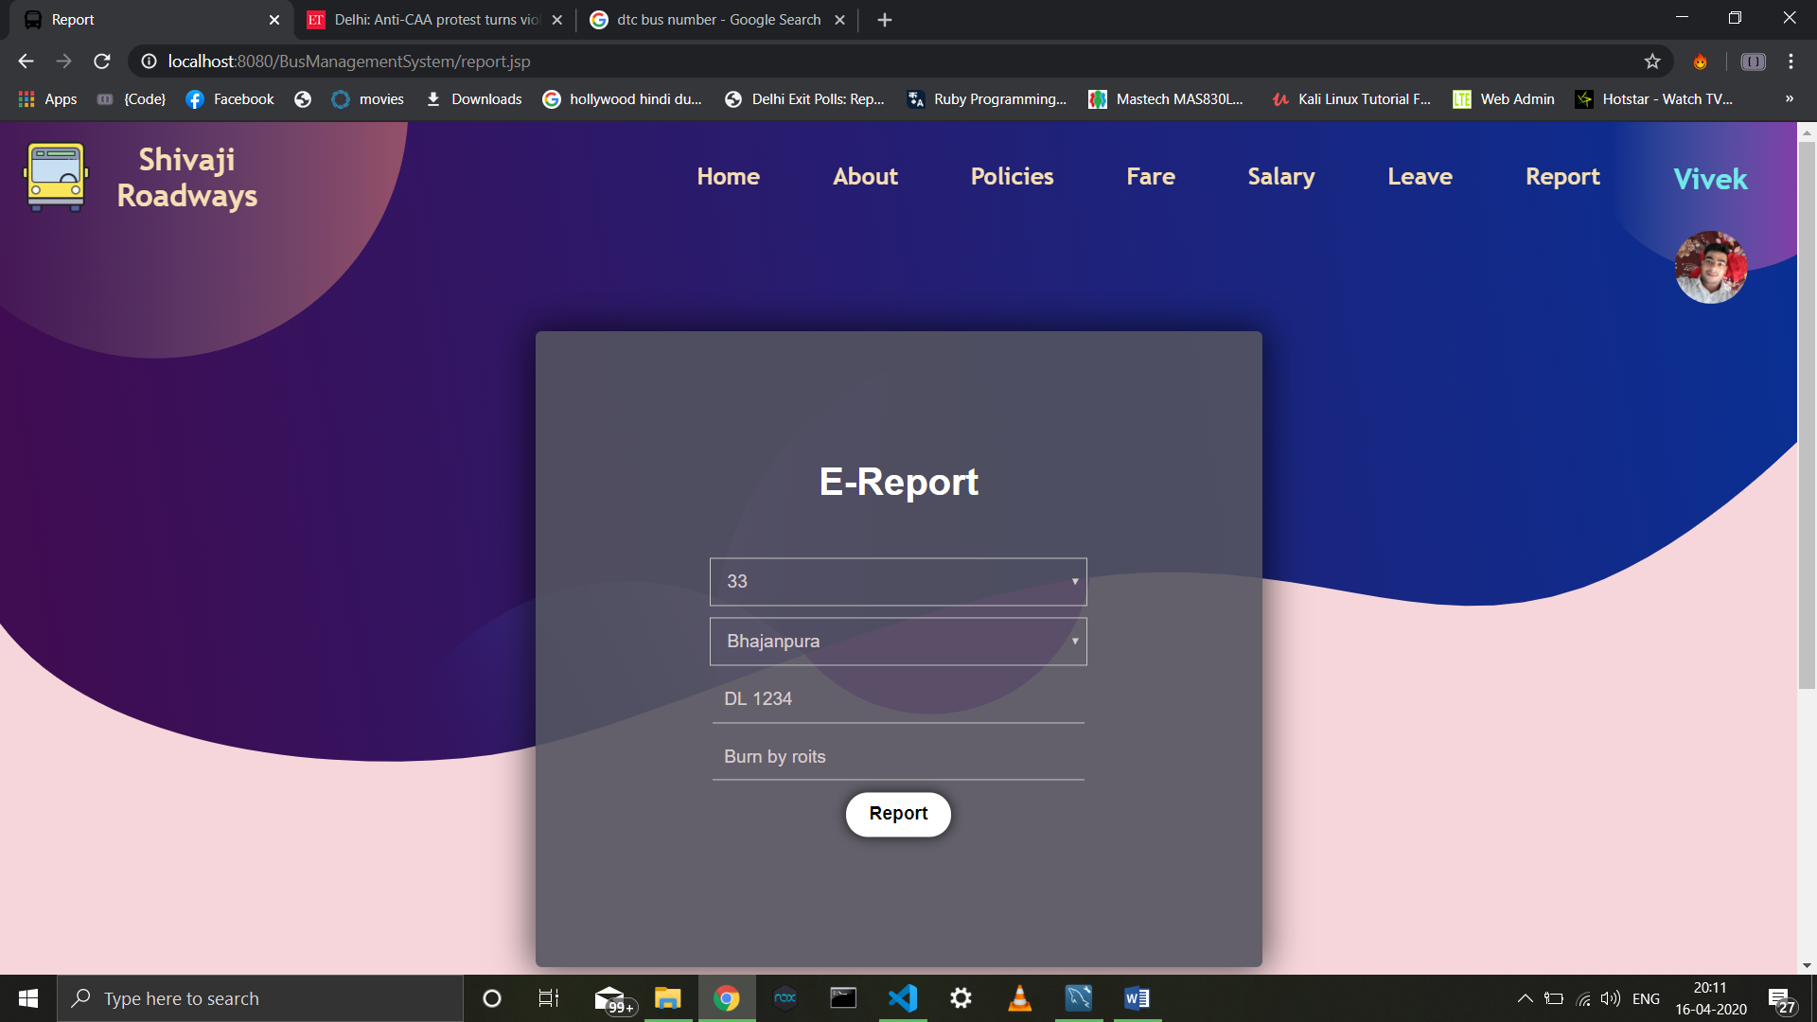

#### Entry into databse

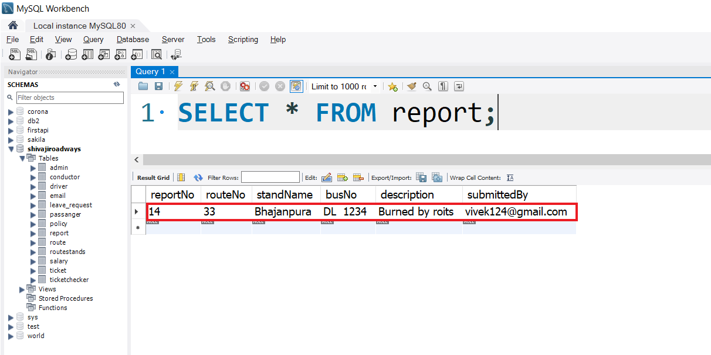

#### Source Code

<!**DOCTYPE** html>

<**html** lang**=**"en">

<head>

    <**meta** charset**=**"UTF-8">

    <**meta** name**=**"viewport" content**=**"width=device-width, initial-scale=1.0">

    <**meta** http-equiv**=**"X-UA-Compatible" content**=**"ie=edge">

    <**link** rel**=**"stylesheet" href**=**"styles/style.css">

    <**link** rel**=**"stylesheet" href**=**"styles/authentication.css">

    <**link** rel**=**"stylesheet" href**=**"styles/common.css">

    <**link** rel**=**"stylesheet" href**=**"styles/leave.css">

    <**link** rel**=**"icon" href**=**"images/icon.png">

    <**title**>Report</**title**>

</head>

<body>

    <%

    if(session.getAttribute("email") == null)

    {

        response.sendRedirect("authentication.jsp");

    }

    else if(session.getAttribute("role").equals("admin"))

    {

        response.sendRedirect("authentication.jsp");

    }

    else if(session.getAttribute("role").equals("passanger"))

    {

        response.sendRedirect("authentication.jsp");

    }

    %>

<%@page import="java.sql.*"%>

<%

    Connection con = null;

    Statement st = null;

    ResultSet rs = null;

    try

    {

        Class.forName("com.mysql.jdbc.Driver");

        con = DriverManager.getConnection("jdbc:mysql://localhost:3306/shivajiroadways", "root", "1234");

        st = con.createStatement();

        String query = "select routeNo from route order by serialNo";

        rs = st.executeQuery(query);

    }

    catch(Exception e)

    {

        out.print(e.getMessage());

    }

%>

    <**jsp:include** page**=**"navigationPannel.jsp"></**jsp:include**>

    <**jsp:include** page**=**"svg.jsp"></**jsp:include**>

    <**div** class**=**"container">

        <**div** class**=**"workspace">

            <**form** onsubmit**=**"**return** submitReport();">

                <**h1**>E-Report</**h1**>

                <**select** name**=**"routeNo" onchange**=**"updateStands(this.value);">

                    <**option** value**=**"" disabled selected >Route No</**option**>

                    <%

                        while(rs.next())

                        {%>

                            <**option**><%=rs.getString("routeNo")%></**option**>

                        <%}

                    %>

                </**select**>

                <**select** name**=**"standName">

                    <**option** value**=**"" disabled selected >Stand Name</**option**>

                    <**option**>Ashoke Nagar</**option**>

                    <**option**>Nand Nagri</**option**>

                    <**option**>Seema Puri</**option**>

                    <**option**>GTB Nagar</**option**>

                </**select**>

                <**input** type**=**"text" name**=**"busNo" placeholder**=**"Bus No.">

                <**input** type**=**"text" name**=**"description" placeholder**=**"Description">

                <**input** type**=**"submit" id**=**"submitButton" value**=**"Report">

            </**form**>

        </**div**>

    </**div**>

    <**jsp:include** page**=**"footer.jsp"></**jsp:include**>

</body>

<**script** src**=**"scripts/navPannel.js"></**script**>

<script>

**function** submitReport()

    {

**var** routeNo **=** document.getElementsByName("routeNo")[0].value;

**var** standName **=** document.getElementsByName("standName")[0].value;

**var** busNo **=** document.getElementsByName("busNo")[0].value;

**var** description **=** document.getElementsByName("description")[0].value;

**var** param **=** "?routeNo=" + routeNo + "&standName=" + standName + "&busNo=" + busNo + "&description=" + description;

        param **=** param.replace("+", "%2b")

        param **=** param.replace("(", "%28")

        param **=** param.replace(")", "%29")

**var** xmlhttp **=** **new** XMLHttpRequest();

        xmlhttp.open("POST", "submitReport.jsp" + param, false);

        xmlhttp.onreadystatechange **=** **function**(){

**var** submitButton **=** document.getElementById("submitButton")

            submitButton.value **=** xmlhttp.responseText.trim();

        }

        xmlhttp.send();

**return** false;

    }

**function** updateStands(routeNo)

    {

**var** standName **=** document.getElementsByName('standName')[0];

**var** param **=** "?routeNo=" +  routeNo;

        param **=** param.replace("+", "%2b")

**var** xmlhttp **=** **new** XMLHttpRequest();

        xmlhttp.open("POST", "ticketAJAX.jsp" + param, false);

        xmlhttp.onreadystatechange **=** **function**(){

            standName.innerHTML **=** xmlhttp.responseText;

        }

        xmlhttp.send();

    }

</script>

</html>

#### Signing In with TC’s account

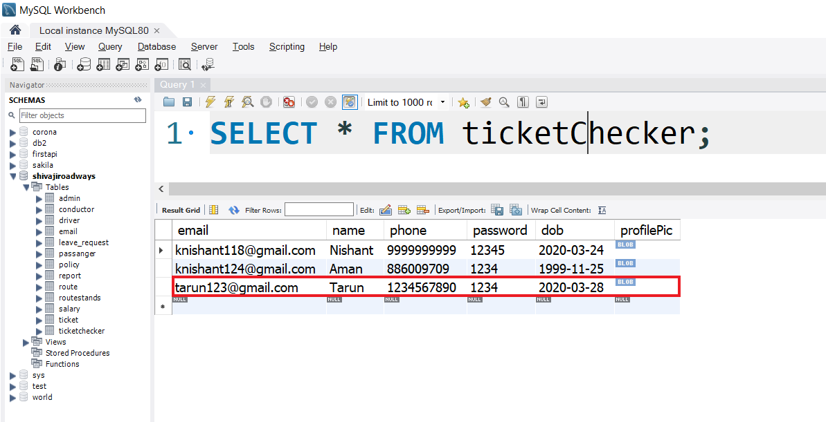

**Role**: Ticket Checker

Credentials:

* **Email**: [tarun123@gmail.com](mailto:tarun123@gmail.com)
* **Password**: 1234

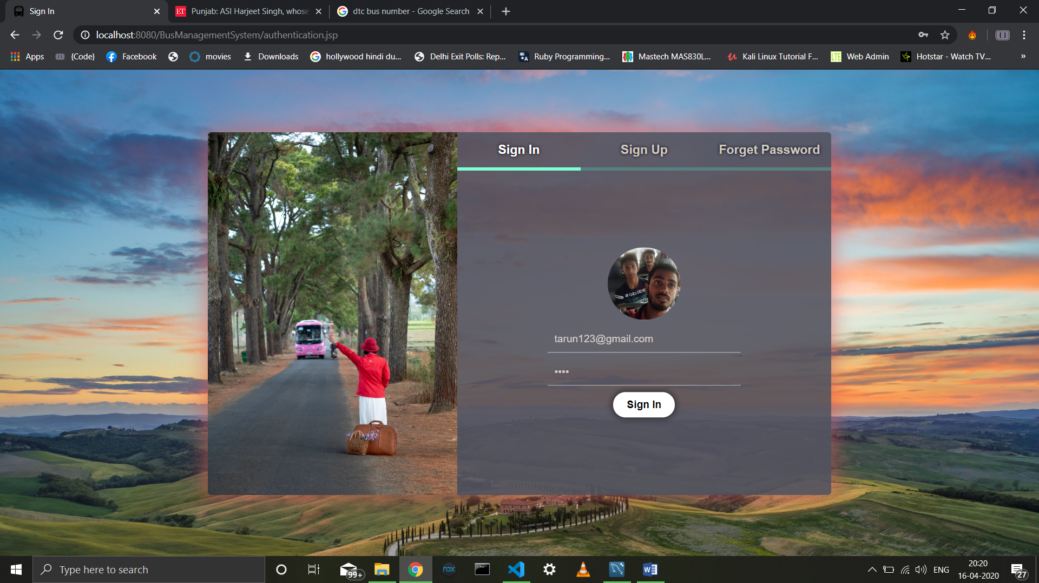

#### Signed In

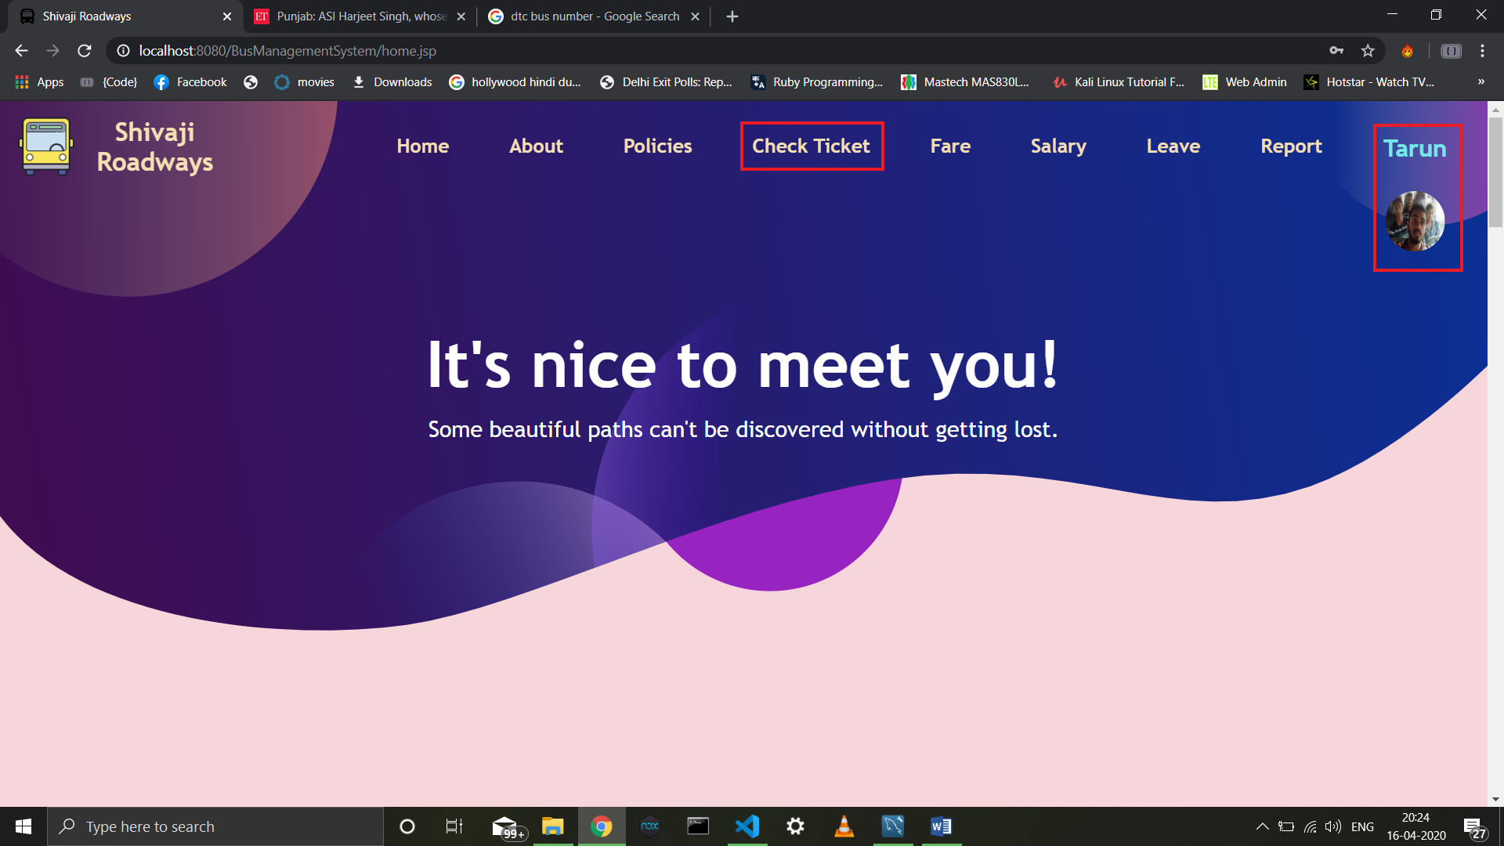

We have a new link **Check Ticket** in our navigation panel

This module is Ticket Checker specific so that no one other than TC have access to this page.

#### checkTicket.jsp

This module is for validating tickets digitally this process is faster and much accurate than manual ticket checking.

#### Output

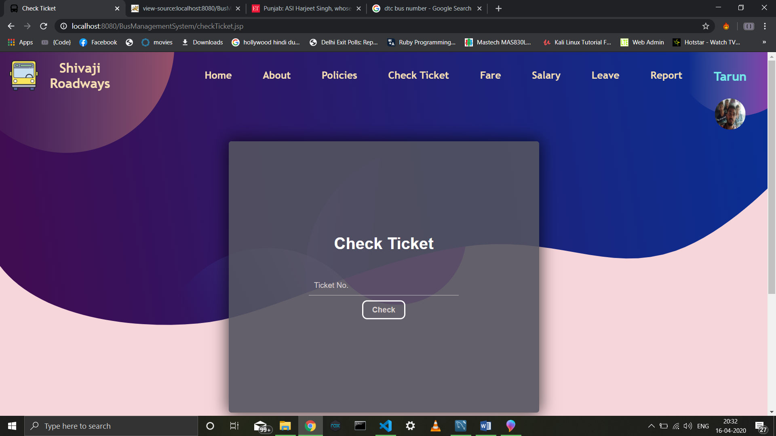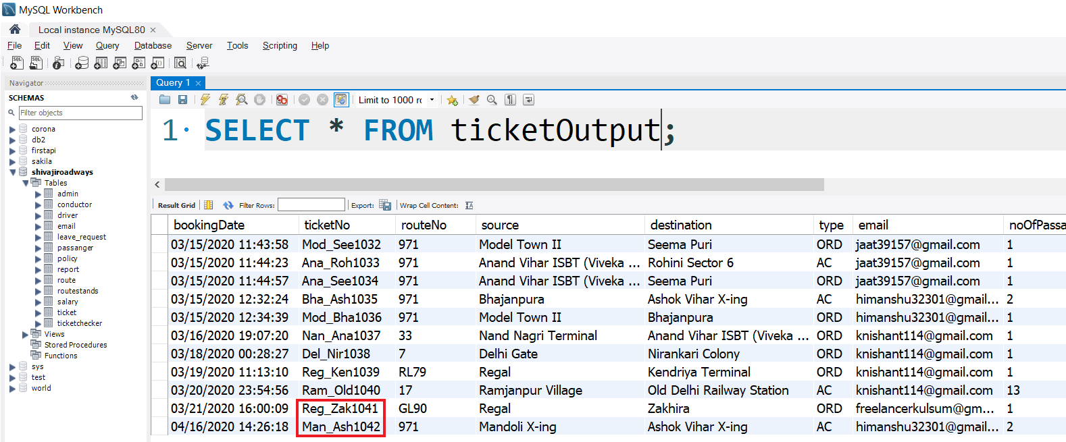

We are going to take these 2 as tests:

Test 1: ticketNo → **Reg_Zar1041**

Test 2: ticketNo → **Man_Ash1042**

Output of test 1: **Reg_Zar1041**

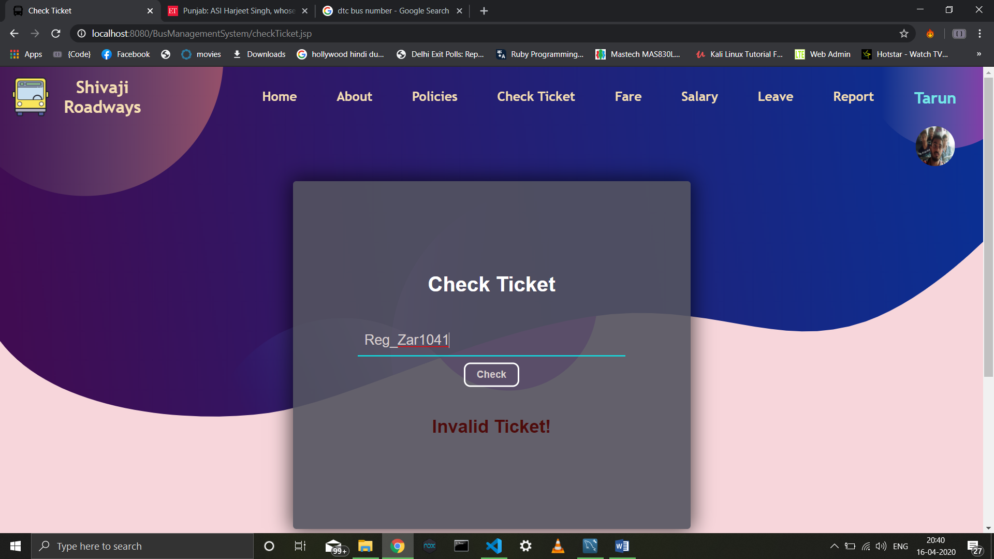

**Invalid Ticket!**

Because this ticket have already expired

Output of test 2: **Man_Ash1042**

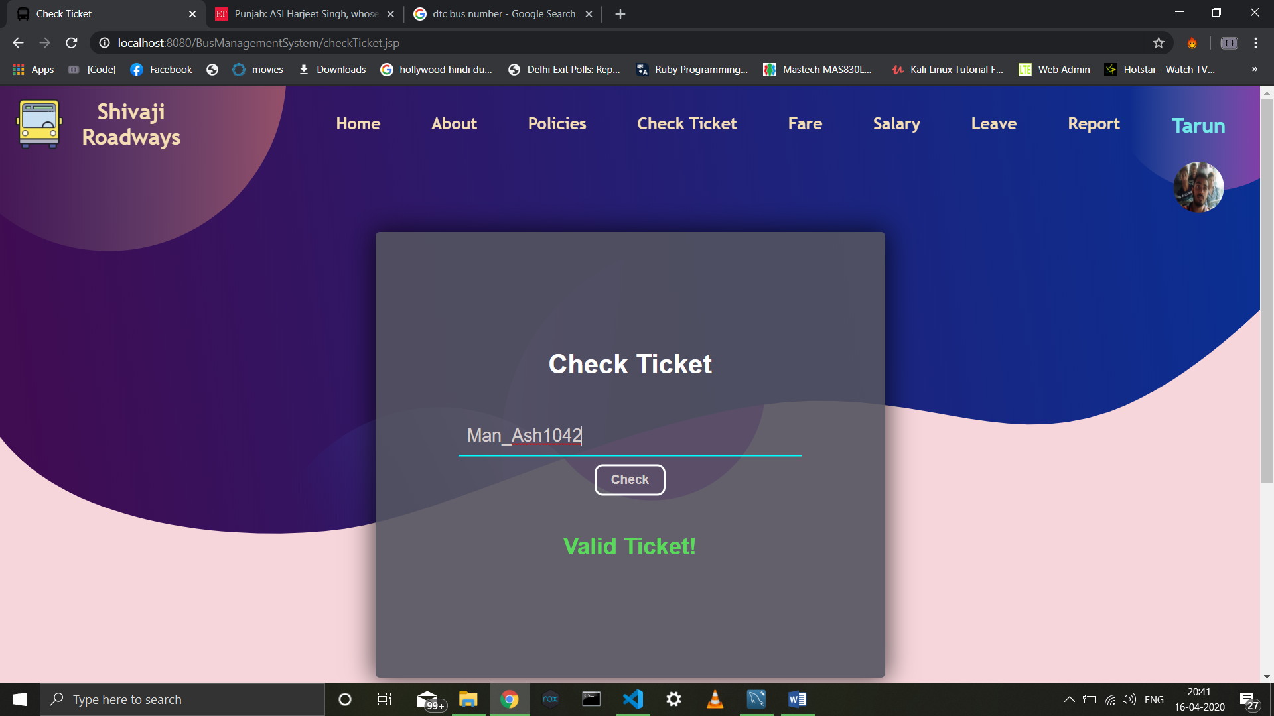

**Valid Ticket!**

#### Source Code

<!**DOCTYPE** html>

<**html** lang**=**"en">

<**head**>

    <**meta** charset**=**"UTF-8">

    <**meta** name**=**"viewport" content**=**"width=device-width, initial-scale=1.0">

    <**meta** http-equiv**=**"X-UA-Compatible" content**=**"ie=edge">

    <**link** rel**=**"stylesheet" href**=**"styles/style.css">

    <**link** rel**=**"stylesheet" href**=**"styles/authentication.css">

    <**link** rel**=**"stylesheet" href**=**"styles/common.css">

    <**link** rel**=**"stylesheet" href**=**"styles/leave.css">

    <**link** rel**=**"icon" href**=**"images/icon.png">

    <**title**>Check Ticket</**title**>

</**head**>

<**body**>

    <%

    if(session.getAttribute("email") == null || !session.getAttribute("role").equals("ticketchecker"))

    { response.sendRedirect("authentication.jsp"); }%>

    <**jsp:include** page**=**"navigationPannel.jsp"></**jsp:include**>

    <**jsp:include** page**=**"svg.jsp"></**jsp:include**>

    <**div** class**=**"container">

        <**div** class**=**"workspace">

            <**form** onsubmit**=**"**return** checkTicket();">

                <**h1**>Check Ticket</**h1**>

                <**input** type**=**"text" id**=**"ticketNo" name**=**"ticketNo" style**=**"width: 18vw;" placeholder**=**"Ticket No.">

                <**input** type**=**"submit" value**=**"Check">

                <**h1** id**=**"result"></**h1**>

            </**form**>

        </**div**>

    </**div**>

    <**jsp:include** page**=**"footer.jsp"></**jsp:include**>

</**body**>

<**script** src**=**"scripts/navPannel.js"></**script**>

<**script**>

**function** checkTicket()

{

**var** ticketNo **=** document.getElementById("ticketNo").value;

    ticketNo **=** ticketNo.slice(7, ticketNo.lenght)

    console.log(ticketNo);

**if**(parseInt(param))

    {

        document.getElementById("result").innerText **=** "invalid"

**return** false;

    }

**var** param **=** "?ticketNo=" +  ticketNo;

    param **=** encodeURI(param);

    console.log(param);

**var** xmlhttp **=** **new** XMLHttpRequest();

    xmlhttp.open("POST", "checkTicketAJAX.jsp" + param, false);

    xmlhttp.onreadystatechange **=** **function**(){

**var** result **=** document.getElementById("result");

**var** status **=** xmlhttp.responseText.trim()

**if**(status < 0 **||** status > 23)

        {

            result.style.color **=** "rgb(78, 12, 12)";

            result.innerText **=** "Invalid Ticket!";

        }

**else**

        {

            result.style.color **=** "rgb(90, 218, 90)";

            result.innerText **=** "Valid Ticket!";

        }

        setInterval(**function**(){ location.reload(); }, 2000);

    }

    xmlhttp.send();

**return** false;

}

</**script**</**html**>

#### Signing In with Admin’s account

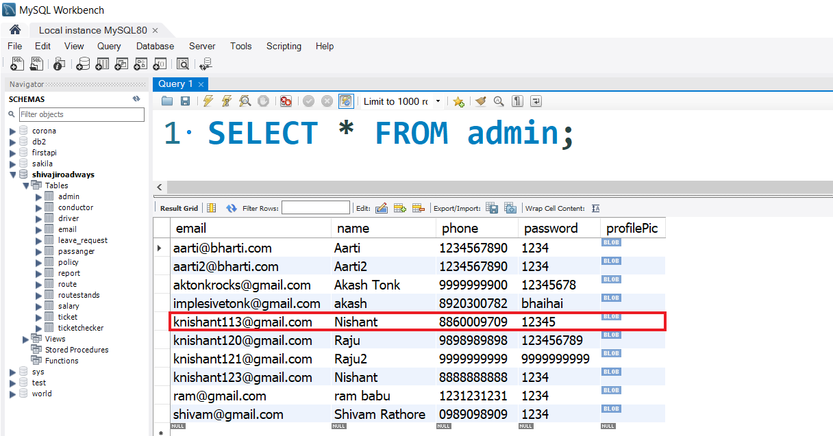

**Role**: Admin

Credentials:

* **Email**: [knishant113@gmail.com](mailto:knishant113@gmail.com)
* **Password**: 12345

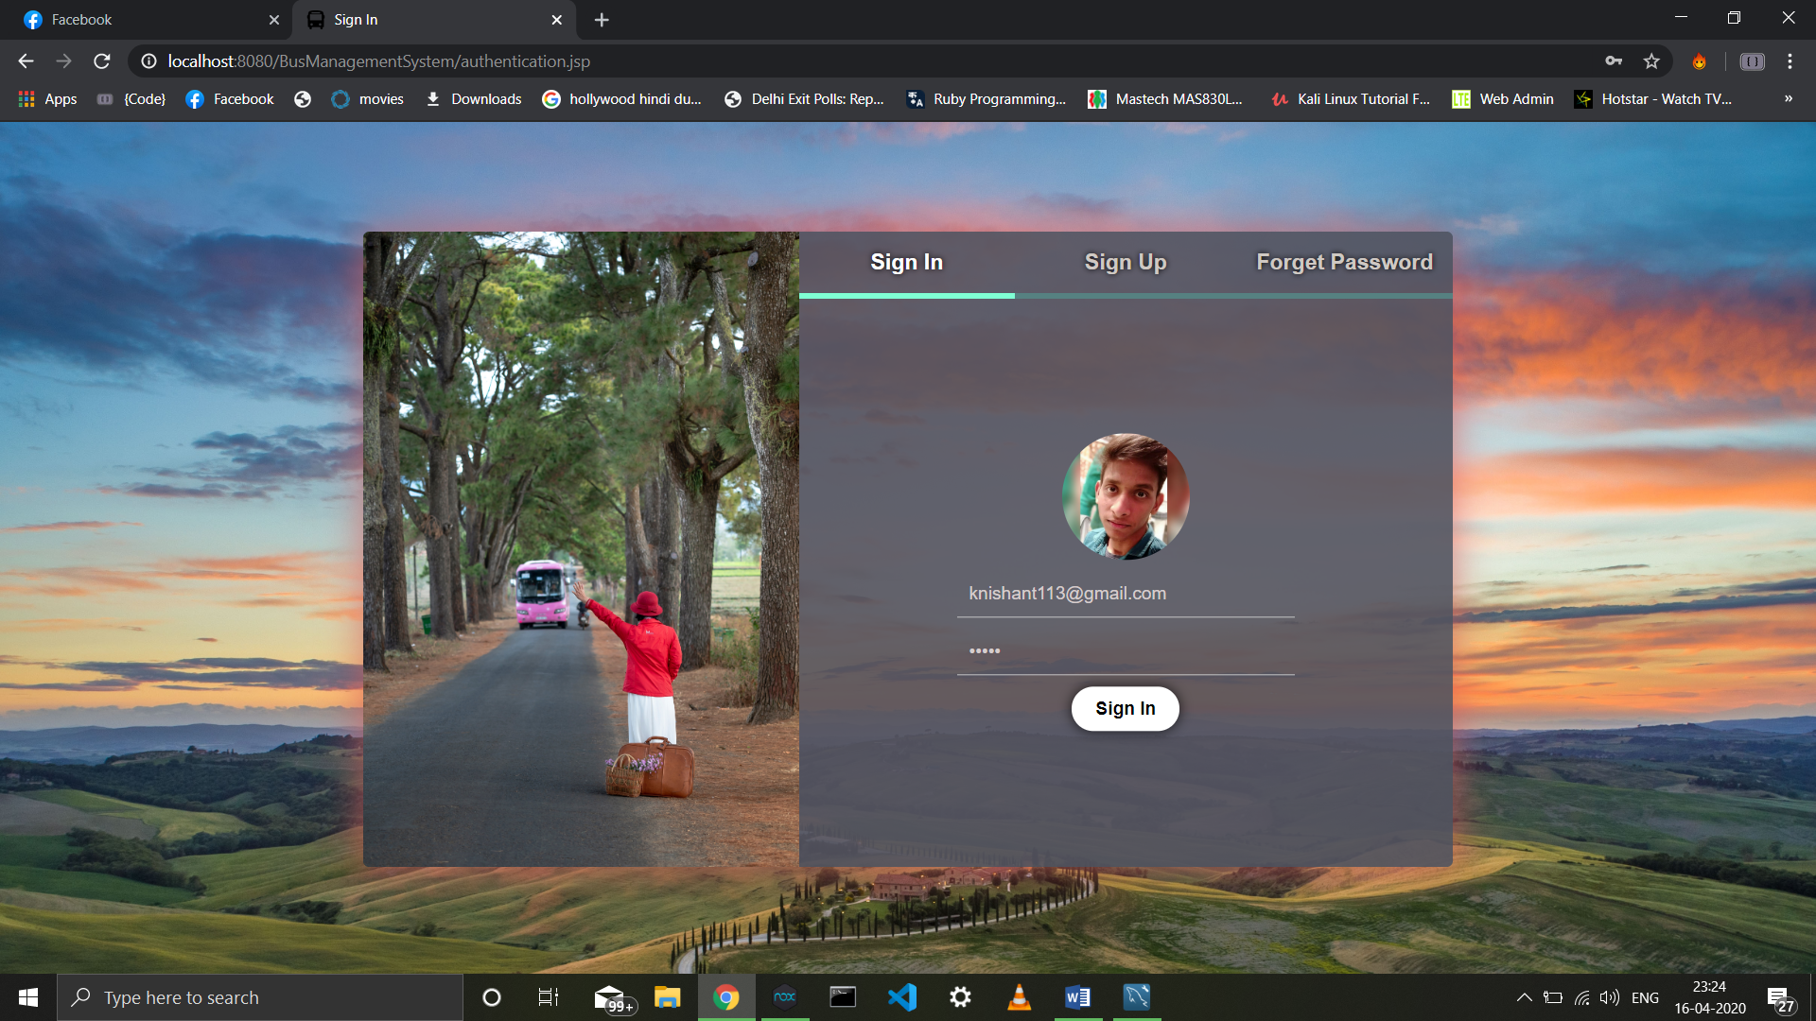

#### Signed In

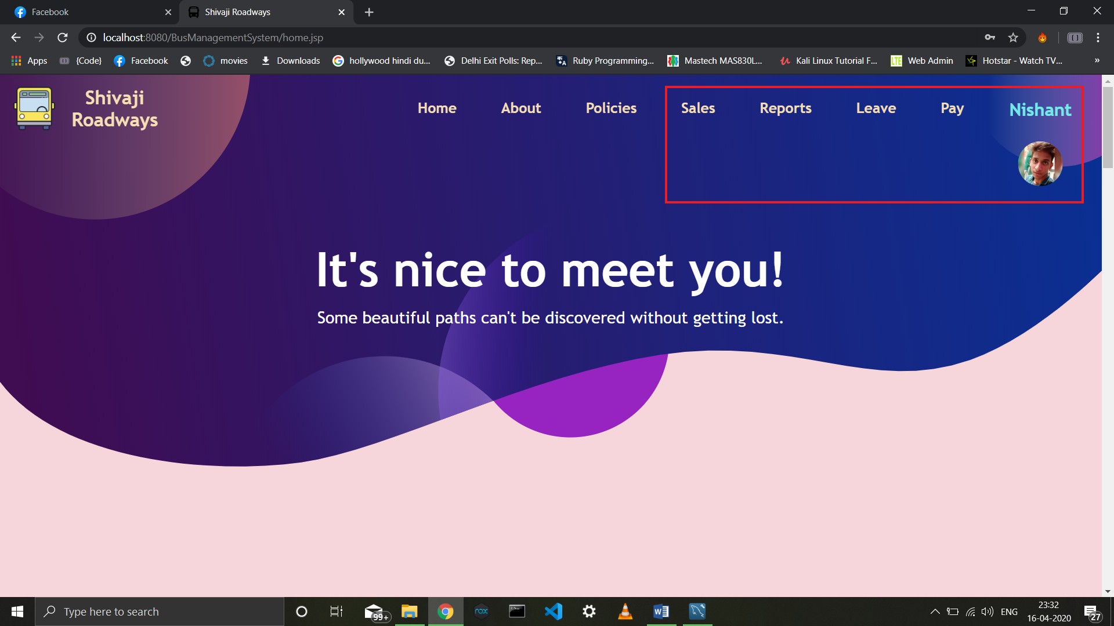

We have some new links in our navigation panel

* Sales
* Reports
* Leave
* Pay

Let’s explore them one by one

#### sales.jsp

This page is for giving soled ticket summary to Admin.

#### Output

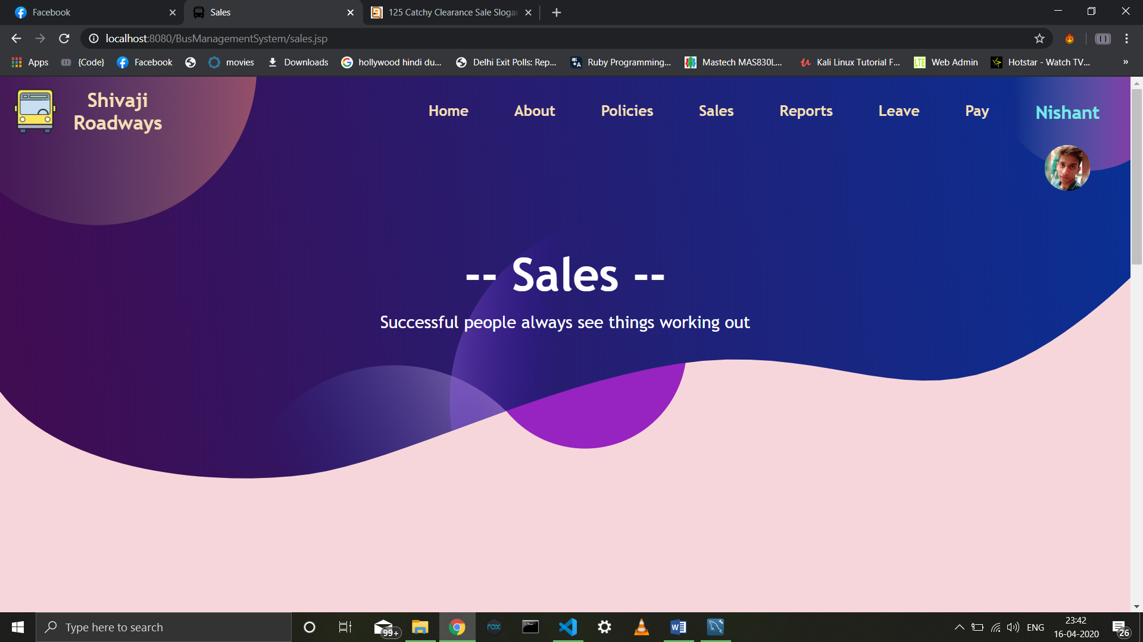

Soled ticket data in database

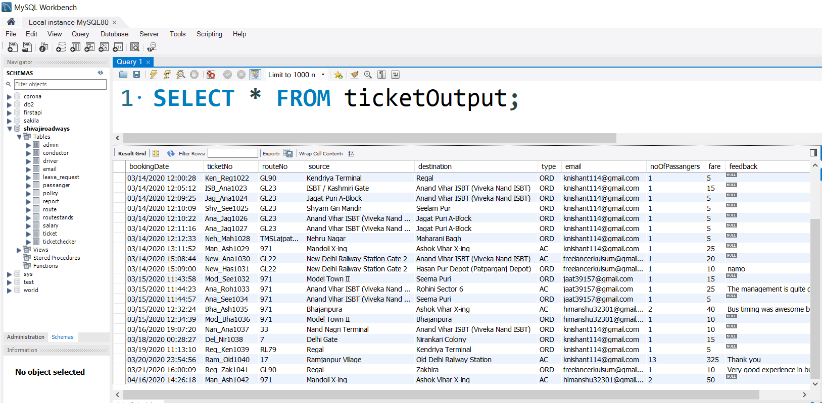

Data retrieval from the database

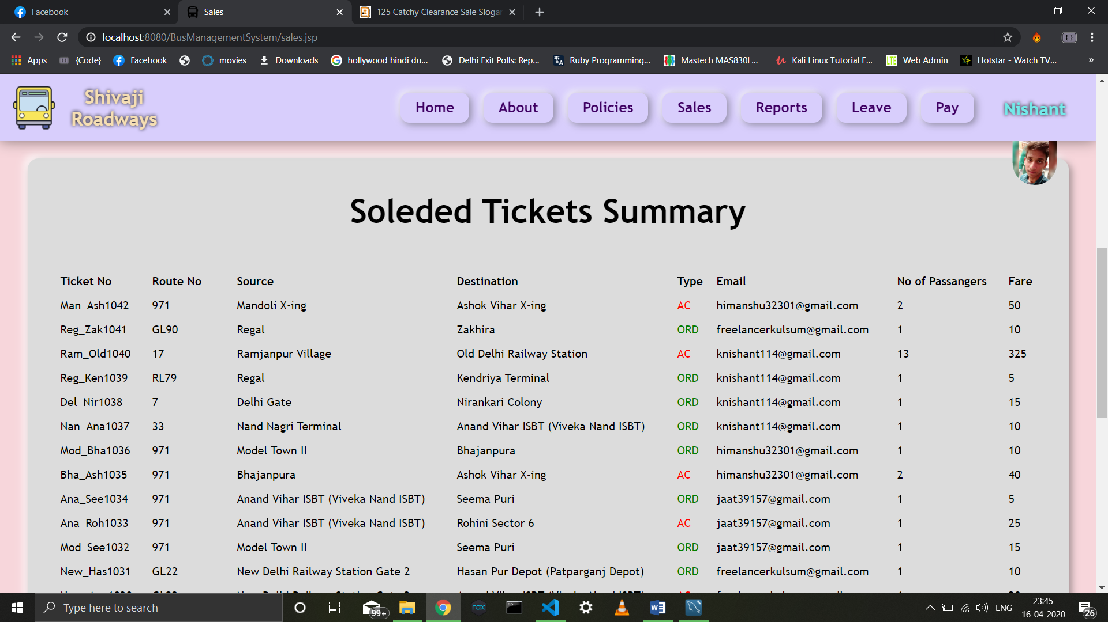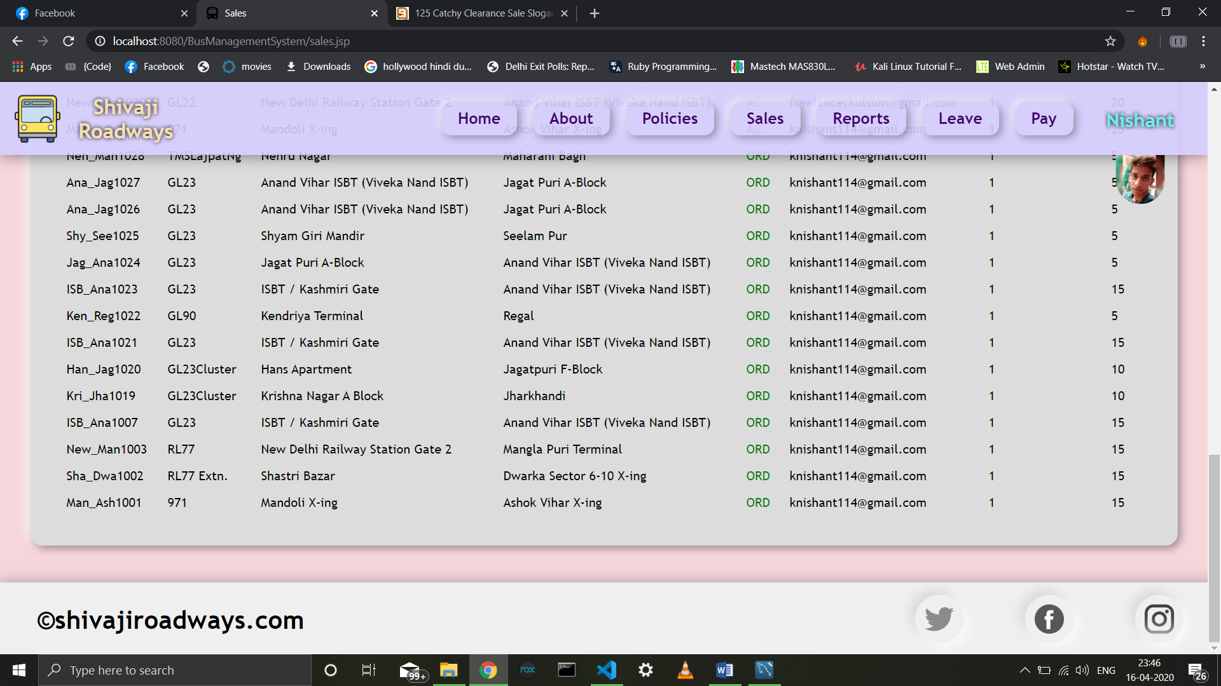

#### Source Code

<!**DOCTYPE** html>

<**html** lang**=**"en">

<head>

    <**meta** charset**=**"UTF-8">

    <**meta** name**=**"viewport" content**=**"width=device-width, initial-scale=1.0">

    <**meta** http-equiv**=**"X-UA-Compatible" content**=**"ie=edge">

    <**link** rel**=**"stylesheet" href**=**"styles/style.css">

    <**link** rel**=**"stylesheet" href**=**"styles/common.css">

    <**link** rel**=**"stylesheet" href**=**"styles/policies.css">

    <**link** rel**=**"icon" href**=**"images/icon.png">

    <**style**>

**.policy**

        {

            width**:** 95%;

        }

        .policy table

        {

            width**:** 100%;

        }

        .policy table tr

        {

            text-align**:** left;

        }

    </**style**>

    <**title**>Sales</**title**>

</head>

<body>

<%

    if(session.getAttribute("email") == null || !session.getAttribute("role").equals("admin"))

    {

        response.sendRedirect("authentication.jsp");

    }

%>

<%@page import="java.sql.*"%>

    <**jsp:include** page**=**"navigationPannel.jsp"></**jsp:include**>

    <**div** class**=**"container">

        <**jsp:include** page**=**"svg.jsp"></**jsp:include**>

        <**div** class**=**"innerContainer">

            <**h1**>-- Sales --</**h1**>

            <**p**>Successful people always see things working out</**p**>

        </**div**>

        <**div** class**=**"policy">

            <**h1**>Soleded Tickets Summary</**h1**>

            <**table**>

                <**tr**>

                    <**th**>Ticket No</**th**>

                    <**th**>Route No</**th**>

                    <**th**>Source</**th**>

                    <**th**>Destination</**th**>

                    <**th**>Type</**th**>

                    <**th**>Email</**th**>

                    <**th**>No of Passangers</**th**>

                    <**th**>Fare</**th**>

                </**tr**>

                <%

                    Connection con = null;

                    Statement st = null;

                    ResultSet rs = null;

                    try

                    {

                        Class.forName("com.mysql.jdbc.Driver");

                        con = DriverManager.getConnection("jdbc:mysql://localhost:3306/shivajiroadways", "root", "1234");

                        st = con.createStatement();

                        String query = "select * from ticketOutput order by bookingDate desc";

                        rs = st.executeQuery(query);

                        while(rs.next())

                        {%>

                            <**tr** title**=**"<%=rs.getString("bookingDate")%>">

                                <**td**><%=rs.getString("ticketNo")%></**td**>

                                <**td**><%=rs.getString("routeNo").length() < 11 ? rs.getString("routeNo") : rs.getString("routeNo").substring(0, 11)%></**td**>

                                <**td**><%=rs.getString("source")%></**td**>

                                <**td**><%=rs.getString("destination")%></**td**>

                                <**td** style**=**'color: <%=rs.getString("type").equals("AC")?"red": "green"%>;'><%=rs.getString("type")%></**td**>

                                <**td**><%=rs.getString("email")%></**td**>

                                <**td**><%=rs.getString("noOfPassangers")%></**td**>

                                <**td**><%=rs.getString("fare")%></**td**>

                            </**tr**>

                        <%}

                    }

                    catch(Exception e){out.print(e.getMessage());}

                %>

            </**table**>

        </**div**>

    </**div**>

    <**jsp:include** page**=**"footer.jsp"></**jsp:include**>

</body>

<**script** src**=**"scripts/navPannel.js"></**script**>

</html>

#### reports.jsp

A report is a document that presents information in an organized format for a specific purpose.

#### Output

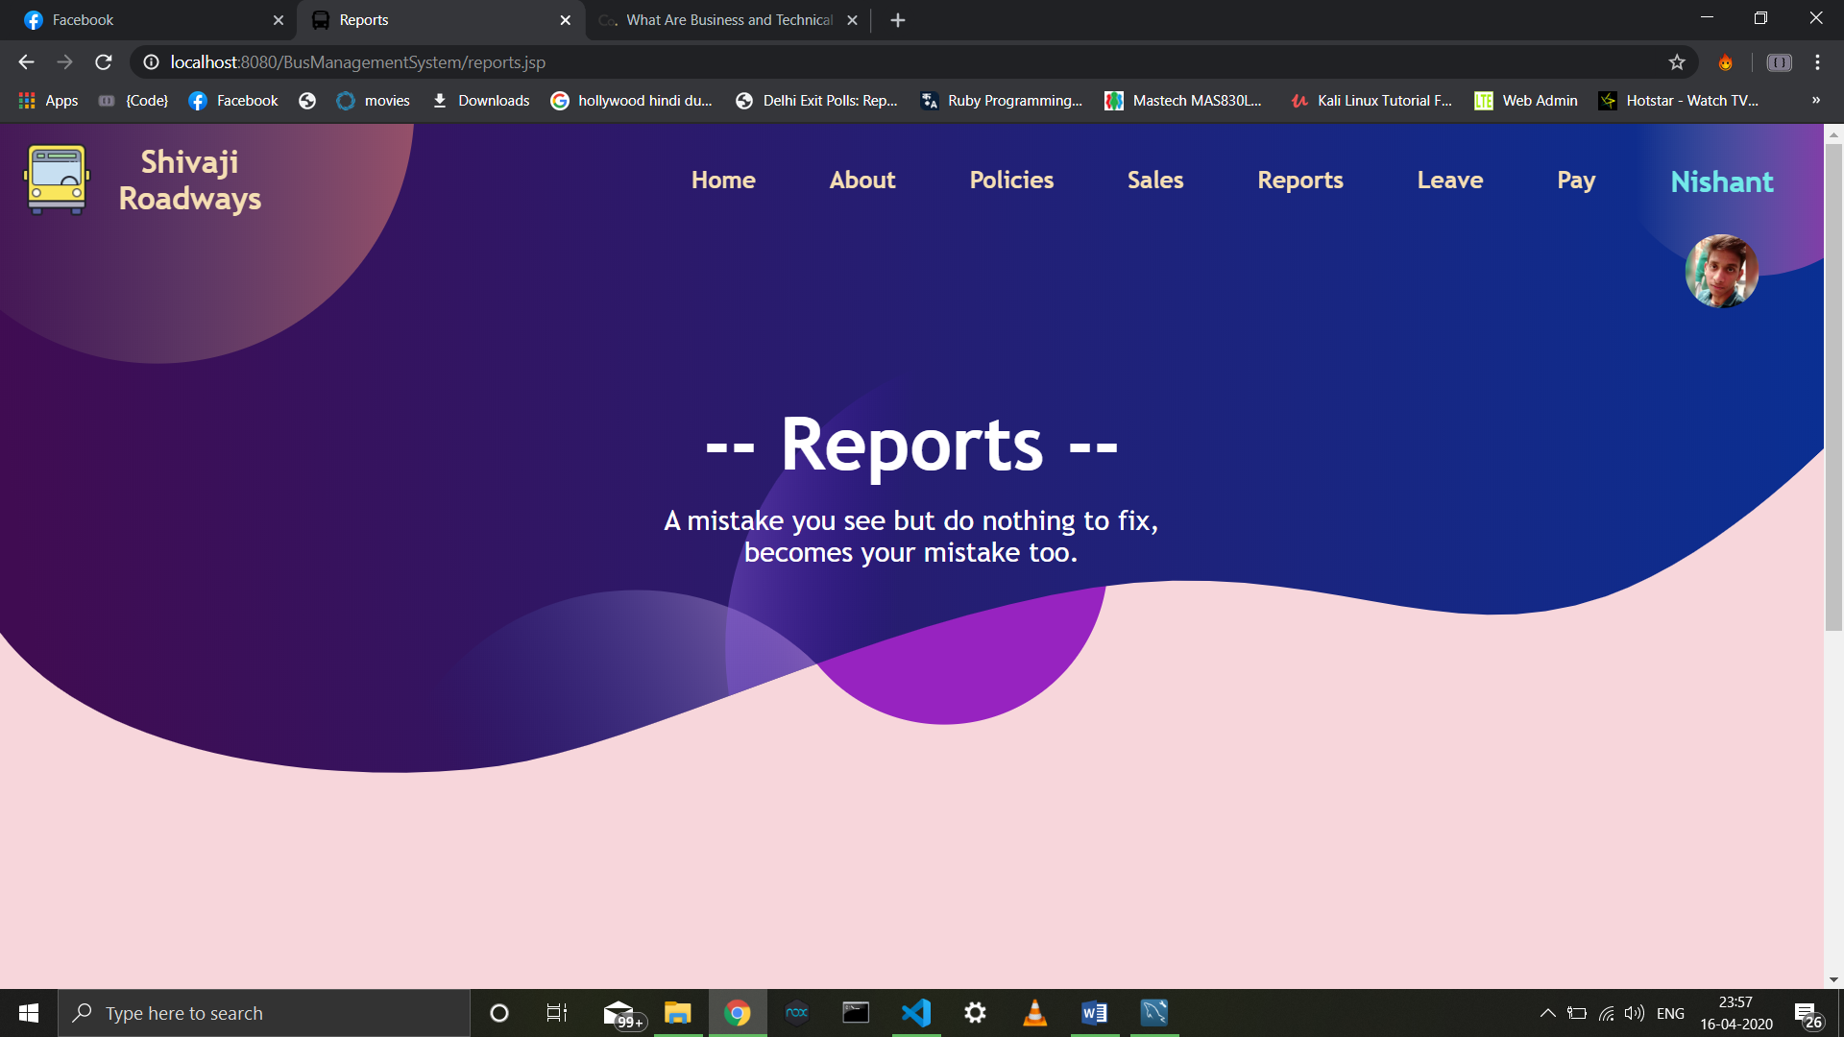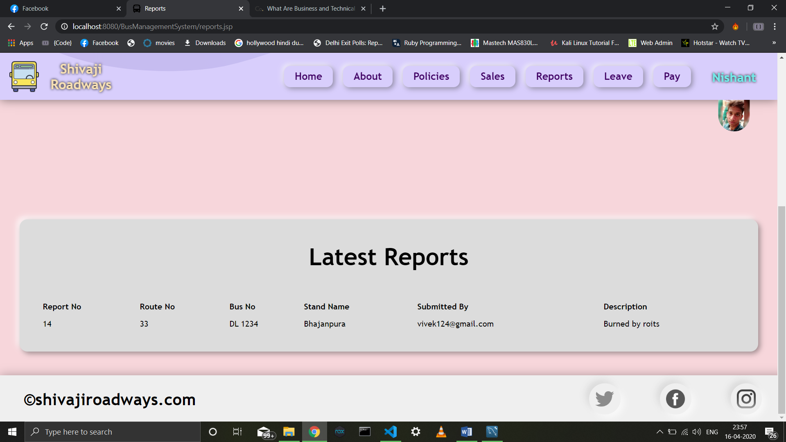

#### Source Code

<!**DOCTYPE** html>

<**html** lang**=**"en">

<head>

    <**meta** charset**=**"UTF-8">

    <**meta** name**=**"viewport" content**=**"width=device-width, initial-scale=1.0">

    <**meta** http-equiv**=**"X-UA-Compatible" content**=**"ie=edge">

    <**link** rel**=**"stylesheet" href**=**"styles/style.css">

    <**link** rel**=**"stylesheet" href**=**"styles/common.css">

    <**link** rel**=**"stylesheet" href**=**"styles/policies.css">

    <**link** rel**=**"icon" href**=**"images/icon.png">

    <**style**>

**.policy**

        {

            width**:** 95%;

        }

        .policy table

        {

            width**:** 100%;

        }

        .policy table tr

        {

            text-align**:** left;

        }

    </**style**>

    <**title**>Reports</**title**>

</head>

<body>

<%

if(session.getAttribute("email") == null || !session.getAttribute("role").equals("admin"))

{

    response.sendRedirect("authentication.jsp");

}

%>

<%@page import="java.sql.*"%>

    <**jsp:include** page**=**"navigationPannel.jsp"></**jsp:include**>

    <**div** class**=**"container">

        <**jsp:include** page**=**"svg.jsp"></**jsp:include**>

        <**div** class**=**"innerContainer">

            <**h1**>-- Reports --</**h1**>

            <**p**>A mistake you see but do nothing to fix,<**br**>becomes your mistake too.</**p**>

        </**div**>

        <**div** class**=**"policy">

            <**h1**>Latest Reports</**h1**>

            <**table**>

                <**tr**>

                    <**th**>Report No</**th**>

                    <**th**>Route No</**th**>

                    <**th**>Bus No</**th**>

                    <**th**>Stand Name</**th**>

                    <**th**>Submitted By</**th**>

                    <**th**>Description</**th**>

                </**tr**>

                <%

                    Connection con = null;

                    Statement st = null;

                    ResultSet rs = null;

                    try

                    {

                        Class.forName("com.mysql.jdbc.Driver");

                        con = DriverManager.getConnection("jdbc:mysql://localhost:3306/shivajiroadways", "root", "1234");

                        st = con.createStatement();

                        String query = "select * from report order by reportNo desc";

                        rs = st.executeQuery(query);

                        while(rs.next())

                        {%>

                            <**tr**>

                                <**td**><%=rs.getInt("reportNo")%></**td**>

                                <**td**><%=rs.getString("routeNo")%></**td**>

                                <**td**><%=rs.getString("busNo")%></**td**>

                                <**td**><%=rs.getString("standName")%></**td**>

                                <**td**><%=rs.getString("submittedBy")%></**td**>

                                <**td**><%=rs.getString("description")%></**td**>

                            </**tr**>

                        <%}

                    }

                    catch(Exception e){out.print(e.getMessage());}

                %>

            </**table**>

        </**div**>

    </**div**>

    <**jsp:include** page**=**"footer.jsp"></**jsp:include**>

</body>

<**script** src**=**"scripts/navPannel.js"></**script**>

</html>

#### leaveRequest.jsp

In this module admin will review is that rightful to allow for leave for a particular staff for a specific purpose

#### Output

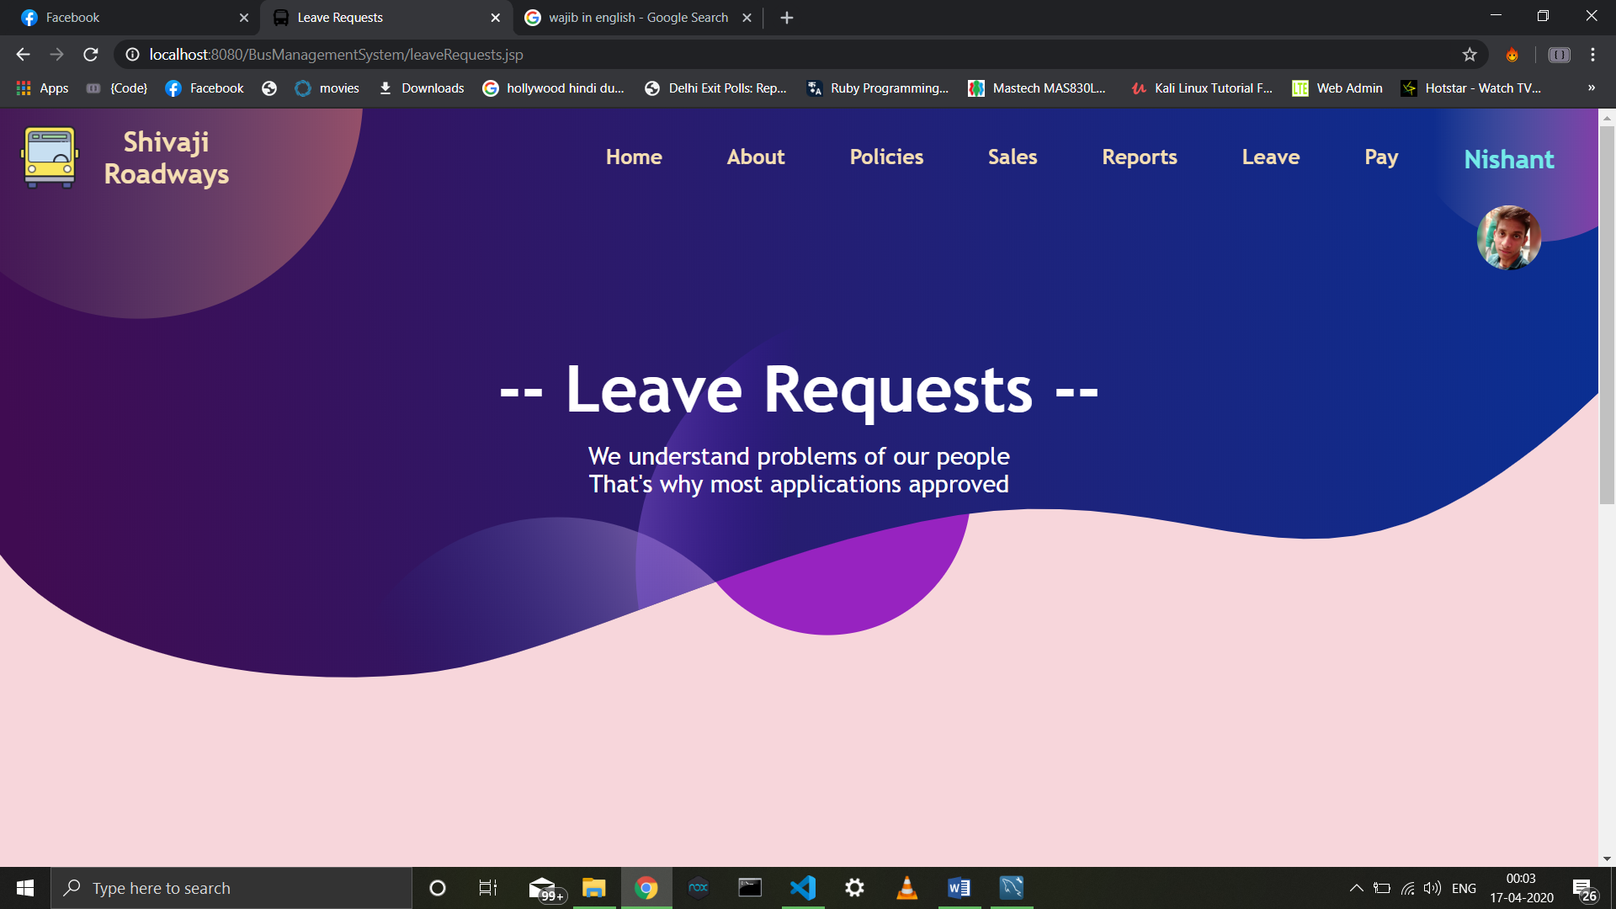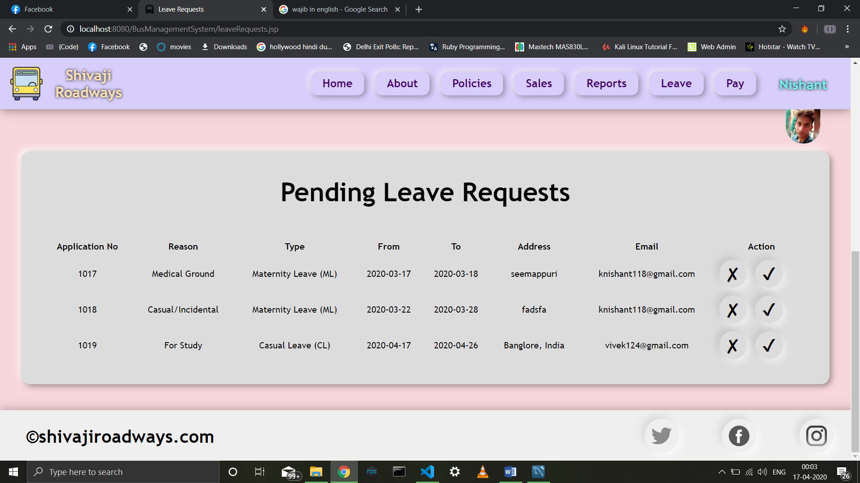

We have 3 pending requests

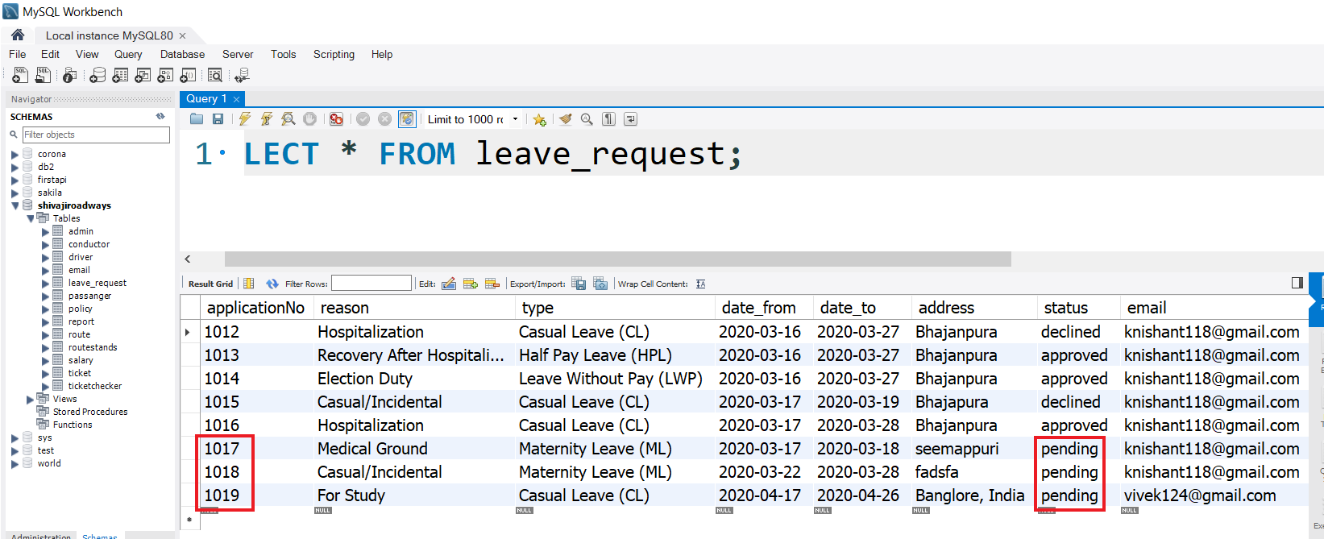

Let’s perform 3 tests on them

Test 1: applicationNo: 1017 → **pending**

Test 2: applicationNo: 1018 → **decline**

Test 3: applicationNo: 1019 → **approved**

Test 2: decling

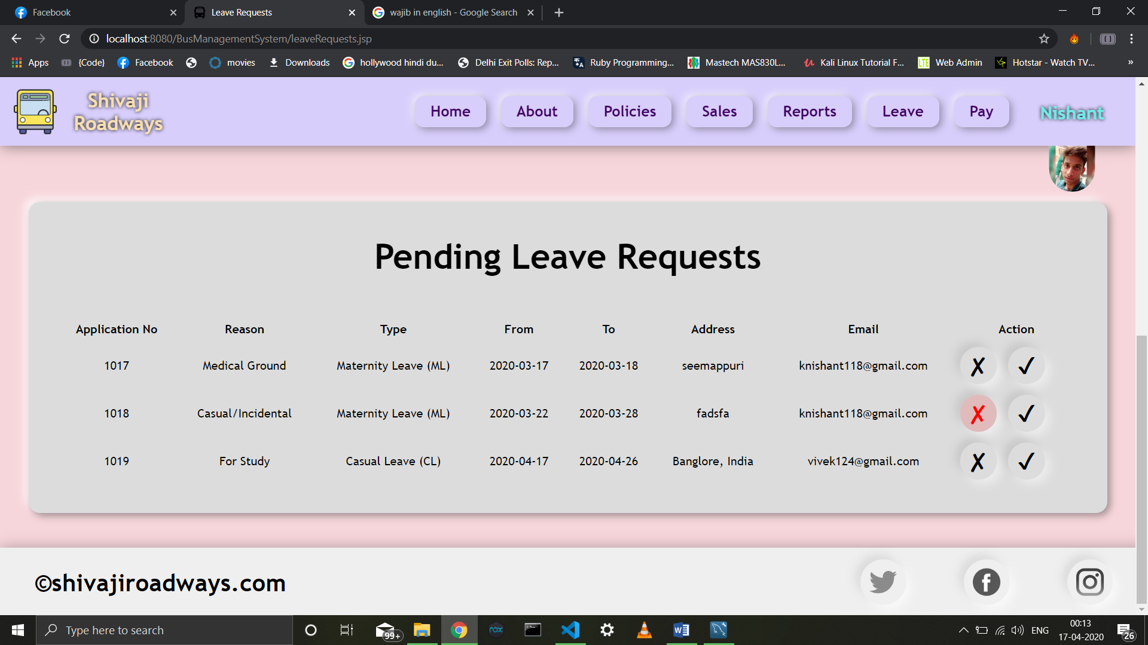

Test 3: approving

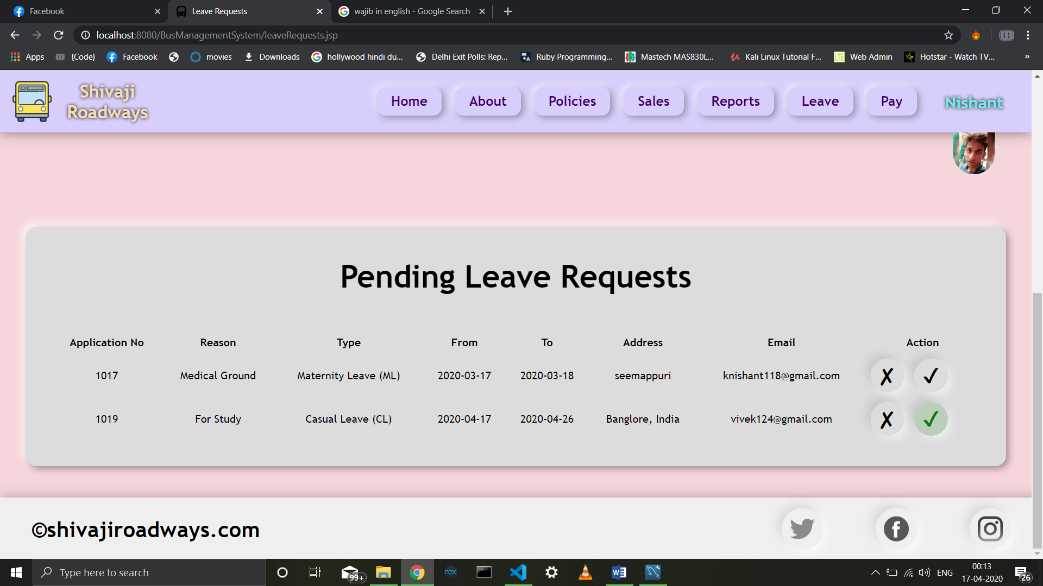

Test 1: pending

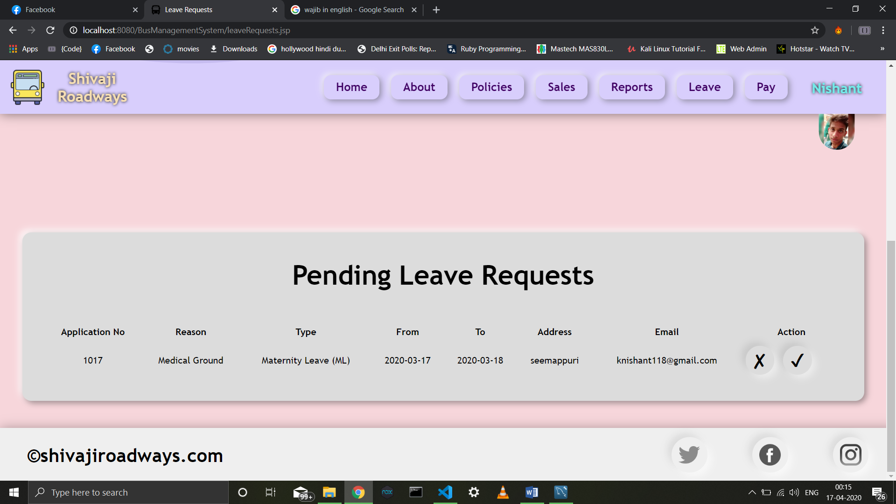

#### Database Output

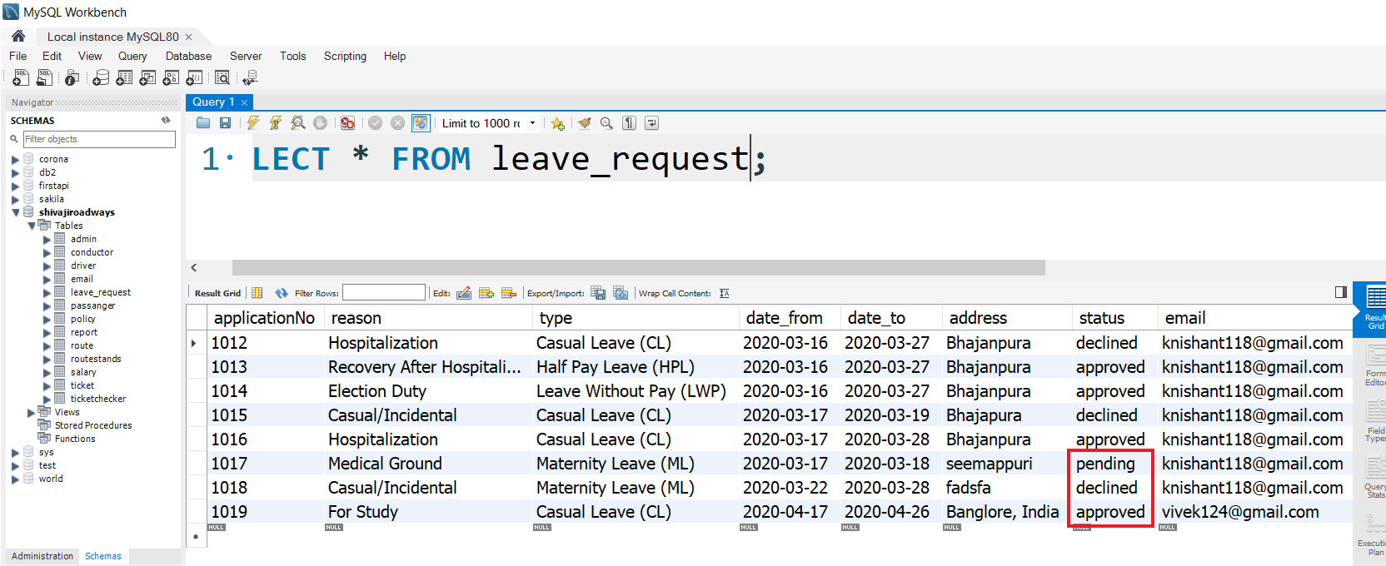

Let’s cross check with staff side

Test 3: applicationNo: **1019**

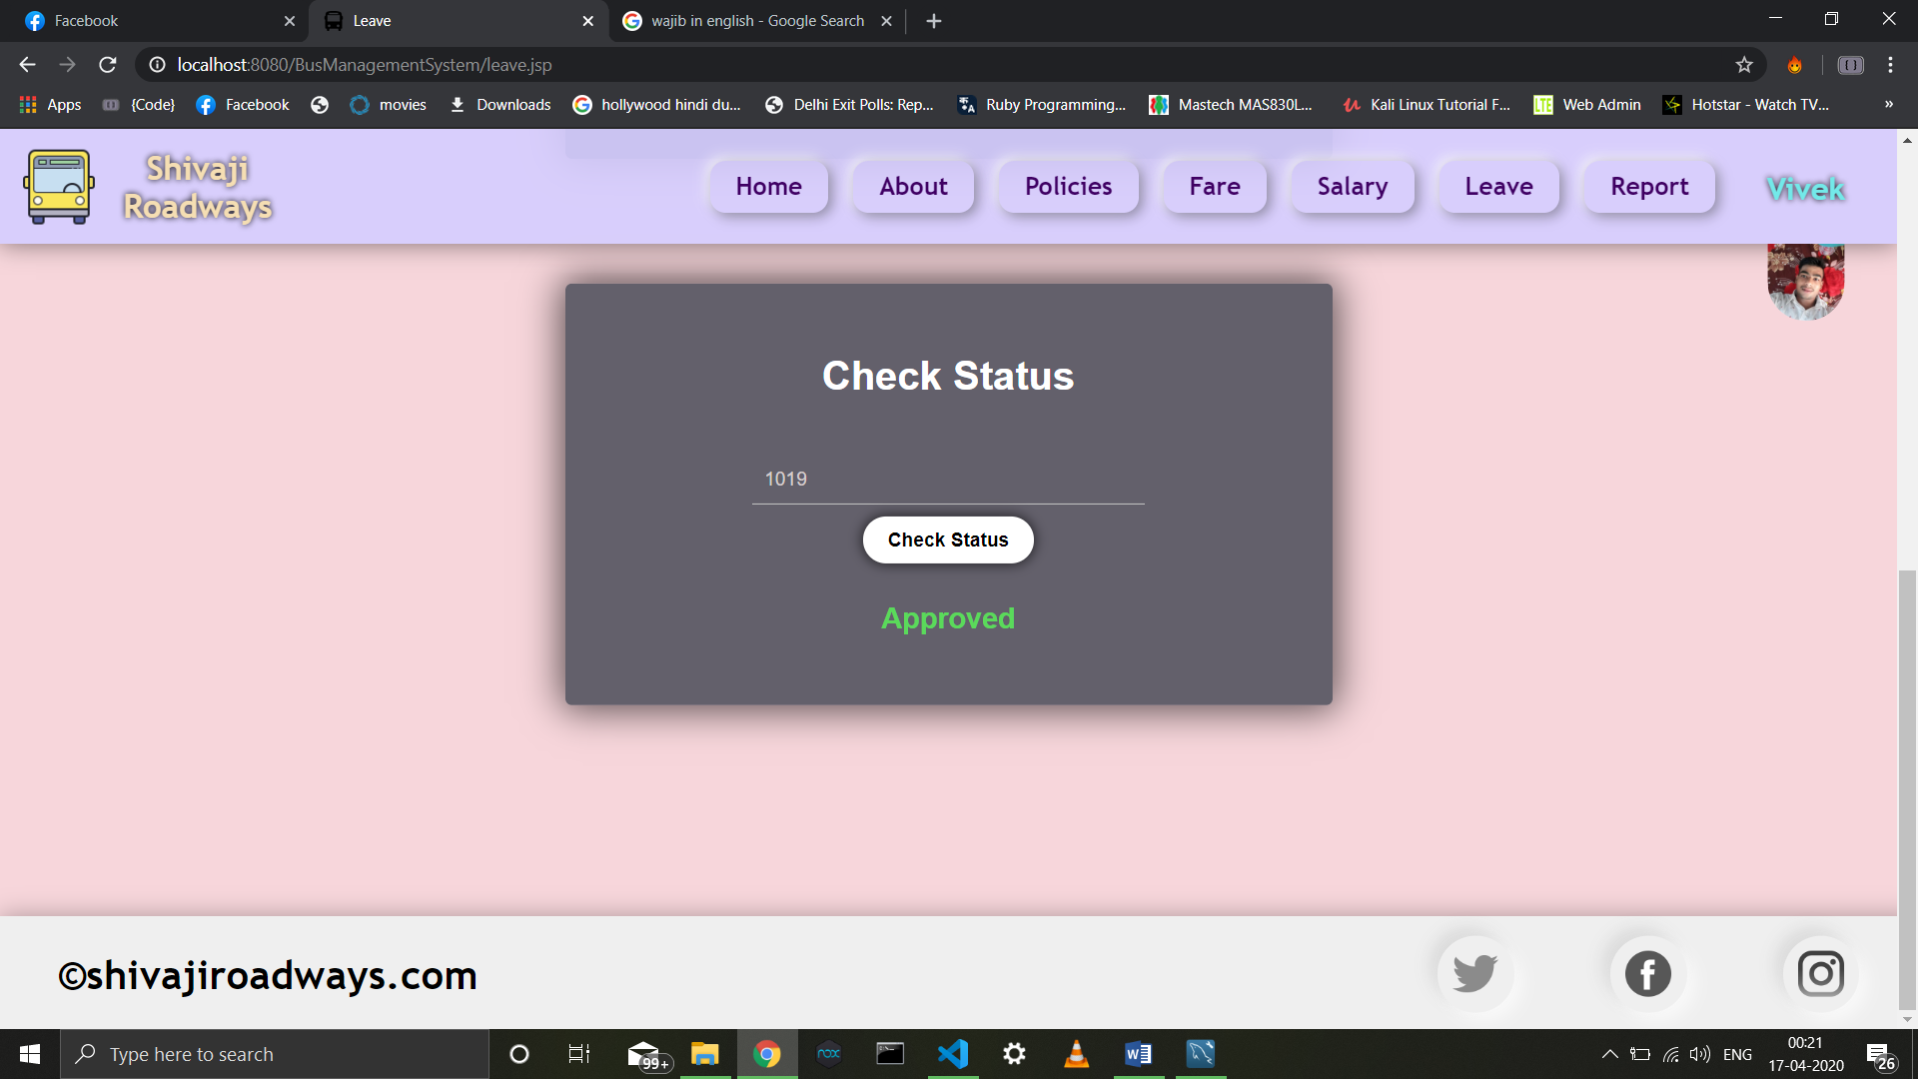

Database Reflects perfectly fine

#### Source Code

<!**DOCTYPE** html>

<**html** lang**=**"en">

<head>

    <**meta** charset**=**"UTF-8">

    <**meta** name**=**"viewport" content**=**"width=device-width, initial-scale=1.0">

    <**meta** http-equiv**=**"X-UA-Compatible" content**=**"ie=edge">

    <**link** rel**=**"stylesheet" href**=**"styles/style.css">

    <**link** rel**=**"stylesheet" href**=**"styles/common.css">

    <**link** rel**=**"stylesheet" href**=**"styles/policies.css">

    <**link** rel**=**"icon" href**=**"images/icon.png">

    <**style**>

**.policy**

        {

            width**:** 95%;

        }

        .policy table

        {

            width**:** 100%;

        }

        .policy table tr

        {

            text-align**:** left;

        }

    </**style**>

    <**title**>Reports</**title**>

</head>

<body>

<%

if(session.getAttribute("email") == null || !session.getAttribute("role").equals("admin"))

{

    response.sendRedirect("authentication.jsp");

}

%>

<%@page import="java.sql.*"%>

    <**jsp:include** page**=**"navigationPannel.jsp"></**jsp:include**>

    <**div** class**=**"container">

        <**jsp:include** page**=**"svg.jsp"></**jsp:include**>

        <**div** class**=**"innerContainer">

            <**h1**>-- Reports --</**h1**>

            <**p**>A mistake you see but do nothing to fix,<**br**>becomes your mistake too.</**p**>

        </**div**>

        <**div** class**=**"policy">

            <**h1**>Latest Reports</**h1**>

            <**table**>

                <**tr**>

                    <**th**>Report No</**th**>

                    <**th**>Route No</**th**>

                    <**th**>Bus No</**th**>

                    <**th**>Stand Name</**th**>

                    <**th**>Submitted By</**th**>

                    <**th**>Description</**th**>

                </**tr**>

                <%

                    Connection con = null;

                    Statement st = null;

                    ResultSet rs = null;

                    try

                    {

                        Class.forName("com.mysql.jdbc.Driver");

                        con = DriverManager.getConnection("jdbc:mysql://localhost:3306/shivajiroadways", "root", "1234");

                        st = con.createStatement();

                        String query = "select * from report order by reportNo desc";

                        rs = st.executeQuery(query);

                        while(rs.next())

                        {%>

                            <**tr**>

                                <**td**><%=rs.getInt("reportNo")%></**td**>

                                <**td**><%=rs.getString("routeNo")%></**td**>

                                <**td**><%=rs.getString("busNo")%></**td**>

                                <**td**><%=rs.getString("standName")%></**td**>

                                <**td**><%=rs.getString("submittedBy")%></**td**>

                                <**td**><%=rs.getString("description")%></**td**>

                            </**tr**>

                        <%}

                    }

                    catch(Exception e){out.print(e.getMessage());}

                %>

            </**table**>

        </**div**>

    </**div**>

    <**jsp:include** page**=**"footer.jsp"></**jsp:include**>

</body>

<**script** src**=**"scripts/navPannel.js"></**script**>

</html>

#### paySalary.jsp

This module is just for giving an illusion of how will the payment module will be work which Is included in future scope of the project.

#### Output

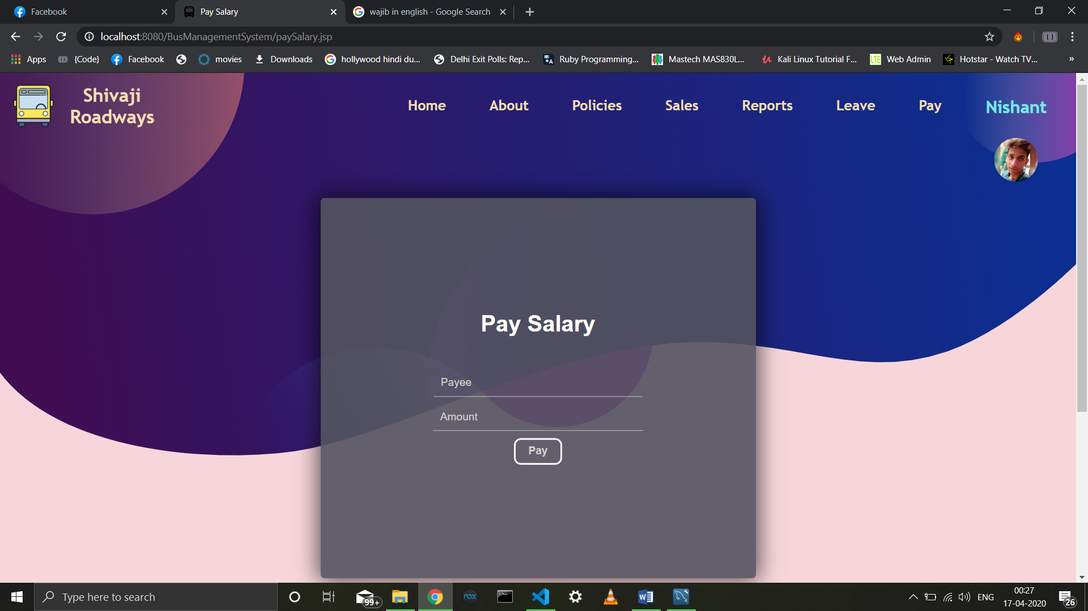

Paying ₹20,500 to [knishant118@gmail.com](mailto:knishant118@gmail.com)

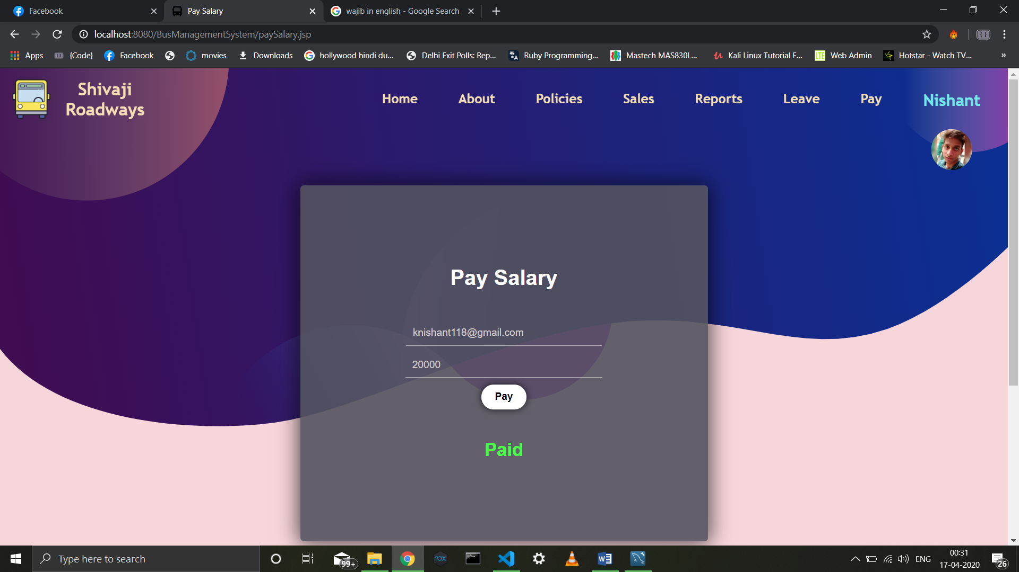

Paying ₹32,000 to [vivek124@gmail.com](mailto:vivek124@gmail.com)

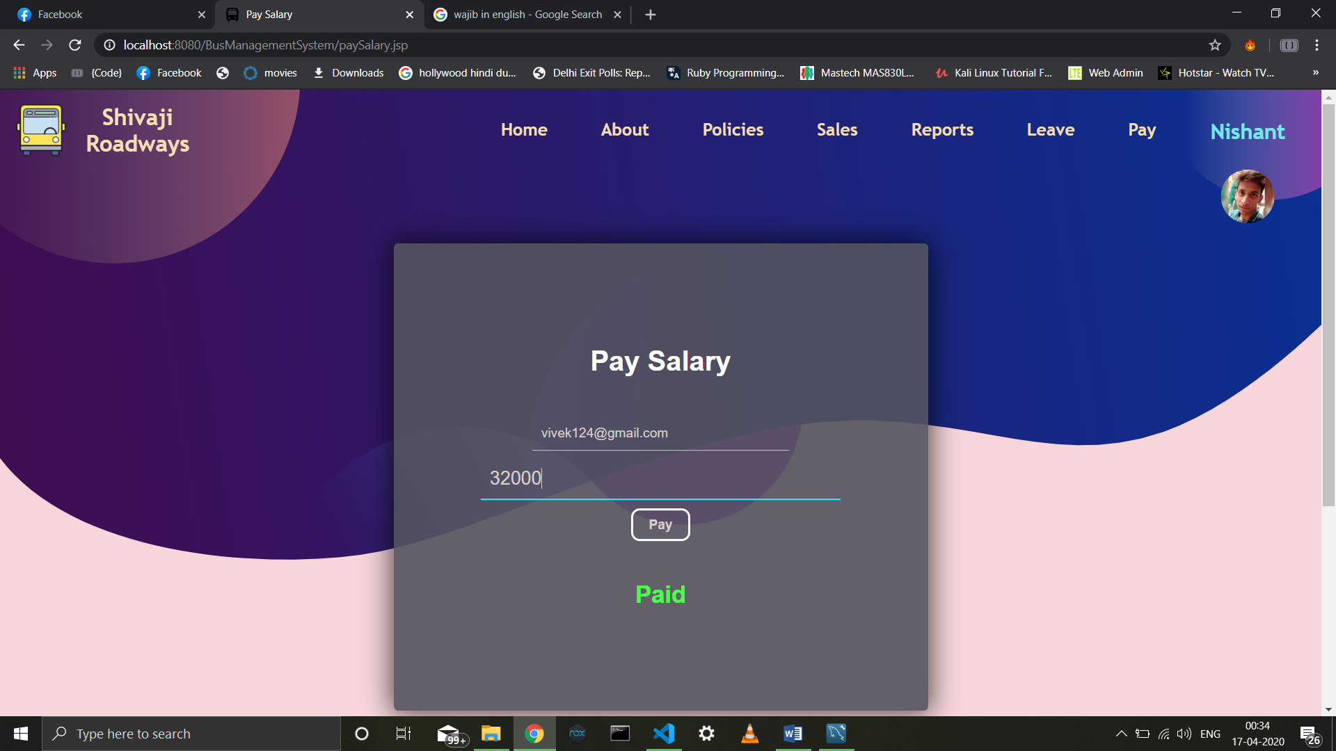

Values updated into database

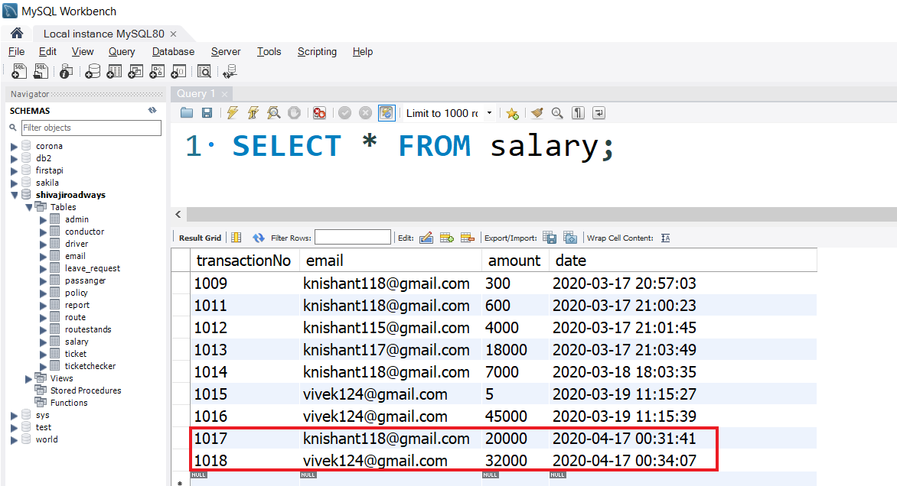

#### Source Code

<!**DOCTYPE** html>

<**html** lang**=**"en">

<head>

    <**meta** charset**=**"UTF-8">

    <**meta** name**=**"viewport" content**=**"width=device-width, initial-scale=1.0">

    <**meta** http-equiv**=**"X-UA-Compatible" content**=**"ie=edge">

    <**link** rel**=**"stylesheet" href**=**"styles/style.css">

    <**link** rel**=**"stylesheet" href**=**"styles/authentication.css">

    <**link** rel**=**"stylesheet" href**=**"styles/common.css">

    <**link** rel**=**"stylesheet" href**=**"styles/leave.css">

    <**link** rel**=**"icon" href**=**"images/icon.png">

    <**title**>Pay Salary</**title**>

    <**style**>

    .searchOutput

    {

        background-color**:**green;

        height**:** 0;

        width**:** 80%;

        margin**:** 0 auto;

        display**:** none;

    }

    .searchOutput .list

    {

        background-color**:** rgb(83, 83, 95);

        width**:** 100%;

        max-height**:** 12.6vw;

        overflow-y**:** scroll;

        position**:** relative;

    }

**.searchOutput** **.list**::-webkit-scrollbar

    {

        display**:** none;

    }

    .searchOutput .list p

    {

        color**:** white;

        padding**:** 1vw;

        font-size**:** 1vw;

        margin**:** 0 auto;

        transition**:** ease all .7s;

    }

    .searchOutput .list p:hover

    {

        background-color**:** white;

        cursor**:** pointer;

        color**:** rgb(83, 83, 95);

    }

**input**[type="search"]:focus + **.searchOutput**

    {

        display**:** block;

    }

    </**style**>

</head>

<body>

<%

if(session.getAttribute("email") == null || !session.getAttribute("role").equals("admin"))

{

    response.sendRedirect("authentication.jsp");

}

%>

    <**jsp:include** page**=**"navigationPannel.jsp"></**jsp:include**>

    <**jsp:include** page**=**"svg.jsp"></**jsp:include**>

    <**div** class**=**"container">

        <**div** class**=**"workspace">

            <**form** onsubmit**=**"**return** pay();">

                <**h1**>Pay Salary</**h1**>

                <**input** type**=**"search" id**=**"payee" placeholder**=**"Payee" onkeyup**=**"getPayee(this.value);" autocomplete**=**"on">

                <**div** class**=**"searchOutput">

                    <**div** class**=**"list""></**div**>

                </**div**>

                <**input** type**=**"text" id**=**"amount" name**=**"amount" style**=**"width: 18vw;" placeholder**=**"Amount">

                <**input** type**=**"submit" value**=**"Pay">

                <**h1** style**=**"color:rgb(70, 255, 70);" id**=**"result"></**h1**>

            </**form**>

        </**div**>

    </**div**>

    <**jsp:include** page**=**"footer.jsp"></**jsp:include**>

</body>

<**script** src**=**"scripts/navPannel.js"></**script**>

<script>

**function** setPayee(value)

{

    document.getElementById('payee').value **=** value;

}

**function** getPayee(payee)

{

**var** param **=** "?payee=" +  payee;

    param **=** param.replace("+", "%2b")

**var** xmlhttp **=** **new** XMLHttpRequest();

    xmlhttp.open("POST", "paySalaryAJAX.jsp" + param, false);

    xmlhttp.onreadystatechange **=** **function**(){

        document.getElementsByClassName('list')[0].innerHTML **=** xmlhttp.responseText;

    }

    xmlhttp.send();

}

function pay()

{

**var** payee **=** document.getElementById("payee").value;

**var** amount **=** document.getElementById("amount").value;

**var** param **=** "?payee=" +  payee + "&amount=" +  amount;

    param **=** encodeURI(param);

    console.log(param);

**var** xmlhttp **=** **new** XMLHttpRequest();

    xmlhttp.open("POST", "paySalaryAJAX2.jsp" + param, false);

    xmlhttp.onreadystatechange **=** **function**(){

        document.getElementById("result").innerText **=** xmlhttp.responseText.trim();;

        setInterval(**function**(){ location.reload(); }, 2000);

    }

    xmlhttp.send();

**return** false;

}

</script>

</html>

#### Hovering over profile picture

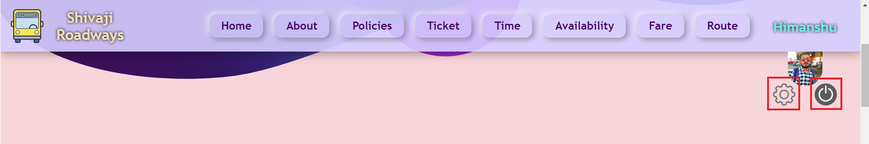

On hovering two icons are invoking these are

* Gear icon → **User Settings**
* Switch icon → **Log Out**

Let’s explore them one by one

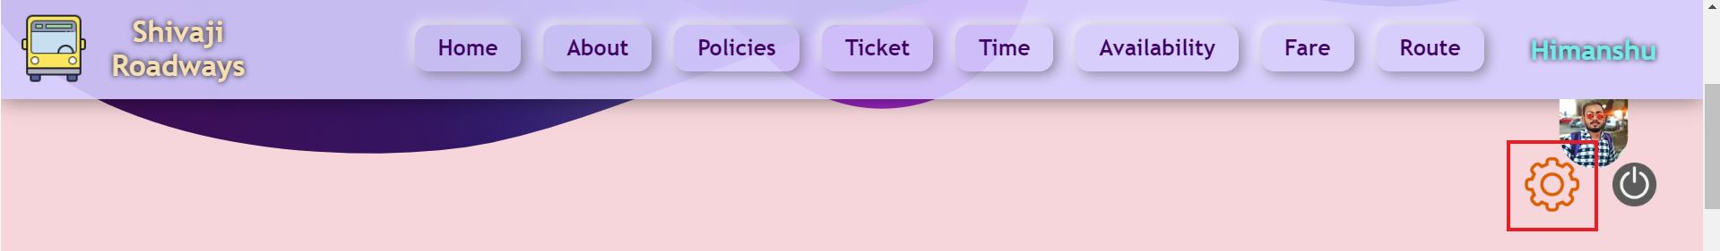

#### settings.jsp

#### Output

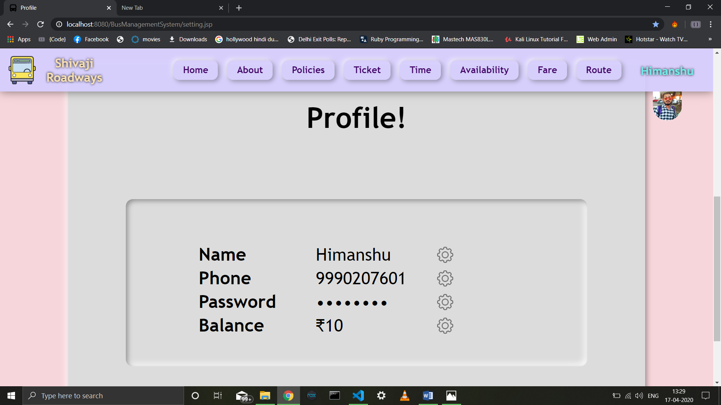

Editing the name

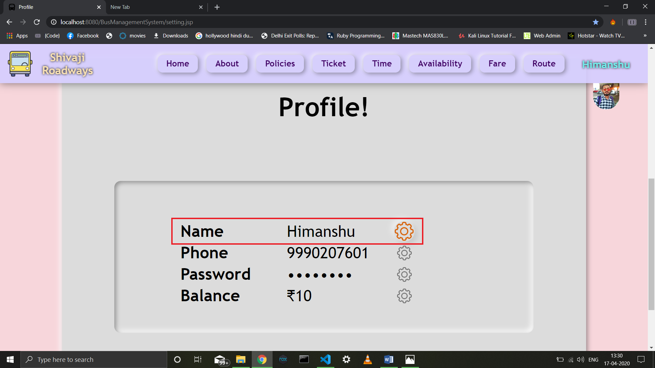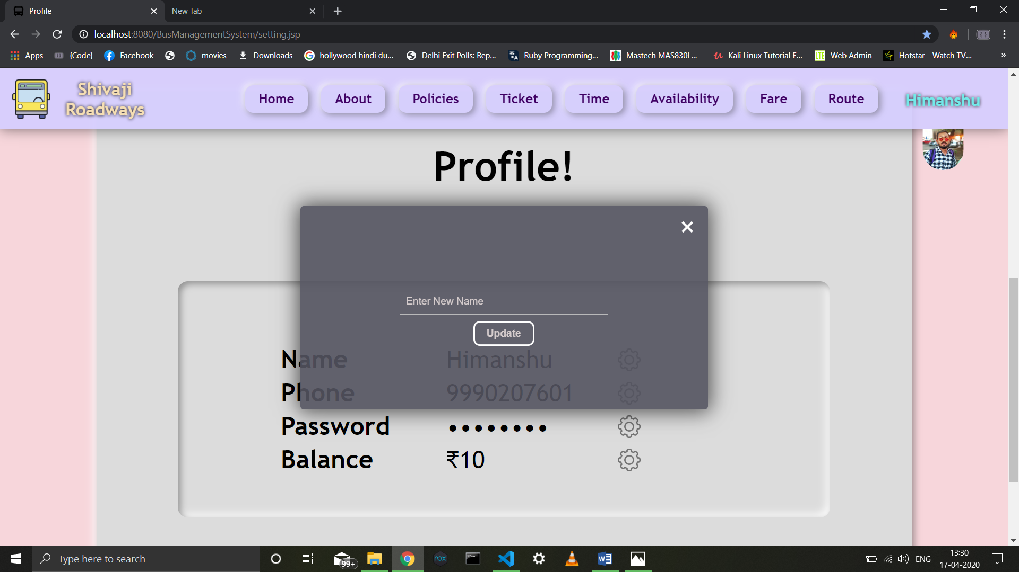

Renaming

**Himanshu → Influencer**

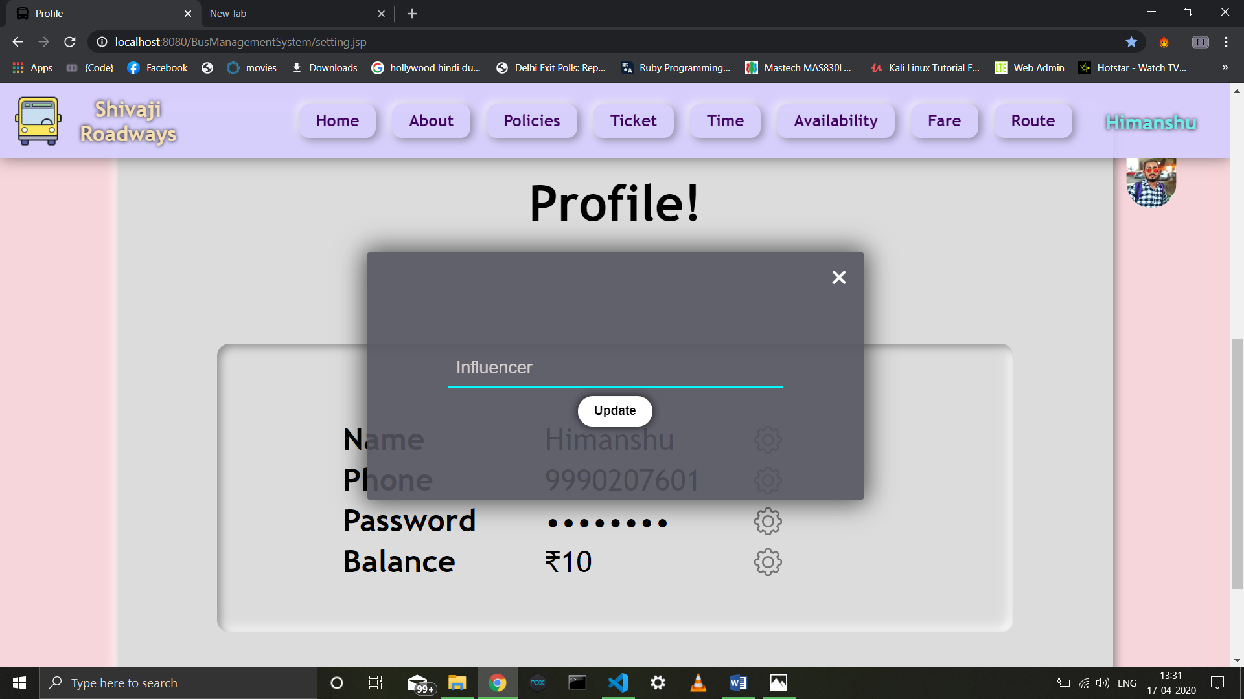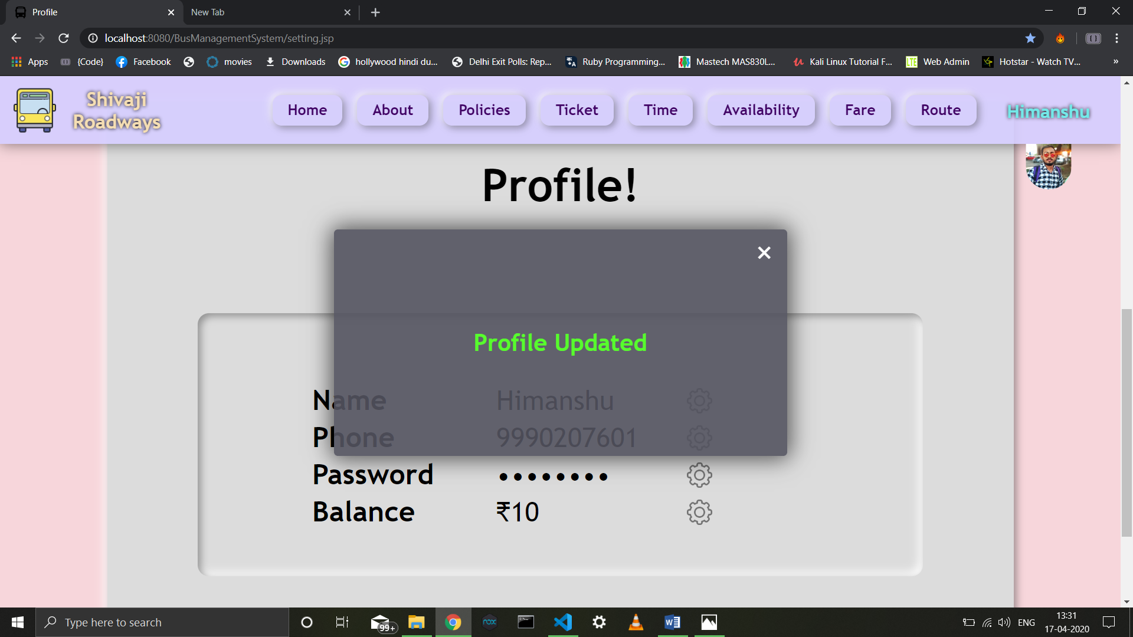

Renamed Successfully

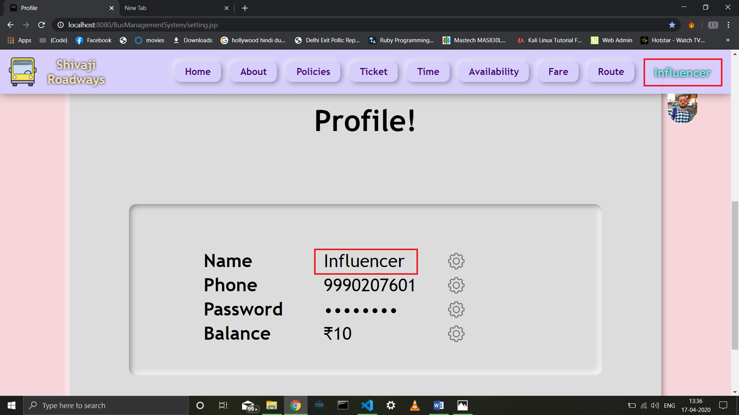

Let’s change **Balance** too.

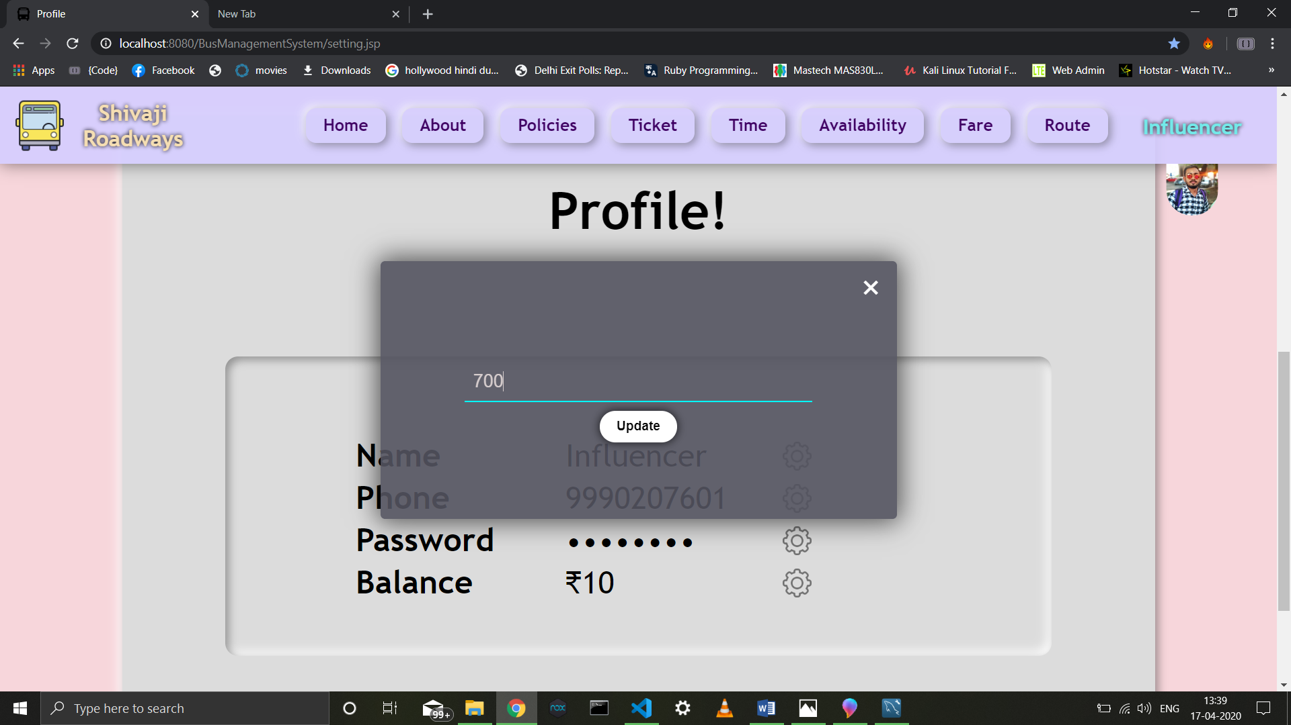

Balance Updated

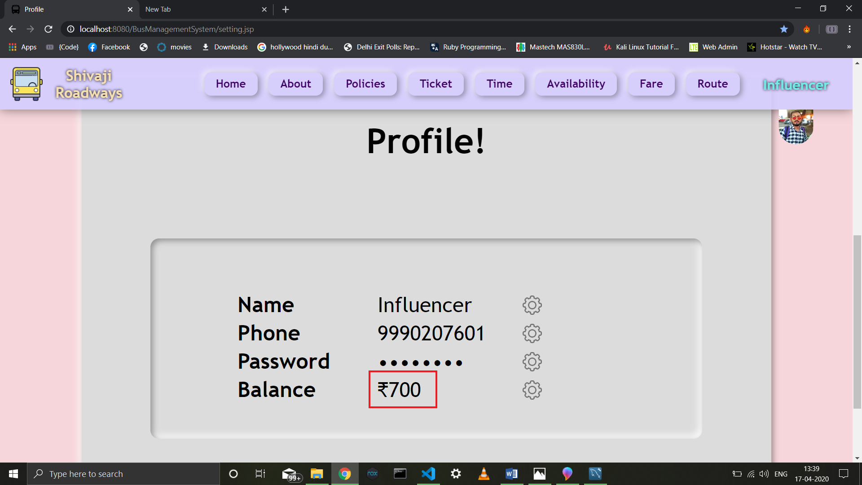

Let’s have a look into database

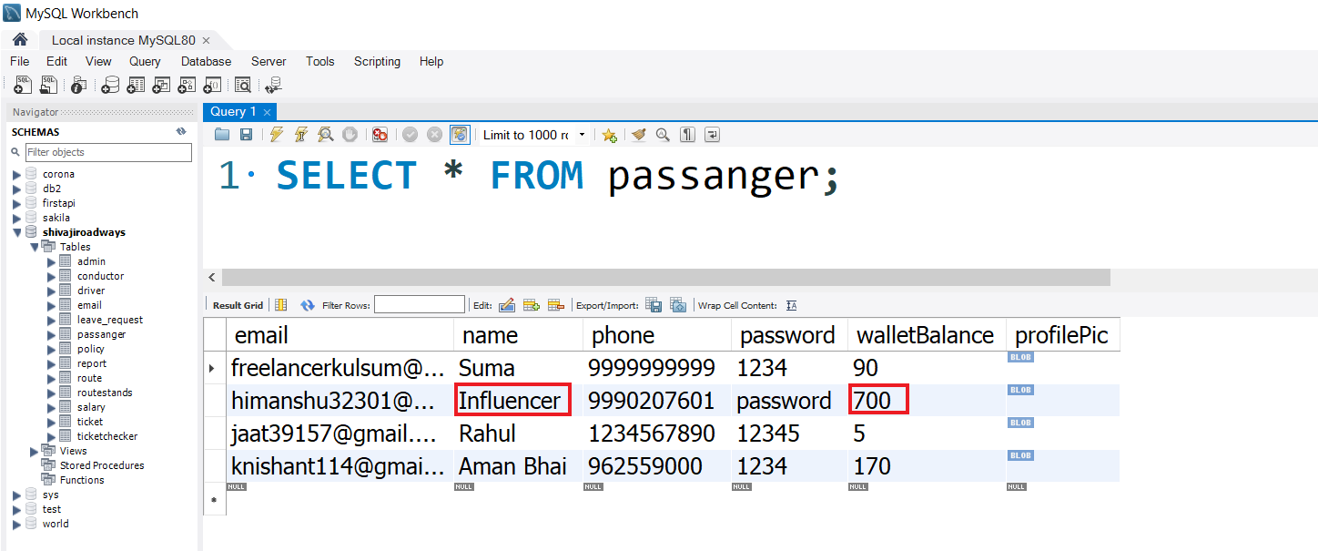

Values are successfully updated

#### Source Code

<!**DOCTYPE** html>

<**html** lang**=**"en">

<head>

    <**meta** charset**=**"UTF-8">

    <**meta** name**=**"viewport" content**=**"width=device-width, initial-scale=1.0">

    <**meta** http-equiv**=**"X-UA-Compatible" content**=**"ie=edge">

    <**link** rel**=**"stylesheet" href**=**"styles/style.css">

    <**link** rel**=**"stylesheet" href**=**"styles/common.css">

    <**link** rel**=**"stylesheet" href**=**"styles/about.css">

    <**link** rel**=**"icon" href**=**"images/icon.png">

    <**title**>Profile</**title**>

    <**style**>

**.staff**

        {

            box-shadow**:** inset 4px 4px 10px rgba(0, 0, 0, 0.356), inset -5px -5px 12px 0 rgb(255, 255, 255);

            border-radius**:** 1vw;

            width**:** 80%;

            padding-top**:** 4vw;

            padding-bottom**:** 4vw;

            margin**:** 4vw auto;

        }

**.staff** **h2**

        {

            font-size**:** 2.8vw;

        }

        .about table

        {

            margin-top**:** 2vw;

            padding-left**:** 10vw;

            padding-right**:** 5vw;

            width**:** 100%;

            table-layout**:** fixed;

        }

        .about table tr th

        {

            font-size**:** 2.5vw;

        }

        .about table tr td

        {

            font-size**:** 2.4vw;

        }

**td**, **th**

        {

            text-transform**:** capitalize;

            text-align**:** left;

        }

        .editButton

        {

            color**:** black;

            float**:** left;

            border-radius**:** 5vw;

            width**:** 2.8vw;

            height**:** 2.8vw;

            font-size**:**2vw;

            padding**:** .2vw;

            background-image**:** url('./images/settings.png');

            background-repeat**:** no-repeat;

            background-size**:** 70% 70%;

            background-position**:** center;

            filter**:** grayscale(1);

            transition**:** ease all .5s;

        }

**.editButton**:hover

        {

            box-shadow**:** 7px 7px 12px rgba(255, 255, 255, 0.45), -7px -7px 12px rgba(70, 70, 70, 0.13);

            filter**:** grayscale(0);

            background-size**:** 90% 90%;

            cursor**:** pointer;

            transform**:** rotateZ(180deg);

        }

**.editButton**:active

        {

            box-shadow**:** inset 7px 7px 12px rgba(255, 255, 255, 0.45), inset -7px -7px 12px rgba(70, 70, 70, 0.13);

        }

        .updationWindow

        {

            position**:** fixed;

            z-index**:** 2;

            left**:** 50%;

            top**:** 50%;

            transform**:** translate(-50%, -50%);

            background-color**:**rgba(83, 83, 95, 0.90);

            box-shadow**:** 0 0 30px 4px rgba(0, 0, 0, 0.63);

            width**:** 0vw;

            height**:** 0vw;

            opacity**:** 0;

            border-radius**:** 5px;

            transition**:** ease all .5s;

            overflow**:** hidden;

        }

**#close**

        {

            float**:** right;

            display**:** block;

            padding**:** 0.5vw;

            text-align**:** center;

            height**:** 2vw;

            width**:** 2vw;

            font-size**:** 1.5vw;

            margin**:** .5vw;

            color**:** white;

            user-select**:** none;

            border-radius**:** 10vw;

            transition**:** ease all .5s;

        }

**#close**:hover

        {

            background-color**:**rgba(28, 28, 53, 0.63);

            cursor**:** pointer;

        }

**form**

        {

            position**:** relative;

            display**:** none;

            clear**:** both;

            top**:** 35%;

            transform**:** translateY(-50%);

            font-family**:** sans-serif;

            margin**:** 0 auto;

            width**:** 80%;

            /* background-color: yellow; */

        }

**form** **input**[type="text"], **form** **input**[type="password"], **form** **input**[type="range"], **form** **input**[type="search"]

        {

            display**:** block;

            outline**:** none;

            width**:** 60%;

            background**:** transparent;

            border**:** none;

            border-bottom**:** 1px solid rgb(197, 197, 197);

            font-size**:** 1vw;

            margin**:** 10px auto;

            padding**:** 10px;

            color**:** rgb(214, 205, 205);

            caret-color**:** rgb(214, 205, 205);

            animation-name**:** input2;

            animation-duration**:** 0.6s;

            animation-fill-mode**:** forwards;

        }

**form** **h1**

        {

            color**:** white;

            text-align**:** center;

            margin-bottom**:** 3vw;

        }

        form select

        {

            display**:** block;

            outline**:** none;

            width**:** 65%;

            background**:** transparent;

            border**:** none;

            color**:** rgb(214, 205, 205);

            border**:** 1px solid rgb(197, 197, 197);

            font-size**:** 1vw;

            margin**:** 10px auto;

            padding**:** 10px;

            caret-color**:** rgb(214, 205, 205);

            animation-name**:** input2;

            animation-duration**:** 0.6s;

            animation-fill-mode**:** forwards;

        }

**input**[type="date"]

        {

            display**:** block;

            outline**:** none;

            width**:** 60%;

            background**:** transparent;

            border**:** none;

            color**:** rgb(214, 205, 205);

            border**:** 1px solid rgb(197, 197, 197);

            font-size**:** 1vw;

            margin**:** 10px auto;

            padding**:** 10px;

            caret-color**:** rgb(214, 205, 205);

            animation-name**:** input2;

            animation-duration**:** 0.6s;

            animation-fill-mode**:** forwards;

        }

        form select option

        {

            display**:** block;

            outline**:** none;

            width**:** 65%;

            background-color**:** rgb(83, 83, 95);

            border**:** none;

            color**:** white;

            border**:** 1px solid rgb(197, 197, 197);

            font-size**:** 1vw;

            margin**:** 10px auto;

            padding**:** 10px;

            caret-color**:** rgb(214, 205, 205);

            animation-name**:** input2;

            animation-duration**:** 0.6s;

            animation-fill-mode**:** forwards;

        }

**form** **input**[type="submit"], **input**[type="button"]

        {

            display**:** block;

            outline**:** none;

            /* width: 60%; */

            background**:** transparent;

            color**:** rgb(214, 205, 205);

            border**:** 2px solid white;

            border-radius**:** 10px;

            font-size**:** 1vw;

            font-weight**:** bold;

            margin**:** 10px auto;

            padding**:** 8px 18px;

        }

**form** **input**[type="submit"]:hover, **form** **input**[type="submit"]:focus, **input**[type="button"]:hover, **input**[type="button"]:focus

        {

            position**:** relative;

            cursor**:** pointer;

            animation-name**:** submit;

            animation-duration**:** 1s;

            animation-fill-mode**:** forwards;

        }

**@keyframes** submit

        {

            100%

            {

                color**:** black;

                background-color**:** white;

                box-shadow**:** 0 0 10px 1px rgba(0, 0, 0, 0.63);

                border-radius**:** 50px;

            }

        }

**form** **input**::placeholder

        {

            color**:**  rgb(214, 205, 205);

        }

**input**[type="text"]:focus, **input**[type="password"]:focus, **input**[type="search"]:focus

        {

            animation-name**:** input;

            animation-duration**:** 0.6s;

            animation-fill-mode**:** forwards;

        }

**@keyframes** input

        {

            100%

            {

                border-bottom**:**1.9px solid aqua;

                width**:** 80%;

                font-size**:** 1.4vw;

            }

        }

**select**:focus

        {

            animation-name**:** select;

            animation-duration**:** 0.6s;

            animation-fill-mode**:** forwards;

        }

**@keyframes** select

        {

            100%

            {

                border**:**1.9px solid aqua;

            }

        }

**optgroup**

        {

            background-color**:** rgb(83, 83, 95);

        }

**option**:disabled

        {

            color**:** rgb(214, 205, 205);

        }

**#dob**::before

        {

            content**:** "D.O.B.: \00a0";

        }

**#result**

        {

            color**:** rgb(87, 254, 45);

            display**:** none;

            position**:** relative;

            top**:** 30%;

            transform**:** translateY(-50%);

            clear**:** both;

            text-align**:** center;

            margin-bottom**:** 3vw;

        }

        </**style**>

</head>

<body>

    <**div** class**=**"updationWindow">

        <**div** id**=**"close" onclick**=**"closeWindow();">&#10006;</**div**>

        <**h1** id**=**"result"></**h1**>

        <**form** id**=**"nameForm" onsubmit**=**"**return** updateData('name');">

            <**input** type**=**"text" name**=**"name" placeholder**=**"Enter New Name">

            <**input** type**=**"submit" value**=**"Update">

        </**form**>

        <**form** id**=**"phoneForm" onsubmit**=**"**return** updateData('phone');">

            <**input** type**=**"text" name**=**"phone" placeholder**=**"Enter New Phone No">

            <**input** type**=**"submit" value**=**"Update">

        </**form**>

        <**form** id**=**"passwordForm" onsubmit**=**"**return** updateData('password');">

            <**input** type**=**"password" name**=**"password" placeholder**=**"Enter New Password">

            <**input** type**=**"submit" value**=**"Update">

        </**form**>

        <**form** id**=**"walletBalanceForm" onsubmit**=**"**return** updateData('walletBalance');">

            <**input** type**=**"text" name**=**"walletBalance" placeholder**=**"Add Amount to be added">

            <**input** type**=**"submit" value**=**"Update">

        </**form**>

        <**form** id**=**"dobForm" onsubmit**=**"**return** updateData('dob');">

            <**input** type**=**"date" id**=**"dob" name**=**'dob'>

            <**input** type**=**"submit" value**=**"Update">

        </**form**>

        <**form** id**=**"licenceForm" onsubmit**=**"**return** updateData('licenceNo');">

            <**input** type**=**"text" name**=**"licenceNo" placeholder**=**"Enter Licence No">

            <**input** type**=**"submit" value**=**"Update">

        </**form**>

        <**form** id**=**"experienceForm" onsubmit**=**"**return** updateData('experience');">

            <**input** type**=**"text" name**=**"experience" placeholder**=**"Enter Experience">

            <**input** type**=**"submit" value**=**"Update">

        </**form**>

    </**div**>

    <**jsp:include** page**=**"navigationPannel.jsp"></**jsp:include**>

    <**div** class**=**"container">

        <**jsp:include** page**=**"svg.jsp"></**jsp:include**>

        <**div** class**=**"innerContainer">

            <**h1**>-- Edit Your Profile! --</**h1**>

            <**p**>To provide bus services in very reasonable prices<**br**>

                with full of safty!</**p**>

        </**div**>

        <**div** class**=**"about" style**=**"margin-top: 25vw; padding-bottom: 0.1vw;">

            <**h1**>Profile!</**h1**>

            <**div** class**=**"staff">

                <**table** >

                    <%@page import="java.sql.*"%>

                    <%

                    String role = (String)session.getAttribute("role");

                    Connection con = null;

                    Statement st = null;

                    ResultSet rs = null;

                    String password = "";

                    try

                    {

                            Class.forName("com.mysql.jdbc.Driver");

                            con = DriverManager.getConnection("jdbc:mysql://localhost:3306/shivajiroadways", "root", "1234");

                            st = con.createStatement();

                            if(role.equals("admin"))

                            {

                                rs = st.executeQuery("select * from admin where email='"+session.getAttribute("email")+"'");

                                if(rs.next())

                                {

                                    for(int i = 0; i < rs.getString("password").length(); i++)

                                    {

                                        password += "&bull;";

                                    }

                                %>

                                    <**tr**>

                                        <**th**>Name</**th**><**td**><%=rs.getString("name")%><**td**><**div** class**=**"editButton" onclick**=**"change('name')"></**div**></**td**>

                                    </**tr**>

                                    <**tr**>

                                        <**th**>Phone</**th**><**td**><%=rs.getString("phone")%><**td**><**div** class**=**"editButton" onclick**=**"change('phone')"></**div**></**td**>

                                    </**tr**>

                                    <**tr**>

                                        <**th**>Password</**th**><**td**><%=password%><**td**><**div** class**=**"editButton" onclick**=**"change('password')"></**div**></**td**>

                                    </**tr**>

                                <%}

                            }

                            else if(role.equals("passanger"))

                            {

                                rs = st.executeQuery("select * from passanger where email='"+session.getAttribute("email")+"'");

                                if(rs.next())

                                {

                                    for(int i = 0; i < rs.getString("password").length(); i++)

                                    {

                                        password += "&bull;";

                                    }

                                %>

                                    <**tr**>

                                        <**th**>Name</**th**><**td**><%=rs.getString("name")%><**td**><**div** class**=**"editButton" onclick**=**"change('name')"></**div**></**td**>

                                    </**tr**>

                                    <**tr**>

                                        <**th**>Phone</**th**><**td**><%=rs.getString("phone")%><**td**><**div** class**=**"editButton" onclick**=**"change('phone')"></**div**></**td**>

                                    </**tr**>

                                    <**tr**>

                                        <**th**>Password</**th**><**td**><%=password%><**td**><**div** class**=**"editButton" onclick**=**"change('password')"></**div**></**td**>

                                    </**tr**>

                                    <**tr**>

                                        <**th**>Balance</**th**><**td**>&#8377;<%=rs.getString("walletBalance")%><**td**><**div** class**=**"editButton" onclick**=**"change('walletBalance')"></**div**></**td**>

                                    </**tr**>

                                <%}

                            }

                            else if(role.equals("ticketchecker"))

                            {

                                rs = st.executeQuery("select * from ticketchecker where email='"+session.getAttribute("email")+"'");

                                if(rs.next())

                                {

                                    for(int i = 0; i < rs.getString("password").length(); i++)

                                    {

                                        password += "&bull;";

                                    }

                                %>

                                    <**tr**>

                                        <**th**>Name</**th**><**td**><%=rs.getString("name")%><**td**><**div** class**=**"editButton" onclick**=**"change('name')"></**div**></**td**>

                                    </**tr**>

                                    <**tr**>

                                        <**th**>Phone</**th**><**td**><%=rs.getString("phone")%><**td**><**div** class**=**"editButton" onclick**=**"change('phone')"></**div**></**td**>

                                    </**tr**>

                                    <**tr**>

                                        <**th**>Password</**th**><**td**><%=password%><**td**><**div** class**=**"editButton" onclick**=**"change('password')"></**div**></**td**>

                                    </**tr**>

                                    <**tr**>

                                        <**th**>D.O.B.</**th**><**td**><%=rs.getString("dob")%><**td**><**div** class**=**"editButton" onclick**=**"change('dob')"></**div**></**td**>

                                    </**tr**>

                                <%}

                            }

                            else if(role.equals("driver"))

                            {

                                rs = st.executeQuery("select * from driver where email='"+session.getAttribute("email")+"'");

                                if(rs.next())

                                {

                                    for(int i = 0; i < rs.getString("password").length(); i++)

                                    {

                                        password += "&bull;";

                                    }

                                %>

                                    <**tr**>

                                        <**th**>Name</**th**><**td**><%=rs.getString("name")%><**td**><**div** class**=**"editButton" onclick**=**"change('name')"></**div**></**td**>

                                    </**tr**>

                                    <**tr**>

                                        <**th**>Phone</**th**><**td**><%=rs.getString("phone")%><**td**><**div** class**=**"editButton" onclick**=**"change('phone')"></**div**></**td**>

                                    </**tr**>

                                    <**tr**>

                                        <**th**>Password</**th**><**td**><%=password%><**td**><**div** class**=**"editButton" onclick**=**"change('password')"></**div**></**td**>

                                    </**tr**>

                                    <**tr**>

                                        <**th**>Licence</**th**><**td**><%=rs.getString("licenceNo")%><**td**><**div** class**=**"editButton" onclick**=**"change('licence')"></**div**></**td**>

                                    </**tr**>

                                    <**tr**>

                                        <**th**>Experience</**th**><**td**><%=rs.getString("experience")%> years<**td**><**div** class**=**"editButton" onclick**=**"change('experience')"></**div**></**td**>

                                    </**tr**>

                                    <**tr**><**th**>D.O.B.</**th**><**td**><%=rs.getString("dob")%><**td**><**div** class**=**"editButton" onclick**=**"change('dob')"></**div**></**td**></**tr**>

                                <%}

                            }

                            else if(role.equals("conductor"))

                            {

                                rs = st.executeQuery("select * from conductor where email='"+session.getAttribute("email")+"'");

                                if(rs.next())

                                {

                                    for(int i = 0; i < rs.getString("password").length(); i++)

                                    {

                                        password += "&bull;";

                                    }

                                %>

                                    <**tr**>

                                        <**th**>Name</**th**><**td**><%=rs.getString("name")%><**td**><**div** class**=**"editButton" onclick**=**"change('name')"></**div**></**td**>

                                    </**tr**>

                                    <**tr**>

                                        <**th**>Phone</**th**><**td**><%=rs.getString("phone")%><**td**><**div** class**=**"editButton" onclick**=**"change('phone')"></**div**></**td**>

                                    </**tr**>

                                    <**tr**>

                                        <**th**>Password</**th**><**td**><%=password%><**td**><**div** class**=**"editButton" onclick**=**"change('password')"></**div**></**td**>

                                    </**tr**>

                                    <**tr**>

                                        <**th**>D.O.B.</**th**><**td**><%=rs.getString("dob")%><**td**><**div** class**=**"editButton" onclick**=**"change('dob')"></**div**></**td**>

                                    </**tr**>

                                <%}

                            }

                        }

                        catch(Exception e){out.print(e.getMessage());}

                    %>

                </**table**>

            </**div**>

        </**div**>

    <**jsp:include** page**=**"footer.jsp"></**jsp:include**>

</body>

<**script** src**=**"scripts/navPannel.js"></**script**>

<script>

**function** change(arg)

    {

**var** updatingWindow **=** document.getElementsByClassName("updationWindow")[0];

        updatingWindow.style.height **=** "20vw";

        updatingWindow.style.width **=** "40vw";

        updatingWindow.style.opacity **=** "1";

**if**(arg **==** "name")

        {

            document.getElementById("nameForm").style.display **=** "block";

        }

**else** **if**(arg **==** "phone")

        {

            document.getElementById("phoneForm").style.display **=** "block";

        }

**else** **if**(arg **==** "password")

        {

            document.getElementById("passwordForm").style.display **=** "block";

        }

**else** **if**(arg **==** "walletBalance")

        {

            document.getElementById("walletBalanceForm").style.display **=** "block";

        }

**else** **if**(arg **==** "dob")

        {

            document.getElementById("dobForm").style.display **=** "block";

        }

**else** **if**(arg **==** "licence")

        {

            document.getElementById("licenceForm").style.display **=** "block";

        }

**else** **if**(arg **==** "experience")

        {

            document.getElementById("experienceForm").style.display **=** "block";

        }

    }

**function** closeWindow()

    {

**var** updatingWindow **=** document.getElementsByClassName("updationWindow")[0];

        updatingWindow.style.height **=** "0";

        updatingWindow.style.width **=** "0";

        updatingWindow.style.opacity **=** "0";

**var** form **=** document.getElementsByTagName("form");

**for**(i **=** 0; i < form.length; i**++**)

        {

            form[i].style.display **=** "none";

        }

    }

**function** updateData(item)

    {

**var** value **=** document.getElementsByName(item)[0].value;

        console.log(item, value);

**var** xmlhttp **=** **new** XMLHttpRequest();

**var** param **=** "?item=" +  item + "&value=" + value;

        param **=** encodeURI(param);

        xmlhttp.open("POST", "updateProfile.jsp" + param, false);

        xmlhttp.onreadystatechange **=** **function**()

        {

**var** result **=** document.getElementById("result");

**var** form **=** document.getElementsByTagName("form");

**for**(i **=** 0; i < form.length; i**++**)

            {

                form[i].style.display **=** "none";

            }

            result.style.display **=** "block";

            result.innerText **=** xmlhttp.responseText.trim();

            setInterval(**function**(){

**var** updatingWindow **=** document.getElementsByClassName("updationWindow")[0];

                updatingWindow.style.height **=** "0";

                updatingWindow.style.width **=** "0";

                updatingWindow.style.opacity **=** "0";

            }, 1000);

            setInterval(**function**(){

                location.reload();

            }, 1500);

        }

        xmlhttp.send();

**return** false;

    }

</script>

</html>

#### logout.java

#### Output

Logging out

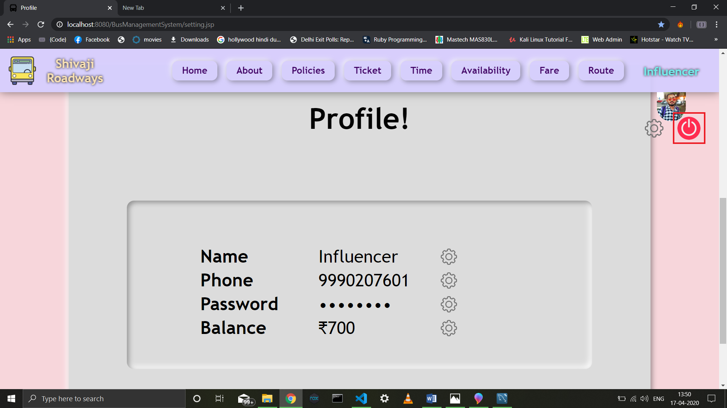

Logged out

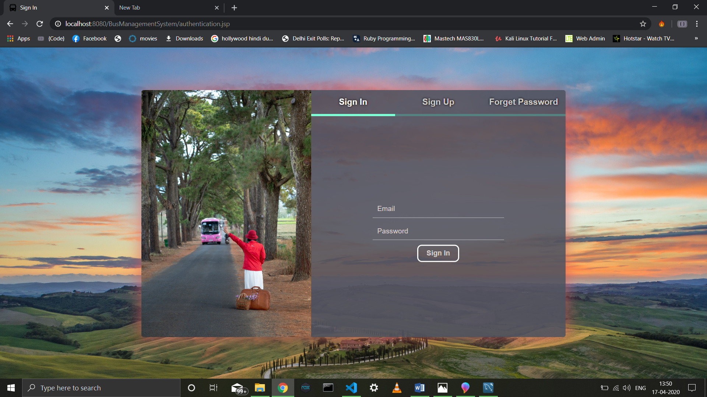

#### Source Code

import java.io.*;

import javax.servlet.*;

import javax.servlet.http.*;

public class logout extends HttpServlet {

    protected void doGet(HttpServletRequest request, HttpServletResponse response)

            throws ServletException, IOException {

        HttpSession session = request.getSession();

        session.invalidate();

        response.sendRedirect("authentication.jsp");

    }

}

#### Sign Up

#### Output

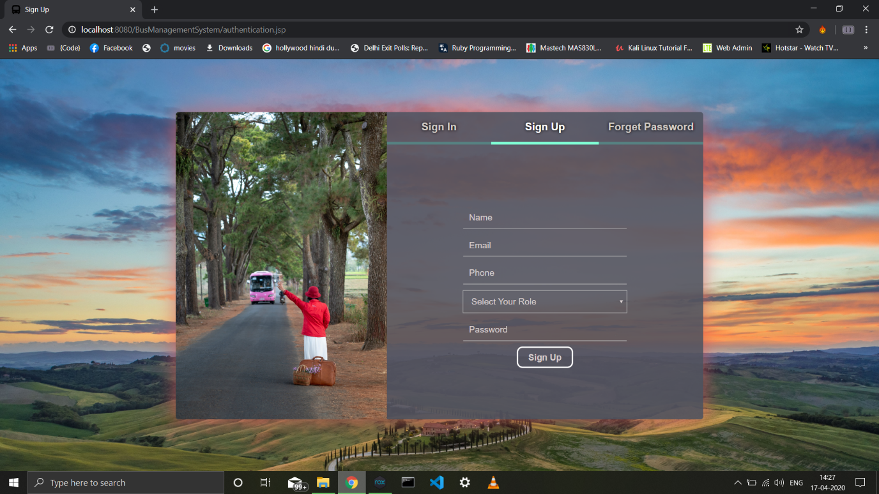

Signing up for Conductor

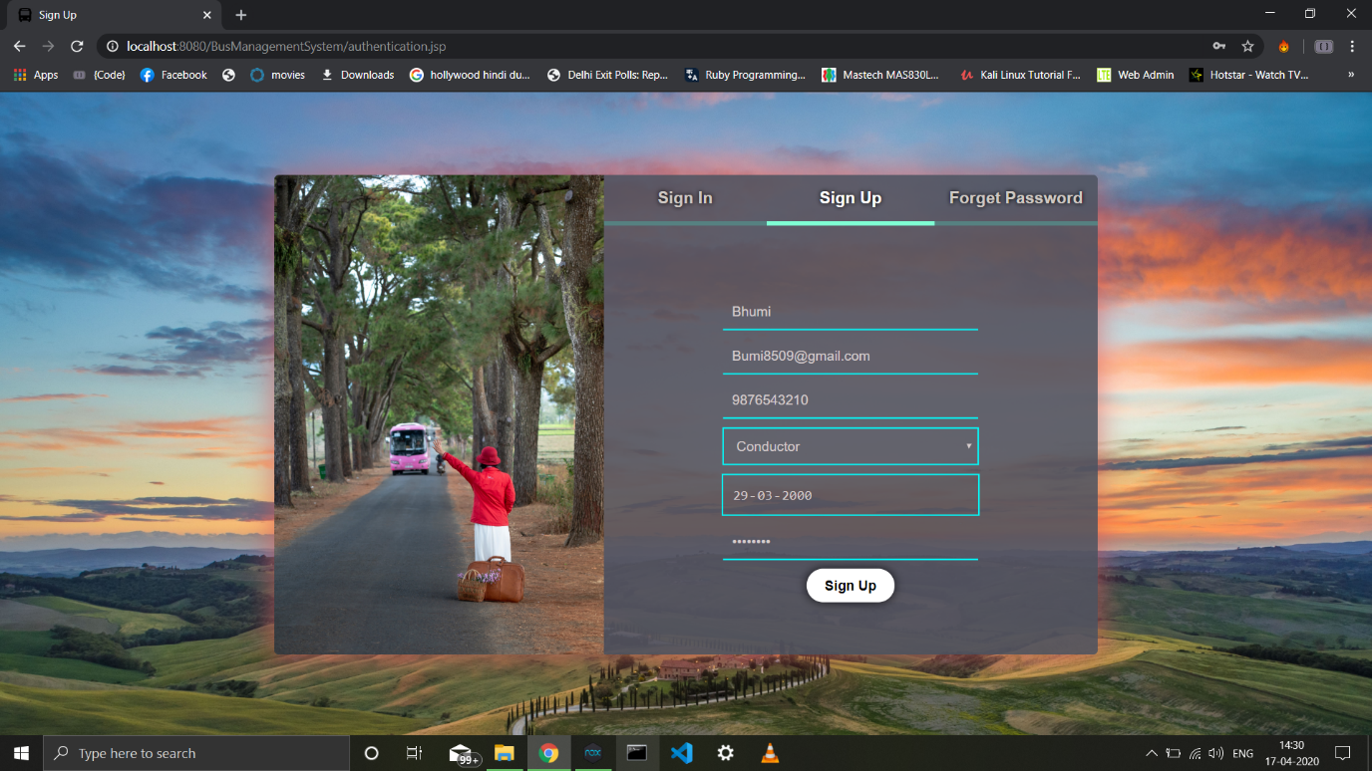

**Selection**: action → SignUp

|  |  |
| --- | --- |
| Name | Bhumi |
| Email | Bumi8509@gmail.com |
| Phone | 9876543210 |
| Role | Conductor |
| Date of birth | 29/03/2000 |
| Password | abcbhumi |

A **randomly generated** OTP sent for account verification

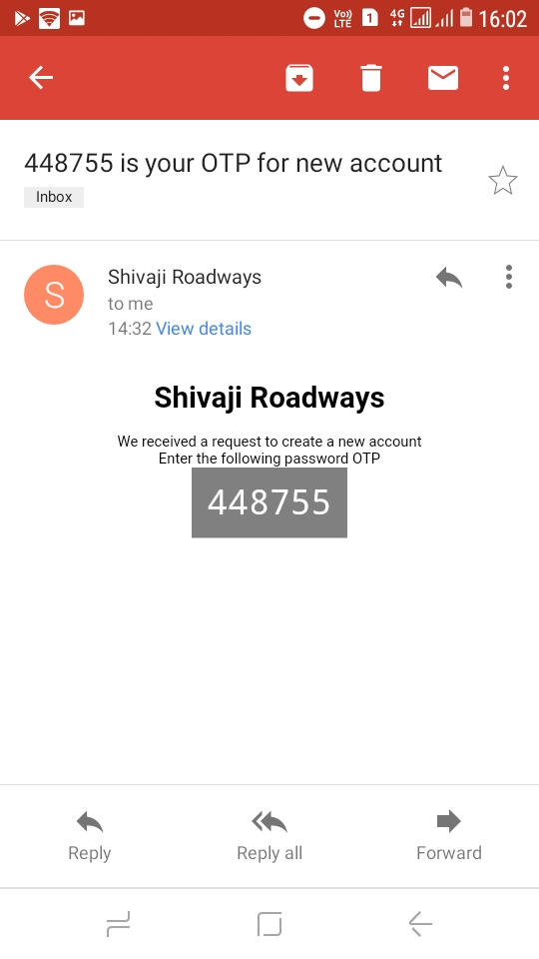

**448755 →** [**Bumi8509@gmail.com**](mailto:Bumi8509@gmail.com)

Entering OTP

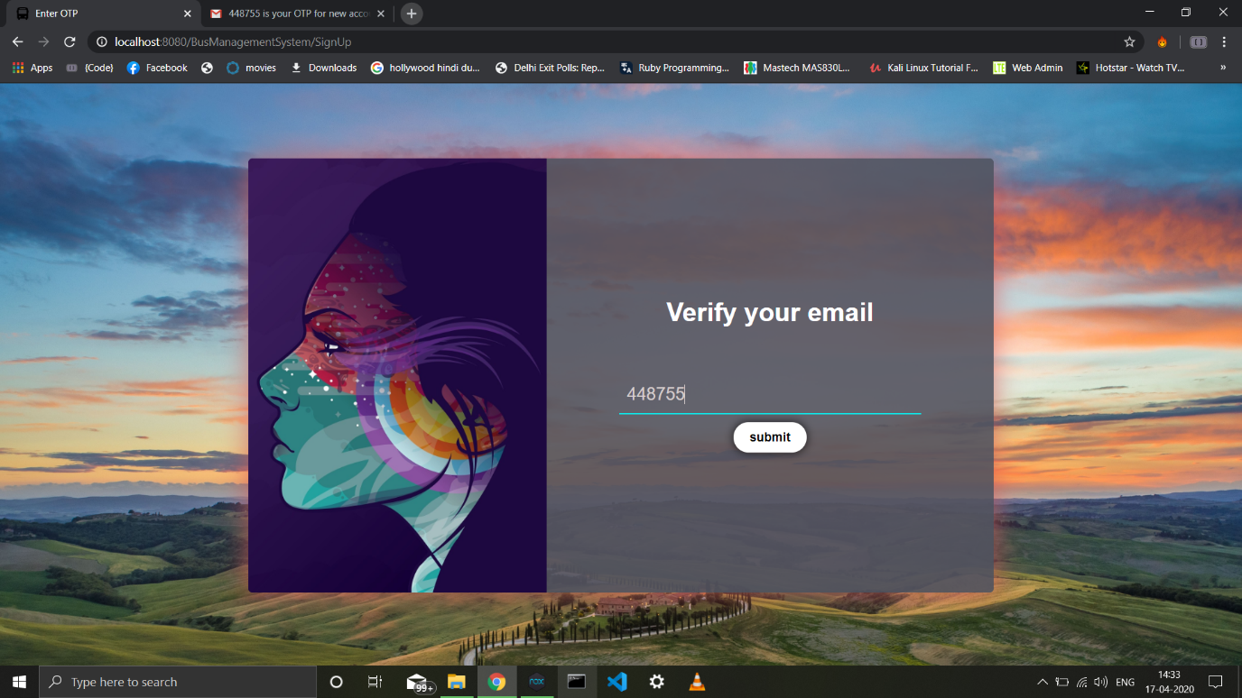

An optional prompt for uploading a profile picture

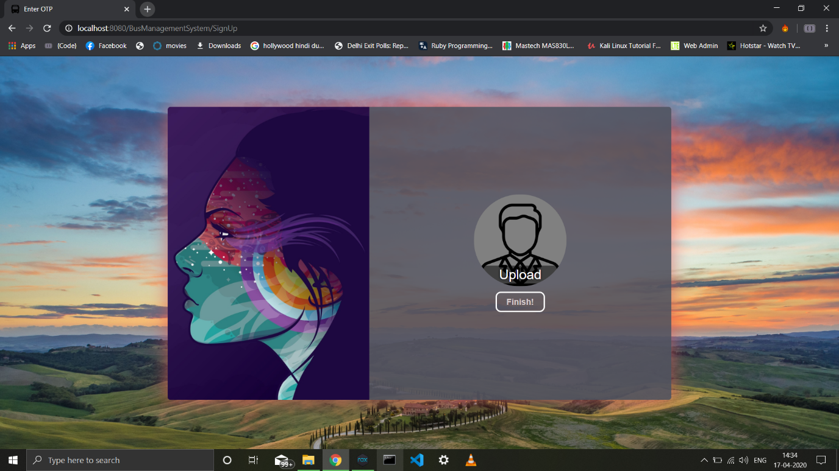

Selecting Profile Picture

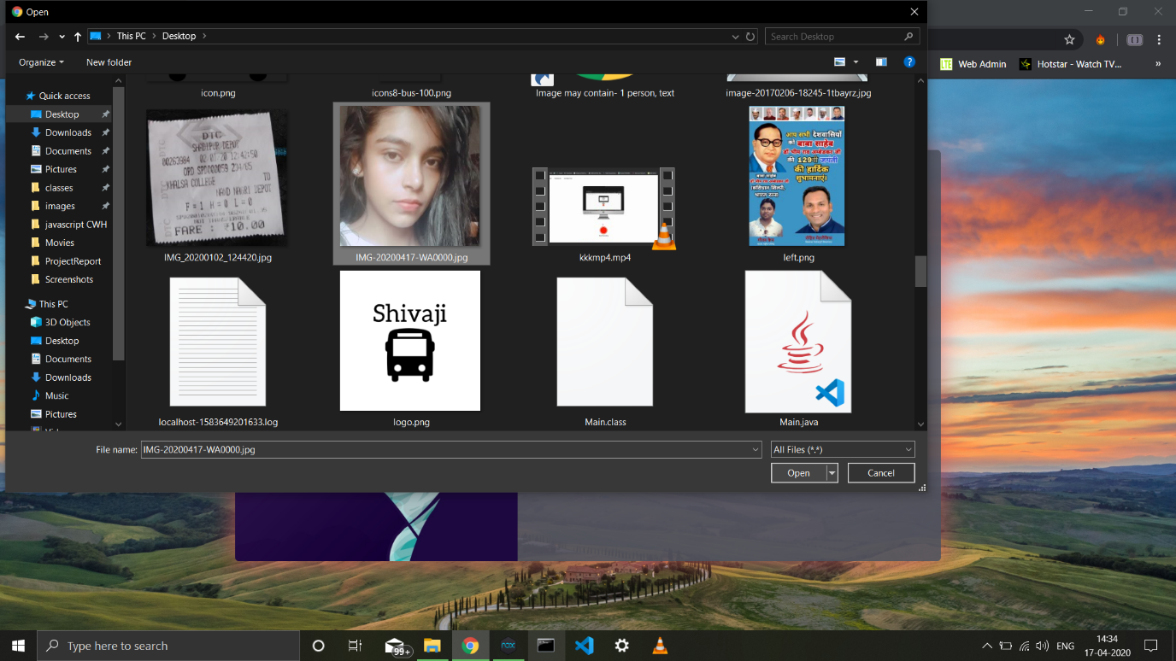

Image uploaded

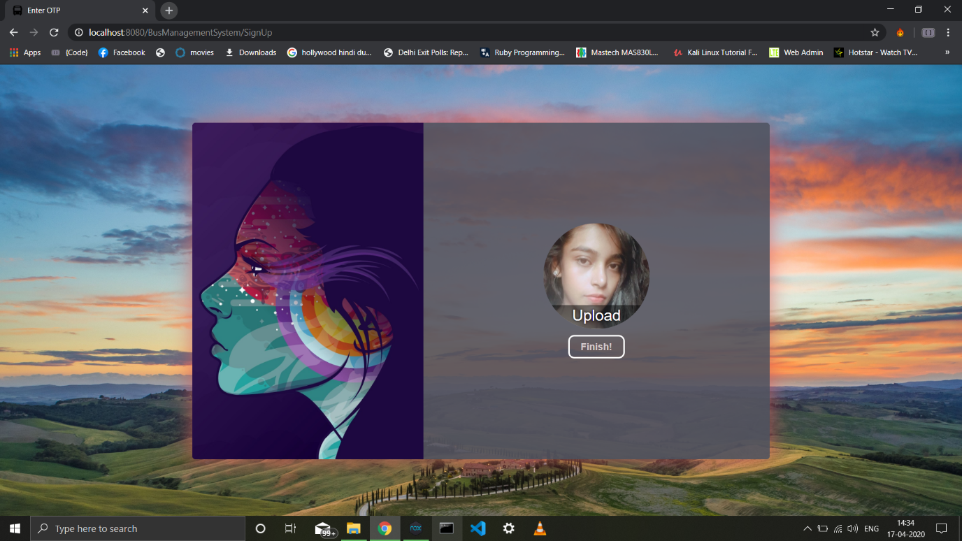

Registration Completed!

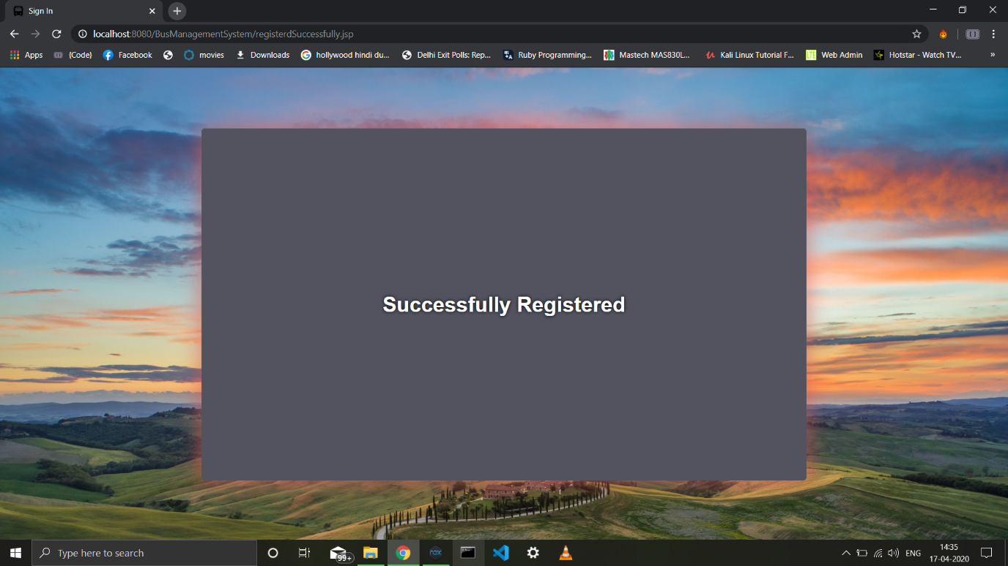

Trying to logging in…

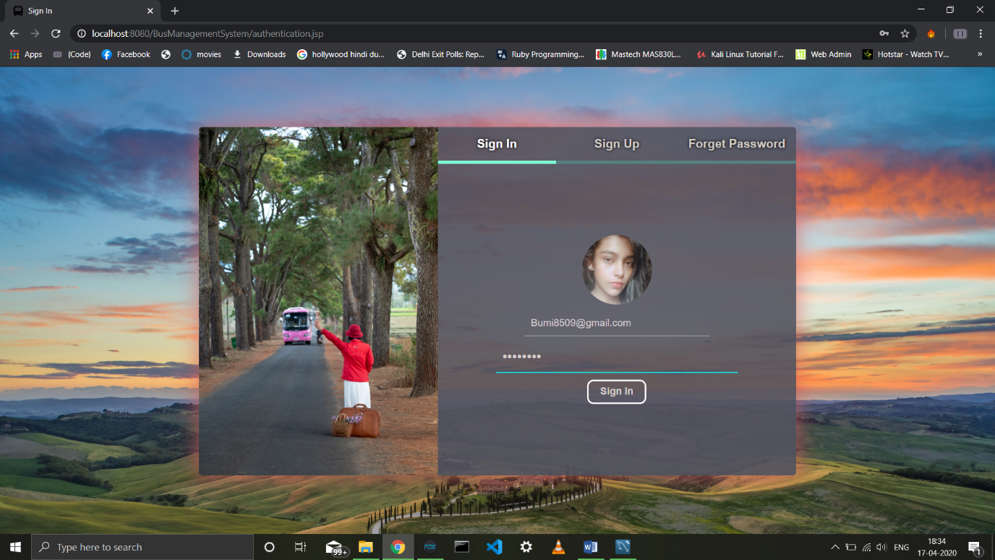

Logged In!

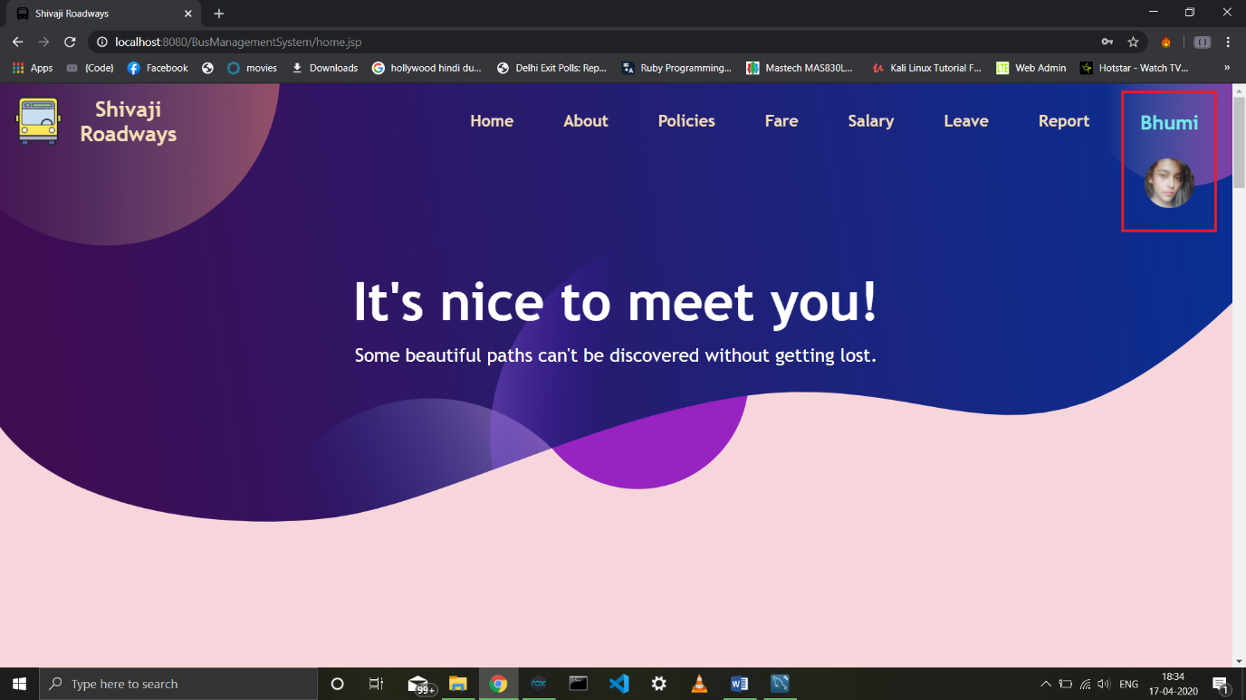

#### Output From Database

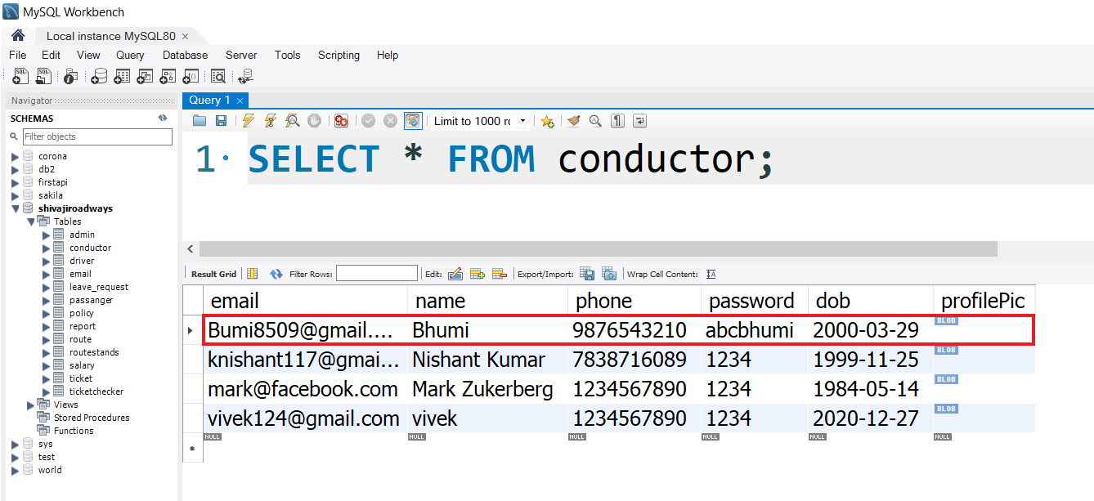

Entry successfully added into Database

#### SignUp.java

import java.io.*;

import javax.servlet.*;

import javax.servlet.http.*;

public class SignUp extends HttpServlet {

    protected void doPost(HttpServletRequest request, HttpServletResponse response)

            throws ServletException, IOException {

        response.setContentType("text/html;charset=UTF-8");

        PrintWriter out = response.getWriter();

        HttpSession session = request.getSession();

        String name = request.getParameter("name");

        String phone = request.getParameter("phone");

        String email = request.getParameter("email");

        String role = request.getParameter("role");

        String password = request.getParameter("password");

        String balance = null;

        String licenceNo = null;

        String experience = null;

        String joiningDate = null;

        if(role.equals("Passanger"))

        {

            balance = request.getParameter("walletBalance");

            session.setAttribute("tempBalance", balance);

        }

        if(role.equals("Driver"))

        {

            licenceNo = request.getParameter("licenceNo");

            experience = request.getParameter("experience");

            joiningDate = request.getParameter("joiningDate");

            session.setAttribute("tempLicenceNo", licenceNo);

            session.setAttribute("tempExperience", experience);

            session.setAttribute("tempJoiningDate", joiningDate);

        }

        if(role.equals("Conductor"))

        {

            joiningDate = request.getParameter("joiningDate");

            session.setAttribute("tempJoiningDate", joiningDate);

        }

        if(role.equals("Ticket Checker"))

        {

            joiningDate = request.getParameter("joiningDate");

            session.setAttribute("tempJoiningDate", joiningDate);

        }

        session.setAttribute("tempName", name);

        session.setAttribute("tempPhone", phone);

        session.setAttribute("tempEmail", email);

        session.setAttribute("tempRole", role);

        session.setAttribute("tempPassword", password);

        String to = request.getParameter("email");

        String otp=GenerateOTP.get();

        String subject = otp+" is your OTP for new account";

        String message =otp;

        String user = "knishant113@gmail.com"; //gmail user ID

        String pass = "xxxxxxx"; //gmail user password

        SendMail.sendForSignUP(to,subject, message, user, pass);

        request.setAttribute("otp", otp);

        request.getRequestDispatcher("confirmEmail.jsp").forward(request, response);

        response.sendRedirect("confirmEmail.jsp");

    }

}

#### singUpProcess.jsp

<%@page import="java.sql.*"%><%@ page import = "java.io.*,java.util.*, javax.servlet.*" %>

<%@ page import = "javax.servlet.http.*" %>

<%@ page import = "org.apache.commons.fileupload.*" %>

<%@ page import = "org.apache.commons.fileupload.disk.*" %>

<%@ page import = "org.apache.commons.fileupload.servlet.*" %>

<%@ page import = "org.apache.commons.io.output.*" %>

<%

   File file ;

   int maxFileSize = 5000 * 1024;

   int maxMemSize = 5000 * 1024;

   String fileName = "";

   ServletContext context = pageContext.getServletContext();

   String filePath = context.getInitParameter("file-upload");

   String contentType = request.getContentType();

   if ((contentType.indexOf("multipart/form-data") >= 0)) {

      DiskFileItemFactory factory = new DiskFileItemFactory();

      factory.setSizeThreshold(maxMemSize);

      factory.setRepository(new File("c:\\temp"));

      ServletFileUpload upload = new ServletFileUpload(factory);

      upload.setSizeMax( maxFileSize );

      try { .

         List fileItems = upload.parseRequest(request);

         Iterator i = fileItems.iterator();

         out.println("<**html**>");

         out.println("<**head**>");

         out.println("<**title**>JSP File upload</**title**>");

         out.println("</**head**>");

         out.println("<**body**>");

         while ( i.hasNext () ) {

            FileItem fi = (FileItem)i.next();

            if ( !fi.isFormField () ) {

               // Get the uploaded file parameters

               String fieldName = fi.getFieldName();

               int dotPos = fi.getName().lastIndexOf(".");

               String extn = fi.getName().substring(dotPos, fi.getName().length());

               fileName = (String)session.getAttribute("tempEmail")+extn;

               boolean isInMemory = fi.isInMemory();

               long sizeInBytes = fi.getSize();

               // Write the file

               if( fileName.lastIndexOf("\\") >= 0 ) {

                  file = new File( filePath +

                  fileName.substring( fileName.lastIndexOf("\\"))) ;

               } else {

                  file = new File( filePath +

                  fileName.substring(fileName.lastIndexOf("\\")+1)) ;

               }

               fi.write( file ) ;

               out.println("Uploaded Filename: " + filePath +

               fileName + "<**br**>");

            }

         }

         out.println("</**body**>");

         out.println("</**html**>");

      } catch(Exception ex) {

         System.out.println(ex);

      }

   } else {

      out.println("<**html**>");

      out.println("<**head**>");

      out.println("<**title**>Servlet upload</**title**>");

      out.println("</**head**>");

      out.println("<**body**>");

      out.println("<**p**>No file uploaded</**p**>");

      out.println("</**body**>");

      out.println("</**html**>");

   }

    String name = (String)session.getAttribute("tempName");

    String email = (String)session.getAttribute("tempEmail");

    String phone = (String)session.getAttribute("tempPhone");

    String role = (String)session.getAttribute("tempRole");

    String password = (String)session.getAttribute("tempPassword");

    String balance = null;

    String licenceNo = null;

    String experience = null;

    String joiningDate = null;

    Connection con = null;

    Statement st = null;

    String query = null;

    if(role.equals("Admin"))

    {

        try

        {

            Class.forName("com.mysql.jdbc.Driver");

            con = DriverManager.getConnection("jdbc:mysql://localhost:3306/shivajiroadways", "root", "1234");

            st = con.createStatement();

            query = "insert into Email values('" + email + "')";

            st.executeUpdate(query);

            query = "insert into admin(email, name, phone, password, profilePic) values('"+email+"', '"+name+"', '"+phone+"', '"+password+"', '"+fileName+"');";

            st.executeUpdate(query);

        }

        catch(Exception e)

        {

            out.print(e.getMessage());

        }

    }

    if(role.equals("Passanger"))

    {

        balance = (String)session.getAttribute("tempBalance");

        out.print(" account balance: "+balance);

        try

        {

            Class.forName("com.mysql.jdbc.Driver");

            con = DriverManager.getConnection("jdbc:mysql://localhost:3306/shivajiroadways", "root", "1234");

            st = con.createStatement();

            query = "insert into Email values('" + email + "')";

            st.executeUpdate(query);

            query = "insert into passanger(email, name, phone, password, walletBalance, profilePic) values('"+email+"', '"+name+"', '"+phone+"', '"+password+"', '"+Integer.parseInt(balance)+"', '"+fileName+"');";

            st.executeUpdate(query);

        }

        catch(Exception e)

        {

            out.print(e.getMessage());

        }

    }

    if(role.equals("Driver"))

    {

        licenceNo = (String)session.getAttribute("tempLicenceNo");

        experience = (String)session.getAttribute("tempExperience");

        joiningDate = (String)session.getAttribute("tempJoiningDate");

        out.print(" licenceNo: "+licenceNo+" experience: "+experience+" joiningDate: "+joiningDate);

        try

        {

            Class.forName("com.mysql.jdbc.Driver");

            con = DriverManager.getConnection("jdbc:mysql://localhost:3306/shivajiroadways", "root", "1234");

            st = con.createStatement();

            query = "insert into Email values('" + email + "')";

            st.executeUpdate(query);

            query = "insert into driver(email, name, phone, password, licenceNo, experience, dob, profilePic)  values('"+email+"', '"+name+"', '"+phone+"', '"+password+"', '"+licenceNo+"', '"+Integer.parseInt(experience)+"', '"+joiningDate+"', '"+fileName+"');";

            st.executeUpdate(query);

        }

        catch(Exception e)

        {

            out.print(e.getMessage());

        }

    }

    if(role.equals("Conductor"))

    {

        joiningDate = (String)session.getAttribute("tempJoiningDate");

        out.print(" joiningDate: "+joiningDate);

        try

        {

            Class.forName("com.mysql.jdbc.Driver");

            con = DriverManager.getConnection("jdbc:mysql://localhost:3306/shivajiroadways", "root", "1234");

            st = con.createStatement();

            query = "insert into Email values('" + email + "')";

            st.executeUpdate(query);

            query = "insert into conductor(email, name, phone, password, dob, profilePic)  values('"+email+"', '"+name+"', '"+phone+"', '"+password+"', '"+joiningDate+"', '"+fileName+"');";

            st.executeUpdate(query);

        }

        catch(Exception e)

        {

            out.print(e.getMessage());

        }

    }

    if(role.equals("Ticket Checker"))

    {

        joiningDate = (String)session.getAttribute("tempJoiningDate");

        out.print(" joiningDate: "+joiningDate);

        try

        {

            Class.forName("com.mysql.jdbc.Driver");

            con = DriverManager.getConnection("jdbc:mysql://localhost:3306/shivajiroadways", "root", "1234");

            st = con.createStatement();

            query = "insert into Email values('" + email + "')";

            st.executeUpdate(query);

            query = "insert into ticketchecker(email, name, phone, password, dob, profilePic)  values('"+email+"', '"+name+"', '"+phone+"', '"+password+"', '"+joiningDate+"', '"+fileName+"');";

            st.executeUpdate(query);

        }

        catch(Exception e)

        {

            out.print(e.getMessage());

        }

    }

    response.sendRedirect("registerdSuccessfully.jsp");

%>

#### Forget Password

We are assuming that the user [himanshu32301@gmail.com](mailto:himanshu32301@gmail.com) have forgot the account password

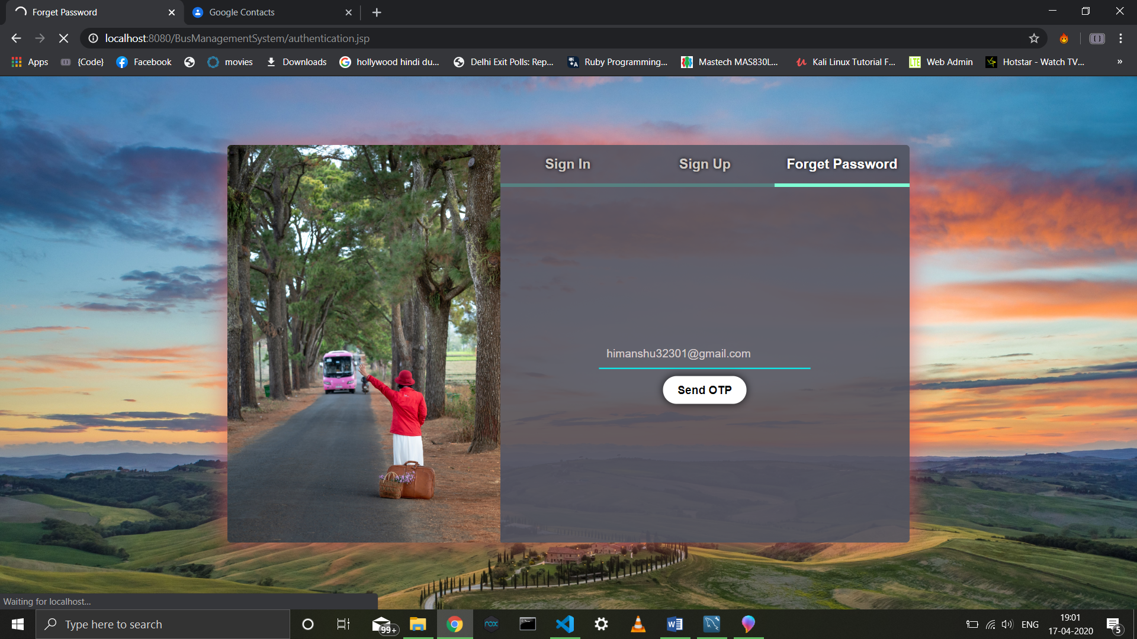

Sending a randomly generated OTP

**489893 →** [**himanshu32301@gmail.com**](mailto:himanshu32301@gmail.com)

**7**

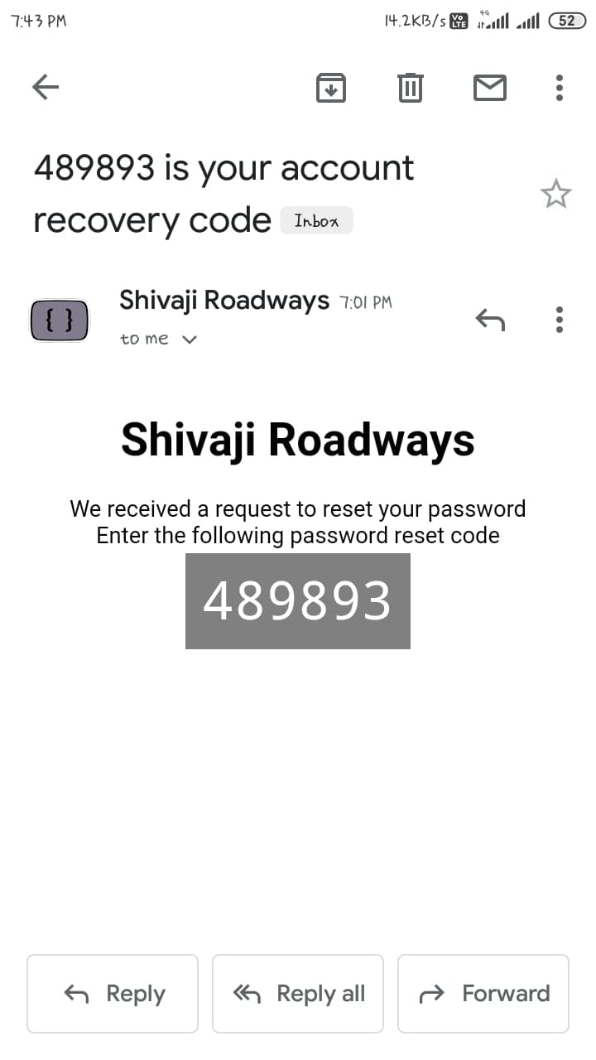

Entering OTP…

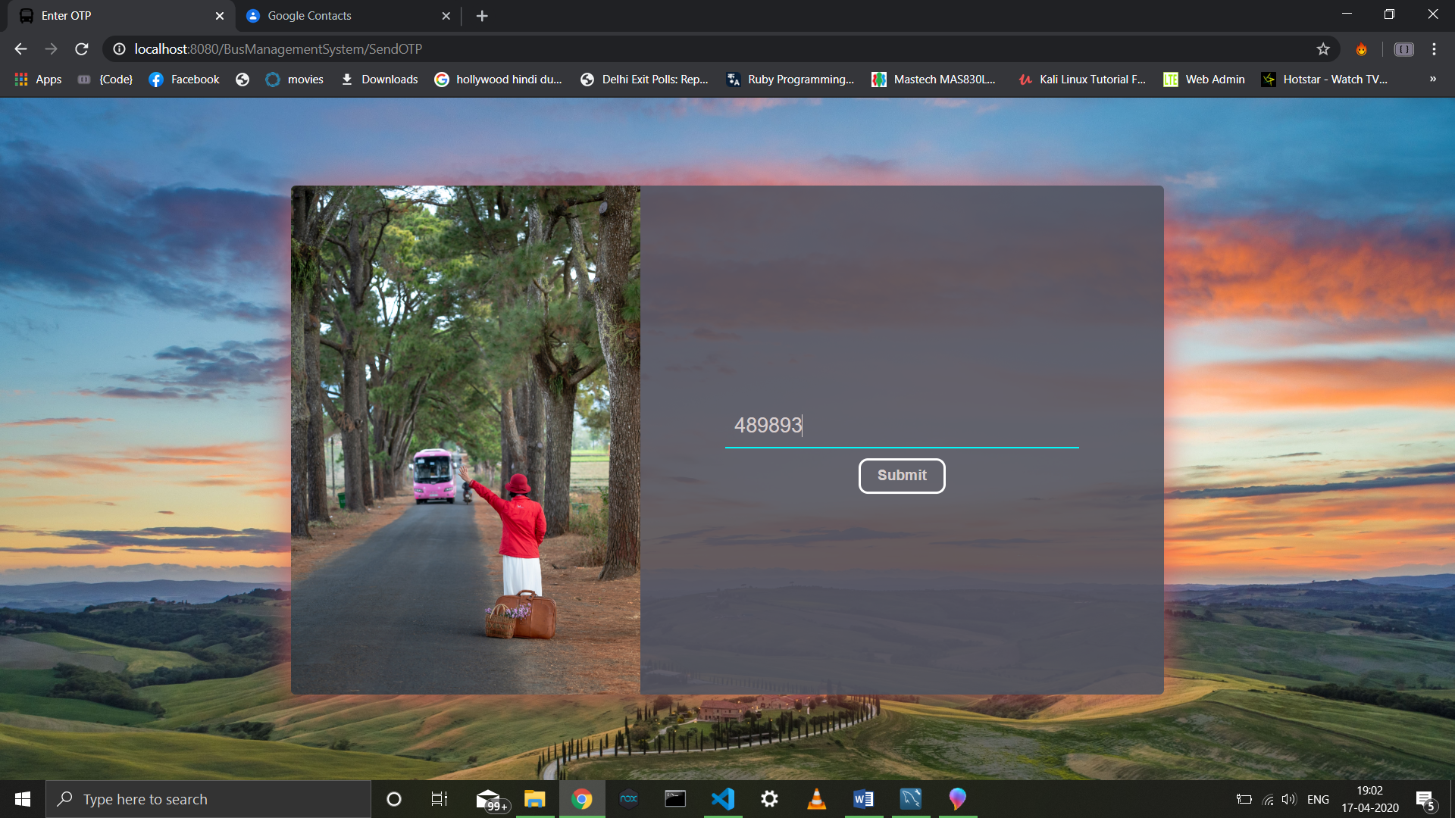

Prompt for create a new password

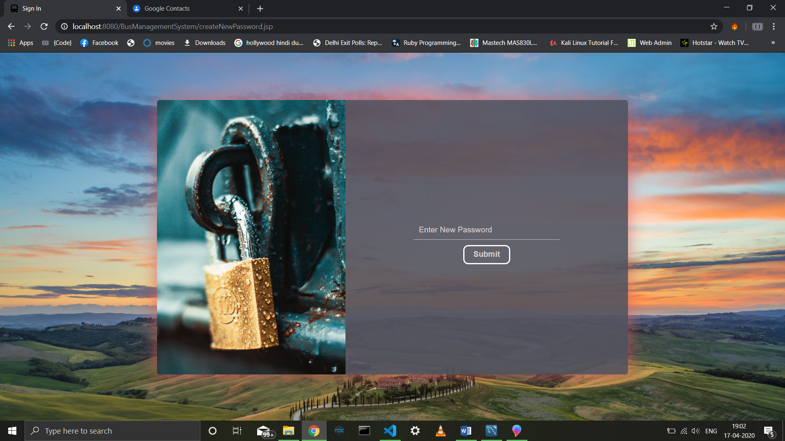

Creating new password

New Password: **MRTN_influ**

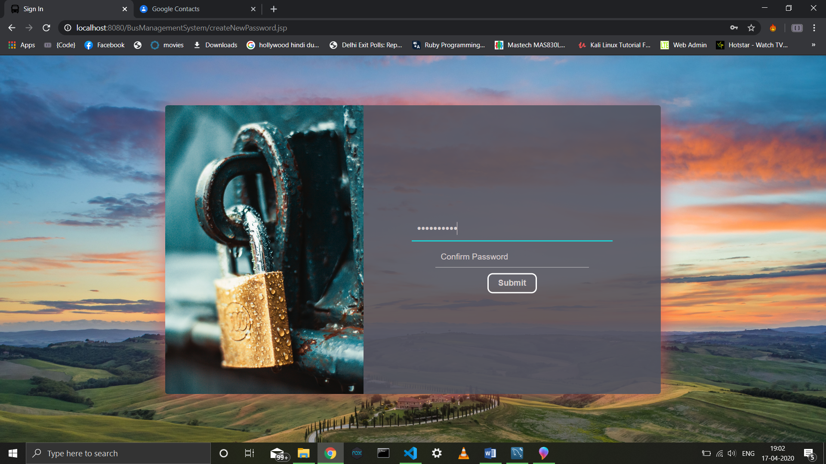

Confirming Passoword

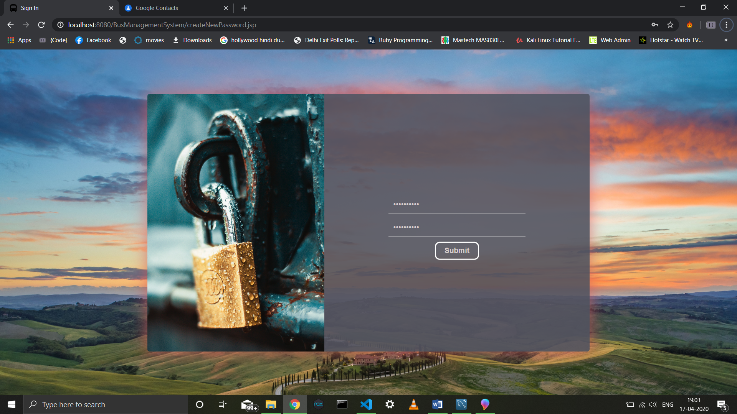

Password Updated

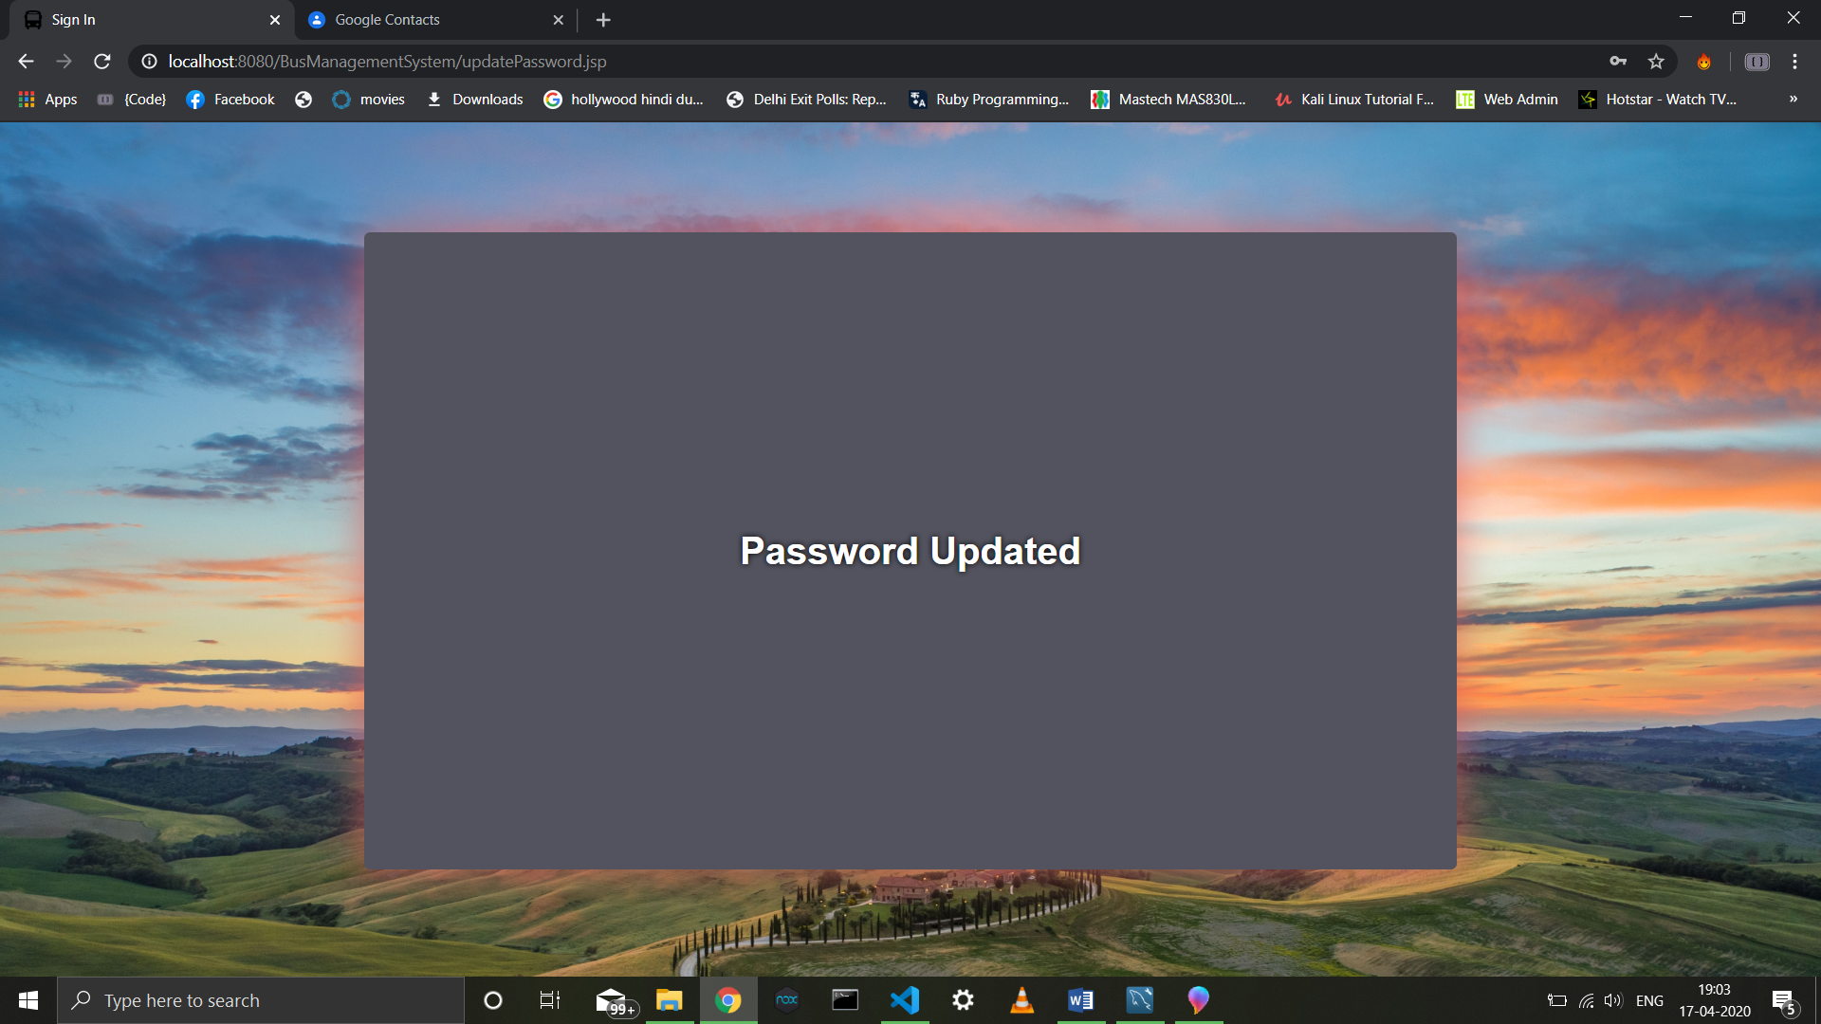

Database **before** password update

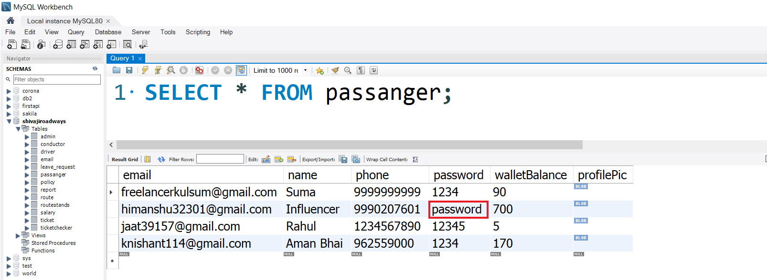

**After** Update

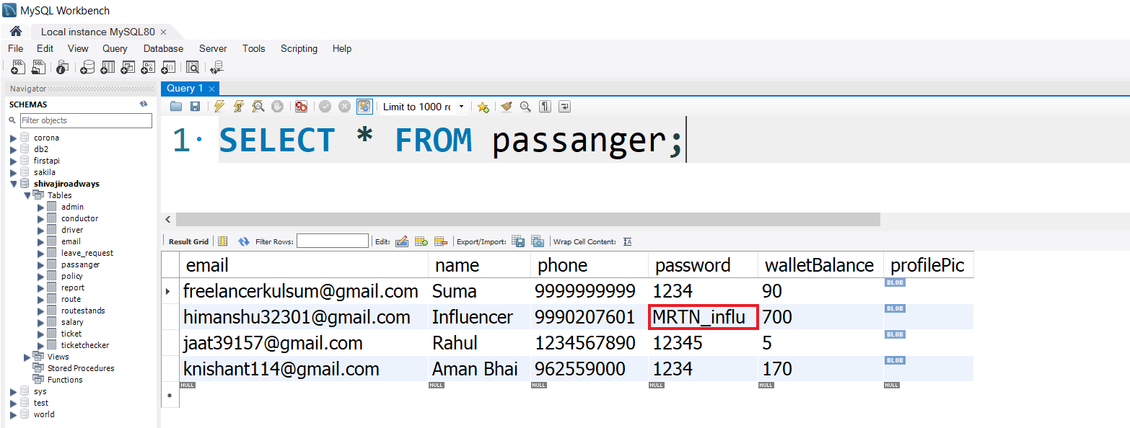

#### Source Code

#### updatePassword.jsp

<%@page import="java.sql.*"%>

<%

    String password = request.getParameter("newPassword");

    String email = (String)session.getAttribute("emailForOTP");

    Connection con = null;

    Statement st = null;

    ResultSet rs = null;

    try

    {

        Class.forName("com.mysql.jdbc.Driver");

        con = DriverManager.getConnection("jdbc:mysql://localhost:3306/shivajiroadways", "root", "1234");

        st = con.createStatement();

        String query = "select 'admin' as tablename from admin  where email = '"+email+"' union select 'passanger' as tablename from  passanger  where email = '"+email+"' union select 'conductor' as tablename from conductor  where email = '"+email+"' union select 'ticketchecker' as tablename from ticketchecker  where email = '"+email+"'";

        rs = st.executeQuery(query);

        rs.next();

        query = "update "+rs.getString("tablename")+" set password = '"+password+"' where email = '"+email+"'";

        st.executeUpdate(query);

        %>

        <**head**>

            <**meta** charset**=**"UTF-8">

            <**meta** name**=**"viewport" content**=**"width=device-width, initial-scale=1.0">

            <**meta** http-equiv**=**"X-UA-Compatible" content**=**"ie=edge">

            <**meta** http-equiv**=**"refresh" content**=**"3;url=authentication.jsp" />

            <**link** rel**=**"stylesheet" href**=**"styles/style.css">

            <**link** rel**=**"stylesheet" href**=**"styles/authentication.css">

            <**link** rel**=**"icon" href**=**"images/icon.png">

            <**title**>Password Updated</**title**>

            <**style**>

**.container**

                {

                    background-color**:** rgb(83, 83, 95)

                }

**h1**

                {

                    color**:** white;

                    text-shadow**:** 0px 0px 5px black;

                    text-align**:** center;

                    position**:** relative;

                    top**:** 50%;

                    transform**:** translateY(-50%);

                }

            </**style**>

        </**head**>

        <**body**>

            <**div** class**=**"container">

                <**h1**>Password Updated<**h1**>

            </**div**>

        </**body**>

        <**script** src**=**"scripts/authentication.js"></**script**>

        </**html**>

        <%

    }

    catch(Exception e){ out.print(e.getMessage()); }

%>

#### createNewPassword.jsp

<!**DOCTYPE** html>

<**html** lang**=**"en">

<head>

    <**meta** charset**=**"UTF-8">

    <**meta** name**=**"viewport" content**=**"width=device-width, initial-scale=1.0">

    <**meta** http-equiv**=**"X-UA-Compatible" content**=**"ie=edge">

    <**link** rel**=**"stylesheet" href**=**"styles/style.css">

    <**link** rel**=**"stylesheet" href**=**"styles/authentication.css">

    <**link** rel**=**"icon" href**=**"images/icon.png">

    <**title**>Create New Password</**title**>

</head>

<body>

    <**div** class**=**"container">

        <**div** class**=**"imageDiv" style**=**"background-image: url('images/lock.jpg')">

        </**div**>

        <**div** class**=**"workspace">

            <**form** action**=**"updatePassword.jsp" method**=**"POST" onsubmit**=**"**return** mathcPassword();">

                <**input** type**=**"password"

                            name**=**"newPassword"

                            id**=**"newPassword"

                            placeholder**=**"Enter New Password"

                            onkeyup**=**"confirmPasswordField(this.value.length)">

                <**input** type**=**"hidden" placeholder**=**"Confirm Password" id**=**"confirmPassword">

                <**input** type**=**"submit">

            </**form**>

        </**div**>

    </**div**>

</body>

<**script** src**=**"scripts/authentication.js"></**script**>

<script>

**function** mathcPassword()

    {

**if**(document.getElementById("newPassword").value **!=** document.getElementById("confirmPassword").value)

        {

            document.getElementById("confirmPassword").value **=** "";

            document.getElementById("confirmPassword").placeholder **=** "Passwords didn't match!";

            document.getElementById("confirmPassword").style.borderBottom **=** "1.9px solid rgb(241, 101, 7)";

**return** false;

        }

**else**

**return** true;

    }

</script>

</html>

#### addFeedback.jsp

This module is for saving the feedbacks of the user.

The process in which part of the output of a system in returned to its input in order to regulate its further output.

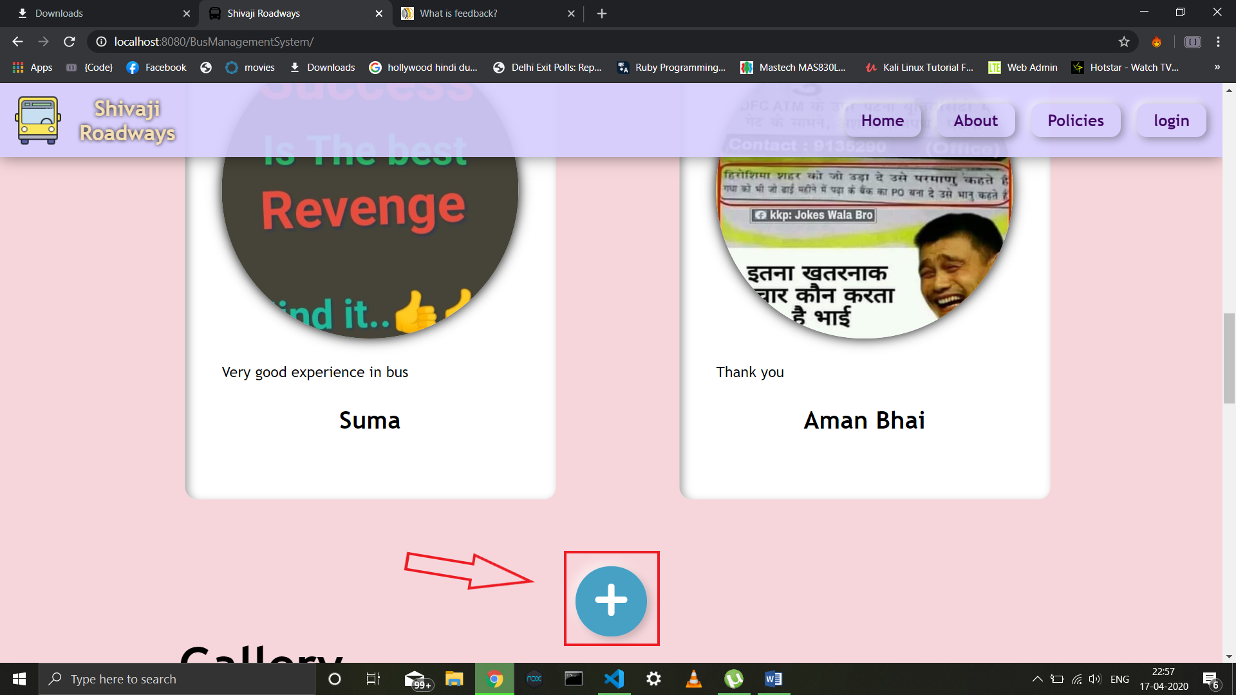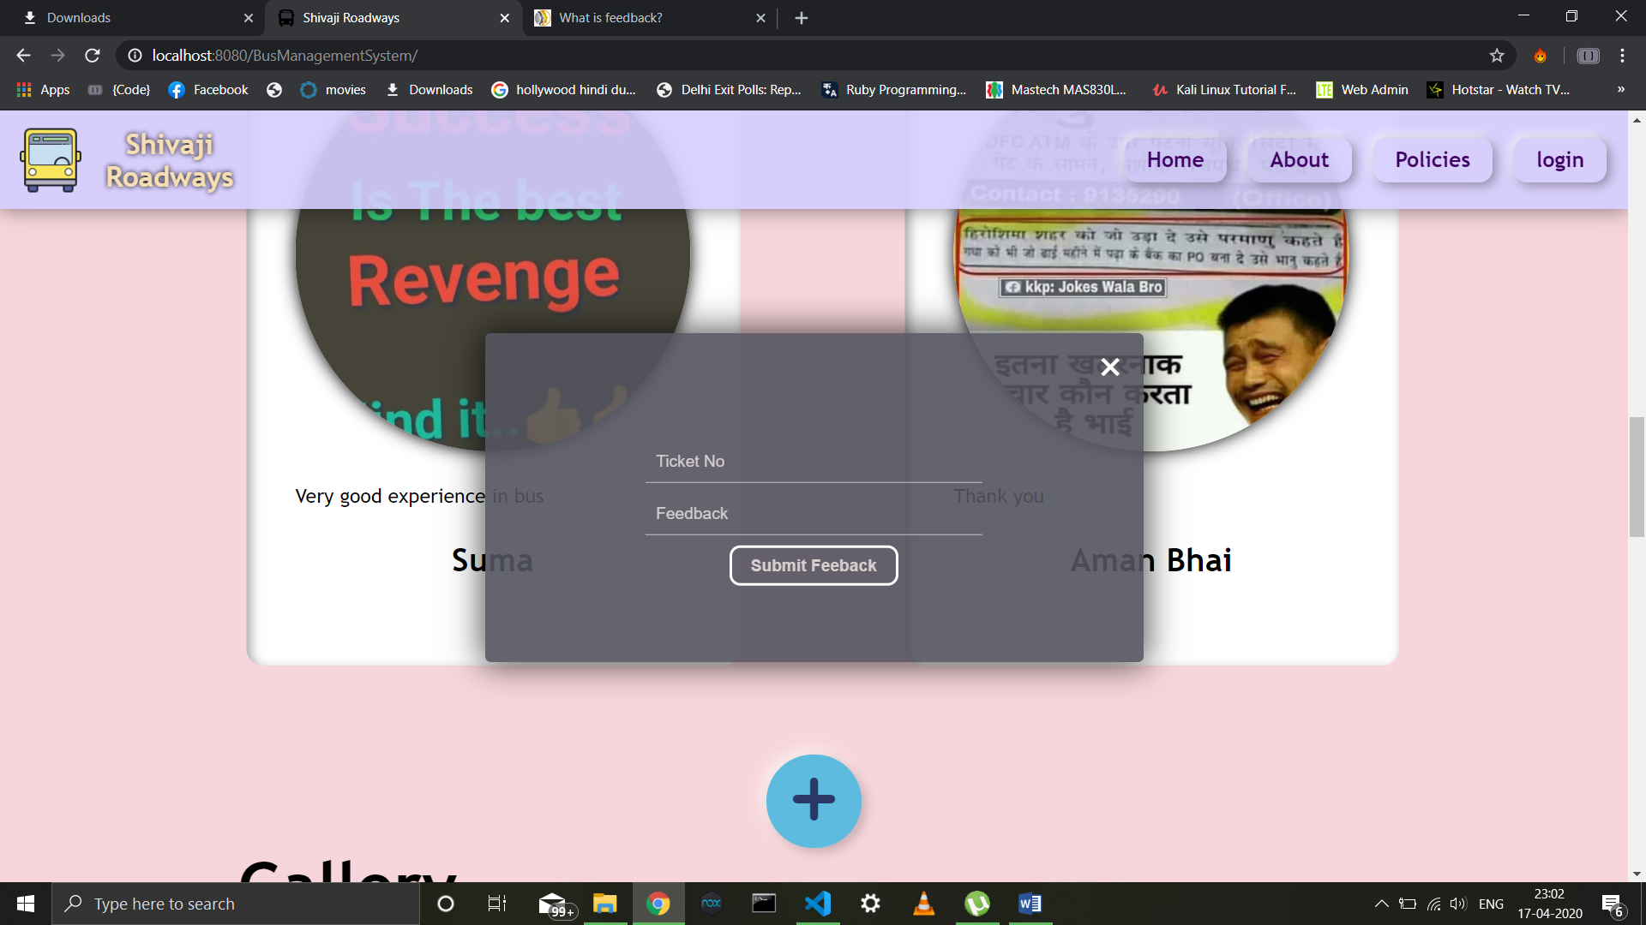

Parameters:

**Ticket No:** MAN_ASH_1042

#### **Feedback:** Bus timing was awesome but need to increase hygienic environment in the buses

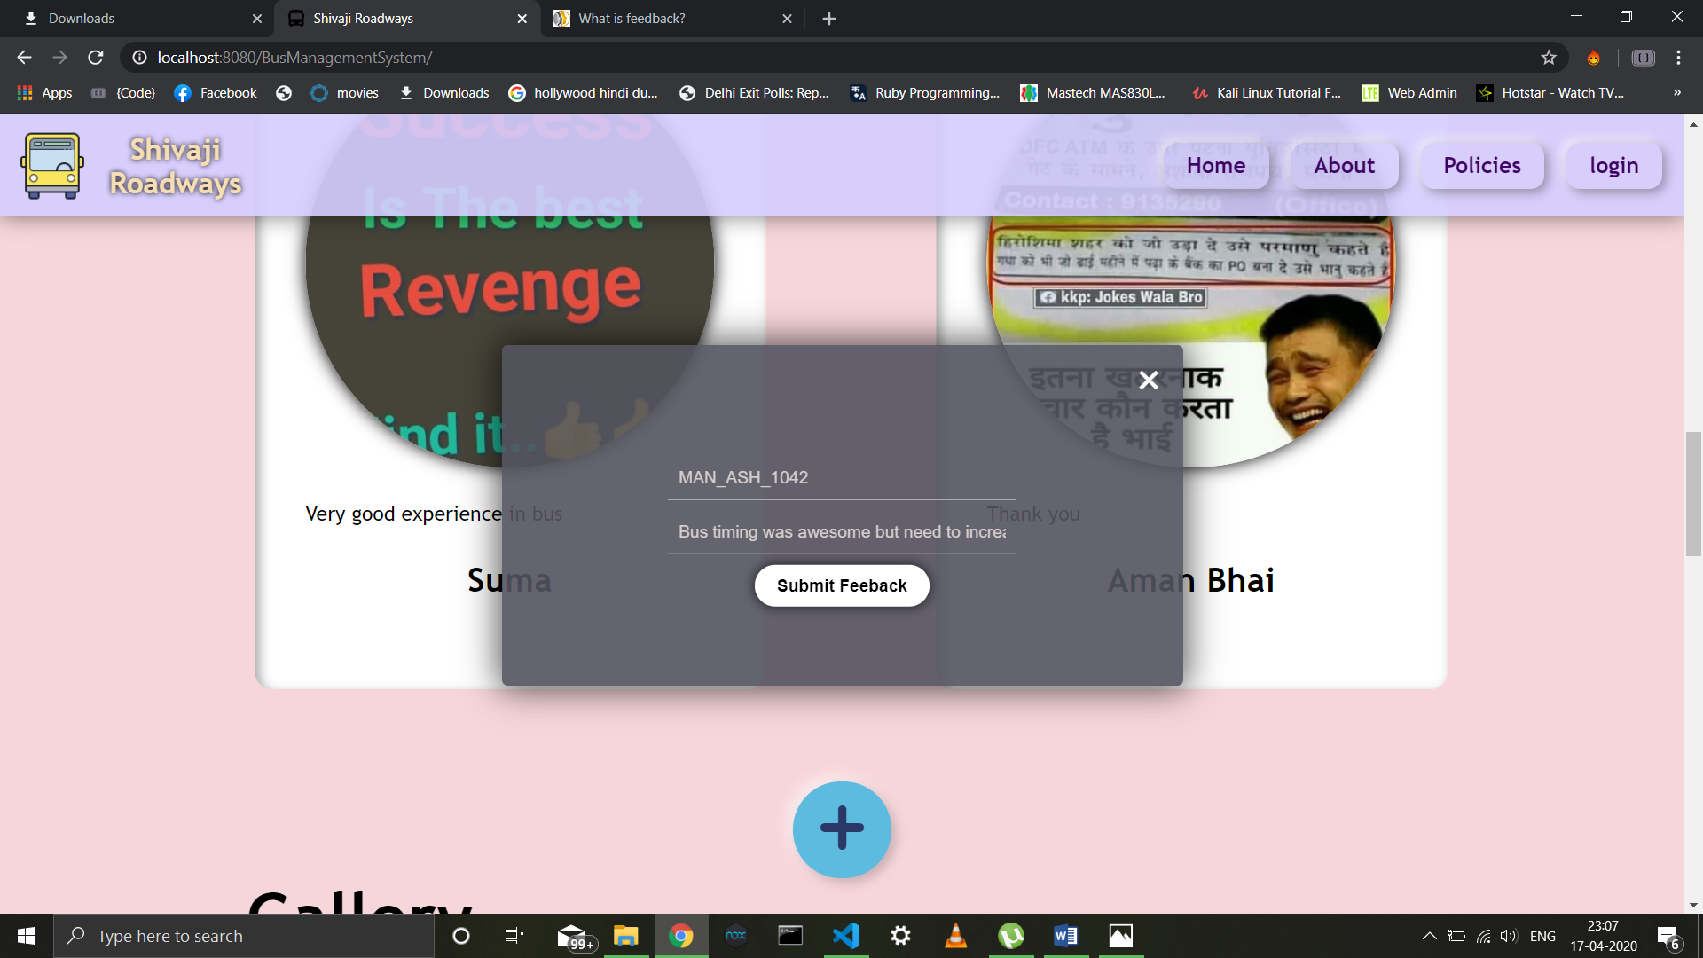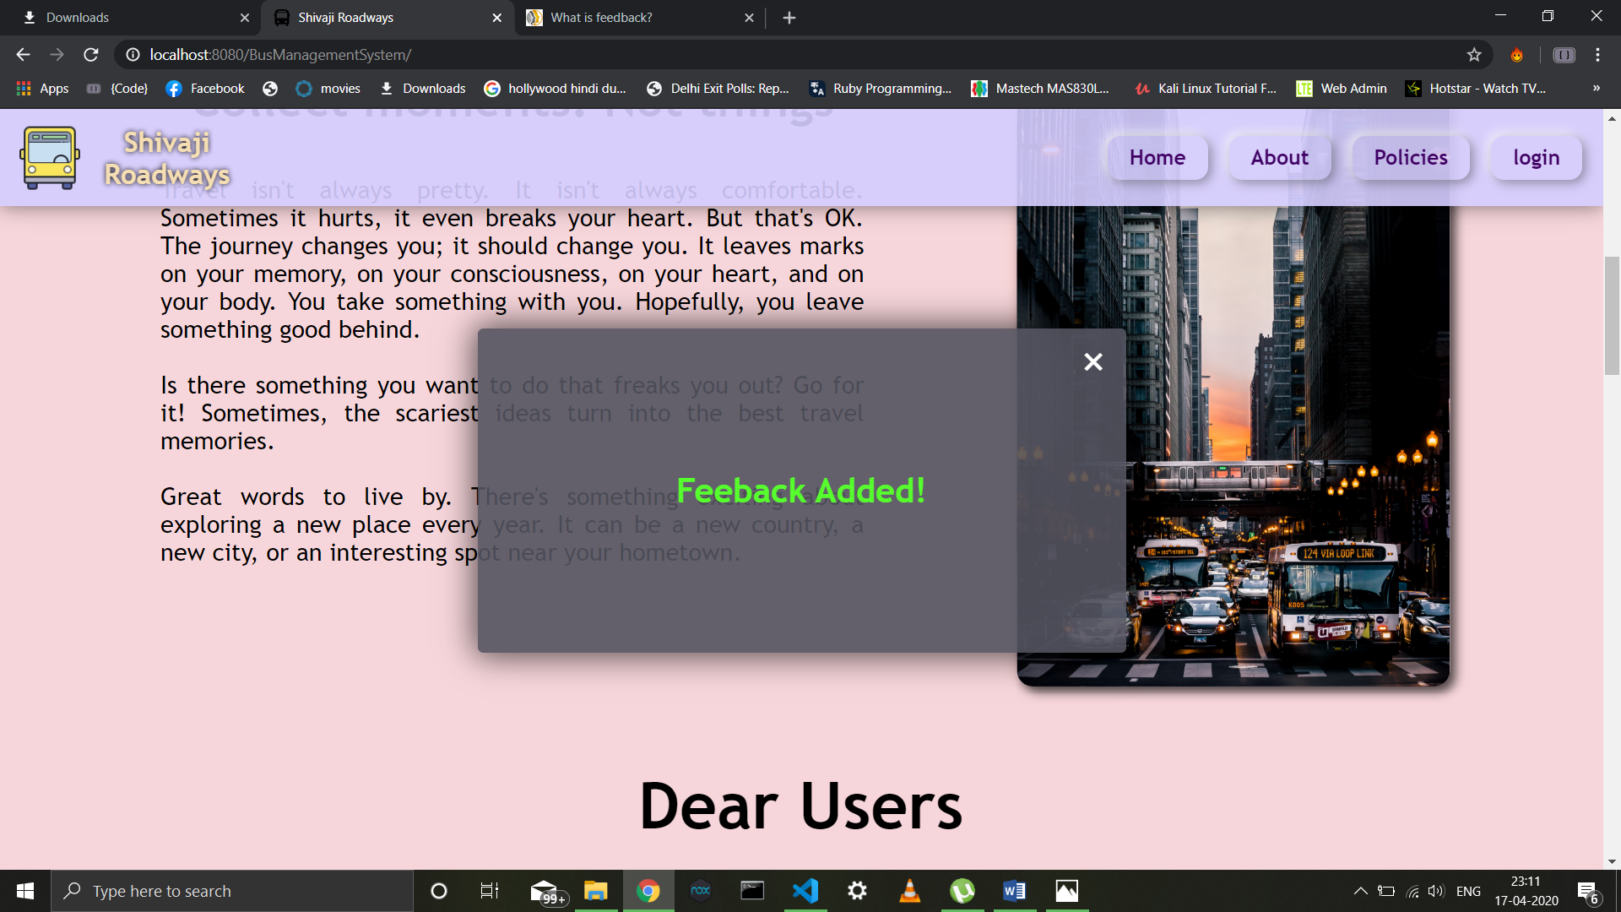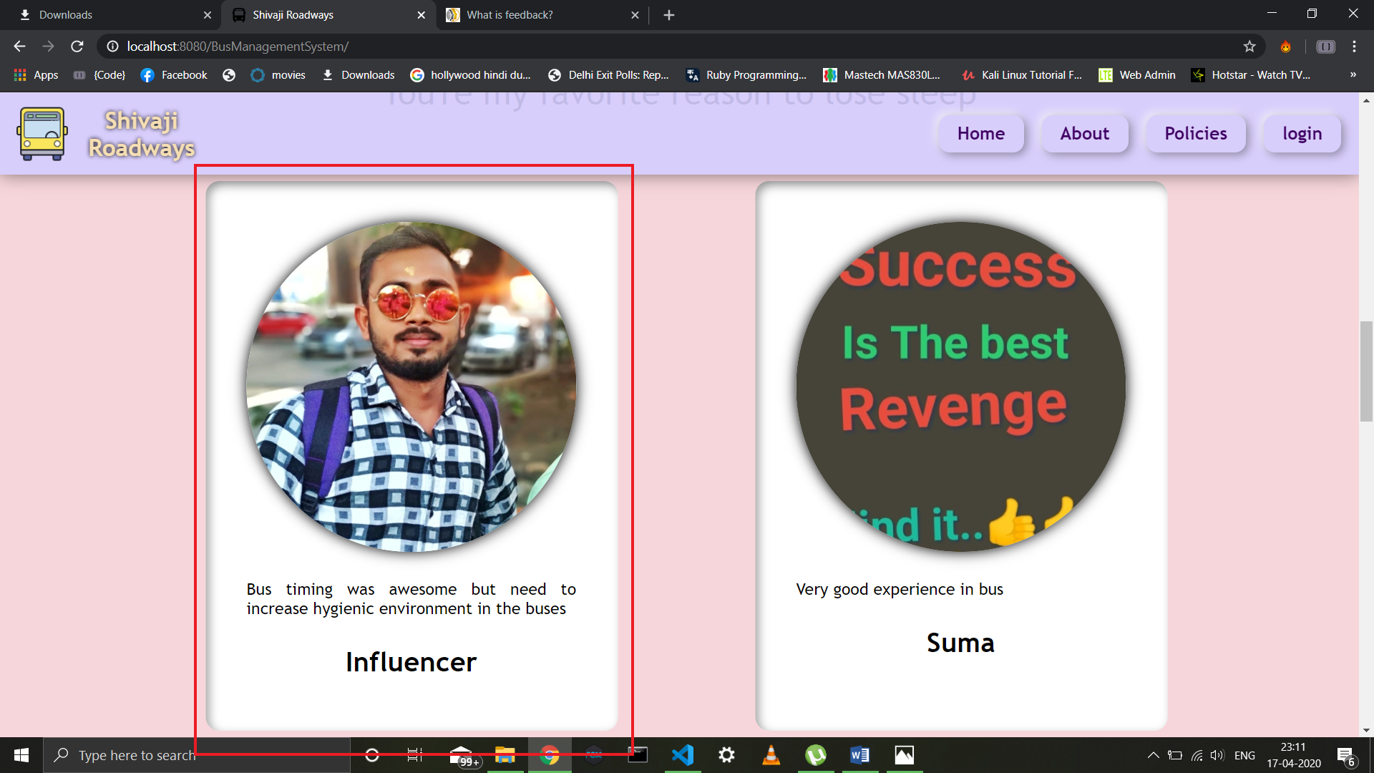

#### Entry Added into Database

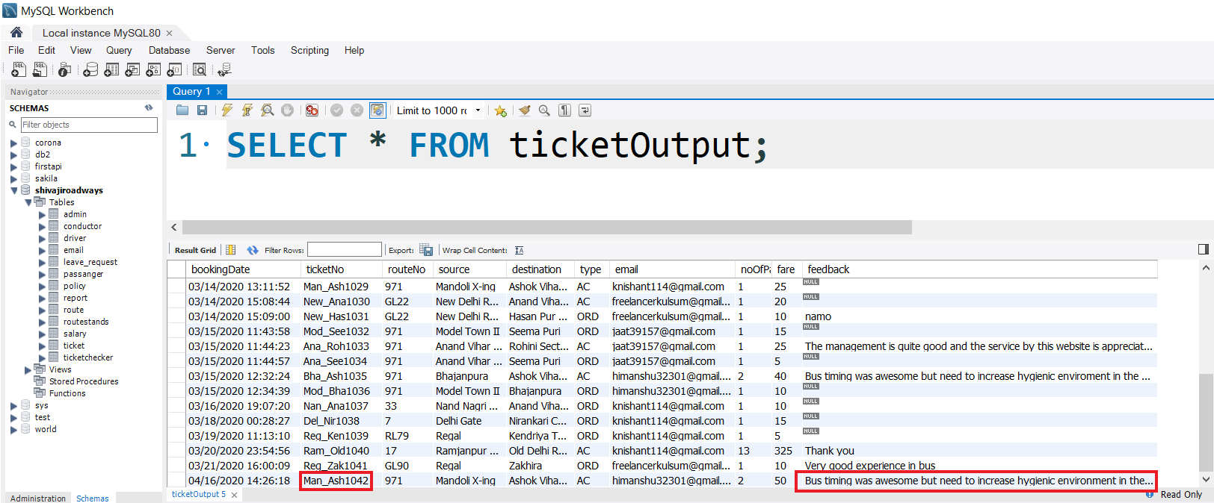

#### Source Code

<%@page import="java.sql.*"%>

<%

    String ticketNo = request.getParameter("ticketNo");

    String feedback = request.getParameter("feedback");

    Connection con = null;

    Statement st = null;

    try

    {

        Class.forName("com.mysql.jdbc.Driver");

        con = DriverManager.getConnection("jdbc:mysql://localhost:3306/shivajiroadways", "root", "1234");

        st = con.createStatement();

        String query = "update ticket set feedback='"+feedback+"' where ticketNo='"+ticketNo+"'";

        if(st.executeUpdate(query) > 0)

        {

            out.print("Feeback Added!");

        }

        else

            out.print("Invalid Ticket No");

    }

    catch(Exception e){out.print(e.getMessage());}

%>

#### 

# Source Code Without Output

#### Directory: BusManagementSystem/

#### authenticationAJAX.jsp

<%@page import="java.sql.*"%>

<%

    String email = request.getParameter("email");

    Connection con = null;

    Statement st = null;

    ResultSet rs = null;

    try

    {

        Class.forName("com.mysql.jdbc.Driver");

        con = DriverManager.getConnection("jdbc:mysql://localhost:3306/shivajiroadways", "root", "1234");

        st = con.createStatement();

        String query = "select profilePic from admin where email='"+email+"' union select profilePic from passanger where email='"+email+"' union select profilePic from driver where email='"+email+"' union select profilePic from conductor where email='"+email+"' union select profilePic from ticketchecker where email='"+email+"'";

        rs = st.executeQuery(query);

        if(rs.next())

        {%>

            <**div** class**=**"img" style**=**"background-image: url('./images/userProfile/<%=rs.getString("profilePic")%>');"></**div**>

        <%}

    }

    catch(Exception e)

    {

        out.print(e.getMessage());

    }

%>

#### availableBusesAJAX2.jsp

<%@page import="java.sql.*"%>

<%

    String keyword = request.getParameter("keyword");

    Connection con = null;

    Statement st = null;

    ResultSet rs = null;

    try

    {

        Class.forName("com.mysql.jdbc.Driver");

        con = DriverManager.getConnection("jdbc:mysql://localhost:3306/shivajiroadways", "root", "1234");

        st = con.createStatement();

        String query = "select distinct(standName) from routeStands where standName like '%"+keyword+"%'";

        rs = st.executeQuery(query);

    }

    catch(Exception e)

    {

        out.print(e.getMessage());

    }

%>

<%

    while(rs.next())

    {%>

        <**p** onmouseover**=**"setTo(this.innerText);"><%=rs.getString("standName")%></**p**>

    <%}

%>

#### changeLeaveStatus.jsp

<%@page import="java.sql.*"%>

<%

    String applicationNo = request.getParameter("applicationNo");

    String status = request.getParameter("status");

    Connection con = null;

    Statement st = null;

    try

    {

        Class.forName("com.mysql.jdbc.Driver");

        con = DriverManager.getConnection("jdbc:mysql://localhost:3306/shivajiroadways", "root", "1234");

        st = con.createStatement();

        String query = "update leave_request set status='"+status+"' where applicationNo = " + applicationNo;

        st.executeUpdate(query);

    }

    catch(Exception e){out.print(e.getMessage());}

%>

#### checkTicketAJAX.jsp

<%@page import="java.sql.*"%>

<%

    String ticketNo = request.getParameter("ticketNo");

    try

    {

        Integer.parseInt(ticketNo);

    }

    catch(Exception e){out.print(-1);}

    Connection con = null;

    Statement st = null;

    ResultSet rs = null;

    try

    {

        Class.forName("com.mysql.jdbc.Driver");

        con = DriverManager.getConnection("jdbc:mysql://localhost:3306/shivajiroadways", "root", "1234");

        st = con.createStatement();

        String query = "select  timestampdiff(HOUR ,bookingTime, current_timestamp()) as remainValidity from ticket where ticketNo = " + ticketNo;

        rs = st.executeQuery(query);

        if(rs.next())

        {

            out.print(rs.getString("remainValidity"));

        }

        else

        {

            out.print(-1);

        }

    }

    catch(Exception e)

    {e.getMessage();}

%>

#### estimatedTimeAJAX.jsp

<%@page import="java.sql.*"%>

<%

    String routeNo = request.getParameter("routeNo");

    Connection con = null;

    Statement st = null;

    ResultSet rs = null;

    try

    {

        Class.forName("com.mysql.jdbc.Driver");

        con = DriverManager.getConnection("jdbc:mysql://localhost:3306/shivajiroadways", "root", "1234");

        st = con.createStatement();

        String query = "select standName from routeStands WHERE routeNo = '" + routeNo + "'";

        rs = st.executeQuery(query);

    }

    catch(Exception e)

    {

        out.print(e.getMessage());

    }

%>

<**option** class**=**"placeholder" value**=**"" disabled selected style**=**"color: rgb(214, 205, 205);">From</**option**>

<%

    for(int i =1 ; rs.next(); i++)

    {%>

        <**option** value**=**"<%=i%>"><%=rs.getString("standName")%></**option**>

    <%}

%>

#### fareAJAX.jsp

<%@page import="java.sql.*"%>

<%

    int fare = 0;

    String routeNo = request.getParameter("routeNo");

    String sourceName = request.getParameter("source");

    String destinationName = request.getParameter("destination");

    String busType = request.getParameter("type");

    int no = Integer.parseInt(request.getParameter("noOfPassangers"));

    Connection con = null;

    Statement st = null;

    ResultSet rs = null;

    try

    {

        Class.forName("com.mysql.jdbc.Driver");

        con = DriverManager.getConnection("jdbc:mysql://localhost:3306/shivajiroadways", "root", "1234");

        st = con.createStatement();

        String query = "select standNo from routestands where routeNo='" + routeNo + "' and standName='" + sourceName + "' union select standNo from routestands where routeNo='" + routeNo + "' and standName='" + destinationName + "';";

        rs = st.executeQuery(query);

        rs.next();

        int sourceNo = rs.getInt("standNo");

        rs.next();

        int destinationNo = rs.getInt("standNo");

        int destance = Math.abs(sourceNo - destinationNo);

        if(busType.equals("ORD"))

        {

            if(destance <= 2)

                fare = 5 * no;

            else if(destance <= 5)

                fare = 10 * no;

            else

                fare = 15 * no;

        }

        else if(busType.equals("AC"))

        {

            if(destance <= 2)

                fare = 10 * no;

            else if(destance <= 4)

                fare = 15 * no;

            else if(destance <= 6)

                fare = 20 * no;

            else

                fare = 25 * no;

        }

    }

    catch(Exception e){out.print(e.getMessage());}

%>

<%="&#x20B9;"+fare%>

#### leaveRequestAJAX.jsp

<%@page import="java.sql.*"%>

<%

    String reason = request.getParameter("reason");

    String type = request.getParameter("type");

    String date_from = request.getParameter("from");

    String date_to = request.getParameter("to");

    String address = request.getParameter("tempAddress");

    String email = (String)session.getAttribute("email");

    Connection con = null;

    Statement st = null;

    ResultSet rs = null;

    try

    {

        Class.forName("com.mysql.jdbc.Driver");

        con = DriverManager.getConnection("jdbc:mysql://localhost:3306/shivajiroadways", "root", "1234");

        st = con.createStatement();

        String query = "insert into leave_request(reason, type, date_from, date_to, address, email, status) values('"+reason+"', '"+type+"', '"+date_from+"', '"+date_to+"', '"+address+"', '"+email+"', 'pending');";

        st.executeUpdate(query);

        query = "select applicationNo from leave_request where email = '"+email+"' order by applicationNo desc limit 1";

        rs = st.executeQuery(query);

        if(rs.next())

            out.print("Application no: " + rs.getInt("applicationNo"));

    }

    catch(Exception e){out.print(e.getMessage());}

%>

#### OTPnotMatched.jsp

<!**DOCTYPE** html>

<**html** lang**=**"en">

<head>

    <**meta** charset**=**"UTF-8">

    <**meta** name**=**"viewport" content**=**"width=device-width, initial-scale=1.0">

    <**meta** http-equiv**=**"X-UA-Compatible" content**=**"ie=edge">

    <**meta** http-equiv**=**"refresh" content**=**"3;url=authentication.jsp" />

    <**link** rel**=**"stylesheet" href**=**"styles/style.css">

    <**link** rel**=**"stylesheet" href**=**"styles/authentication.css">

    <**link** rel**=**"icon" href**=**"images/icon.png">

    <**title**>OTP Not Matched</**title**>

    <**style**>

        .container

        {

            background-color**:** rgb(83, 83, 95)

        }

**h1**

        {

            color**:** white;

            text-shadow**:** 0px 0px 5px black;

            text-align**:** center;

            position**:** relative;

            top**:** 50%;

            transform**:** translateY(-50%);

        }

    </**style**>

</head>

<body>

    <**div** class**=**"container">

        <**h1**>OTP didn't matched<**h1**>

    </**div**>

</body>

<**script** src**=**"scripts/authentication.js"></**script**>

</html>

#### paySalaryAJAX.jsp

<%@page import="java.sql.*"%>

<%

    String payee = request.getParameter("payee");

    Connection con = null;

    Statement st = null;

    ResultSet rs = null;

    try

    {

        Class.forName("com.mysql.jdbc.Driver");

        con = DriverManager.getConnection("jdbc:mysql://localhost:3306/shivajiroadways", "root", "1234");

        st = con.createStatement();

        String query = "select email from Driver where email like '%"+payee+"%' union select email from conductor where email like '%"+payee+"%' union select email from ticketchecker where email like '%"+payee+"%';";

        rs = st.executeQuery(query);

    }

    catch(Exception e)

    {

        out.print(e.getMessage());

    }

%>

<%

    while(rs.next())

    {%>

        <**p** onmouseover**=**"setPayee(this.innerText);"><%=rs.getString("email")%></**p**>

    <%}

%>

#### paySalaryAJAX2.jsp

<%@page import="java.sql.*"%>

<%

    String payee = request.getParameter("payee");

    String amount = request.getParameter("amount");

    Connection con = null;

    Statement st = null;

    ResultSet rs = null;

    try

    {

        Class.forName("com.mysql.jdbc.Driver");

        con = DriverManager.getConnection("jdbc:mysql://localhost:3306/shivajiroadways", "root", "1234");

        st = con.createStatement();

        String query = "insert into salary(email, amount) values('"+payee+"', "+amount+")";

        if(st.executeUpdate(query) > 0)

            out.print("Paid");

    }

    catch(Exception e)

    {e.getMessage();}

%>

#### routeAJAX.jsp

<%@page import="java.sql.*" %>

<%

    String r = request.getParameter("routeNo");

    Connection con = null;

    Statement st = null;

    ResultSet rs = null;

    try

    {

        Class.forName("com.mysql.jdbc.Driver");

        con = DriverManager.getConnection("jdbc:mysql://localhost:3306/shivajiroadways", "root", "1234");

        st = con.createStatement();

        String query = "SELECT source, destination FROM route WHERE routeNo = '" + r+ "'";

        rs = st.executeQuery(query);

    }

    catch(Exception e)

    {

        out.print(e.getMessage());

    }

    rs.next();

%>

<**p**><%=rs.getString("source")%></**p**>

<**p**><**b**>&#8597;</**b**></**p**>

<**p**><%=rs.getString("destination")%></**p**>

#### routeAJAX2.jsp

<%@page import="java.sql.*" %>

<%

    String r = request.getParameter("routeNo");

    Connection con = null;

    Statement st = null;

    ResultSet rs = null;

    try

    {

        Class.forName("com.mysql.jdbc.Driver");

        con = DriverManager.getConnection("jdbc:mysql://localhost:3306/shivajiroadways", "root", "1234");

        st = con.createStatement();

        String query = "select standNo, standName from routeStands where routeNo = '"+r+"';";

        rs = st.executeQuery(query);

        while(rs.next())

        {%>

            <**p**><%=rs.getInt("standNo") + "   "%><%=rs.getString("standName")%></**p**>

        <%}

    }

    catch(Exception e)

    {

        out.print(e.getMessage());

    }

%>

#### ticketAJAX.jsp

<%@page import="java.sql.*"%>

<%

    String routeNo = request.getParameter("routeNo");

    Connection con = null;

    Statement st = null;

    ResultSet rs = null;

    try

    {

        Class.forName("com.mysql.jdbc.Driver");

        con = DriverManager.getConnection("jdbc:mysql://localhost:3306/shivajiroadways", "root", "1234");

        st = con.createStatement();

        String query = "select standName from routeStands WHERE routeNo = '" + routeNo + "'";

        rs = st.executeQuery(query);

    }

    catch(Exception e)

    {

        out.print(e.getMessage());

    }

%>

<**option** class**=**"placeholder" value**=**"" disabled selected >From</**option**>

<%

    while(rs.next())

    {%>

        <**option**><%=rs.getString("standName")%></**option**>

    <%}

%>

#### Directory: BusManagementSystem/Scripts

#### authentication.js

**var** toggleState**=**1;

{

    document.title**=**"Sign In";

**var** sin**=**document.getElementById('sin').style;

**var** sup**=**document.getElementById('sup').style;

**var** fp**=**document.getElementById('fp').style;

    sup.color**=**"rgb(207, 201, 195)";

    sin.color**=**"white";

    fp.color**=**"rgb(207, 201, 195)";

    sup.borderBottomColor**=**"";

    sin.borderBottomColor**=**"aquamarine";

    fp.borderBottomColor**=**"";

}

**function** toggleFun(selected)

{

**if**(toggleState**==**1)

    {

**if**(selected**==**"sup")

        {

            toggleState**=**2;

            document.title**=**"Sign Up";

**var** screen**=**document.getElementById("formContainer");

            screen.className**=**'';

            screen.classList.add("shiftLeft1");

            {

**var** sin**=**document.getElementById('sin').style;

**var** sup**=**document.getElementById('sup').style;

**var** fp**=**document.getElementById('fp').style;

                sin.color**=**"rgb(207, 201, 195)";

                sup.color**=**"white";

                fp.color**=**"rgb(207, 201, 195)";

                sin.borderBottomColor**=**"";

                sup.borderBottomColor**=**"aquamarine";

                fp.borderBottomColor**=**"";

            }

        }

**else** **if**(selected**==**"fp")

        {

            toggleState**=**3;

            document.title**=**"Forget Password";

**var** screen**=**document.getElementById("formContainer");

            screen.className**=**'';

            screen.classList.add("shiftdLeft1");

            {

**var** sin**=**document.getElementById('sin').style;

**var** sup**=**document.getElementById('sup').style;

**var** fp**=**document.getElementById('fp').style;

                sin.color**=**"rgb(207, 201, 195)";

                fp.color**=**"white";

                sup.color**=**"rgb(207, 201, 195)";

                sin.borderBottomColor**=**"";

                fp.borderBottomColor**=**"aquamarine";

                sup.borderBottomColor**=**"";

            }

        }

    }

**else** **if**(toggleState**==**2)

    {

**if**(selected**==**"sin")

        {

            toggleState**=**1;

            document.title**=**"Sign In";

**var** screen**=**document.getElementById("formContainer");

            screen.className**=**'';

            screen.classList.add("shiftRight2");

            {

**var** sin**=**document.getElementById('sin').style;

**var** sup**=**document.getElementById('sup').style;

**var** fp**=**document.getElementById('fp').style;

                sup.color**=**"rgb(207, 201, 195)";

                sin.color**=**"white";

                fp.color**=**"rgb(207, 201, 195)";

                sup.borderBottomColor**=**"";

                sin.borderBottomColor**=**"aquamarine";

                fp.borderBottomColor**=**"";

            }

        }

**else** **if**(selected**==**"fp")

        {

            toggleState**=**3;

            document.title**=**"Forget Password";

**var** screen**=**document.getElementById("formContainer");

            screen.className**=**'';

            screen.classList.add("shiftLeft2");

            {

**var** sin**=**document.getElementById('sin').style;

**var** sup**=**document.getElementById('sup').style;

**var** fp**=**document.getElementById('fp').style;

                sin.color**=**"rgb(207, 201, 195)";

                fp.color**=**"white";

                sup.color**=**"rgb(207, 201, 195)";

                sin.borderBottomColor**=**"";

                fp.borderBottomColor**=**"aquamarine";

                sup.borderBottomColor**=**"";

            }

        }

    }

**else** **if**(toggleState**==**3)

    {   **if**(selected**==**"sup")

        {

            toggleState**=**2;

            document.title**=**"Sign Up";

**var** screen**=**document.getElementById("formContainer");

            screen.className**=**'';

            screen.classList.add("shiftRight3");

            {

**var** sin**=**document.getElementById('sin').style;

**var** sup**=**document.getElementById('sup').style;

**var** fp**=**document.getElementById('fp').style;

                sin.color**=**"rgb(207, 201, 195)";

                sup.color**=**"white";

                fp.color**=**"rgb(207, 201, 195)";

                sin.borderBottomColor**=**"";

                sup.borderBottomColor**=**"aquamarine";

                fp.borderBottomColor**=**"";

            }

        }

**else** **if**(selected**==**"sin")

        {

            toggleState**=**1;

            document.title**=**"Sign In";

**var** screen**=**document.getElementById("formContainer");

            screen.className**=**'';

            screen.classList.add("shiftdRight3");

            {

**var** sin**=**document.getElementById('sin').style;

**var** sup**=**document.getElementById('sup').style;

**var** fp**=**document.getElementById('fp').style;

                sup.color**=**"rgb(207, 201, 195)";

                sin.color**=**"white";

                fp.color**=**"rgb(207, 201, 195)";

                sup.borderBottomColor**=**"";

                sin.borderBottomColor**=**"aquamarine";

                fp.borderBottomColor**=**"";

            }

        }

    }

}

**function** toggleFields(field)

{

**if**(field**==**"Conductor" **||** field**==**"Ticket Checker" **||** field**==**"Driver")

    {

        document.getElementById("joiningDate").style.display**=**"block";

    }

**else**

    {

        document.getElementById("joiningDate").style.display**=**"none";

    }

**if**(field**==**"Passanger")

    {

        document.getElementById("walletBalance").style.display**=**"block";

    }

**else**

    {

        document.getElementById("walletBalance").style.display**=**"none";

    }

**if**(field**==**"Driver")

    {

        document.getElementById("licenceNo").style.display**=**"block";

        document.getElementById("experience").style.display**=**"block";

    }

**else**

    {

        document.getElementById("licenceNo").style.display**=**"none";

        document.getElementById("experience").style.display**=**"none";

    }

}

**function** confirmPasswordField(len)

{

**if**(len>4)

    {

        document.getElementById("confirmPassword").type**=**"password";

    }

**else**

    {

        document.getElementById("confirmPassword").value**=**"";

        document.getElementById("confirmPassword").type**=**"hidden";

    }

}

#### disable.js

**function** disableTo(value, len)

{

**var** destination **=** document.getElementsByName('destination')[0];

**for**(i **=** 1; i < len; i**++**)

    {

**if**(destination[i].value **==** value)

            destination[i].disabled **=** true;

**else**

            destination[i].disabled **=** false;

    }

}

**function** disableFrom(value, len)

{

**var** source **=** document.getElementsByName('source')[0];

**for**(i **=** 1; i < len; i**++**)

    {

**if**(source[i].value **==** value)

            source[i].disabled **=** true;

**else**

            source[i].disabled **=** false;

    }

}

#### leave.js

**function** setDates()

{

**var** today **=** **new** Date();

**var** dd **=** today.getDate();

**var** mm **=** today.getMonth() + 1;

**var** yyyy **=** today.getFullYear();

**if** (dd < 10)

    {

        dd **=** '0' + dd;

    }

**if** (mm < 10)

    {

        mm **=** '0' + mm;

    }

**var** from **=** document.getElementById('from')

**var** to **=** document.getElementById('to')

    from.value **=** to.value **=** from.min **=** to.min **=** yyyy+"-"+mm+"-"+dd;

}

**function** updateMin(value)

{

**var** min **=** document.getElementById('to').min;

**if**(min < value)

    {

        document.getElementById('to').value **=** value;

    }

    document.getElementById('to').min **=** value;

}

#### navPannel.js

window.onscroll**=function**()

{

**var** nav**=**document.getElementsByClassName("navPannel")[0].style;

**var** link**=**document.getElementsByClassName("link");

**var** logoHeading**=**document.getElementsByClassName("logoHeading")[0].style;

**if**(**!**window.pageYOffset )

    {

        nav.backgroundColor**=**"rgba(0, 0, 0, 0)";

        nav.boxShadow**=**"none";

        logoHeading.textShadow**=**"none";

**for**(i**=**0; i<link.length; i**++**)

        {

            link[i].style.boxShadow**=**"none";

            link[i].style.color**=**"wheat";

            link[i].onmouseover **=** **function**() {

                this.style.color **=** "black";

                this.style.backgroundColor **=** "var(--bodyColor)";

            }

            link[i].onmouseout **=** **function**() {

                this.style.color **=** "wheat";

                this.style.backgroundColor **=** "rgba(0, 0 , 0, 0)";

            }

        }

**try**

        {

**var** userImg**=**document.getElementsByClassName("userImg")[0].style;

**var** userName**=**document.getElementsByClassName("userName")[0].style;

            userName.textShadow**=**"none";

            userImg.borderRadius**=**"5vw";

        }

**catch**

        {

        }

    }

**else**

    {

        nav.backgroundColor**=**"var(--navBackgroundColor)";

        nav.boxShadow**=**"0px 0px 20px rgba(0, 0, 0, 0.5)";

        logoHeading.textShadow**=**"0px 0px 5px black";

**for**(i**=**0; i<link.length; i**++**)

        {

            link[i].style.boxShadow**=**"var(--navLinkBoxShadow)";

            link[i].style.color**=**"rgb(63, 0, 99)";

            link[i].onmouseover **=** **function**() {

                this.style.color **=** "black";

                this.style.backgroundColor **=** "rgba(0, 0 , 0, 0)";

            }

            link[i].onmouseout **=** **function**() {

                this.style.color **=** "rgb(63, 0, 99)";

                this.style.backgroundColor **=** "rgba(0, 0 , 0, 0)";

            }

        }

**try**

        {

**var** userImg**=**document.getElementsByClassName("userImg")[0].style;

**var** userName**=**document.getElementsByClassName("userName")[0].style;

            userName.textShadow**=**"0px 0px 5px black";

            userImg.borderTopLeftRadius**=**"0";

            userImg.borderTopRightRadius**=**"0";

        }

**catch**{}

    }

}

**function** elemFocused(element){

**if**(window.pageYOffset )

    {

        element.style.boxShadow**=**"var(--navLinkBoxShadowInset)";

    }

}

**function** elemBlurred(element){

    element.style.boxShadow**=**"none";

}

#### validate.js

**var** errorColor **=** "rgb(241, 101, 7)";

//--------------------------------------------------------Validating name---------------------------------------------

**function** validateName()

{

**var** isValid **=** false;

**var** name **=** document.getElementsByName("name")[0];

**if**(name.value **==** "")

    {

        name.placeholder **=** "Please insert name!";

        name.style.borderBottom **=** "1.9px solid "+errorColor;

    }

**else** **if**(name.value.length > 20)

    {

        name.style.borderBottom **=** "1.9px solid "+errorColor;

        name.value **=** "";

        name.placeholder **=** "Max 20 characters allow!"

    }

**else**

    {

        name.style.borderBottom **=** "1.9px solid aqua";

        name.placeholder **=** "Name";

        isValid **=** true;

    }

**return** isValid;

}

//------------------------------------------------------Validating email------------------------------------------------------

**function** validateEmail(num)

{

**var** isValid **=** false;

**var** email**=**document.getElementsByName("email")[num];

**var** dotpos**=**email.value.lastIndexOf(".");

**var** atpos**=**email.value.lastIndexOf("@");

**if**(email.value **==** "")

    {

        email.placeholder **=** "Please insert email!";

        email.style.borderBottom **=** "1.9px solid "+errorColor;

    }

**else** **if**(dotpos**==**-1 **||** atpos**==**-1 **||** dotpos-atpos<4)

    {

        email.style.borderBottom **=** "1.9px solid "+errorColor;

        email.value **=** "";

        email.placeholder **=** "Invalid Email!"

    }

**else**

    {

**var** param **=** "?email=" +  email.value;

        param **=** param.replace("+", "%2b")

**var** xmlhttp **=** **new** XMLHttpRequest();

        xmlhttp.open("POST", "authenticationAJAX.jsp" + param, false);

        xmlhttp.onreadystatechange **=** **function**(){

**if**(num **==** 0)

            {

**if**(xmlhttp.responseText.length < 4)

                {

                    email.style.borderBottom **=** "1.9px solid aqua";

                    email.placeholder **=** "Email";

                    isValid **=** true;

                }

**else**

                {

                    email.style.borderBottom **=** "1.9px solid "+errorColor;

                    email.value **=** "";

                    email.placeholder **=** "Email already exist!";

                }

            }

**if**(num **==** 1)

            {

**if**(xmlhttp.responseText.length > 4)

                {

                    email.style.borderBottom **=** "1.9px solid aqua";

                    email.placeholder **=** "Email";

                    isValid **=** true;

                }

**else**

                {

                    email.style.borderBottom **=** "1.9px solid "+errorColor;

                    email.value **=** "";

                    email.placeholder **=** "Email doesn't exist!";

                }

            }

        }

        xmlhttp.send();

    }

**return** isValid;

}

//------------------------------------------------------Validating phone-----------------------------------------------------

**function** validatePhone()

{

**var** isValid **=** false;

**var** phone **=** document.getElementsByName("phone")[0];

**if**(phone.value **==** "")

    {

        phone.placeholder **=** "Please insert phone!";

        phone.style.borderBottom **=** "1.9px solid "+errorColor;

    }

**else** **if**(phone.value.length **==** 10 **&&** **!**isNaN(phone.value))

    {

        phone.style.borderBottom **=** "1.9px solid aqua";

        phone.placeholder **=** "Phone";

        isValid **=** true;

    }

**else**

    {

        phone.style.borderBottom **=** "1.9px solid "+errorColor;

        phone.value **=** "";

        phone.placeholder **=** "Value should be 10 digit Numerical";

    }

**return** isValid;

}

//-------------------------------------------------------Validating Passowrd---------------------------------------

**function** validatePassword(num)

{

**var** isValid **=** false;

**var** p **=** document.getElementsByName("password")[num];

**if**(p.value **==** "" **&&** p.value.length <= 0)

    {

        p.placeholder **=** "Please insert password!";

        p.style.borderBottom **=** "1.9px solid "+errorColor;

    }

**else** **if**(p.value.length < 4)

    {

        p.value **=** "";

        p.placeholder**=**"Password Should at least 4 digit!";

        p.style.borderBottom **=** "1.9px solid "+errorColor;

    }

**else**

    {

        p.style.borderBottom **=** "1.9px solid aqua";

        p.placeholder **=** "Password";

        isValid **=** true;

    }

**return** isValid;

}

//-------------------------------------------------------Validate Role----------------------------------------------------

**function** validateRole()

{

**var** isValid **=** false;

**var** role **=** document.getElementById("role");

**if**(role.value **==** "")

    {

        role.style.border **=** "1.9px solid "+errorColor;

    }

**else**

    {

        role.style.border **=** "1.9px solid aqua";

        isValid **=** true;

    }

**return** isValid;

}

//-------------------------------------------------------Validate wallet balance------------------------------------------

**function** validateWalletBal()

{

**var** isValid **=** false;

**var** bal **=** document.getElementsByName("walletBalance")[0];

**if**(bal.value **==** "")

    {

        bal.placeholder **=** "Please insert balance!";

        bal.style.borderBottom **=** "1.9px solid "+errorColor;

    }

**else** **if**(bal.value.length < 7 **&&** **!**isNaN(bal.value))

    {

        bal.style.borderBottom **=** "1.9px solid aqua";

        bal.placeholder **=** "Wallet Balance";

        isValid **=** true;

    }

**else**

    {

        bal.style.borderBottom **=** "1.9px solid "+errorColor;

        bal.value **=** "";

        bal.placeholder **=** "Should be in numbers < 7 digit";

    }

**return** isValid;

}

//--------------------------------------------------------Validating licence------------------------------------------------

**function** validateLicence()

{

**var** isValid **=** false;

**var** licence **=** document.getElementsByName("licenceNo")[0];

**if**(licence.value **==** "")

    {

        licence.placeholder **=** "Please insert licence no.!";

        licence.style.borderBottom **=** "1.9px solid "+errorColor;

    }

**else** **if**(licence.value.length **==** 10)

    {

        licence.style.borderBottom **=** "1.9px solid aqua";

        licence.placeholder **=** "Licence";

        isValid **=** true;

    }

**else**

    {

        licence.style.borderBottom **=** "1.9px solid "+errorColor;

        licence.value **=** "";

        licence.placeholder **=** "Licence should be 10 digit alphanumaric";

    }

**return** isValid;

}

//-----------------------------------------------------Validating experience------------------------------------------------

**function** validateExperience()

{

**var** isValid **=** false;

**var** exp **=** document.getElementsByName("experience")[0];

**if**(exp.value **==** "")

    {

        exp.placeholder **=** "Please tell us your experience!";

        exp.style.borderBottom **=** "1.9px solid "+errorColor;

    }

**else** **if**(exp.value.length <= 2 **&&** **!**isNaN(exp.value))

    {

        exp.style.borderBottom **=** "1.9px solid aqua";

        exp.placeholder **=** "Experience";

        isValid **=** true;

    }

**else**

    {

        exp.style.borderBottom **=** "1.9px solid "+errorColor;

        exp.value **=** "";

        exp.placeholder **=** "Experiece: 0 - 99 years";

    }

**return** isValid;

}

//----------------------------------------------------Validating Joining Date-----------------------------------------------

**function** validateJoiningDate()

{

**var** isValid **=** false;

**var** jd **=** document.getElementById("joiningDate");

**if**(jd.value **==** "")

    {

        jd.style.border **=** "1.9px solid "+errorColor;

    }

**else**

    {

        jd.style.border **=** "1.9px solid aqua";

        isValid **=** true;

    }

**return** isValid;

}

**function** validateForm()

{

**var** isValid **=** true;

**if**(validateName() **==** false)

        isValid **=** false;

**if**(validateEmail(0) **==** false)

        isValid **=** false;

**if**(validatePhone() **==** false)

        isValid **=** false;

**if**(validateRole())

    {

**var** role **=** document.getElementById("role");

**if**(role.value **==** 'Passanger')

        {

**if**(validateWalletBal() **==** false)

                isValid **=** false;

        }

**else** **if**(role.value **==** 'Driver')

        {

**if**(validateLicence() **==** false)

                isValid **=** false;

**if**(validateExperience() **==** false)

                isValid **=** false;

**if**(validateJoiningDate() **==** false)

                isValid **=** false;

        }

**else** **if**(role.value **==** 'Conductor')

        {

**if**(validateJoiningDate() **==** false)

                isValid **=** false;

        }

**else** **if**(role.value **==** 'Ticket Checker')

        {

**if**(validateJoiningDate() **==** false)

                isValid **=** false;

        }

    }

**else**

    {

        isValid **=** false;

    }

**if**(validatePassword(1) **==** false)

        isValid **=** false;

**return** isValid;

}

#### scrapRoute.py

import bs4

import requests

url = "https://www.mapsofindia.com/dtc-bus-route/"

data = requests.get(url)

soup = bs4.BeautifulSoup(data.text, 'html.parser')

table = soup.find_all('table')[1]

data = []

row = []

for tr in table.find_all('tr'):

    for td in tr.find_all('td'):

        row.append(td.text.strip())

    data.append(tuple(row))

    row = []

data.remove(('106A', 'Old Delhi Railway Station', 'Fatehpuri'))         #exception value cominig from url

data.remove(('OMS', 'Anand Vihar ISBT (Viveka Nand ISBT)', 'Anand Vihar ISBT (Viveka Nand ISBT)'))         #exception value cominig from url

import mysql.connector

mydb = mysql.connector.connect(host = 'localhost', user = 'root', password = '1234', database = 'shivajiroadways')

cur = mydb.cursor()

query = "INSERT INTO Route(routeNo, source, destination) values(%s, %s, %s)"

cur.executemany(query, data)

mydb.commit()

print("Database updated")

#### scrapRouteStands.py

import bs4

import requests

url = "https://www.mapsofindia.com/dtc-bus-route/"

data = requests.get(url)

soup = bs4.BeautifulSoup(data.text, 'html.parser')

urls = []

count = 0

import mysql.connector

mydb = mysql.connector.connect(host = 'localhost', user = 'root', password = '1234', database = 'shivajiroadways')

cur = mydb.cursor()

def getURLs():

    global count

    table = soup.find_all('table')[1]

    for tr in table.find_all('tr'):

        a = tr.find_all('td')[0].find('a')

        urls.append((a.text.strip(), a['href']))

        count += 1

    urls.remove(('106A', 'https://www.mapsofindia.com/dtc-bus-route/route-for-106a.html'))   #exception value cominig from url

    urls.remove(('OMS', 'https://www.mapsofindia.com/dtc-bus-route/route-for-oms.html'))     #exception value cominig from url

    print('URL list created\n')

def fetchData(url):

    route = requests.get(url[1])

    soup = bs4.BeautifulSoup(route.text, 'html.parser')

    table = soup.find('table')

    firstTr = True

    for tr in table.find_all('tr'):

        if(firstTr):

            firstTr = False

            continue

        td = tr.find_all('td')

        if(td[0].text.strip() == url[0]):

            actualData = []

            print(td[0].text.strip())

            for span in td[1].find_all('span'):

                serial = span.text.strip().replace('.', "")

                standName =  span.next_sibling.strip()

                actualData.append((serial, url[0] , standName))

                print("\t", serial, standName)

            query = "INSERT INTO RouteStands(standNo, routeNo, standName) values(%s, %s, %s)"

            cur.executemany(query, actualData)

            mydb.commit()

        else:

            continue

getURLs()

for url in urls:

    fetchData(url)

print("\n\aAll the data added\n\n\n\t\t\t\t\t+-------------------+")

print("\t\t\t\t\t| MAHNAT RANG LAAYI |")

print("\t\t\t\t\t+-------------------+\n\n")

#### Directory: BusManagementSystem/sql

#### admin.sql

create table Admin

(

    email varchar(50) not null primary key,

    name varchar(30),

    phone varchar(10),

    password varchar(20),

    profilePic BLOB,

**foreign key**(email)

**references** Email(email)

);

#### conductor.sql

create table Conductor

(

    email varchar(50) not null primary key,

    name varchar(30),

    phone varchar(10),

    password varchar(20),

    dob date,

    profilePic BLOB,

**foreign key**(email)

**references** Email(email)

);

#### driver.sql

create table Driver

(

    email varchar(50) not null primary key,

    name varchar(30),

    phone varchar(10),

    password varchar(20),

    licenceNo varchar(10),

    experience int,

    dob date,

    profilePic BLOB,

**foreign key**(email)

**references** Email(email)

);

#### email.sql

create table Email

(

    email varchar(50) primary key

);

#### salary.sql

create table Salary

(

    transactionNo int auto_increment primary key,

    email varchar(50),

    amount int,

    date timestamp DEFAULT CURRENT_TIMESTAMP,

**foreign key**(email) **references** email(email)

);

#### ticketChecker.sql

create table TicketChecker

(

    email varchar(50) not null primary key,

    name varchar(30),

    phone varchar(10),

    password varchar(20),

    dob date,

    profilePic BLOB,

**foreign key**(email)

**references** Email(email)

);

#### leave.sql

create table leave_request

(

    applicationNo int auto_increment primary key,

    reason varchar(50),

    type varchar(50),

    date_from date,

    date_to date,

    address varchar(100),

    status varchar(20),

    email varchar(50),

**foreign key**(email)

**references** Email(email)

);

#### policy.sql

create table Policy

(

    pNo int auto_increment primary key,

    pName varchar(20) not null,

    pDescription varchar(6000) not null

)

#### report.sql

create table Report

(

    reportNo int primary key auto_increment,

    routeNo varchar(50),

    standName varchar(255),

    busNo varchar(10),

    description varchar(999),

    submittedBy varchar(50),

**foreign key**(submittedBy)

**references** email(email)

);

#### route.sql

CREATE TABLE Route

(

    serialNo int primary key auto_increment,

    routeNo varchar(50) unique,

    source varchar(255),

    destination varchar(255)

);

#### Passanger

create table Passanger

(

    email varchar(50) not null primary key,

    name varchar(30),

    phone varchar(10),

    password varchar(20),

    walletBalance int,

    profilePic BLOB,

**foreign key**(email)

**references** Email(email)

);

#### ticket.sql

create table ticket

(

    ticketNo int auto_increment primary key,

    routeNo varchar(50) not null,

    source varchar(255) not null,

    destination varchar(255) not null,

    email varchar(50),

    bookingTime timestamp DEFAULT CURRENT_TIMESTAMP,

    feedback varchar(999),

    type varchar(4),

    noOfpassangers int,

    fare int,

**foreign key**(routeNo) **references** route(routeNo),

**foreign key**(email) **references** passanger(email)

);

#### ticketOutput.sql

create view ticketOutput as

SELECT DATE_FORMAT(bookingTime, '%m/%d/%Y %H:%i:%S')

as bookingDate,

concat(substring(source, 1, 3),

'_',

substring(destination , 1, 3), ticketNo ) as ticketNo, routeNo,

source,

destination,

type,

email,

noOfPassangers,

fare,

feedback FROM ticket;

#### Directory: BusManagementSystem/styles

#### about.css

.innerContainer

{

    text-align: center;

}

.innerContainer h1

{

    color: white;

    font-size: 4vw;

    margin-top: 15vw;

}

.innerContainer p

{

    margin-top: 1vw;

    color: white;

}

.about

{

    border-radius: 1vw;

    box-shadow: 4px 4px 10px rgba(0, 0, 0, 0.356), -5px -5px 12px 0 rgba(255, 255, 255, 0.8);

    margin-top: 30vw;

    margin-bottom: 5vw;

    text-align: center;

    background-color: rgb(220, 220, 220);

    width: 80vw;

    position: relative;

    left: 50%;

    transform: translateX(-50%);

}

.about h1

{

    padding: 5vw;

    font-size: 4vw;

}

.about p

{

    font-size:1.5vw;

    padding-left: 10vw;

    padding-right: 10vw;

    padding-bottom: 5vw;

    text-align: justify;

}

.leadership

{

    border-radius: 1vw;

    box-shadow: 4px 4px 10px rgba(0, 0, 0, 0.356), -5px -5px 12px 0 rgba(255, 255, 255, 0.8);

    margin-top: 5vw;

    margin-bottom: 5vw;

    text-align: center;

    background-color: rgb(220, 220, 220);

    width: 80vw;

    position: relative;

    left: 50%;

    height: 91vw;

    transform: translateX(-50%);

}

.leadership h1

{

    padding: 5vw;

    font-size: 4vw;

}

.leaderRow

{

    width: 100%;

}

.leader

{

    box-shadow: inset 4px 4px 10px rgba(0, 0, 0, 0.356), inset -5px -5px 12px 0 rgb(255, 255, 255);

    border-radius: 1vw;

    width: 32vw;

    margin: 4vw;

    float: left;

    height: 30vw;

}

.leader .leaderImg

{

    box-shadow: 4px 4px 10px rgba(0, 0, 0, 0.356), -5px -5px 12px 0 rgb(255, 255, 255);

    height: 8vw;

    width: 8vw;

    border-radius: 5vw;

    margin: 3vw auto;

    background-size: 100% 100%;

}

.leader h1

{

    font-size: 2.5vw;

    padding: 0;

}

.leader .aboutLeader

{

    margin-top: 20px;

    padding-left: 5vw;

    padding-right: 5vw;

    font-size: 1.1vw;

    text-align: justify;

}

.contacts

{

    border-radius: 1vw;

    box-shadow: 4px 4px 10px rgba(0, 0, 0, 0.356), -5px -5px 12px 0 rgba(255, 255, 255, 0.8);

    margin-top: 5vw;

    margin-bottom: 5vw;

    text-align: center;

    background-color: rgb(220, 220, 220);

    width: 80vw;

    position: relative;

    left: 50%;

    height: 29vw;

    transform: translateX(-50%);

}

.contacts h1

{

    padding: 5vw;

    font-size: 4vw;

}

.contacts table

{

    margin-left: 5vw;

    text-align: left;

    font-size: 2vw;

}

#### authentication.css

h1

{

    color: red;

}

/* ::-webkit-scrollbar

{

    display: none;

} */

body

{

    font-family: Arial, Helvetica, sans-serif;

    background-image: url("../images/formBackground.jpg"); /*Photo by Luca Micheli on Unsplash*/

    background-size: cover;

    background-repeat: no-repeat;

}

.container

{

    position: absolute;

    left: 50%;

    top: 50%;

    border-radius: 5px;

    transform: translate(-50%, -50%);

    box-shadow: 0 0 30px 4px rgba(216, 90, 90, 0.63);

    height: 35vw;

    width: 60vw;

}

.imageDiv

{

    float: left;

    border-top-left-radius: 5px;

    border-bottom-left-radius: 5px;

    background-image: url("../images/girl2.jpg");

    background-size: cover;

    width: 40%;

    height: 100%;

}

.workspace

{

    float: left;

    border-top-right-radius: 5px;

    border-bottom-right-radius: 5px;

    background-color: rgba(83, 83, 95, 0.90);

    overflow: hidden;

    width: 60%;

    height: 100%;

}

#abc

{

    color: green;

    background-color: blue;

}

.actionSelector

{

    /* background-color: red; */

    font-weight: bold;

    font-size: 1.2vw;

    text-align: center;

    margin: 0 auto;

    height: 7%;

}

.actionSelector div

{

    padding-top: 1vw;

    user-select: none;

    border-bottom: 0.3vw solid rgb(86, 129, 129);

    text-shadow: 0px 0px 5px black;

}

.signInMenu

{

    height: 100%;

    float: left;

    width: 33%;

    /* background-color: green; */

}

.signUpMenu

{

    float: left;

    height: 100%;

    width: 34%;

    /* background-color: red; */

}

.forgetPasswordMenu

{

    float: left;

    height: 100%;

    width: 33%;

}

.actionSelector :hover

{

    cursor: pointer;

}

#formContainer

{

    position: relative;

    float: left;

    /* background-color: orange; */

    height: calc(90% - 0.3vw);

    width: 300%;

}

.signIn

{

    float: left;

    height: 100%;

    width: 33.33%;

    /* background-color: red; */

}

.signUp

{

    float: left;

    height: 100%;

    width: 33.33%;

    /* background-color: green; */

}

.forgetPassword

{

    float: left;

    height: 100%;

    width: 33.33%;

    /* background-color: blue; */

}

.shiftLeft1

{

    animation-name: shiftL1;

    animation-duration: 1s;

    animation-fill-mode: forwards;

}

@keyframes shiftL1

{

    0%{

    }

    100%{

        transform: translateX(-33.33%);

    }

}

.shiftdLeft1

{

    animation-name: shiftdL1;

    animation-duration: 2s;

    animation-fill-mode: forwards;

}

@keyframes shiftdL1

{

    0%{

    }

    100%{

        transform: translateX(-66.67%);

    }

}

.shiftRight2

{

    animation-name: shiftR2;

    transform: translateX(-33.33%);

    animation-duration: 1s;

    animation-fill-mode: forwards;

}

@keyframes shiftR2

{

    0%{

    }

    100%{

        transform: translateX(0%);

    }

}

.shiftLeft2

{

    animation-name: shiftL2;

    transform: translateX(-33.33%);

    animation-duration: 1s;

    animation-fill-mode: forwards;

}

@keyframes shiftL2

{

    0%{

    }

    100%{

        transform: translateX(-66.67%);

    }

}

.shiftRight3

{

    animation-name: shiftR3;

    transform: translateX(-66.67%);

    animation-duration: 1s;

    animation-fill-mode: forwards;

}

@keyframes shiftR3

{

    0%{

    }

    100%{

        transform: translateX(-33.33%);

    }

}

.shiftdRight3

{

    animation-name: shiftdR3;

    transform: translateX(-66.67%);

    animation-duration: 2s;

    animation-fill-mode: forwards;

}

@keyframes shiftdR3

{

    0%{

    }

    100%{

        transform: translateX(0%);

    }

}

form

{

    position: relative;

    top: 50%;

    transform: translateY(-50%);

    font-family: sans-serif;

    margin: 0 auto;

    width: 80%;

    /* background-color: yellow; */

}

form input[type="text"], form input[type="password"], form input[type="range"], form input[type="search"]

{

    display: block;

    outline: none;

    width: 60%;

    background: transparent;

    border: none;

    border-bottom: 1px solid rgb(197, 197, 197);

    font-size: 1vw;

    margin: 10px auto;

    padding: 10px;

    color: rgb(214, 205, 205);

    caret-color: rgb(214, 205, 205);

    animation-name: input2;

    animation-duration: 0.6s;

    animation-fill-mode: forwards;

}

form h1

{

    color: white;

    text-align: center;

    margin-bottom: 3vw;

}

form select

{

    display: block;

    outline: none;

    width: 65%;

    background: transparent;

    border: none;

    color: rgb(214, 205, 205);

    border: 1px solid rgb(197, 197, 197);

    font-size: 1vw;

    margin: 10px auto;

    padding: 10px;

    caret-color: rgb(214, 205, 205);

    animation-name: input2;

    animation-duration: 0.6s;

    animation-fill-mode: forwards;

}

input[type="date"]

{

    display: block;

    outline: none;

    width: 60%;

    display: none;

    background: transparent;

    border: none;

    color: rgb(214, 205, 205);

    border: 1px solid rgb(197, 197, 197);

    font-size: 1vw;

    margin: 10px auto;

    padding: 10px;

    caret-color: rgb(214, 205, 205);

    animation-name: input2;

    animation-duration: 0.6s;

    animation-fill-mode: forwards;

}

form select option

{

    display: block;

    outline: none;

    width: 65%;

    background-color: rgb(83, 83, 95);

    border: none;

    color: white;

    border: 1px solid rgb(197, 197, 197);

    font-size: 1vw;

    margin: 10px auto;

    padding: 10px;

    caret-color: rgb(214, 205, 205);

    animation-name: input2;

    animation-duration: 0.6s;

    animation-fill-mode: forwards;

}

form input[type="submit"], input[type="button"]

{

    display: block;

    outline: none;

    /* width: 60%; */

    background: transparent;

    color: rgb(214, 205, 205);

    border: 2px solid white;

    border-radius: 10px;

    font-size: 1vw;

    font-weight: bold;

    margin: 10px auto;

    padding: 8px 18px;

}

form input[type="submit"]:hover, form input[type="submit"]:focus, input[type="button"]:hover, input[type="button"]:focus

{

    position: relative;

    cursor: pointer;

    animation-name: submit;

    animation-duration: 1s;

    animation-fill-mode: forwards;

}

@keyframes submit

{

    100%

    {

        color: black;

        background-color: white;

        box-shadow: 0 0 10px 1px rgba(0, 0, 0, 0.63);

        border-radius: 50px;

    }

}

form input::placeholder

{

    color:  rgb(214, 205, 205);

}

input[type="text"]:focus, input[type="password"]:focus, input[type="search"]:focus

{

    animation-name: input;

    animation-duration: 0.6s;

    animation-fill-mode: forwards;

}

@keyframes input

{

    100%

    {

        border-bottom:1.9px solid aqua;

        width: 80%;

        font-size: 1.4vw;

    }

}

select:focus

{

    animation-name: select;

    animation-duration: 0.6s;

    animation-fill-mode: forwards;

}

@keyframes select

{

    100%

    {

        border:1.9px solid aqua;

    }

}

optgroup

{

    background-color: rgb(83, 83, 95);

}

option:disabled

{

    color: rgb(214, 205, 205);

}

.ImgResult .img

{

    background-size: cover;

    margin: 0 auto;

    background-repeat: no-repeat;

    border-radius: 10vw;

    animation: fadeInAnimation ease 2s;

    animation-iteration-count: 1;

    animation-fill-mode: forwards;

}

@keyframes fadeInAnimation {

    0% {

        height: 1vw;

        width: 1vw;

        opacity: 0;

    }

    100% {

        height: 7vw;

        width: 7vw;

        opacity: 1;

     }

}

#### calFare.css

.busTypeContainer

{

    width: 220px;

    margin: 2vw auto;

}

.busTypeContainer label

{

    background-size: 80% 80%;

    background-repeat: no-repeat;

    background-position: center;

    border-radius: 10px;

    transition: ease-in-out .7s;

}

input[type="radio"]{

    display:none;

}

label:last-child {

    float: right !important;

}

input[type="radio"] + label

{

    border: 2px solid transparent;

    height: 5vw;

    width: 5vw;

    display:inline-block;

    padding: 0 0 0 0px;

    cursor: pointer;

}

input[type="radio"]:checked + label

{

    background-color: rgba(255, 255, 255, 0.63);

    height: 5vw;

    width: 5vw;

    display:inline-block;

    padding: 0 0 0 0px;

    cursor: default;

}

form input[type="submit"]

{

    display: inline;

}

.submitContainer

{

    margin: 0 auto;

    width: 17vw;

}

.submitContainer

{

    position: relative;

    transform: translateY("20px");

}

.submitContainer :first-child

{

    float: right;

    border-color: palevioletred;

}

.submitContainer :first-child:hover

{

    position: relative;

    cursor: pointer;

    animation-name: pink;

    animation-duration: 1s;

    animation-fill-mode: forwards;

}

@keyframes pink

{

    100%

    {

        color: black;

        background-color: palevioletred;

        box-shadow: 0 0 10px 1px rgba(0, 0, 0, 0.63);

        border-radius: 50px;

    }

}

.pinkSubmit

{

    border-color: pink;

}

#### common.css

/* Light mode */

**@media** (prefers-color-scheme**:** light) {

    :root

    {

        --navBackgroundColor**:**rgba(10, 7, 37, 0.73);

        --bodyColor**:** rgb(10, 36, 26);

    }

}

/* Dark mode */

**@media** (prefers-color-scheme**:** dark) {

    :root

    {

        --navBackgroundColor**:** rgba(213, 205, 255, 0.904);

        --bodyColor**:** rgb(247, 214, 219);

        --navLinkBoxShadow**:** 3px 3px 10px rgba(0, 0, 0, 0.356), -3px -3px 10px 0 rgba(255, 255, 255, 0.8);

        --navLinkBoxShadowInset**:**inset 3px 3px 10px rgba(0, 0, 0, 0.356), inset -3px -3px 10px 0 rgba(211, 225, 233, 0.8);

    }

}

body

{

    transition**:** ease all .5s;

    overflow-x**:** hidden;

    background-color**:** var(--bodyColor);

    font-family**:** 'Trebuchet MS',sans-serif;

}

.navPannel

{

    position**:** fixed;

    color**:** wheat;

    top**:** 0px;

    width**:** 100%;

    transition**:** ease all 2s;

    height**:** 6vw;

    z-index**:** 2;

}

.navPannel .logo

{

    float**:** left;

    margin-left**:** 1.1vw;

    position**:** relative;

    top**:** 50%;

    transform**:** translateY(-50%);

    margin-right**:** 5vw;

}

.navPannel .logo .logoImage

{

    background-image**:** url(../images/logo1.png);

    background-repeat**:** no-repeat;

    background-size**:** cover;

    height**:** 4vw;

    width**:** 4vw;

    float**:** left;

}

.navPannel .logo .logoHeading

{

    font-size**:** 1.7vw;

    margin-left**:** .2vw;

    text-align**:** center;

    width**:** 10vw;

    font-weight**:** bolder;

    float**:** left;

    position**:** relative;

}

.navPannel h1

{

    float**:** left;

    position**:** relative;

    top**:** 50%;

    transform**:** translateY(-50%);

}

.innerContainer

{

    z-index**:** 1;

    position**:** relative;

    margin-top**:** 6vw;

    background**:** none;

}

.svgGredient

{

    position**:** absolute;

    z-index**:** -1;

    top**:** 0;

}

.navPannel .navLinks

{

    float**:** right;

    position**:** relative;

    height**:** 100%;

    margin**:** 0;

}

.navPannel a

{

    float**:** right;

    position**:** relative;

    top**:** 50%;

    transform**:** translateY(-50%);

    text-decoration**:** none;

    margin-right**:** 1.3vw;

    font-size**:** 1.3vw;

    padding**:** 0.6vw 1.35vw;

    border-radius**:** 0.8vw;

    font-weight**:** bolder;

    color**:** wheat;

    transition**:** ease all 1s;

}

.navPannel a:hover

{

    border-radius**:** 2vw;

    padding**:** 1vw 2.25vw;

    color**:** black;

    background-color**:** white;

}

.navPannel a:active

{

    box-shadow**:** var(--navLinkBoxShadowInset);

}

.userProfile

{

    float**:** right;

    position**:** relative;

    margin-right**:** 1.3vw;

    font-size**:** 1.6vw !important;

    font-weight**:** bolder;

    color**:** rgb(115, 233, 233);

    /* background-color: black; */

    transition**:** ease all 1s;

    top**:** 1.6vw;

    height**:** 4.4vw;

}

.userProfile:hover

{

    height**:** 7.7vw;

}

.userProfile .userName

{

    padding**:** 0.6vw 1.4vw;

    text-transform**:** capitalize;

    cursor**:** default;

    margin-bottom**:** 1.3vw;

}

.userProfile .userImg

{

    width**:** 4vw;

    height**:** 4vw;

    position**:** relative;

    left**:** 50%;

    transform**:** translateX(-50%);

    border-radius**:** 5vw;

    transition**:** ease all .5s;

    background-repeat**:** no-repeat;

    background-size**:** 100% 100%;

    background-position**:** center;

}

.iconContainer

{

    height**:** 3.2vw;

    width**:** 6.4vw;

    position**:** relative;

    /* background-color: yellow; */

    border-bottom-left-radius**:** 2vw;

    border-bottom-right-radius**:** 2vw;

    top**:** -5vw;

    margin**:** 0 auto;

    opacity**:** 0;

    transition**:** ease all 1s;

}

.userProfile:hover > .iconContainer

{

    opacity**:** 1;

    display**:** block;

    width**:** 8vw;

    margin-top**:** 4.4vw;

    animation-name**:** icons;

    animation-duration**:** 1s;

}

.iconContainer .setting, .iconContainer .logout

{

    height**:** 3.2vw;

    width**:** 3.2vw;

    /* background-color: red; */

    border-radius**:** 5vw;

    background-repeat**:** no-repeat;

    background-size**:** 80% 80%;

    background-position**:** center;

    filter**:** grayscale(1);

    transition**:** ease all .5s;

}

.setting

{

    float**:** left;

    background-image**:** url(../images/settings.png);

}

.logout

{

    float**:** right;

    background-image**:** url(../images/logout.png);

}

.setting:hover, .logout:hover

{

    filter**:** grayscale(0);

    background-size**:** 100% 100%;

    cursor**:** pointer;

}

.setting:hover

{

    transform**:** rotateZ(45deg);

}

.footer

{

    width**:** 100vw;

    height**:** 6vw;

    background-color**:** #efefef;

    box-shadow**:** 0px 0px 20px rgba(0, 0, 0, 0.3);

}

.footer .social, .footer h1

{

    position**:** relative;

    top**:** 50%;

    transform**:** translateY(-50%);

}

.footer h1

{

    margin-left**:** 3vw;

    margin-right**:** 45vw;

    float**:** left;

    font-size**:** 2.1vw;

    color**:** black;

}

.footer .social

{

    width**:** 4vw;

    height**:** 4vw;

    margin-left**:** 5vw;

    border-radius**:** 5vw;

    float**:** left;

    transition**:** ease all .5s;

    background-repeat**:** no-repeat;

    background-size**:**60% 60%;

    filter**:** grayscale(100%);

    background-position**:** center;

    box-shadow**:** 7px 7px 12px rgba(255, 255, 255, 0.6),

                -7px -7px 12px rgba(70, 70, 70, .12);

}

.footer .social:hover

{

    filter**:** grayscale(0%);

}

.footer .social:active

{

    box-shadow**:** inset 7px 7px 12px rgba(255, 255, 255, 0.6),

                inset -7px -7px 12px rgba(70, 70, 70, .12);

}

#### confirmEmail.css

#errorMsg

{

    color: white;

    position: relative;

    top: 50%;

    transform: translateY(-50%);

}

.uploadImg

{

    background-image: url(../images/user.png);

    height: 11vw;

    width: 11vw;

    background-color: gray;

    background-size: 90% 90%;

    background-position: center bottom;

    background-repeat: no-repeat;

    border-radius: 10vw;

    overflow: hidden;

    position: relative;

    left: 50%;

    transform: translateX(-50%);

    transition: ease-in-out .5s;

}

.uploadImg:hover

{

    box-shadow: 0 0 25px 0 rgba(0, 0, 0, 0.75);

}

.uploadImg input

{

    height: 100%;

    width: 100%;

    outline: none;

    opacity: 0;

}

.uploadImg span

{

    font-family: sans-serif ;

    background-color: rgba(0, 0, 0, 0.507);

    font-size: 1.6vw;

    position: relative;

    transform: translateY(-100%);

    padding-top: .2vw;

    padding-bottom: .4vw;

    color: white;

    text-shadow: 0px 0px 4px black;

    text-align: center;

    width: 100%;

    display: block;

}

.uploadImg input:hover

{

    cursor: pointer;

}

.profilePannel

{

    height: 100%;

    margin-top: 30vw;

    transition: ease-in-out 1.5s;

}

form h2

{

    width: 100%;

    text-align: center;

    margin-top: 2vw;

    color: white;

    margin-bottom: 2vw;

}

.options

{

    width: 100%;

    height: 4vw;

    margin-bottom: 3vw;

}

.options .img

{

    height: 4vw;

    width: 4vw;

    background-size: 90% 90%;

    background-position: center bottom;

    background-repeat: no-repeat;

    background-color: wheat;

    border-radius: 10vw;

    margin-left: 2.5vw;

    float: left;

    transition: ease-in-out .5s;

}

.options .img:hover

{

    cursor: pointer;

    box-shadow: 0 0 20px 0 rgba(0, 0, 0, 0.63);

}

#### home.css

**@media** (prefers-color-scheme**:** dark) {

    :root

    {

        --imgBoxShadow**:** 5px 5px 10px rgba(0, 0, 0, 0.692), -5px -5px 10px 0 rgb(241, 204, 204);

    }

}

.greeting, .tagline

{

    color**:** white;

    text-align**:** center;

    user-select**:** none;

}

.greeting

{

    margin-top**:** 15vw;

    font-size**:** 4.25vw;

}

.tagline

{

    margin-top**:** 1vw;

    font-size**:**1.5vw;

}

.imgWithArticle

{

    position**:** relative;

    left**:** 50%;

    transform**:** translateX(-50%);

    width**:** 90%;

    margin-top**:** 25vw;

    height**:** 40vw;

    margin-bottom**:** 5vw;

}

.imgWithArticle .articleDiv

{

    text-align**:** center;

    width**:** 60%;

    float**:** left;

}

.imgWithArticle .articleDiv h1

{

    font-size**:** 3vw;

    margin-top**:** 2vw;

    margin-bottom**:** 3vw;

}

.imgWithArticle .articleDiv p

{

    margin**:** 0 5vw;

    text-align**:** justify;

    font-size**:** 1.5vw;

}

.articleImg

{

    background-image**:** url("../images/vehiclesStopping.jpg");

    background-repeat**:** no-repeat;

    background-size**:** 100% 100%;

    float**:** left;

    margin-left**:** 5%;

    width**:** 30%;

    height**:** 40vw;

    border-radius**:** 1vw;

    margin-bottom**:** 5vw;

    box-shadow**:** var(--imgBoxShadow);

}

.userFeedbacks

{

    position**:** relative;

    left**:** 50%;

    transform**:** translateX(-50%);

    width**:** 90%;

    height**:** 60vw;

}

.userFeedbacks h1

{

    margin-top**:** 2vw;

    font-size**:** 4vw;

    text-align**:** center;

}

.userFeedbacks p

{

    text-align**:** center;

    margin-top**:** 2vw;

    font-size**:** 2.5vw;

}

.userFeedbacks .user

{

    box-shadow**:** inset 4px 4px 10px rgba(0, 0, 0, 0.356), inset -5px -5px 12px 0 rgba(255, 255, 255, 0.8);

    background-color**:** white;

    height**:** 40vw;

    margin-top**:** 5vw;

    width**:** 30vw;

    float**:** left;

    margin-left**:** 10vw;

    border-radius**:** 1vw;

}

.userFeedbacks .user .userImg

{

    box-shadow**:** 0px 0px 15px rgb(0, 0, 0);

    height**:** 24vw;

    width**:** 24vw;

    border-radius**:** 15vw;

    margin-left**:** 3vw;

    margin-top**:** 3vw;

    background-size**:** 100% 100%;

}

.userFeedbacks .user p

{

    font-size**:** 1.2vw;

    text-align**:** justify;

    width**:** 24vw;

    margin**:** 2vw auto;

    overflow**:** hidden;

    text-overflow**:** ellipsis;

    display**:** -webkit-box;

    -webkit-box-orient**:** vertical;

    -webkit-line-clamp**:** 2;

}

.userFeedbacks .user h2

{

    font-size**:** 2vw;

    text-align**:** center;

    margin**:** 2vw auto;

}

.photoGallery

{

    height**:** 125vw;

    width**:** 70vw;

    position**:** relative;

    left**:** 50%;

    transform**:** translateX(-50%);

}

.photoGallery h1

{

    font-size**:** 4vw;

    margin-bottom**:** 4vw;

}

.photoGallery p

{

    margin-bottom**:** 2vw;

    font-size**:** 1.5vw;

}

.photoRow

{

    width**:** 100%;

    color**:** white;

    text-shadow**:** 0px 0px 5px black;

}

.photoRow .Img

{

    width**:** 35vw;

    height**:** 35vw;

    background-repeat**:** no-repeat;

    background-size**:** 100% 100%;

    float**:** left;

    box-shadow**:** 0px 0px 1vw rgba(0, 0, 0, 0.521);

}

.photoRow h1

{

    margin-top**:** 2vw;

    margin-left**:** 2vw;

    margin-bottom**:** 1vw;

}

.photoRow p

{

    margin-left**:** 2vw;

}

.plus

{

    box-shadow**:** 4px 4px 10px rgba(0, 0, 0, 0.2), -5px -5px 12px 0 rgba(255, 255, 255, 0.58);

    background-color**:** rgb(94, 187, 224);

    font-size**:** 5vw;

    width**:** 5.8vw;

    border-radius**:** 10vw;

    text-align**:** center;

    font-family**:** 'Courier New', Courier, monospace;

    font-weight**:** bold;

    margin**:** 0 auto;

    color**:** rgba(33, 33, 83, 0.85);;

    transition**:** ease-in-out .5s;

    user-select**:** none;

}

**.plus**:hover

{

    cursor**:** pointer;

    background-color**:** rgb(71, 161, 197);

    color**:** white;

}

**.plus**:active

{

    box-shadow**:** inset 4px 4px 10px rgba(0, 0, 0, 0.2), inset -5px -5px 12px 0 rgba(255, 255, 255, 0.58);

    color**:** rgb(197, 197, 197);

}

.updationWindow

{

    position**:** fixed;

    z-index**:** 2;

    left**:** 50%;

    top**:** 50%;

    transform**:** translate(-50%, -50%);

    background-color**:**rgba(83, 83, 95, 0.90);

    box-shadow**:** 0 0 30px 4px rgba(0, 0, 0, 0.63);

    width**:** 0vw;

    height**:** 0vw;

    opacity**:** 0;

    border-radius**:** 5px;

    transition**:** ease all .5s;

    overflow**:** hidden;

}

#close

{

    float**:** right;

    display**:** block;

    padding**:** 0.5vw;

    text-align**:** center;

    height**:** 2vw;

    width**:** 2vw;

    font-size**:** 1.5vw;

    margin**:** .5vw;

    color**:** white;

    user-select**:** none;

    border-radius**:** 10vw;

    transition**:** ease all .5s;

}

**#close**:hover

{

    background-color**:**rgba(28, 28, 53, 0.63);

    cursor**:** pointer;

}

form

{

    position**:** relative;

    clear**:** both;

    top**:** 35%;

    transform**:** translateY(-50%);

    font-family**:** sans-serif;

    margin**:** 0 auto;

    width**:** 80%;

    /* background-color: yellow; */

}

**form** **input**[type="text"], **form** **input**[type="password"], **form** **input**[type="range"], **form** **input**[type="search"]

{

    display**:** block;

    outline**:** none;

    width**:** 60%;

    background**:** transparent;

    border**:** none;

    border-bottom**:** 1px solid rgb(197, 197, 197);

    font-size**:** 1vw;

    margin**:** 10px auto;

    padding**:** 10px;

    color**:** rgb(214, 205, 205);

    caret-color**:** rgb(214, 205, 205);

    animation-name**:** input2;

    animation-duration**:** 0.6s;

    animation-fill-mode**:** forwards;

}

form h1

{

    color**:** white;

    text-align**:** center;

    margin-bottom**:** 3vw;

}

**form** **input**[type="submit"], **input**[type="button"]

{

    display**:** block;

    outline**:** none;

    /* width: 60%; */

    background**:** transparent;

    color**:** rgb(214, 205, 205);

    border**:** 2px solid white;

    border-radius**:** 10px;

    font-size**:** 1vw;

    font-weight**:** bold;

    margin**:** 10px auto;

    padding**:** 8px 18px;

}

**form** **input**[type="submit"]:hover, **form** **input**[type="submit"]:focus, **input**[type="button"]:hover, **input**[type="button"]:focus

{

    position**:** relative;

    cursor**:** pointer;

    animation-name**:** submit;

    animation-duration**:** 1s;

    animation-fill-mode**:** forwards;

}

@keyframes submit

{

    100%

    {

        color**:** black;

        background-color**:** white;

        box-shadow**:** 0 0 10px 1px rgba(0, 0, 0, 0.63);

        border-radius**:** 50px;

    }

}

**form** **input**::placeholder

{

    color**:**  rgb(214, 205, 205);

}

**input**[type="text"]:focus, **input**[type="password"]:focus, **input**[type="search"]:focus

{

    animation-name**:** input;

    animation-duration**:** 0.6s;

    animation-fill-mode**:** forwards;

}

@keyframes input

{

    100%

    {

        border-bottom**:**1.9px solid aqua;

        width**:** 80%;

        font-size**:** 1.4vw;

    }

}

#result

{

    color**:** rgb(87, 254, 45);

    display**:** none;

    position**:** relative;

    top**:** 30%;

    transform**:** translateY(-50%);

    clear**:** both;

    text-align**:** center;

    margin-bottom**:** 3vw;

}

#### leave.css

body

{

    background-image: none;

}

.container

{

    position: relative;

    width: 40vw;

    margin-top: 29vw;

    box-shadow: none;

}

.workspace

{

    border-top-left-radius: 5px;

    border-bottom-left-radius: 5px;

    width: 100%;

    height: 100%;

    box-shadow: 0 0 30px 4px rgba(0, 0, 0, 0.63);

}

input[type="date"]

{

    display: block;

}

#from::before

{

    content: "From \00a0";

}

#to::before

{

    content: "To \00a0\00a0\00a0";

}

#rangeOutput

{

    text-align: center;

    outline: none;

    background: transparent;

    border: none;

    color: rgb(214, 205, 205);

    margin-top: 2vw;

}

#rangeOutput::before

{

    content: "Passangers: \00a0";

}

#result

{

    margin-top: 3vw;

    color: white;

    text-align: center;

    width: 100%;

    position: relative;

    font-size: 1.8vw;

}

#result p

{

    padding: .3vw;

}

#### policies.css

.innerContainer

{

    text-align: center;

    margin-bottom: 30vw;

}

.innerContainer h1

{

    color: white;

    font-size: 4vw;

    margin-top: 15vw;

}

.innerContainer p

{

    font-size:1.5vw;

    margin-top: 1vw;

    color: white;

}

.policy

{

    border-radius: 1vw;

    box-shadow: 4px 4px 10px rgba(0, 0, 0, 0.356), -5px -5px 12px 0 rgba(255, 255, 255, 0.8);

    margin-bottom: 3vw;

    text-align: center;

    background-color: rgb(220, 220, 220);

    width: 80vw;

    position: relative;

    left: 50%;

    transform: translateX(-50%);

}

.policy h1

{

    padding: 3vw;

    font-size: 3vw;

}

.policy p

{

    padding-left: 10vw;

    padding-right: 10vw;

    padding-bottom: 5vw;

    font-size: 1.5vw;

    text-align: justify;

}

.policy table

{

    margin: 0  auto;

    padding-top: 0;

    padding-left: 2vw;

    padding-right: 2vw;

    padding-bottom: 2vw;

    width: 75%;

    border-spacing: 1vw;

}

#### style.css

*

{

    margin: 0;

    padding: 0;

}

#### ticket.css

**@media** screen

{

#msg

{

    text-align**:** center;

    width**:** 100%;

    position**:** absolute;

    top**:** 50%;

    transform**:** translateY(-50%);

    font-family**:** 'Trebuchet MS',sans-serif;

}

.container

{

    display**:** none;

}

}

**@media** print

{

#msg

{

    display**:** none;

}

@page

{

    size**:** 500px 500px;

    margin**:** 0;

    padding**:** 0;

}

body

{

    background-color**:** black;

}

.container {

    position**:** relative;

    padding**:** 8px 8px 8px 8px;

    height**:** 465px;

    color**:** black;

    font-family**:** 'SimSun';

    padding-left**:** 40px;

    padding-right**:** 40px;

    font-size**:** 25px;

    text-transform**:** uppercase;

    background-color**:** white;

    background-position**:** 40px 20px;

    background-size**:** 10% 10%;

}

**.container**::before {

    background**:** linear-gradient(-135deg, black 5px, transparent 0), linear-gradient(135deg, black 5px, transparent 0);

    background-position**:** left-top;

    background-repeat**:** repeat-x;

    background-size**:** 10px 10px;

    content**:** "";

    display**:** block;

    position**:** absolute;

    top**:** 0px;

    left**:** 0px;

    width**:** 100%;

    height**:** 9px;

}

.container:after {

    background**:** linear-gradient(-45deg, black 5px, transparent 0), linear-gradient(45deg, black 5px, transparent 0);

    background-position**:** left-bottom;

    background-repeat**:** repeat-x;

    background-size**:** 10px 10px;

    content**:** " ";

    display**:** block;

    position**:** absolute;

    bottom**:** 0px;

    left**:** 0px;

    width**:** 100%;

    height**:** 9px;

    border**:** none;

}

.container div, .container p

{

    margin-top**:** 15px;

}

}

#### Directory: BusManagementSystem/WEB-INF

#### web.xml

<?**xml** version="1.0" encoding="UTF-8"?>

<**web-app** xmlns="http://xmlns.jcp.org/xml/ns/javaee"

  xmlns:xsi="http://www.w3.org/2001/XMLSchema-instance"

  xsi:schemaLocation="http://xmlns.jcp.org/xml/ns/javaee

                      http://xmlns.jcp.org/xml/ns/javaee/web-app_4_0.xsd"

  version="4.0"

  metadata-complete="true">

    <servlet>

        <servlet-name>SendOTP</servlet-name>

        <servlet-class>SendOTP</servlet-class>

    </**servlet**>

    <servlet-mapping>

        <servlet-name>SendOTP</servlet-name>

        <url-pattern>/SendOTP</url-pattern>

    </servlet-mapping>

    <servlet>

        <servlet-name>SignUp</servlet-name>

        <servlet-class>SignUp</servlet-class>

    </**servlet**>

    <servlet-mapping>

        <servlet-name>SignUp</servlet-name>

        <url-pattern>/SignUp</url-pattern>

    </servlet-mapping>

    <servlet>

        <servlet-name>logout</servlet-name>

        <servlet-class>logout</servlet-class>

    </**servlet**>

    <servlet-mapping>

        <servlet-name>logout</servlet-name>

        <url-pattern>/logout</url-pattern>

    </servlet-mapping>

    <servlet>

        <servlet-name>signIn</servlet-name>

        <servlet-class>signIn</servlet-class>

    </**servlet**>

    <servlet-mapping>

        <servlet-name>signIn</servlet-name>

        <url-pattern>/signIn</url-pattern>

    </servlet-mapping>

    <servlet>

        <servlet-name>mail</servlet-name>

        <servlet-class>MailApp</servlet-class>

    </**servlet**>

    <servlet-mapping>

        <servlet-name>mail</servlet-name>

        <url-pattern>/mail</url-pattern>

    </servlet-mapping>

    <servlet>

        <servlet-name>CompareOTP</servlet-name>

        <servlet-class>CompareOTP</servlet-class>

    </**servlet**>

    <servlet-mapping>

        <servlet-name>CompareOTP</servlet-name>

        <**url-pattern**>/CompareOTP</**url-pattern**>

    </servlet-mapping>

    <welcome-file-list>

        <**welcome-file**>home.jsp</**welcome-file**>

    </welcome-file-list>

    <context-param>

   <**description**>Location to store uploaded file</**description**>

   <**param-name**>file-upload</**param-name**>

   <param-value>

      C:\Program Files\Apache Software Foundation\Tomcat 9.0\webapps\BusManagementSystem\images\userProfile\

    </param-value>

    </context-param>

</web-app>

#### Directory: BusManagementSystem/WEB-INF/classes

#### GenerateOTP.java

import java.util.*;

public class GenerateOTP

{

    public static String get()

    {

        Random rand= new Random();

        String otp= new String();

        for(int i=0; i<6; i++)

            otp+=Integer.toString(rand.nextInt(10));

        return(otp);

    }

}

#### compareOTP.java

import java.io.*;

import javax.servlet.*;

import javax.servlet.http.*;

public class CompareOTP extends HttpServlet {

    protected void doPost(HttpServletRequest request, HttpServletResponse response)

            throws ServletException, IOException {

        String actualPassword = request.getParameter("actualPassword");

        String enteredPassword = request.getParameter("enteredPassword");

        if(actualPassword.equals(enteredPassword))

        {

            response.sendRedirect("createNewPassword.jsp");

        }

        else

        {

            response.sendRedirect("OTPnotMatched.jsp");

        }

    }

}

#### SendMail.java

import java.io.*;

import java.util.*;

import javax.mail.*;

import javax.mail.internet.*;

public class SendMail

{

    public static void send(String to, String sub,

                         String msg, final String user,final String pass)

    {

        Properties props = new Properties();

        props.put("mail.smtp.host", "smtp.gmail.com");

        props.put("mail.smtp.port", "587");

        props.put("mail.smtp.auth", "true");

        props.put("mail.smtp.starttls.enable", "true");

        Session session = Session.getInstance(props,new javax.mail.Authenticator()

        {

            protected PasswordAuthentication getPasswordAuthentication()

            {

                 return new PasswordAuthentication(user,pass);

            }

        });

        try {

            MimeMessage message = new MimeMessage(session);

            message.setFrom(new InternetAddress(user, "Shivaji Roadways"));

            message.addRecipient(Message.RecipientType.TO,new InternetAddress(to));

            message.setSubject(sub);

            message.setContent("<center><h1>Shivaji Roadways</h1><p>We received a request to reset your password<br>Enter the following password reset code</p><code style='background-color: gray; font-size: 30px; color: white; padding: 10px;'>"+msg+"</code></center>", "text/html");

            Transport.send(message);

        }

        catch(Exception e) {

             e.printStackTrace();

        }

    }

    public static void sendForSignUP(String to, String sub,

                         String msg, final String user,final String pass)

    {

        //create an instance of Properties Class

        Properties props = new Properties();

        props.put("mail.smtp.host", "smtp.gmail.com");

        props.put("mail.smtp.port", "587");

        props.put("mail.smtp.auth", "true");

        props.put("mail.smtp.starttls.enable", "true");

        Session session = Session.getInstance(props,new javax.mail.Authenticator()

        {

            protected PasswordAuthentication getPasswordAuthentication()

            {

                 return new PasswordAuthentication(user,pass);

            }

        });

        try {

            MimeMessage message = new MimeMessage(session);

            message.setFrom(new InternetAddress(user, "Shivaji Roadways"));

            message.addRecipient(Message.RecipientType.TO,new InternetAddress(to));

            message.setSubject(sub);

            message.setContent("<center><h1>Shivaji Roadways</h1><p>We received a request to create a new account<br>Enter the following password OTP</p><code style='background-color: gray; font-size: 30px; color: white; padding: 10px;'>"+msg+"</code></center>", "text/html");

            Transport.send(message);

        }

        catch(Exception e) {

             e.printStackTrace();

        }

    }

}

#### SendOTP.java

import java.io.*;

import javax.servlet.*;

import javax.servlet.http.*;

public class SendOTP extends HttpServlet {

    protected void doPost(HttpServletRequest request, HttpServletResponse response)

            throws ServletException, IOException {

        response.setContentType("text/html;charset=UTF-8");

        PrintWriter out = response.getWriter();

        String to = request.getParameter("email");

        HttpSession session = request.getSession();

        session.setAttribute("emailForOTP", to);

        String otp=GenerateOTP.get();

        String subject = otp+" is your account recovery code";

        String message =otp;

        String user = "knishant113@gmail.com"; //gmail user ID

        String pass = "xxxxxxxx"; //gmail user password

        SendMail.send(to,subject, message, user, pass);

        request.setAttribute("otp", otp);

        request.getRequestDispatcher("EnterOTP.jsp").forward(request, response);

        response.sendRedirect("EnterOTP.jsp");

    }

}

# Testing

## Testing Process

#### Manual Testing

Manual Testing is the Software Testing Process that allows the tester to locate bugs or defect in the Software Program being tested.

The role of the tester is to use the software like the end user would, and then identify problems and mitigate them to ensure optimum functionality of the Software.

The tester solely responsible for executing all test cases manually without turning to any automation tools.

The execution is undertaken by the tester preparing a test plan document detailing the systematic approach to Software Testing.

#### Automation Testing

Automation Testing is a technique that uses an application to undertake the implementation of the Software Testing Cycle in its entirety.

It uses scripted sequences executed by Testing Tools. It is a process that validates software functionality prior to the release of the Software into Production.

It is a way of simplifying manual efforts into a set of scripts that can be accessed and worked upon by the system. Automation Testing considerably reduces the time involved in the whole process of Software Testing while simultaneously enhancing the efficiency and effectiveness of the process.

Depending on the Software Testing Process that is followed, there are two major types of Software Testing.

**Structured:**

This is the kind of Software Testing wherein the test and test cases are derived from a thought knowledge of the structural code of the Software and its Internal Implementation.

Since it directly deals with the knowledge of the code, it is mostly undertaken by a trained team of developers.

**Unstructured:**

This is the kind of Software Testing that is performed without prior planning or documentation.

It is considered to be the least formal testing method and is only intended to run once unless of course an error is detected.

In that case, it is run repeatedly until the error, in mitigated. Also known as Ad Hoc Testing, it is performed by Improvisation, as the sole aim is to detect a bug by taking up whatever means needed.

**Manual Structured testing process is adopted by me.**

## Test Cases

|  |  |
| --- | --- |
| Project Name | BusManagementSystem |
| Module Name | Log In |
| Created By | Nishant |
| Creation Date | 27-04-2020 |
| Reviewed By | Nishant |
| Reviewed Date | 27-04-2020 |

|  |  |  |  |  |
| --- | --- | --- | --- | --- |
| Test Scenario ID | TS_LOGIN_001 |  |  |  |
| Description | To check the login functionality |  |  |  |
| Test Case ID | TC_LOGIN_001 | TC_LOGIN_002 | TC_LOGIN_003 | TC_LOGIN_004 |
| Test Case Description | Enter: Valid email and Valid password | Enter: Valid email and Invalid password | Enter: Invalid email and Valid password | Enter: Invalid email and Invalid password |
| Preconditions | Valid URL Logged Out Test Data | Valid URL Logged Out Test Data | Valid URL Logged Out Test Data | Valid URL Logged Out Test Data |
| Test Data | Email: knishant113@gmail.com Password: 12345 | Email: knishant113@gmail.com Password: 123Invalid124 | Email: knishanffaail.com Password: 12345 | Email: knishanffaail.com Password: 123Invalid124 |
| Expected Results | User should logged in and able to see admin navigation panel | Page should be reloaded | Page should be reloaded | Page should be reloaded |
| Actual Results | Logged in and able to see admin navigation panel | Page Reloaded | Page Reloaded | Page Reloaded |
| Status | Pass | Pass | Pass | Pass |
| Comments( If Any) | No Comments | No Comments | No Comments | No Comments |

#### Login

#### Sign Up

|  |  |  |  |
| --- | --- | --- | --- |
| Test Scenario ID | TS_SIGNUP_001 |  |  |
| Description | To check the registration functionality |  |  |
| Test Case ID | TC_SIGNUP_001 | TC_SIGNUP_002 | TC_SIGNUP_003 |
| Test Case Description | Sign up for registration Valid Name Valid Email (unregistered) Valid Phone Valid Password | Sign up for registration Valid Name Valid Email (registered) Valid Phone Valid Password | Sign up for registration Invalid Name Invalid Email Invalid Phone Invalid Password |
| Preconditions | Valid URL Logged Out Test Data | Valid URL Logged Out Test Data | Valid URL Logged Out Test Data |
| Test Data | Name: Dev Ed Email: deved@aol.com Phone: 8798096709 Password: 12345 | Name: Dev Ed Email: knishant113@gmail.com Phone: 8798096709 Password: 12346 | Name: Aafdsfasdfasfasdfasfadsfasffasd Email: devedacom Phone: 8798096709abc Password: 12 |
| Expected Results | User should get an validation OTP email on the given email id | User should get an error message: Email already registered | Errors: name: max 20 characters allow email: invalid email phone: value should be 10 digit numeric password: password should be at least 4 digit |
| Actual Results | User get OTP | Error: Email already registered | Same as expected |
| Status | Pass | Pass | Pass |
| Comments( If Any) | No Comments | No Comments | No Comments |

#### Forget Password

|  |  |  |  |
| --- | --- | --- | --- |
| Test Scenario ID | TS_FPASS_001 |  |  |
| Description | To check functionality of  Forget password module |  |  |
| Test Case ID | TC_FP_001 | TC_FP_002 | TC_FP_003 |
| Test Case Description | Forgetting password valid email (Registered) | Forgetting password valid email (Unregistered) | Forgetting password Invalid email |
| Preconditions | Valid URL Logged Out Test Data | Valid URL Logged Out Test Data | Valid URL Logged Out Test Data |
| Test Data | Email: knishant113@gmail.com | Email: navinbashyal@gmail.com | Email: knishantail.com |
| Expected Results | User should get an OTP email on the given email id | Error: Email Doesn’t exist | Error: Invalid email |
| Actual Results | User get OTP | Email Doesn’t exist | Invalid email |
| Status | Pass | Pass | Pass |
| Comments( If Any) | No Comments | No Comments | No Comments |

# Security Implementation

Application security describes security measures at the application level that aim to prevent data or code within the app from being stolen of hijacked. It encompasses the security consideration that happen during application development and design, but it also involes systes and approaches to protect apps after they get deployed.

Application security may include hardware, software, and procedures that identify or minimize security vulnerabilities. A router that prevents anyone from viewing a computer’s IP address from the Internet is a form of hardware application security.

But security measures at the application level are also typically built into the software, such as a n application firewall that strictly defines what activities are allowed and prohibited. Procedures can entail things like an application security routine that includes protocols such as regular testing.

#### Application security definition

Application security is the process of developing, adding, and testing security features within applications to prevent security vulnerabilities against threats such as unauthorized access and modification.

#### Importance of security implementation

Application security is important because today’s applications are often available over various networks and connected to the cloud. Increasing vulnerabilities to security threats and breaches. There is increasing pressure and incentive to not only ensure security at the network level but also within applications themselves. One reason for this is bacuse hackers are going after apps with their attacks more today than in the past Application security testing can reveal weakness at the application level, helping to prevent these attacks.

#### Types of security implementation

Different types of application security features include authentication. Authorization, encryption, logging, and application security testing. Developers can also code applications to reduce security vulnerabilities

* **Authentication:** When software developers build procedures into an application to ensure that only authorized users gain access to it. Authentication procedures ensure that a user in who they say they are. This can be accomplished by requiring the user to provide a user name and password when logging in to an application. Multi-factor authentication requires more than one form of authentication – The factors might include something you know (a password), something you have (a mobile device), and something you are (a thumb print or facial recognition).
* **Authorization:** After a user has been authenticated, the user may be authorized to access and use the application. The system can validate that a user has permission to access the application by comparing user’s Identity with a list of autherized users Authentication must happen before authorization so that the application matches only validated user credentials to the authorized user list.
* **Encryption**: After a user has been authenticated and is using the application, other security measures can protect sensitive data from being seen or even used by a cybercriminal. In cloud-based applications, where traffic containing sensitive data travels between the end user and the cloud, that traffic can be encrypted to keep the data safe.
* **Logging**: If there is a security breach in an application, logging can help identify who got access to the data and how. Application log files provide a time-stamped record of which aspects of the application were accessed and by whom.
* **Application security testing**: A necessary process to ensure that all of these security controls work properly.

# Limitations of the Project

The limitation of something is the act or process of controlling it

#### Limited Mobile Experience

Coding is extremely important for mobile viewing for your website.

Many web builders like me have a very limited mobile optimization in their web builder. Why does mobile matter? Mobile viewing of websites has finally surpassed desktop browsing as of a years ago. Over 50% of users view websites on their mobile devices. When you run into an issue with how content or a part of the design looks on mobile devices, the website builder does not let you do any further customization. You are simply limited to their built-in mobile rendering which does not always translate your content and design into an ideal look and feel, potentially causing user experience issues.

#### The Website Doesn’t Quite Look “Right”

Most websites builders show you a preview of the website before you publish. However, it rarely looks exactly like the preview. As a result, you may spend a significant amount of time creating a website that doesn’t actually look high quality like you intended. Naturally, these can be exceptionally frustrating, and you are again limited to what the website builder “allows” you to do.

#### Ease-of-Use

Website builders often appear easy to use at fist which is big plus. However, when you try to delve into links, customizing pages, and resizing images, they start to become a painstaking process. It can take a while to learn how to change contain sections of the website to avoid upsetting the website builder. This can be extremely time-consuming. Ultimately, you are still at the mercy of what the website builder “will allow” in terms of built-in functionality.

#### Cookie-Cutter Template Selection

A lot of website builders bypass the lack of coding knowledge by only giving customers certain templates to choose from their site. Thus, you can only put text in this spot and only a picture in that spot, but if you need more space for more content outside of their design framework you are out of luck. It makes it a bit hard for your business to stand out in the crowd.

#### Missing SEO Elements

Most websites builders do **NOT** truly and fully integrate SEO or lead generation into their process of creating you own website. They often don’t tell you to incorporate a call-to-action on your website or create a soft offer for your customers in order to capture email address. Your website needs these elements and more to make your website needs these elements and more to make your website a way to convert leads into actual customers.

# Is this project for Client/Industry?

## No

This Project is not for any Industry or Client. This project is solely made for **Final Year Project** of BCA IGNOU**.** I’m assuming here the Company **(Assumed Shivaji Roadways)** for which I’m making this **Bus Management System** is a new company in industry so that they do not tell me about how the Software will work and they also don’t know which are the modules those they need for managing their company efficiently.

I’m responsible for making this web project successful, and if in future any company will exist like Shivaji Roadways and they want’s a web application like my project so absolutely I would like to sale them my project.

# Future Applications of the Project

The Project has covered almost all the requirements. Further requirements and improvements can easily be done since the code mainly structured and modular in nature.

The project has a very vast scope in future. The project can be updated in near future as and when requirement for the same arises, as it is very flexible in terms of expansion.

**The following are the future scope for the project:**

* **Maps:** We can add module for maps to know traffic, bus stand location and availability of busses on that particular location where he/she is.
* **Bar code Reader:** We can add module for reading barcode for instantly validate an issued ticket or pass is valid or not this will very helpful for ticket checker and another reason behind this module implementation may be ticket checking need at least 5 minutes which may be very useful for someone.
* **GPS:** We can add a module by some hardware implementation in this module we need to insert a GPS on each and every bus to inform passenger how far is the nearest bus, so that is case of urgency passengers can go for Metro service or any other such as auto rickshaw, gramin sewa etc.
* **Maintenance on bus:**

We can add this module to store information regarding maintenance on buses this will store, Bus No., Date of Service, Type of repairing, cost on repairing and status of bus.

# Bibliography

Finally, we have a system where a user who books the bus ticket giving the details and doing the necessary payment option. He gets a token with all detail he boards on the bus on given time.

The conductor who is staff will check the ticket and punch the conformation owner check the bills in the end. The user drops the destination. Hence completes the task of the system